Event 2000.04.04 – (2000-095)

Particle event: To(Ep>10 MeV) – 04d17^{h}
Tmax₁(Ep>10 MeV) – 5d02^{h}, Jmax₁ (Ep>10 MeV) – 25 /cm².s.sr
Tmax₂(Ep>10 MeV) – 6d06^{h}, Jmax₂ (Ep>10 MeV) – 4 /cm².s.sr
Duration of the event – 3 days
Energy of the SCR and 0.1 GCR fluxes balance – Eb(max₁) = 105 MeV
– Eb(max₂) = 75 MeV
Sources: ● solar flare 04d15^{h}11^{m}, C9.7/2F, N16W66, АR8933
Main X-ray burst 1-8 Ǻ: onset – 04d15^{h}12^{m}, max – 04d15^{h}41^{m}, Ф = 0.023 J/m²
CME: 04d16^{h}33^{m}, V = 1188 km/s, Δφ = 360º, dA = 265º

Particle fluxes and associated phenomena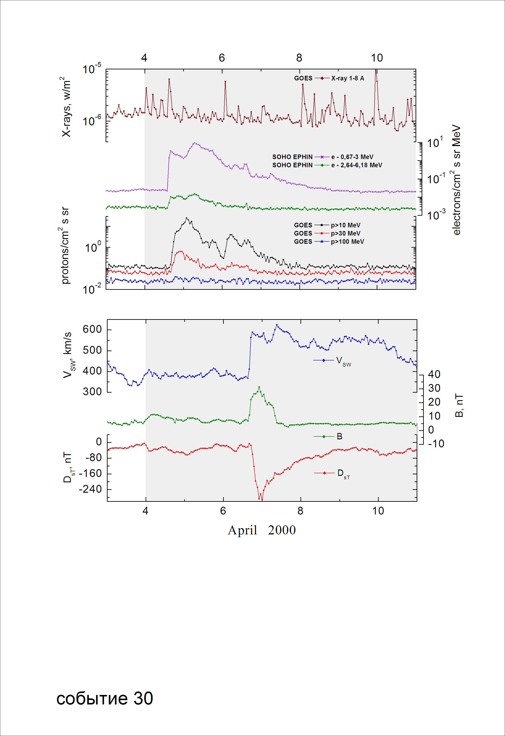
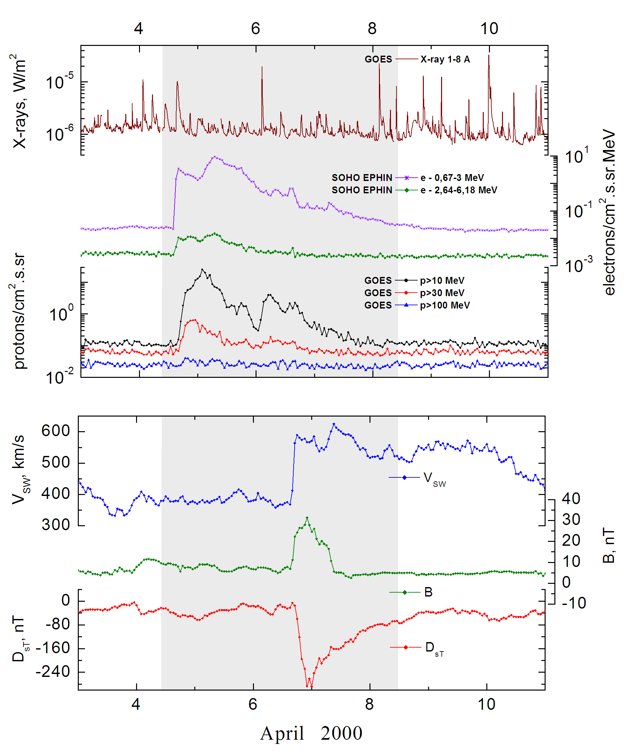
Integral time-of-maximum proton spectrum 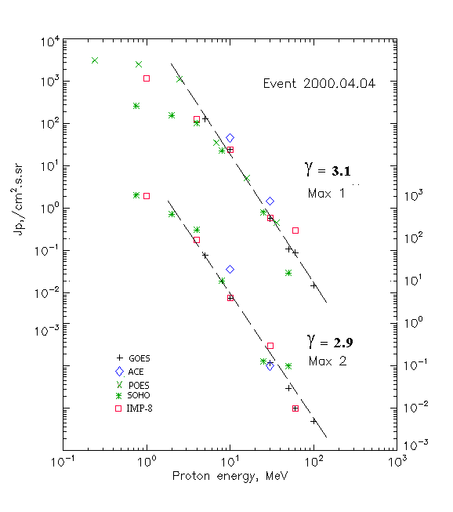

Integral fluxes of protons for the event of 2000 April 04

S/c, instruments | Eр, MeV | To | Tmax | Jmax,  /cm².s.sr | Dura-tion | Comments
GOES-10
EPS | >5 | 17^{h} | 5d02^{h}/6d06 ^{h} | 130.9/41.1 | 4d
EPS | >10 | 17^{h} | 5d02^{h}/6d06 ^{h} | 25/4 | 3d
EPS | >30 | 17^{h} | 23^{h}/6d06 ^{h} | 0.6/0.12 | 2d
EPS | >50 | 17^{h} | 22^{h}/6d06 ^{h} | 0.11/0.03 | 1d
EPS | >60 | 18^{h} | 21^{h}/6d06 ^{h} | 0.09/0.01 | 1d
EPS | >100 | 18^{h} | 20^{h}/6d06 ^{h} | 0.015/0.005 | 1d
POES-15
MEPED | >0.24 | 18^{h} | 5d10^{h}/ - | 3200/ - | 4d
MEPED | >0.8 | 18^{h} | 5d10^{h}/ - | 2500/ - | 4d
MEPED | >2.5 | 18^{h} | 5d10^{h}/ - | 1120/ - | 4d
MEPED | >6.9 | 18^{h} | 5d10^{h}/ - | 36/ - | 4d
MEPED | >16 | 18^{h} | 5d10^{h}/ - | 5.2/ - | 4d
MEPED | >36 | 18^{h} | 5d10^{h}/ - | 0.46/ - | 4d
MEPED | >70 | ⁻ | - | - | -
MEPED | >140 | ⁻ | - | - | -
IMP-8
CPME | >1 | 18^{h} | 05d02^{h}/06d06^{h} | 1200/1060 | 7 d
CPME | >4 | 18^{h} | 05d02^{h}/06d06^{h} | 131/94 | 5 d
CPME | >10 | 18^{h} | 05d02^{h}/06d06^{h} | 24/4 | 4 d
CPME | >30 | 18^{h} | 05d02^{h}/06d06^{h} | 0.6/0.3 | 1 d
CPME | >60 | 18^{h} | 05d02^{h}/06d06^{h} | 0.3/0.01 | 1 d
ACE
SIS | >10 | 18^{h} | 05d06^{h}/06d18^{h} | 46.5/19.1 | 2 d
SIS | >30 | 18^{h} | 21^{h}/06d18^{h} | 1.5/ 0.1 | 1 d
SOHO
EPHIN (INT) | >50 | 18^{h} | 21^{h}/06d15^{h} | 0.03/0.1 | 2d

Differential fluxes of protons for the event of 2000 April 04

S/c, instruments | ∆Е, MeV | To | Tmax | Jmax  /cm².s.sr.MeV | Dura-tion | Comments
IMP-8
CPME | 1-2 | 19^{h} | - /10^{h} | - /950 | 8d
CPME | 2-4.6 | 19^{h} | - /10^{h} | - /143 | 8d
CPME | 4.6-15 | 19^{h} | - /10^{h} | - /6 | 5d
CPME | 15-25 | 19^{h} | - /10^{h} | - /0.07 | 3d
CPME | 25-48 | 19^{h} | - / - | - / - | 2d
CPME | 48-96 | 19^{h} | - / - | - / - | 1d
CPME | 96-145 | 19^{h} | - / - | - / - | 1d
CPME | 145-440 | 19^{h} | - / - | - / - | 1d
SOHO
LION | 0,75-2 | 19^{h} | 05d02^{h}/06d15^{h} | 59/407 | 6d
LION | 2-6 | 19^{h} | 05d02^{h}/06d15^{h} | 13.4/55.5 | 6d
EPHIN | 4-8 | 19^{h} | 05d02^{h}/06d15^{h} | 20.3/38.7 | 8d
EPHIN | 8-25 | 18^{h} | 05d03^{h}/06d15^{h} | 1.3/0.6 | 5d
EPHIN | 25-41 | 17^{h} | 05d00^{h}/06d15^{h} | 0.028/0.001 | 4d
EPHIN | 41-53 | - ‘ - | - ‘ - | - ‘ - | - ‘ -

References:
No information on publications, excepting for:
http://www.swpc.noaa.gov/ftpdir/indices/SPE.txt

