Event 2000.06.07 – (2000-159)

Particle event: To(Ep>10 MeV) – 07d00^{h}
Tmax(Ep>10 MeV) – 8d10^{h}, Jmax (Ep>10 MeV) – 54 /cm².s.sr
Duration of the event – 3 days
Energy of the SCR and 0.1 GCR fluxes balance – Eb= 100 MeV

Sources: ● solar flare 06d11^{h}25^{m}, X2.3/3B, N20E18, АR9026
Main X-ray burst 1-8 Ǻ: onset – 06d14^{h}28^{m}, max – 06d15^{h}25^{m}, Ф = 0.36 J/m²
CME: 06d15^{h}54^{m}, V = 1119 km/s, Δφ = 360º, dA = 047º

Particle fluxes and associated phenomena
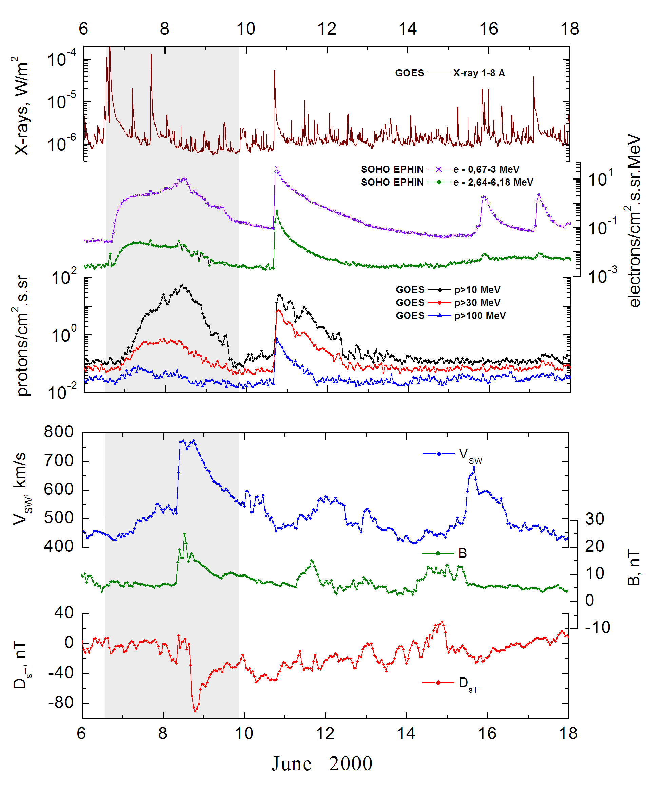
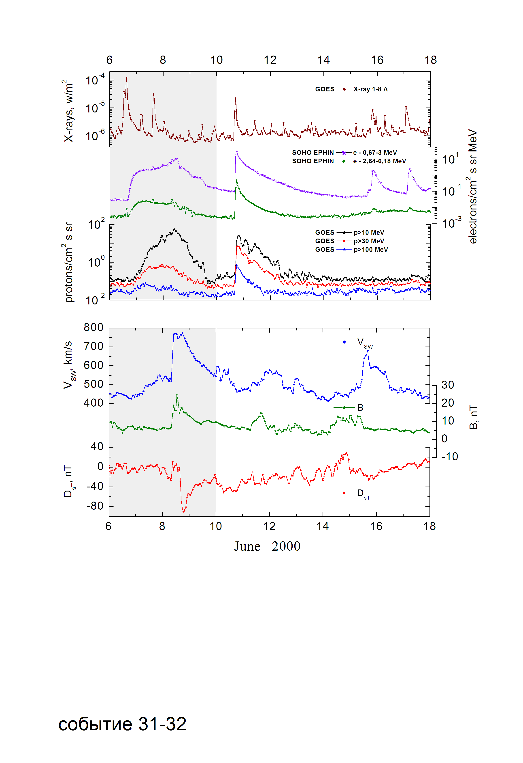

Integral time-of-maximum proton spectrum

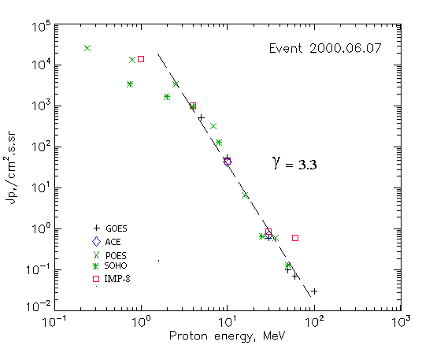

Integral fluxes of protons for the event of 2000 June 07

S/c, instruments | Eр, MeV | To | Tmax | Jmax,  /cm².s.sr | Dura-tion | Comments
GOES-10
EPS | >5 | 01^{h} | 08d10^{h} | 520 | 3d
EPS | >10 | 01^{h} | 08d10^{h} | 54 | 3d
EPS | >30 | 00^{h} | 08d09^{h} | 0.6 | 3d
EPS | >50 | - | 08d08^{h} | 0.1 | 2d
EPS | >60 | - | 08d07^{h} | 0.07 | 2d
EPS | >100 | - | 08d07^{h} | 0.03 | 2d
POES-15
MEPED | >0.24 | - | 08d10^{h} | 25310 | 3d
MEPED | >0.8 | - | 08d10^{h} | 13250 | 3d
MEPED | >2.5 | - | 08d10^{h} | 3290 | 3d
MEPED | >6.9 | - | 08d10^{h} | 320 | 2d
MEPED | >16 | - | 08d10^{h} | 6.5 | 2d
MEPED | >36 | - | 08d10^{h} | 0.6 | 2d
MEPED | >70 | - | - | - | -
MEPED | >140 | - | - | - | -
IMP-8
CPME | >1 | 6d23^{h} | 08d11^{h} | 13700 | 3 d
CPME | >4 | 6d22^{h} | 08d11^{h} | 994 | 3 d
CPME | >10 | 02^{h} | 08d10^{h} | 44 | 3 d
CPME | >30 | 02^{h} | 08d09^{h} | 0.85 | 2 d
CPME | >60 | 02^{h} | 08d09^{h} | 0.6 | 2 d
ACE
SIS | >10 | 01^{h} | 08d12^{h} | 42 | 3d
SIS | >30 | 06d23^{h} | 07d11^{h} | 0.7 | 2d
SOHO
EPHIN (INT) | >50 | 06d22^{h} | 08d10^{h} | 0.13 | 2d

Differential fluxes of protons for the event of 2000 June 07

S/c, instruments | ∆Е, MeV | To | Tmax | Jmax  /cm².s.sr.MeV | Dura-tion | Comments
IMP-8
CPME | 1-2 | 06d23^{h} | 08d10^{h} | 980 | 4d
CPME | 2-4.6 | 06d23^{h} | 08d10^{h} | 178 | 4d
CPME | 4.6-15 | 06d23^{h} | 08d10^{h} | 67 | 4d
CPME | 15-25 | 06d23^{h} | 08d10^{h} | 0.9 | 3d
CPME | 25-48 | 06d23^{h} | 08d10^{h} | 0.017 | 3d
CPME | 48-96 | 06d23^{h} | 08d09^{h} | 0.002 | 2d
CPME | 96-145 | - | - | - | -
CPME | 145-440 | - | - | - | -
SOHO
LION | 0,75-2 | 06d23^{h} | 08d12^{h} | 996 | 4d
LION | 2-6 | 07d00^{h} | 08d11^{h} | 176 | 4d
EPHIN | 4-8 | 06d22^{h} | 08d12^{h} | 205 | 4d
EPHIN | 8-25 | 06d21^{h} | 08d09^{h} | 7.5 | 3d
EPHIN | 25-41 | 06d19^{h} | 08d09^{h} | 0.023 | 3d
EPHIN | 41-53 | - ‘ - | - ‘ - | - ‘ - | - ‘ -

References:
No information on publications, excepting for:
http://www.swpc.noaa.gov/ftpdir/indices/SPE.txt

