Event 2000.06.10 – (2000-162)

Particle event: To(Ep>10 MeV) – 10d17^{h}
Tmax(Ep>10 MeV) – 10d20^{h}, Jmax (Ep>10 MeV) – 24/cm².s.sr
Duration of the event – 4 days
Energy of the SCR and 0.1 GCR fluxes balance – Eb = 390 MeV

Sources: ● solar flare 10d16^{h}22^{m}, M5.2/3B, N22W39, АR9026
Main X-ray burst 1-8 Ǻ: onset – 10d16^{h}40^{m}, max – 10d17^{h}02^{m}, Ф = 0.073 J/m²
CME: 10d17^{h}08^{m}, V = 1108 km/s, Δφ = 360º, dA = 307º
Δ SC 11d08^{h}01^{m}, Δ SC 12d22^{h}08^{m}

Particle fluxes and associated phenomena
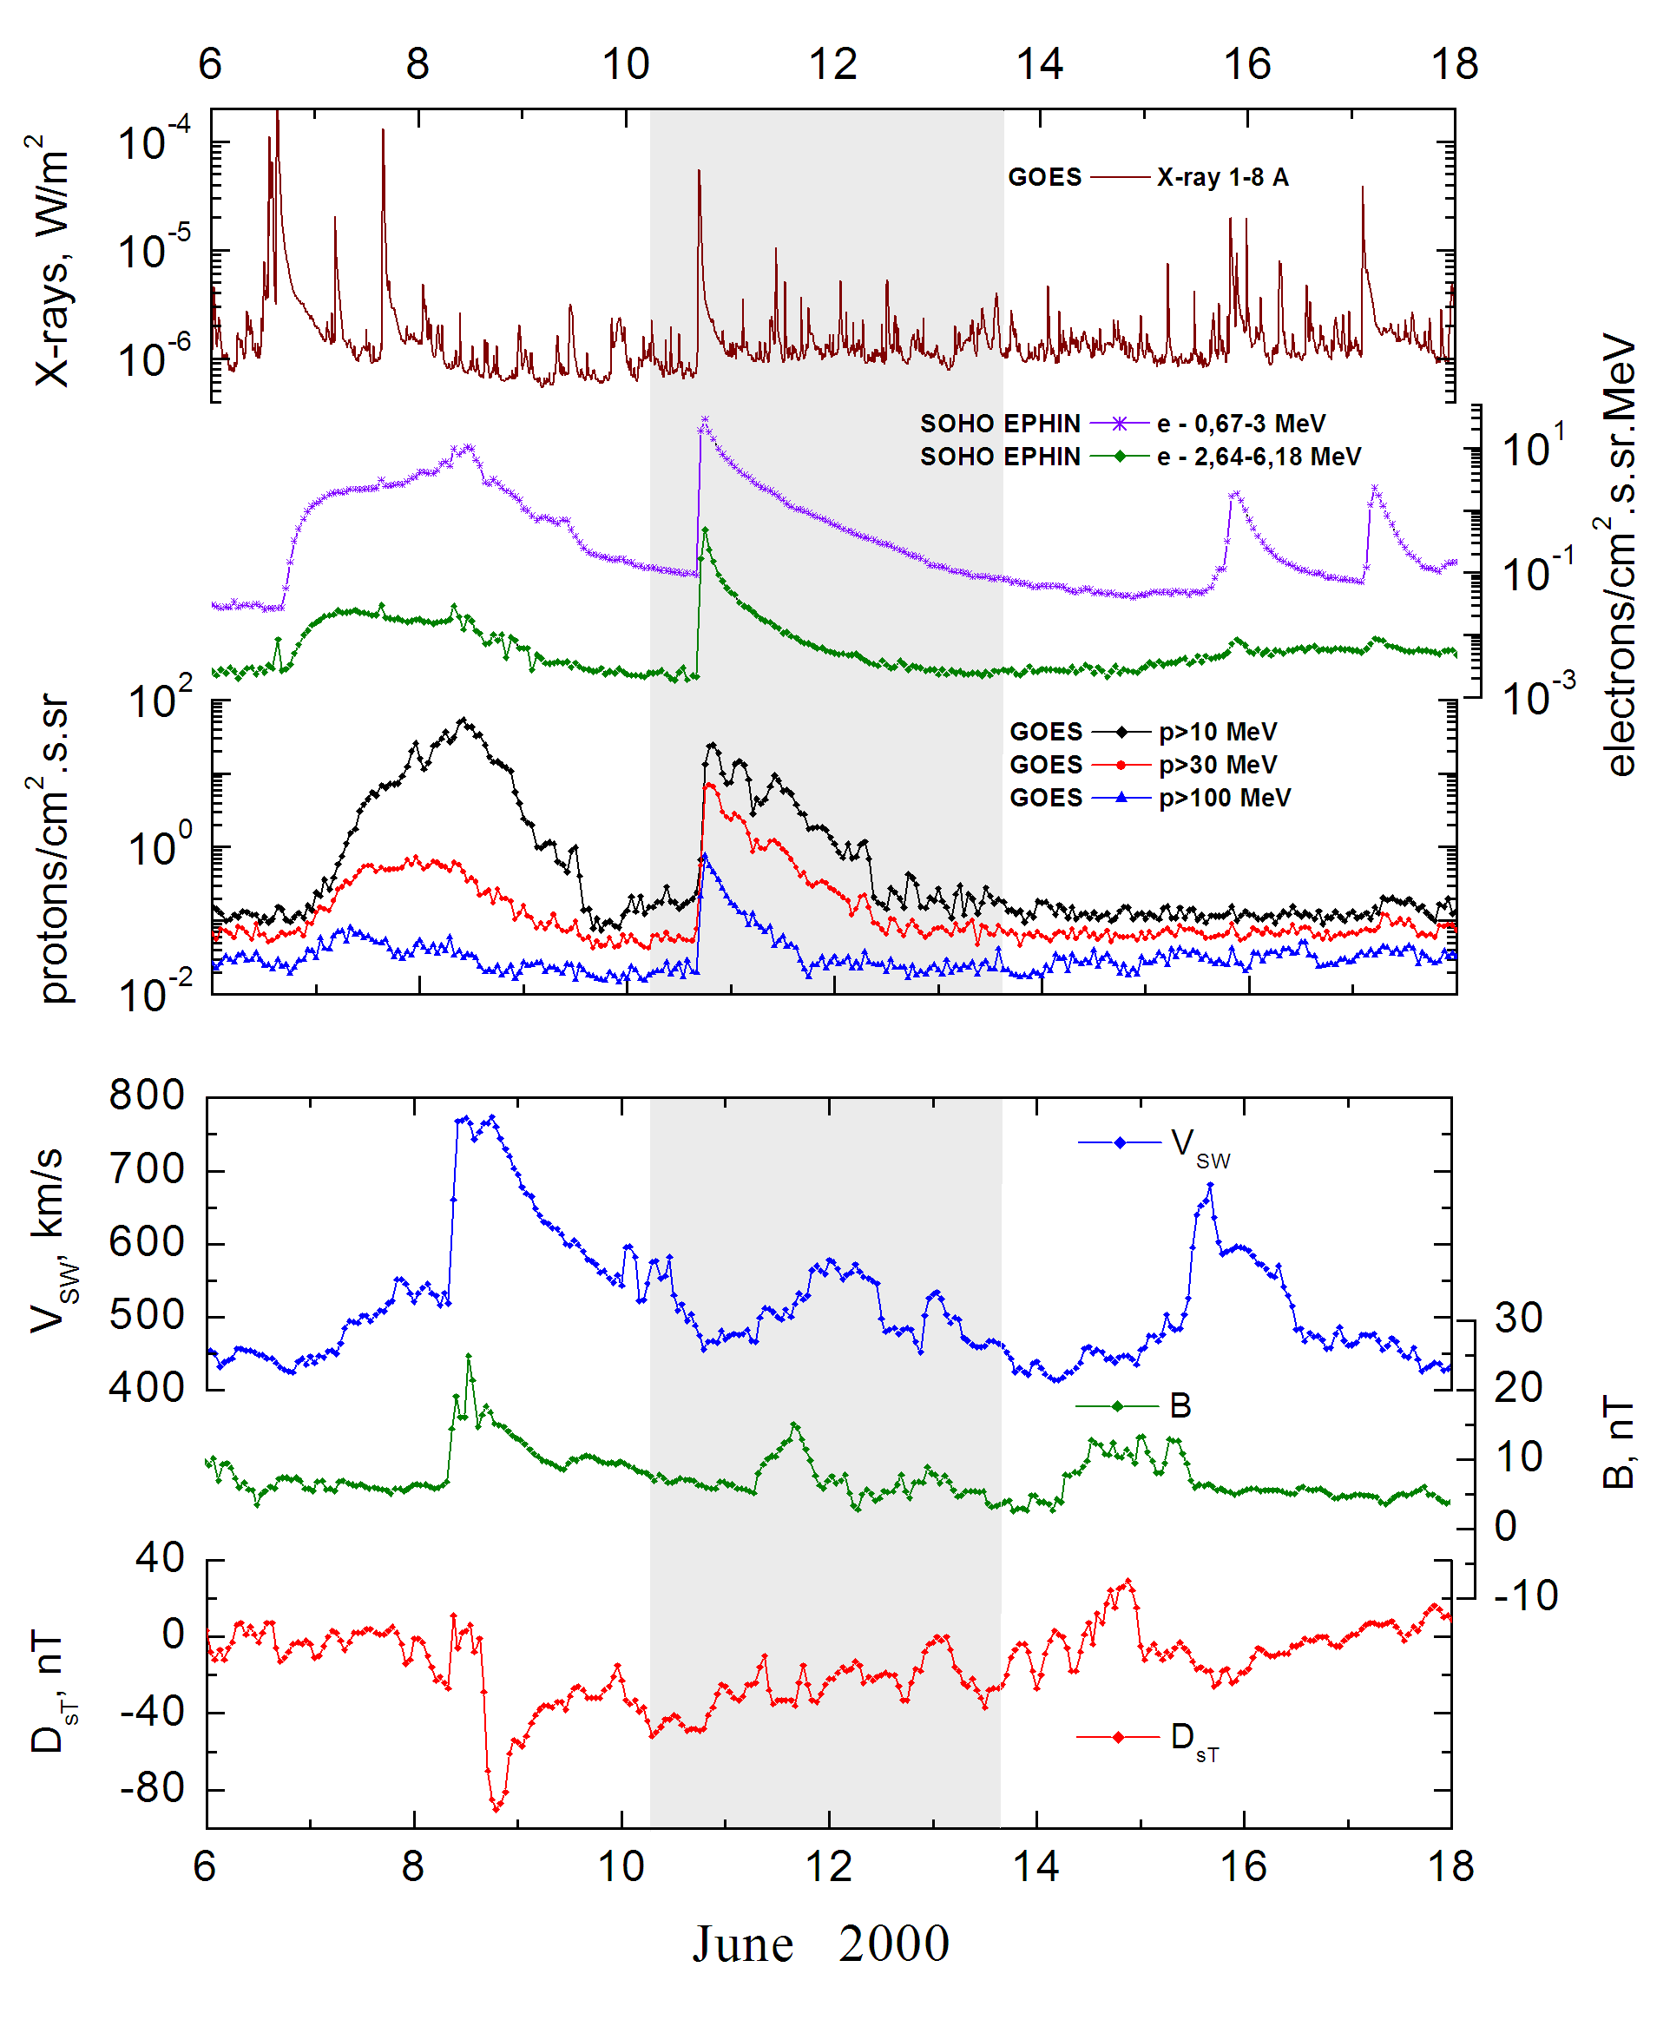

Integral time-of-maximum proton spectrum
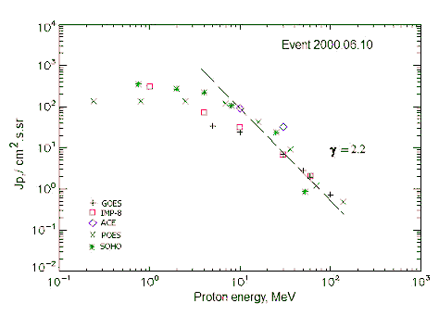

Integral fluxes of protons for the event of 2000 June 10

S/c, instruments | Eр, MeV | To | Tmax | Jmax,  /cm².s.sr | Dura-tion | Comments
GOES-10
EPS | >5 | 17^{h} | 20^{h} | 34.4 | >3d
EPS | >10 | 17^{h} | 20^{h} | 24 | >3d
EPS | >30 | 17^{h} | 19^{h} | 6.9 | >2d
EPS | >50 | 17^{h} | 18^{h} | 2.8 | >1d
EPS | >60 | 17^{h} | 18^{h} | 1.96 | >1d
EPS | >100 | 17^{h} | 18^{h} | 0.73 | 1d
POES-15
MEPED | >0.24 | 17^{h} | 19^{h} | 137 | 3d
MEPED | >0.8 | 17^{h} | 19^{h} | 137 | 3d
MEPED | >2.5 | 17^{h} | 19^{h} | 137 | 3d
MEPED | >6.9 | 17^{h} | 19^{h} | 119 | 3d
MEPED | >16 | 17^{h} | 19^{h} | 41.5 | 3d
MEPED | >36 | 17^{h} | 19^{h} | 9.2 | 3d
MEPED | >70 | 17^{h} | 19^{h} | 1.2 | 3d
MEPED | >140 | 17^{h} | 19^{h} | 0.48 | 3d
IMP-8
CPME | >1 | 14^{h} | 23^{h} | 303 | 5 d
CPME | >4 | 14^{h} | 21^{h} | 73.2 | 4 d
CPME | >10 | 15^{h} | 19^{h} | 31.1 | 4 d
CPME | >30 | 15^{h} | 19^{h} | 6.8 | 1.5 d
CPME | >60 | 16^{h} | 19^{h} | 2.1 | 1.5 d
ACE
SIS | >10 | 17^{h} | 18^{h} | 92 | 3d
SIS | >30 | 17^{h} | 18^{h} | 32.5 | 2d
SOHO
EPHIN (INT) | >50 | - | 22^{h} | 0.85 | 1.5d

Differential fluxes of protons for the event of 2000 June 10

S/c, instruments | ∆Е, MeV | To | Tmax | Jmax  /cm².s.sr.MeV | Dura-tion | Comments
IMP-8
CPME | 1-2 | 21^{h} | 11d01^{h} | 197 | 4d
CPME | 2-4.6 | 19^{h} | 23^{h} | 56.4 | 4d
CPME | 4.6-15 | 19^{h} | 21^{h} | 4.9 | 4d
CPME | 15-25 | 18^{h} | 18^{h} | 1.8 | 3d
CPME | 25-48 | 18^{h} | 19^{h} | 0.25 | 3d
CPME | 48-96 | 16^{h} | 19^{h} | 0.052 | 2d
CPME | 96-145 | - | - | - | -
CPME | 145-440 | - | - | - | -
SOHO
LION | 0,75-2 | 19^{h} | 21^{h} | 46 | 5d
LION | 2-6 | 19^{h} | 21^{h} | 12.7 | 5d
EPHIN | 4-8 | 19^{h} | 21^{h} | 28.4 | 5d
EPHIN | 8-25 | 19^{h} | 20^{h} | 4.9 | 5d
EPHIN | 25-41 | 19^{h} | 19^{h} | 1.1 | 5d
EPHIN | 41-53 | - ‘ - | - ‘ - | - ‘ - | - ‘ -

References:
No information on publications, excepting for:
http://www.swpc.noaa.gov/ftpdir/indices/SPE.txt

