Event 2000.06.17 – (2000-169)

Particle event: To(Ep>10 MeV) – 17d07^{h}
Tmax(Ep>10 MeV) –18d06^{h}, Jmax (Ep>10 MeV) – 1.7 /cm².s.sr *)
Duration of the event – 2 days *)
Energy of the SCR and 0.1 GCR fluxes balance – Eb = 110 MeV
*) According to data IMP-8 (CPME)

Sources: ● solar flare 17d02^{h}25^{m}, M3.5/2B, N22W72, АR9033
Ø solar flare 18d01^{h}52^{m}, X1.0/SF, N23W85, АR9033
Main X-ray burst 1-8 Ǻ : onset – 17d02^{h}25^{m}, max – 17d02^{h}37^{m}, Ф = 0.024 J/m²
CME: 17d03^{h}28^{m}, V = 857 km/s, Δφ = 133º, dA=301º;

Particle fluxes and associated phenomena
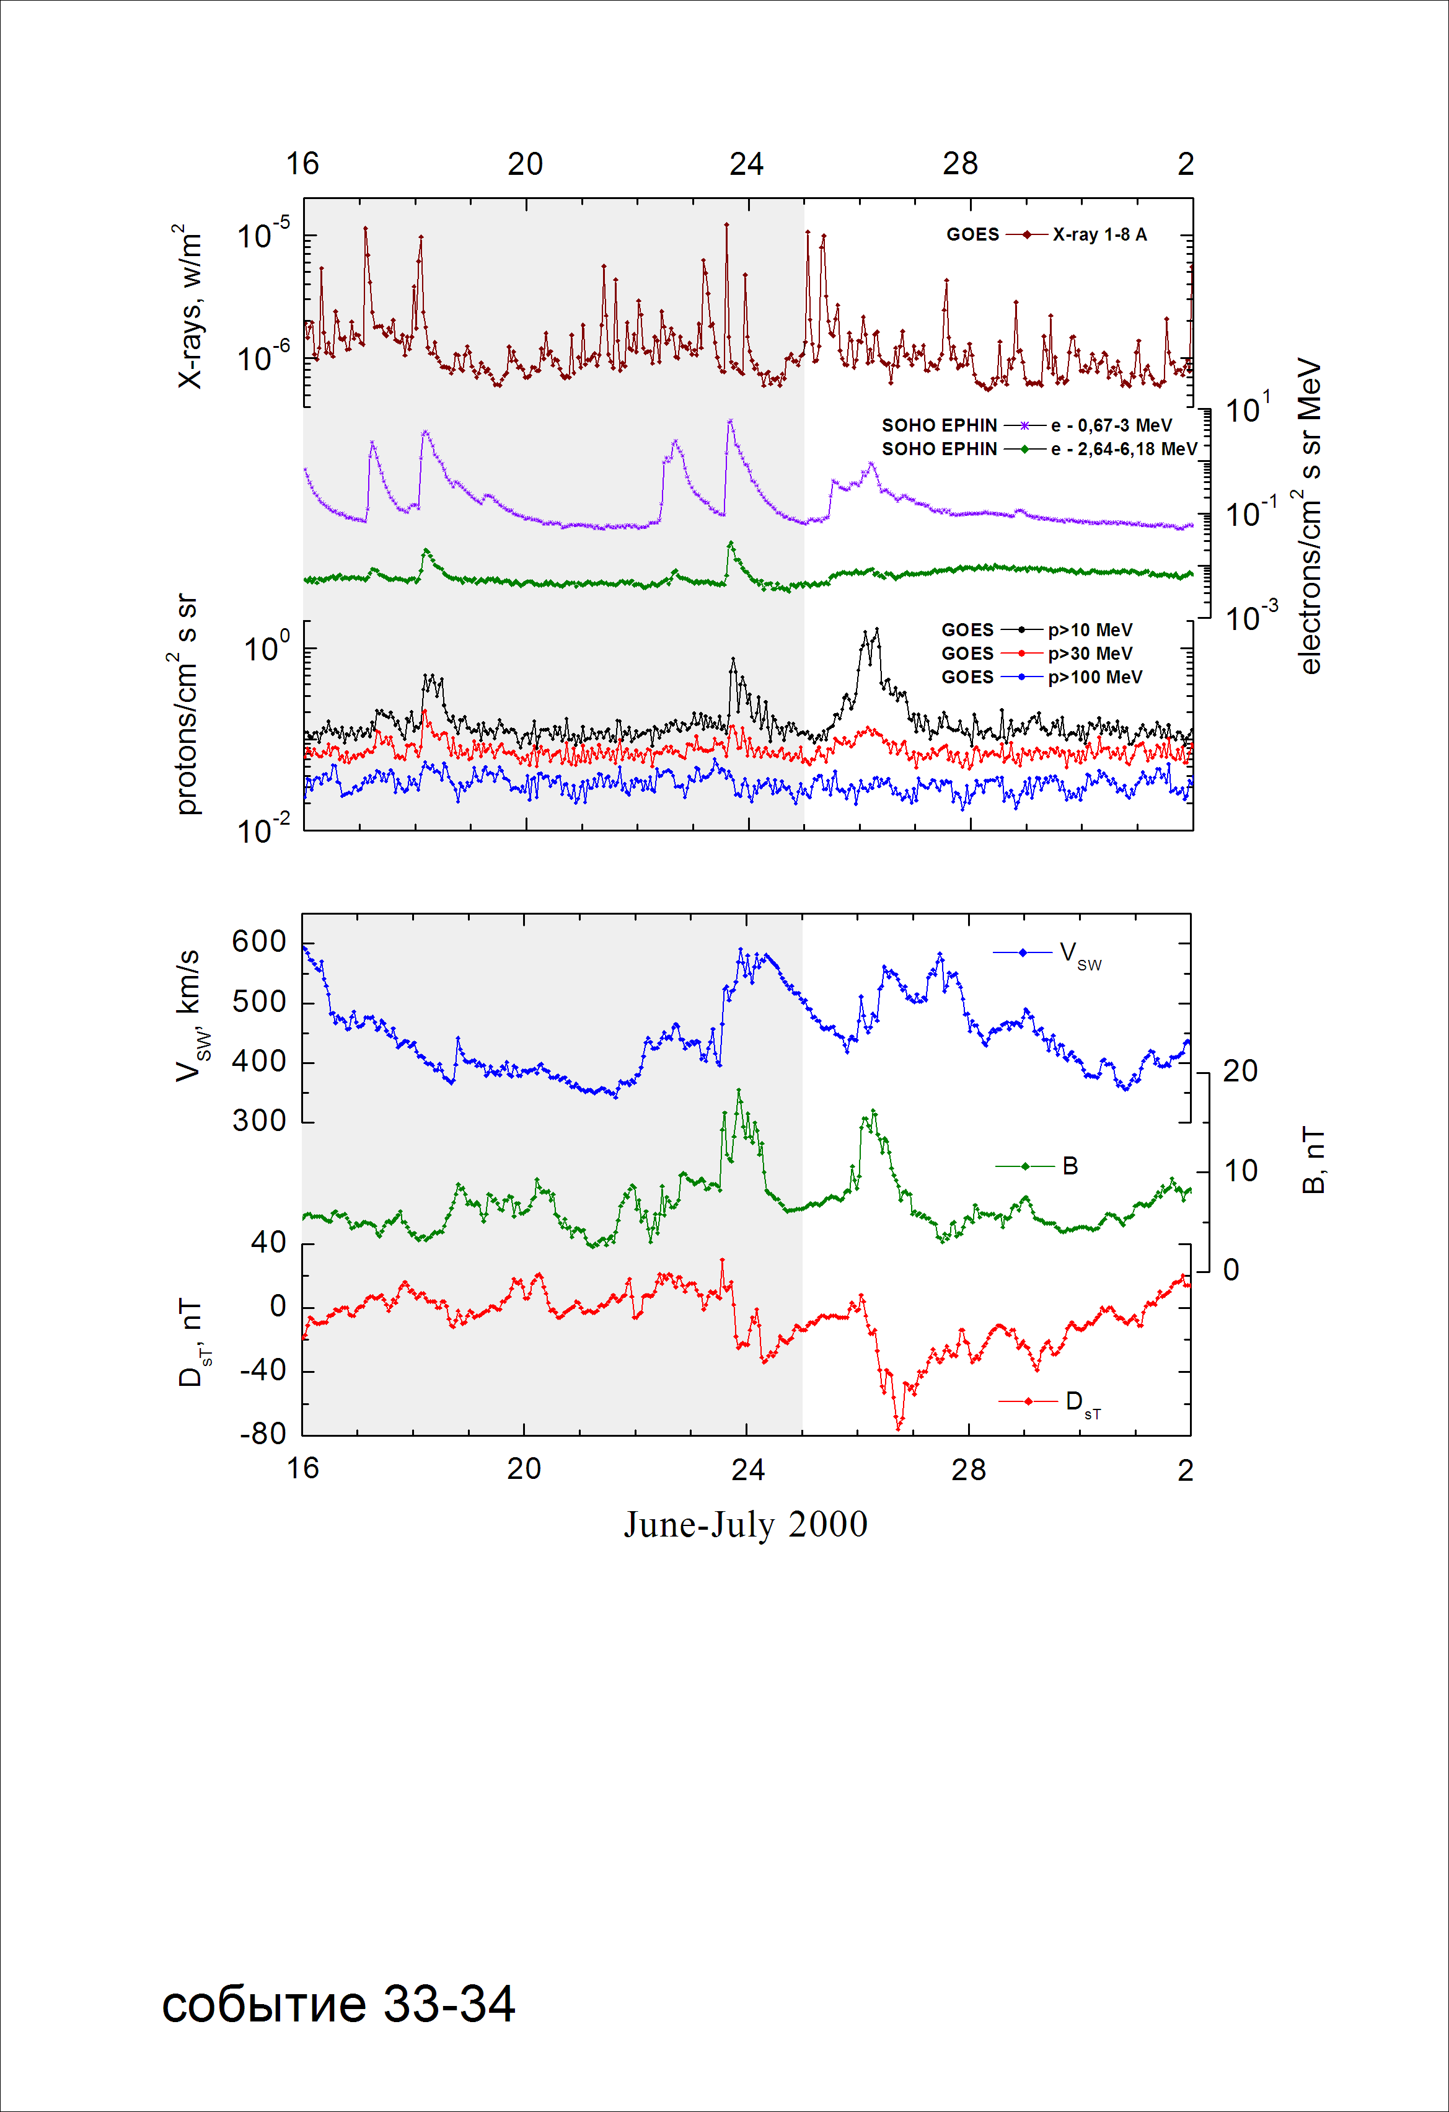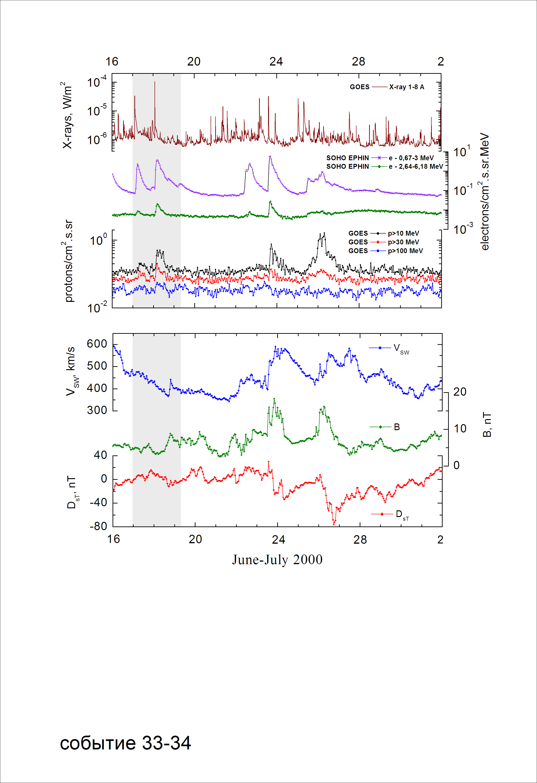

Integral time-of-maximum proton spectrum

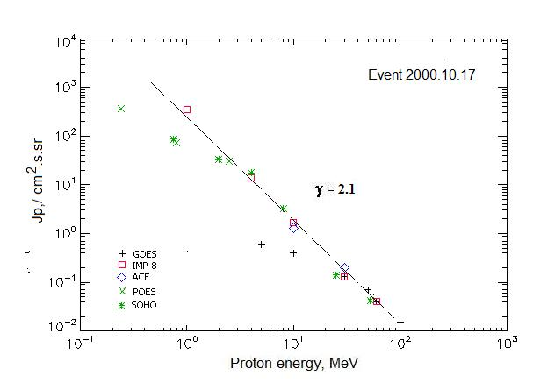

Integral fluxes of protons for the event of 2000 June 17

S/c, instruments | Eр, MeV | To | Tmax | Jmax,  /cm².s.sr | Dura-tion | Comments
GOES-10
EPS | >5 | 07^{h} | 18d05^{h} | 0.6 | 1d
EPS | >10 | 07^{h} | 18d04^{h} | 0.4 | 1d
EPS | >30 | 07^{h} | 18d04^{h} | 0.13 | 1d
EPS | >50 | 07^{h} | 18d04^{h} | 0.07 | 1d
EPS | >60 | 07^{h} | 18d04^{h} | 0.04 | 1d
EPS | >100 | 07^{h} | 18d04^{h} | 0.015 | 1d
POES-15
MEPED | >0.24 | 14^{h} | 18d04^{h} | 371 | 3d
MEPED | >0.8 | 14^{h} | 18d04^{h} | 73 | 3d
MEPED | >2.5 | 14^{h} | 18d04^{h} | 31 | 3d
MEPED | >6.9 | - | - | - | -
MEPED | >16 | - | - | - | -
MEPED | >36 | - | - | - | -
MEPED | >70 | - | - | - | -
MEPED | >140 | - | - | - | -
IMP-8
CPME | >1 | 10^{h} | 18d03^{h} | 356 | 3 d
CPME | >4 | 08^{h} | 18d05^{h} | 14 | 2 d
CPME | >10 | 07^{h} | 18d06^{h} | 1.7 | 2 d
CPME | >30 | - | 18d06^{h} | 0.13 | 1.5 d
CPME | >60 | - | 18d06^{h} | 0.04 | 0.5 d
ACE
SIS | >10 | 07^{h} | 18d06^{h} | 1.3 | 1d
SIS | >30 | 07^{h} | 18d04^{h} | 0.2 | 1d
SOHO
EPHIN (INT) | >50 | - | 18d05^{h} | 0.008 | -

Differential fluxes of protons for the event of 2000 June 17

S/c, instruments | ∆Е, MeV | To | Tmax | Jmax  /cm².s.sr.MeV | Dura-tion | Comments
IMP-8
CPME | 1-2 | 09^{h} | 18d02^{h} | 274 | 3d
CPME | 2-4.6 | 08^{h} | 18d03^{h} | 34.6 | 3d
CPME | 4.6-15 | 06^{h} | 18d03^{h} | 0.77 | 2d
CPME | 15-25 | 05^{h} | 18d01^{h} | 0.045 | 1,5d
CPME | 25-48 | 05^{h} | 18d05^{h} | 0.008 | 0,5d
CPME | 48-96 | - | 18d05^{h} | 0.0025 | 0,5d
CPME | 96-145 | - | - | - | -
CPME | 145-440 | - | - | - | -
SOHO
LION | 0,75-2 | 06^{h} | 18d06^{h} | 30.3 | 3d
LION | 2-6 | 06^{h} | 18d06^{h} | 3.9 | 3d
EPHIN | 4-8 | 06^{h} | 18d05^{h} | 3.9 | 3d
EPHIN | 8-25 | 05^{h} | 18d05^{h} | 0.81 | 3d
EPHIN | 25-41 | 05^{h} | 18d04^{h} | 0.006 | 3d
EPHIN | 41-53 | - “ - | - “ - | - “ - | - “ -

References:
No information on publications, excepting for:
http://www.swpc.noaa.gov/ftpdir/indices/SPE.txt

