Event 2000.07.13 – (2000-195)

Particle event: To(Ep>10 MeV) – 13d06^{h}
Tmax(Ep>10 MeV) –13d10^{h}, Jmax (Ep>10 MeV) – 5 /cm².s.sr
Duration of the event – 1.5 days
Energy of the SCR and 0.1 GCR fluxes balance – Eb = 40 MeV

Sources: ๏ solar flare 12d18^{h}41^{m}, M5.7/2F, N16W64, АR9070
Main X-ray burst 1-8 Ǻ : onset – 12d18^{h}41^{m}, max – 12d18^{h}47^{m}, Ф = 0.063 J/m²
CME: 12d20^{h}30^{m}, V = 820 km/s, Δφ = 101º, dA = 281º
▲SC 13d09^{h}42^{m}

Particle fluxes and associated phenomena
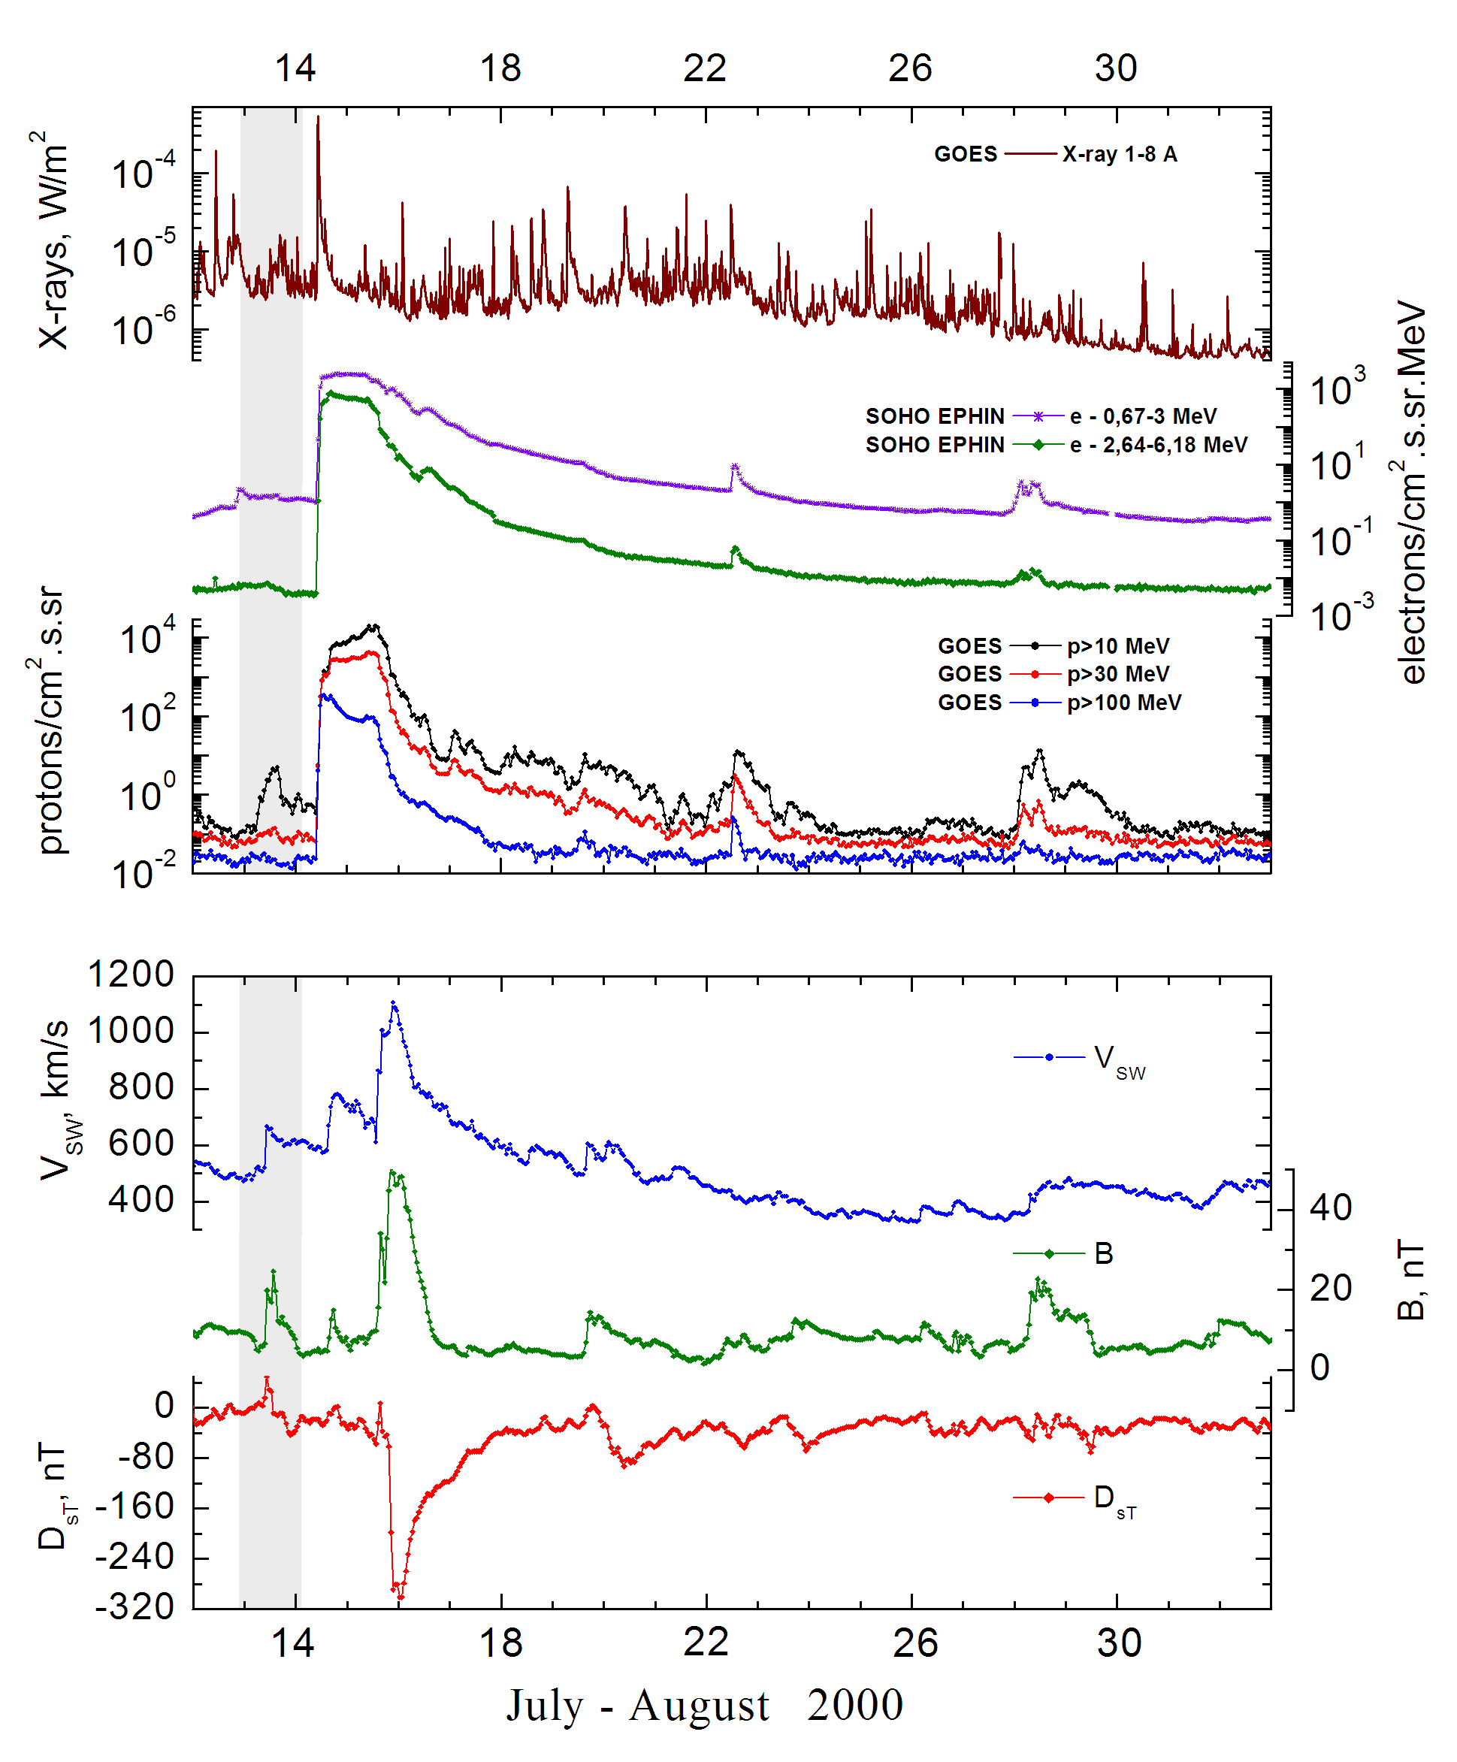
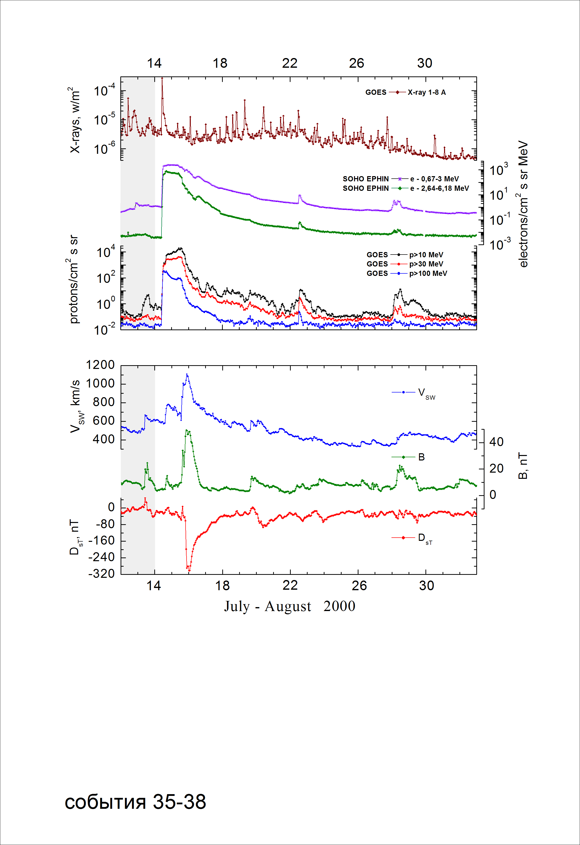
Integral time-of-maximum proton spectrum
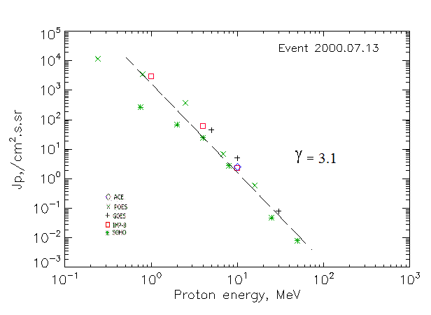

Integral fluxes of protons for the event of 2000 July 13

S/c, instruments | Eр, MeV | To | Tmax | Jmax,  /cm².s.sr | Dura-tion | Comments
GOES 10
EPS | >5 | 06^{h} | 15^{h} | 45 | 1.5d
EPS | >10 | 06^{h} | 15^{h} | 5 | 1.5d
EPS | >30 | 06^{h} | 14^{h} | 0.08 | 1d
EPS | >50 | - | - | - | -
EPS | >60 | - | - | - | -
EPS | >100 | - | - | - | -
POES-15
MEPED | >0.24 | - | 09^{h} | 11490 | 1.5 d
MEPED | >0.8 | - | 09^{h} | 3480 | 1.5 d
MEPED | >2.5 | - | 09^{h} | 362 | 1.5 d
MEPED | >6.9 | - | 09^{h} | 7 | 1.5 d
MEPED | >16 | - | 09^{h} | 0.6 | 1.5 d
MEPED | >36 | - | - | - | -
MEPED | >70 | - | - | - | -
MEPED | >140 | - | - | - | -
IMP-8
CPME | >1 | 02^{h} | 10^{h} | 2920 | 1.5 d
CPME | >4 | 02^{h} | 10^{h} | 62 | 1.5 d
CPME | >10 | 02^{h} | 10^{h} | 2.3 | 1.5 d
CPME | >30 | - | - | - | -
CPME | >60 | - | - | - | -
ACE
SIS | >10 | 12d20^{h} | 14^{h} | 2.5 | 1.5 d
SIS | >30 | - | - | - | 1.5 d
SOHO
EPHIN (INT) | >50 | - | 14^{h} | 0.008 | -

Differential fluxes of protons for the event of 2000 July 13

S/c, instruments | ∆Е, MeV | To | Tmax | Jmax  /cm².s.sr.MeV | Dura-tion | Comments
IMP-8
CPME | 1-2 | 12d17^{h} | 10^{h} | 2630 | 2d
CPME | 2-4.6 | 12d17^{h} | 10^{h} | 200 | 2d
CPME | 4.6-15 | 12d17^{h} | 10^{h} | 3.85 | 2d
CPME | 15-25 | - | - | - | -
CPME | 25-48 | - | - | - | -
CPME | 48-96 | - | - | - | -
CPME | 96-145 | - | - | - | -
CPME | 145-440 | - | - | - | -
SOHO
LION | 0,75-2 | 12d19^{h} | 12^{h} | 111 | 1.5d
LION | 2-6 | 12d19^{h} | 12^{h} | 10.8 | 1.5d
EPHIN | 4-8 | 12d20^{h} | 12^{h} | 5.5 | 1.5d
EPHIN | 8-25 | 12d20^{h} | 11^{h} | 0.16 | 1.5d
EPHIN | 25-41 | 12d20^{h} | 10^{h} | 0.0014 | 1d
EPHIN | 41-53 | - “ - | - “ - | - “ - | - “ -

References:
No information on publications, excepting for:
http://www.swpc.noaa.gov/ftpdir/indices/SPE.txt

