Event 2000.07.16– (2000-198)

Particle event: To(Ep>10 MeV) – 16d11^{h}
Tmax₁(Ep>10 MeV) – 16d12^{h}, Jmax₁(Ep>10 MeV) – 100 /cm².s.sr
Tmax₂(Ep>10 MeV) – 17d02^{h}, Jmax₂(Ep>10 MeV) – 37 /cm².s.sr
Duration of the event – 3 days
Energy of the SCR and 0.1 GCR fluxes balance – Eb(max₁) = 370 MeV
– Eb(max₂) = 320 MeV
Sources: ● solar flare 15d08^{h}20^{m}, M1.3/SF, N16W12 АR9077
Main X-ray burst 1-8 Ǻ: onset – 15d08^{h}20^{m}, max – 15d08^{h}33^{m}, Ф = 0.018 J/m²
▲SC 15d14^{h}37^{m}, ▲SC 19d15^{h}27^{m}

Particle fluxes and associated phenomena

- 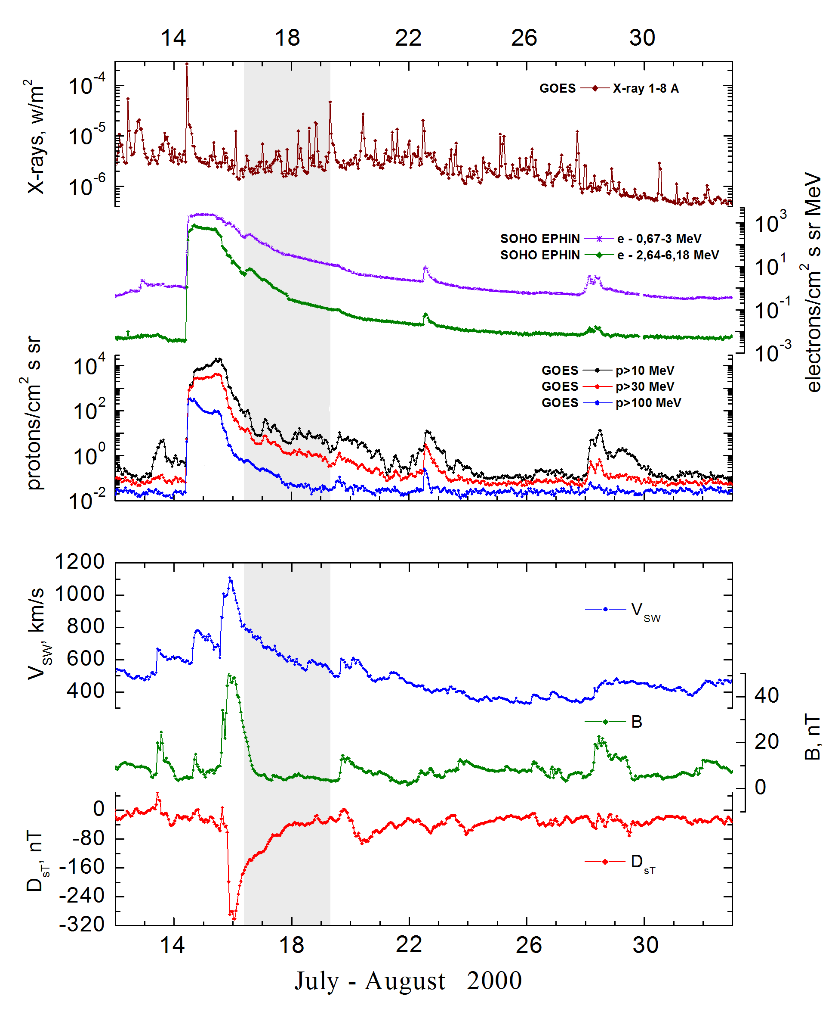

Integral time-of-maximum proton spectrum
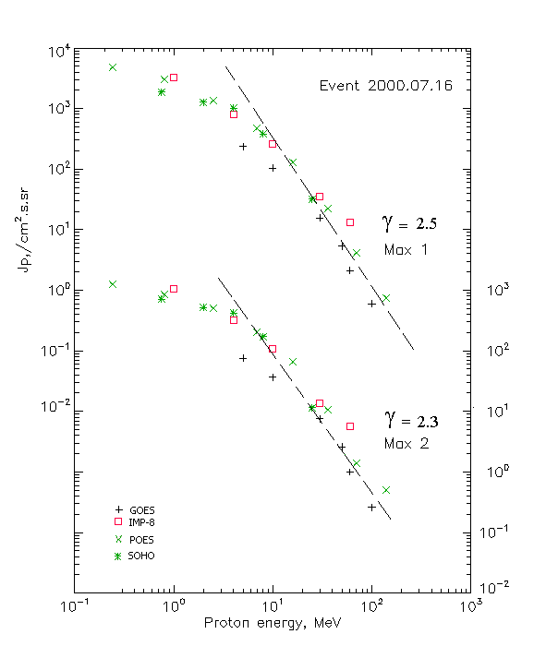

Integral fluxes of protons for the event of 2000 July 16

S/c, instruments | Eр, MeV | To | Tmax | Jmax,  /cm².s.sr | Dura-tion | Comments
GOES-10
EPS | >5 | 11^{h} | 12^{h}/17d03^{h} | 236/75.8 | 3d
EPS | >10 | 11^{h} | 12^{h}/17d02^{h} | 100/37 | 3d
EPS | >30 | 11^{h} | 12^{h}/17d02^{h} | 15.7/7.6 | 3d
EPS | >50 | 11^{h} | 12^{h}/17d02^{h} | 5.4/2.6 | 3d
EPS | >60 | 11^{h} | 12^{h}/17d02^{h} | 2.1/1.0 | 3d
EPS | >100 | 11^{h} | 12^{h}/17d01^{h} | 0.6/0.26 | 3d
POES-15
MEPED | >0.24 | 11^{h} | 12^{h}/17d02^{h} | 4660/1825 | 3d
MEPED | >0.8 | 11^{h} | 12^{h}/17d02^{h} | 3254/1290 | 3d
MEPED | >2.5 | 11^{h} | 12^{h}/17d02^{h} | 1690/712 | 3d
MEPED | >6.9 | 11^{h} | 12^{h}/17d02^{h} | 620/294 | 3d
MEPED | >16 | 11^{h} | 12^{h}/17d02^{h} | 184/84 | 3d
MEPED | >36 | 11^{h} | 12^{h}/17d02^{h} | 32/14 | 3d
MEPED | >70 | 11^{h} | 12^{h}/17d02^{h} | 5.2/2.1 | 3d
MEPED | >140 | 11^{h} | 12^{h}/17d02^{h} | 1./0.9 | 3d
IMP-8
CPME | >1 | 11^{h} | 13^{h}/17d03^{h} | 3210/1060 | 3d
CPME | >4 | 11^{h} | 12^{h}/17d02^{h} | 810/323 | 3d
CPME | >10 | 10^{h} | 12^{h}/17d02^{h} | 258/110 | 3d
CPME | >30 | 10^{h} | 11^{h}/17d02^{h} | 35.2/13.6 | 3d
CPME | >60 | 10^{h} | 11^{h}/17d01^{h} | 13.4/5.6 | 3d
ACE
SIS | >10 | 10^{h} | - | - | -
SIS | >30 | 10^{h} | - | - | -
SOHO
EPHIN (INT) | >50 | 11^{h} | 15^{h}/17d03^{h} | 4.3/1.7 | 3d

Differential fluxes of protons for the event of 2000 July 16

S/c, instruments | ∆Е, MeV | To | Tmax | Jmax  /cm².s.sr.MeV | Dura-tion | Comments
IMP-8
CPME | 1-2 | 10^{h} | 12^{h}/17d02^{h} | 1610/508 | 3d
CPME | 2-4.6 | 10^{h} | 12^{h}/17d03^{h} | 466/145 | 3d
CPME | 4.6-15 | 10^{h} | 12^{h}/17d02^{h} | 50.6/19.8 | 3d
CPME | 15-25 | 10^{h} | 12^{h}/17d03^{h} | 12.3/6.1 | 3d
CPME | 25-48 | 10^{h} | 11^{h}/17d02^{h} | 1.35/0.5 | 3d
CPME | 48-96 | 10^{h} | 11^{h}/17d02^{h} | 0.15/0.05 | 3d
CPME | 96-145 | - | - | - | -
CPME | 145-440 | - | - | - | -
SOHO
LION | 0,75-2 | 11^{h} | 16^{h}/17d03^{h} | 332/115 | 3d
LION | 2-6 | 11^{h} | 16^{h}/17d03^{h} | 67.4/23.5 | 3d
EPHIN | 4-8 | 11^{h} | 15^{h}/17d03^{h} | 158/63.2 | 3d
EPHIN | 8-25 | 11^{h} | 16^{h}/17d03^{h} | 20.8/9.4 | 3d
EPHIN | 25-41 | 11^{h} | 15^{h} /17d03^{h} | 1.2/0.56 | 3d
EPHIN | 41-53 | - “ - | - “ - | - “ - | - “ -

References:
No information on publications, excepting for:
http://www.swpc.noaa.gov/ftpdir/indices/SPE.txt

