Event 2000.09.12 – (2000-256)

Particle event: To(Ep>10 MeV) – 12d14^{h}
Tmax(Ep>10 MeV) – 13d02^{h}, Jmax (Ep>10 MeV) – 180 /cm².s.sr
Duration of the event – 6 days
Energy of the SCR and 0.1 GCR fluxes balance – Eb = 350 MeV

Sources: ● solar flare 12d11^{h}22^{m}, 2F/M1.0, S19W08, АR9163
Main X-ray burst 1-8 Ǻ: onset – 12d11^{h}31^{m}, max – 12d12^{h}00^{m}, Ф = 0.045 J/m²
CME: 12d11^{h}54^{m}, V = 1550 km/s, Δφ = 360º, dA =220 º
▲SC15d04^{h}50^{m}, ▲SC15d19^{h}12^{m}, ▲SC18d14^{h}44^{m}

Particle fluxes and associated phenomena
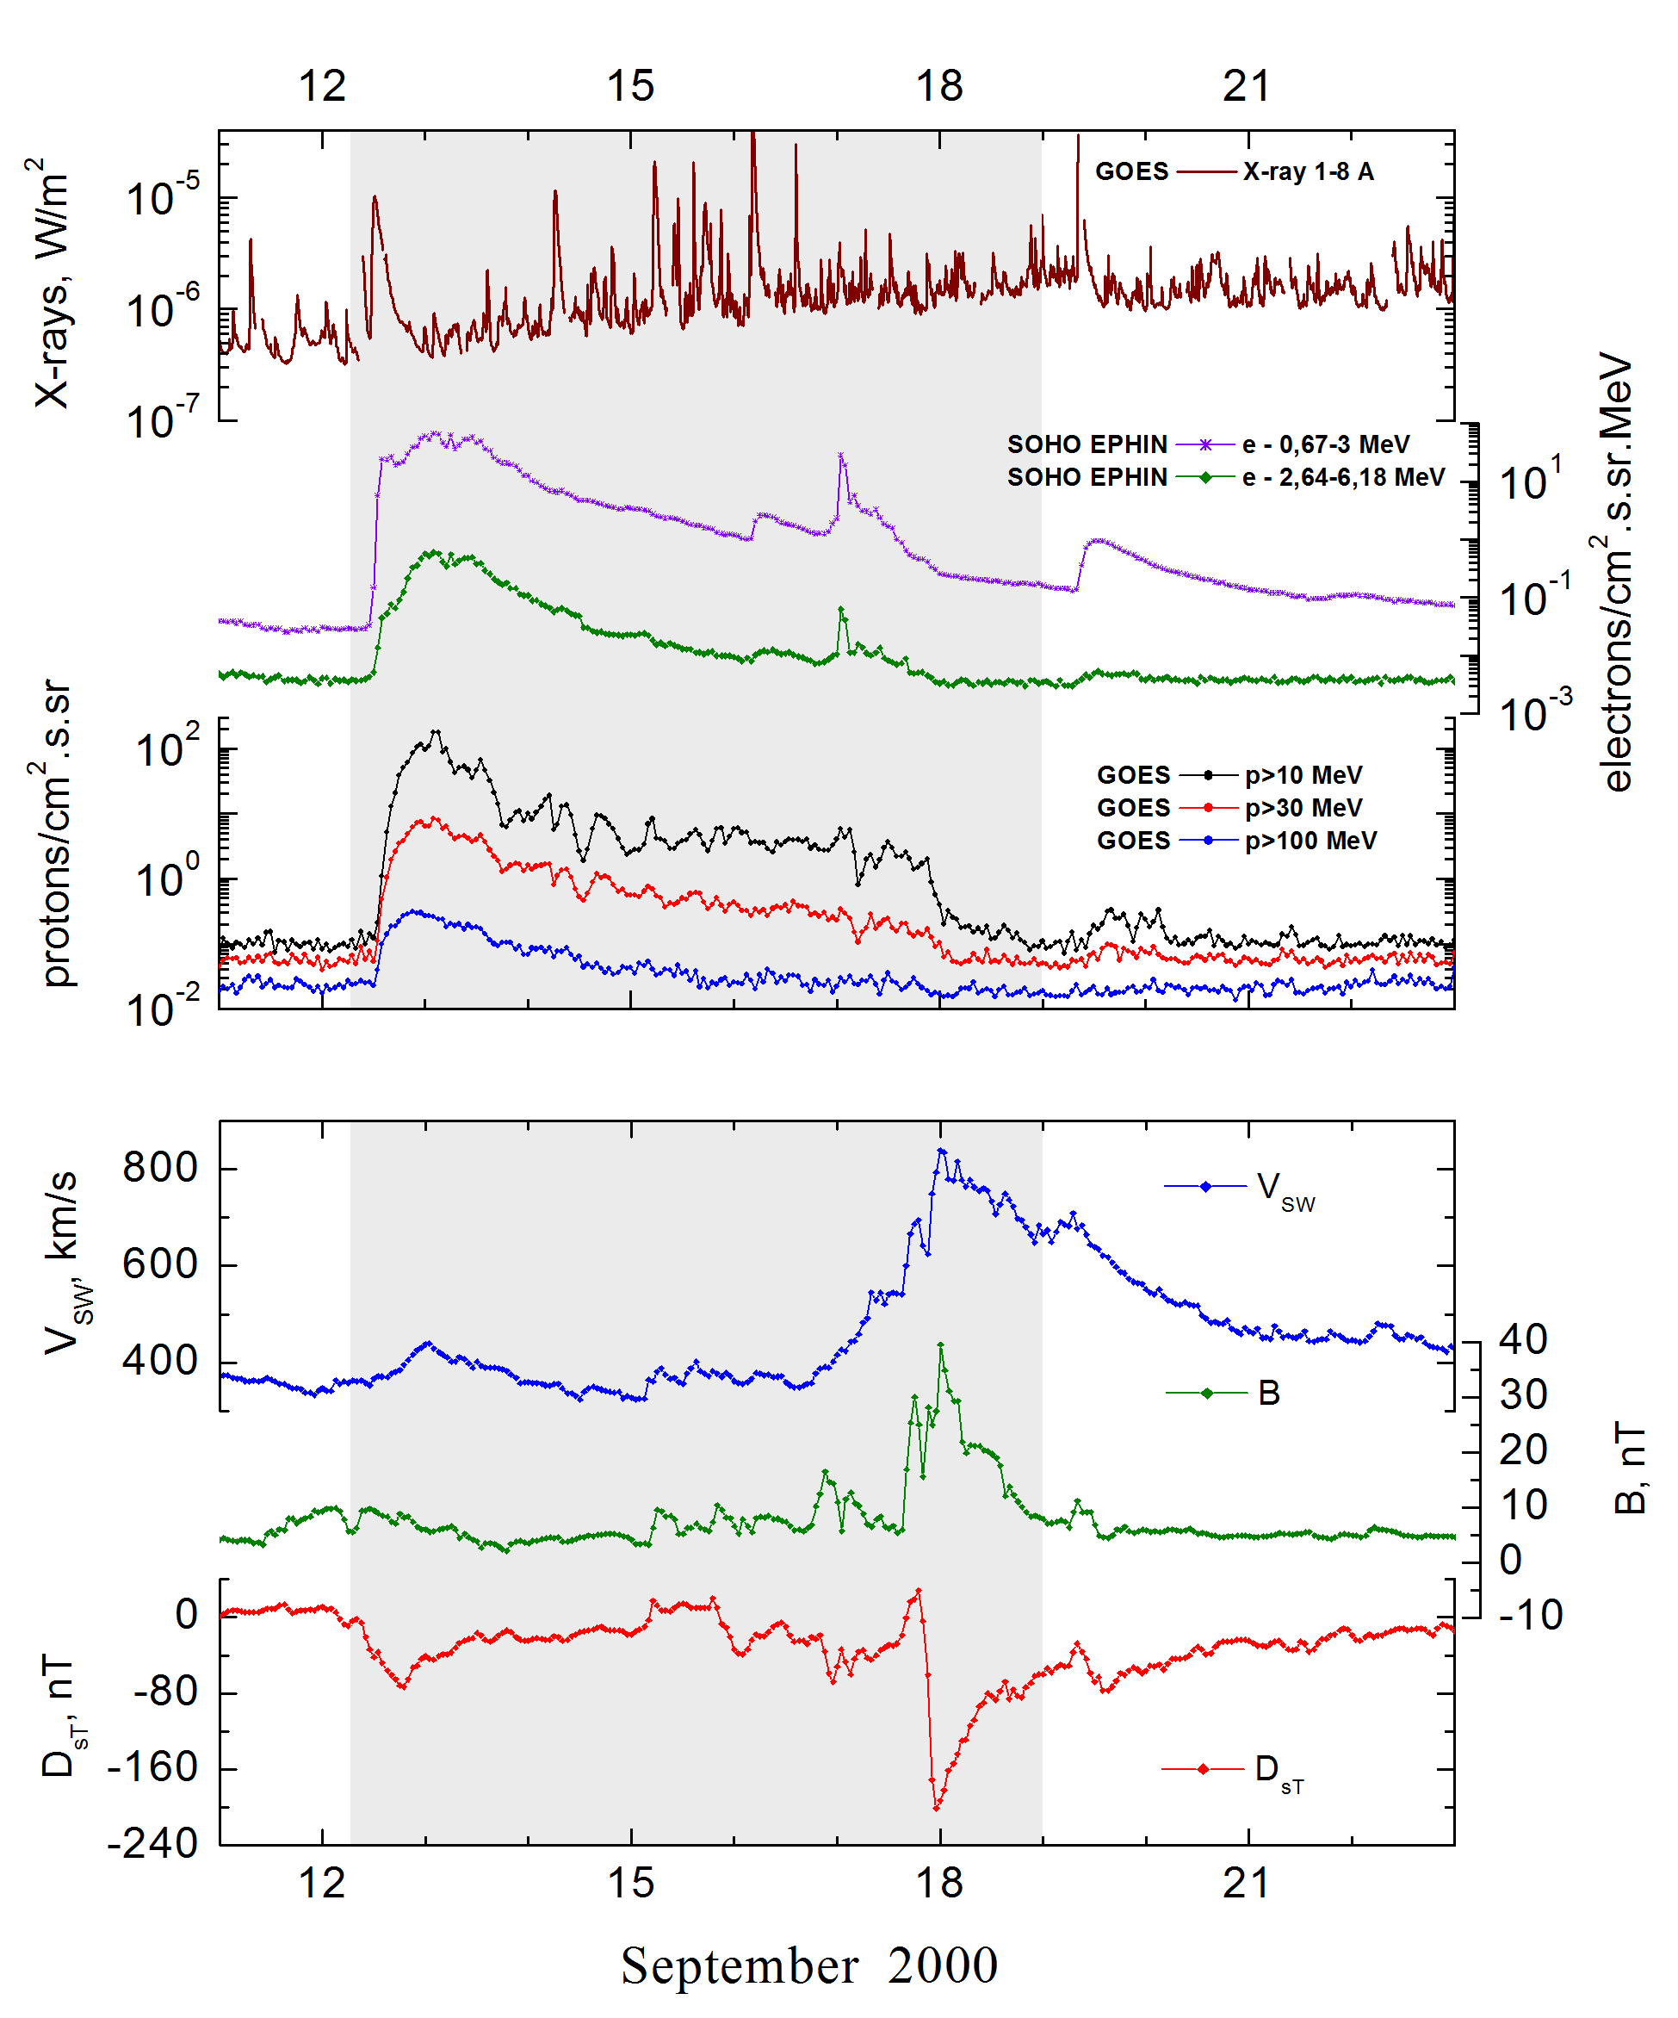
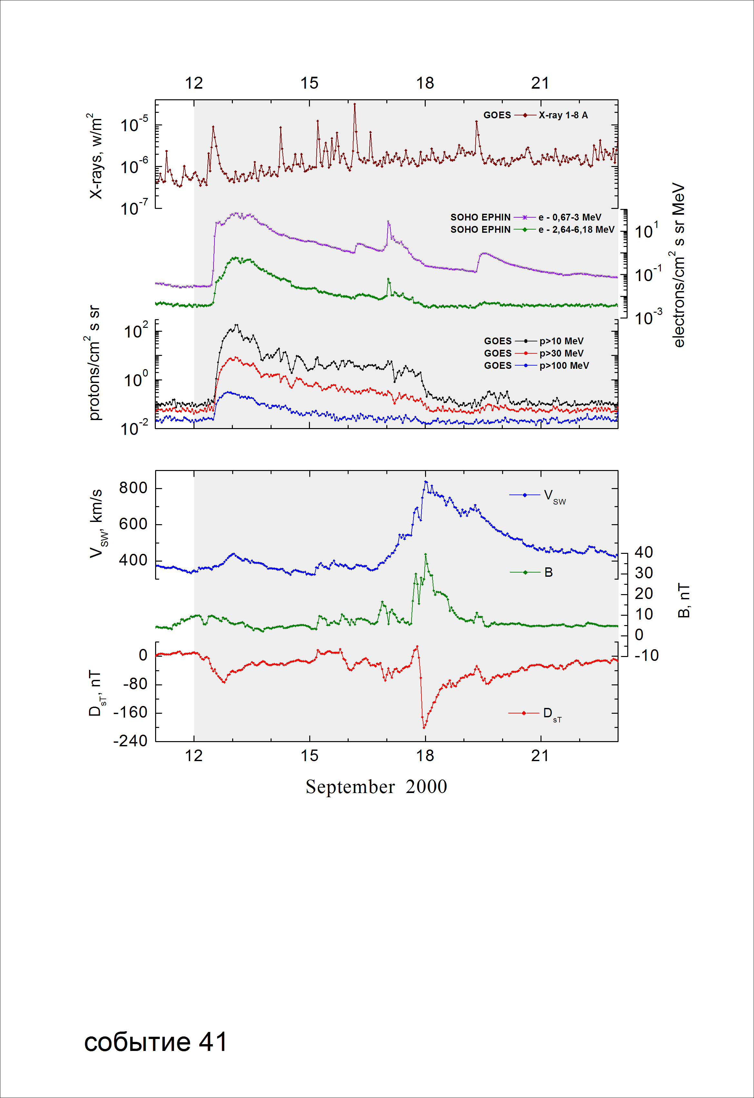
Integral time-of-maximum proton spectrum
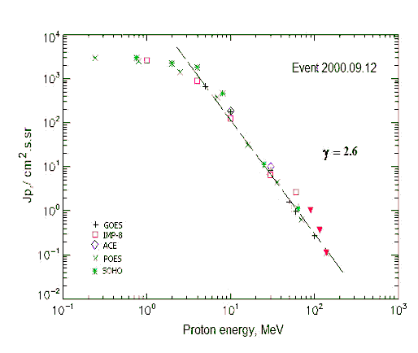

Integral fluxes of protons for the event of 2000 September 12

S/c, instruments | Eр, MeV | To | Tmax | Jmax,  /cm².s.sr | Dura-tion | Comments
GOES-10
EPS | >5 | 14^{h} | 13d03^{h} | 670 | 6d
EPS | >10 | 14^{h} | 13d02^{h} | 180 | 6d
EPS | >30 | 14^{h} | 13d02^{h} | 8.4 | 5d
EPS | >50 | 14^{h} | 13d02^{h} | 1.6 | 5d
EPS | >60 | 14^{h} | 13d00^{h} | 0.97 | 5d
EPS | >100 | 14^{h} | 21^{h} | 0.27 | 3d
POES-16
MEPED | >0.24 | - | 13d00^{h} | 2961 | 6d
MEPED | >0.8 | - | 13d00^{h} | 2501 | 6d
MEPED | >2.5 | - | 13d00^{h} | 1424 | 6d
MEPED | >6.9 | - | 13d00^{h} | 381 | 6d
MEPED | >16 | - | 13d00^{h} | 31.5 | 5d
MEPED | >36 | - | 13d00^{h} | 4.54 | 5d
MEPED | >70 | - | 13d00^{h} | 0.63 | 5d
MEPED | >140 | - | 13d00^{h} | 0.11 | 3d
IMP-8
CPME | >1 | 14^{h} | 13d03^{h} | 2610 | 7d
CPME | >4 | 14^{h} | 13d03^{h} | 920 | 7d
CPME | >10 | 14^{h} | 13d03^{h} | 128 | 6d
CPME | >30 | 14^{h} | 13d03^{h} | 6.6 | 6d
CPME | >60 | 14^{h} | 13d03^{h} | 2.7 | 5d
ACE
SIS | >10 | 14^{h} | 13d03^{h} | 188 | 3d
SIS | >30 | 14^{h} | 13d03^{h} | 10 | 2d
SOHO
EPHIN (INT) | >50 | 14^{h} | 13d01^{h} | 1.2 | 3d
BALLOONS
Mu | > 94 |  | 13d(08^{h}-08^{h}) | 1.01
Mu | >116 |  | 13d(08^{h}-08^{h}) | 0.36
Mu | >140 |  | 13d(08^{h}-08^{h}) | 0.11

Differential fluxes of protons for the event of 2000 September 12

S/c, instruments | ∆Е, MeV | To | Tmax | Jmax  /cm².s.sr.MeV | Dura-tion | Comments
IMP-8
CPME | 1-2 | 15^{h} | 13d04^{h} | 810 | 7d
CPME | 2-4.6 | 15^{h} | 13d03^{h} | 445 | 7d
CPME | 4.6-15 | 14^{h} | 13d03^{h} | 57 | 6d
CPME | 15-25 | 14^{h} | 13d03^{h} | 4.4 | 6d
CPME | 25-48 | 14^{h} | 13d02^{h} | 0.22 | 5d
CPME | 48-96 | 13^{h} | 13d02^{h} | 0.028 | 5d
CPME | 96-145 | - | - | - | -
CPME | 145-440 | - | - | - | -
SOHO
LION | 0,75-2 | 15^{h} | 13d04^{h} | 412 | 7d
LION | 2-6 | 15^{h} | 13d04^{h} | 109 | 7d
EPHIN | 4-8 | 14^{h} | 13d04^{h} | 296 | 7d
EPHIN | 8-25 | 14^{h} | 13d04^{h} | 26.8 | 6d
EPHIN | 25-41 | 14^{h} | 13d04^{h} | 0.35 | 6d
EPHIN | 41-53 | - “ - | - “ - | - “ - | - “ -

References:
Nitta N.V., E.W. Cliver, A.J. Tylka, and P. Smit. Source regions of major solar energetic particle events. – Proc. 28th Int. Cosmic Ray Conf., Tsukuba, Japan, v.6, p.3363-3366, 2003.

