Event 2000.10.25 – (2000-299)

Particle event: To(Ep>10 MeV) – 25d13^{h}
Tmax(Ep>10 MeV) – 25d23^{h}, Jmax (Ep>10 MeV) – 4.1/cm².s.sr
Duration of the event – 3 days
Energy of the SCR and 0.1 GCR fluxes balance – Eb = 95 MeV

Sources: ▪ solar flare 25d08^{h}45^{m}, C4/…, … W90, АR‒ unknown
Main X-ray burst 1-8 Ǻ : onset – 25d08^{h} 45^{m}, max – 25d11^{h}25^{m}, Ф = 0.065 J/m²
CME: 25d08^{h}26^{m}, V= 0770 km/s, Δφ = 360º, dA = 275º
▲SC 28d09^{h}54^{m}

Particle fluxes and associated phenomena
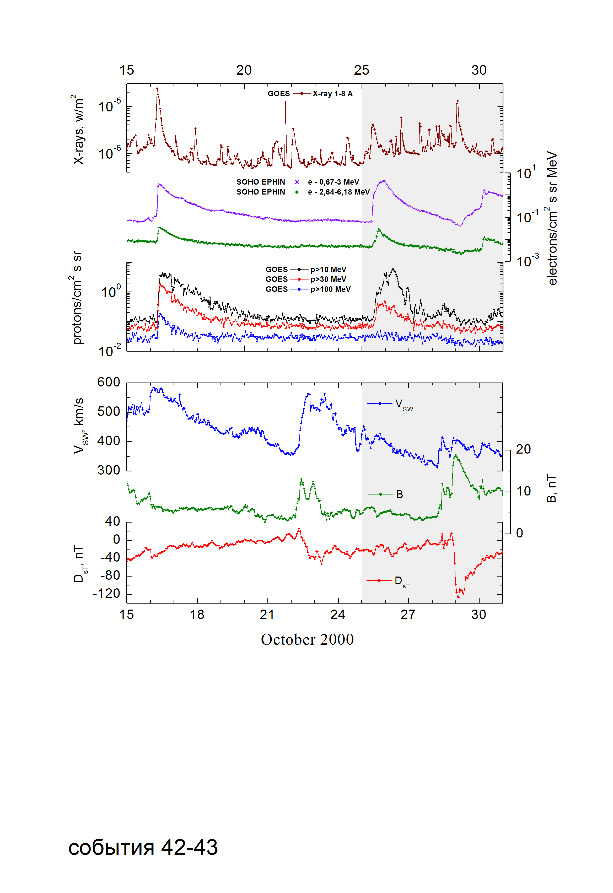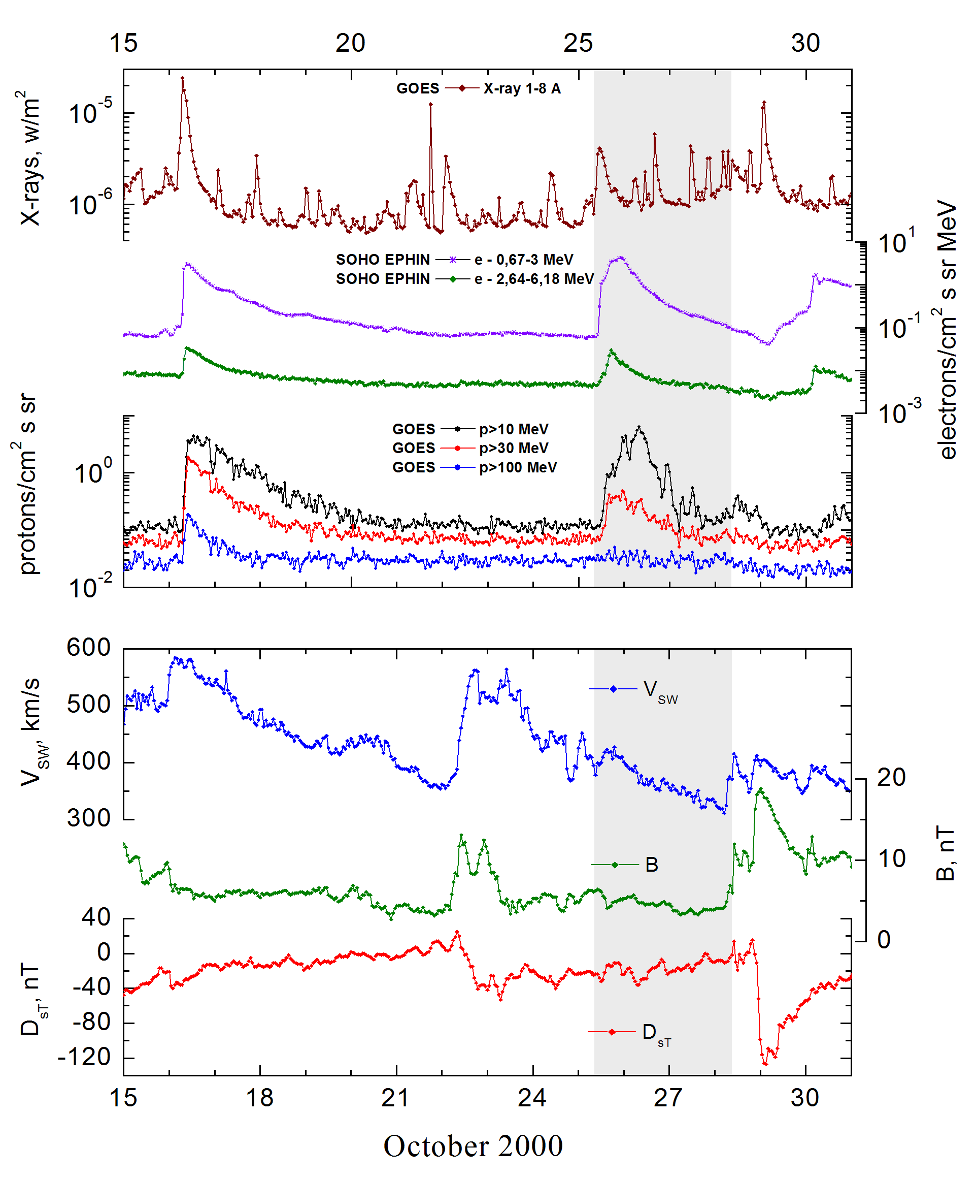

Integral time-of-maximum proton spectrum
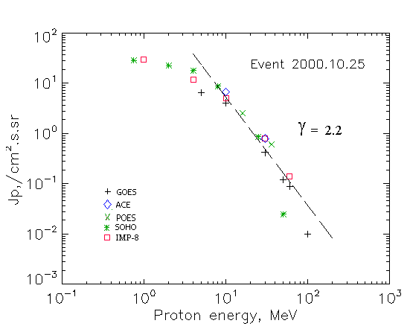

Integral fluxes of protons for the event of 2000 October 25

S/c, instruments | Eр, MeV | To | Tmax | Jmax,  /cm².s.sr | Dura-tion | Comments
GOES-10
EPS | >5 | 13^{h} | 23 ^{h} | 6.5 | 3d
EPS | >10 | 13^{h} | 23 ^{h} | 4.1 | 3d
EPS | >30 | 13^{h} | 23 ^{h} | 0.42 | 2d
EPS | >50 | 13^{h} | 23 ^{h} | 0.12 | 2d
EPS | >60 | - | 24^{h} | 0.09 | 1.5d
EPS | >100 | - | 24 ^{h} | 0.01 | -
POES-16
MEPED | >0.24 | - | - | - | -
MEPED | >0.8 | - | - | - | -
MEPED | >2.5 | - | - | - | -
MEPED | >6.9 | - | - | - | -
MEPED | >16 | - | 19^{h} | 2.52 | 3d
MEPED | >36 | - | 19^{h} | 0.6 | 2d
MEPED | >70 | - | - | - | -
MEPED | >140 | - | - | - | -
IMP-8
CPME | >1 | 13^{h} | 23^{h} | 30 | 3d
CPME | >4 | 13^{h} | 23^{h} | 12 | 3d
CPME | >10 | 13^{h} | 22^{h} | 5 | 3d
CPME | >30 | 13^{h} | 21^{h} | 0.8 | 1d
CPME | >60 | 13^{h} | 21^{h} | 0.14 | 1d
ACE
SIS | >10 | 12^{h} | 20^{h} | 6.8 | 2 d
SIS | >30 | 12^{h} | 19^{h} | 0.8 | 5 h
SOHO
EPHIN (INT) | >50 | 12^{h} | 20^{h} | 0.025 | 0.5d

Differential fluxes of protons for the event of 2000 October 25

S/c, instruments | ∆Е, MeV | To | Tmax | Jmax  /cm².s.sr.MeV | Dura-tion | Comments
IMP-8
CPME | 1-2 | 13^{h} | 26d02^{h} | 19 | 3d
CPME | 2-4.6 | 13^{h} | 26d02^{h} | 8.5 | 3d
CPME | 4.6-15 | 13^{h} | 22^{h} | 0.8 | 3d
CPME | 15-25 | 13^{h} | 22^{h} | 024 | 3d
CPME | 25-48 | 13^{h} | 21^{h} | 0.026 | 1.5d
CPME | 48-96 | 13^{h} | 19^{h} | 0.002 | 1.5d
CPME | 96-145 | - | - | - | -
CPME | 145-440 | - | - | - | -
SOHO
LION | 0,75-2 | 12^{h} | 20^{h} | 3.6 | 3.5d
LION | 2-6 | 12^{h} | 19^{h} | 1.1 | 3.5d
EPHIN | 4-8 | 12^{h} | 20^{h} | 2.3 | 3.5d
EPHIN | 8-25 | 12^{h} | 20^{h} | 0.47 | 3.5d
EPHIN | 25-41 | 12^{h} | 20^{h} | 0.031 | 3.5d
EPHIN | 41-53 | - “ - | - “ - | - “ - | - “ -

References:
No information on publications, excepting for:
http://www.swpc.noaa.gov/ftpdir/indices/SPE.txt

