Event 2000.11.08 – (2000-313)

Particle event: To(Ep>10 MeV) – 08d23^{h}
Tmax(Ep>10 MeV) – 09d15^{h}, Jmax (Ep>10 MeV) –9.7·10³/cm².s.sr
Duration of the event – 8 days
Energy of the SCR and 0.1 GCR fluxes balance – Eb = 650 MeV

Sources: ● solar flare 08d22^{h}40^{m}, 3F/M7.4, N20W66, R9213
Main X-ray burst 1-8 Ǻ: onset – 08d22^{h} 42^{m}, max – 08d23^{h} 28^{m}, Ф = 0.21 J/m²
CME: 08d23^{h}06^{m} , V = 1738 km/s, Δφ = 170º, dA = 299º
▲SC 10d06^{h}28^{m}

Particle fluxes and associated phenomena
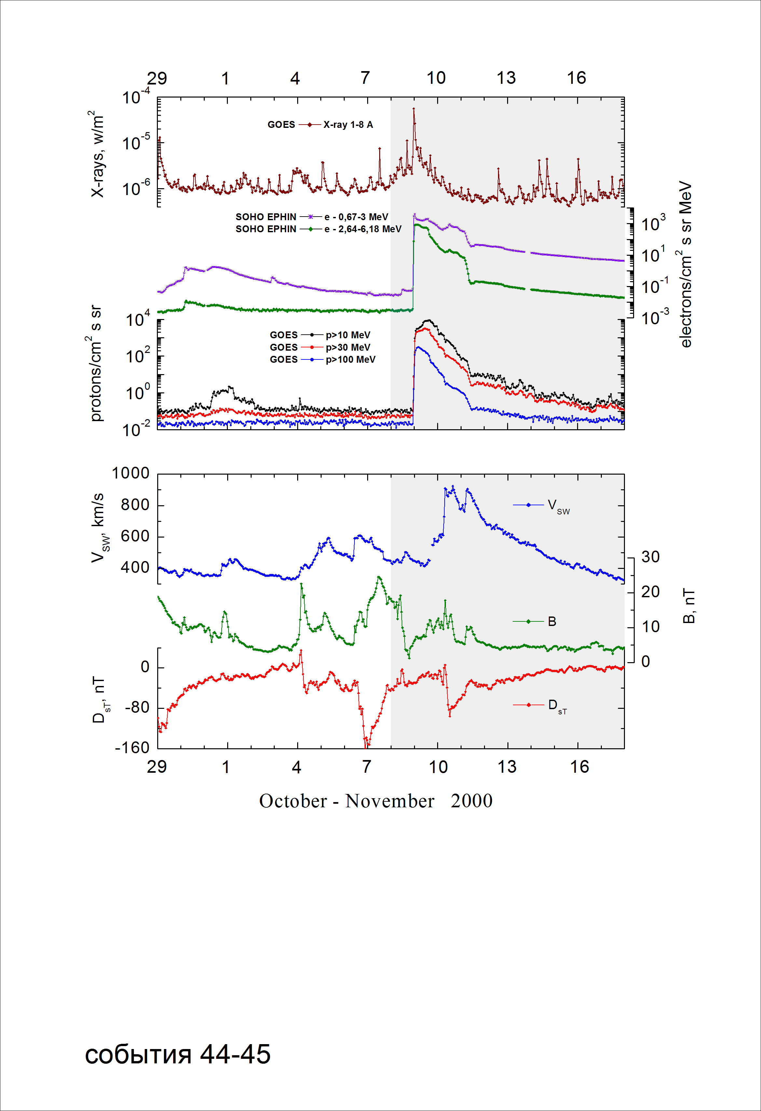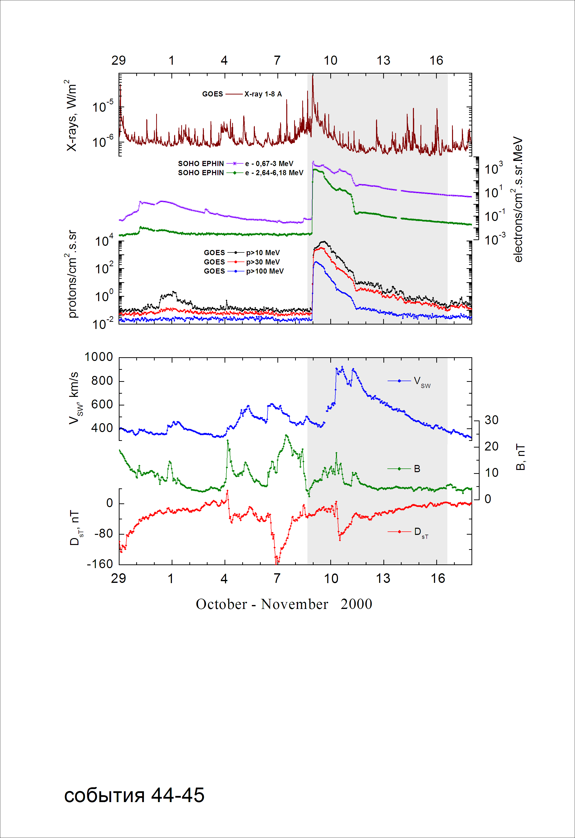

Integral time-of-maximum proton spectrum
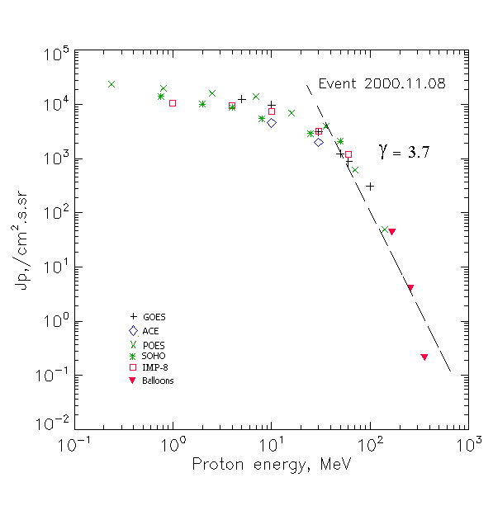

Integral fluxes of protons for the event of 2000 November 08

S/c, instruments | Eр, MeV | To | Tmax | Jmax,  /cm².s.sr | Dura-tion | Comments
GOES-10
EPS | >5 | 23^{h} | 09d15^{h} | 12524 | 8d
EPS | >10 | 23^{h} | 09d15^{h} | 9740 | 6d
EPS | >30 | 23^{h} | 09d11^{h} | 3113 | 6d
EPS | >50 | 23^{h} | 09d04^{h} | 1239 | 6d
EPS | >60 | 23^{h} | 09d04^{h} | 877 | 5d
EPS | >100 | 23^{h} | 09d04^{h} | 306 | 5d
POES-16
MEPED | >0.24 | - | 09d04^{h} | 23230 | 8d
MEPED | >0.8 | - | 09d04^{h} | 19670 | 8d
MEPED | >2.5 | - | 09d04^{h} | 15740 | 6d
MEPED | >6.9 | - | 09d04^{h} | 13670 | 6d
MEPED | >16 | - | 09d04^{h} | 7000 | 8d
MEPED | >36 | - | 09d04^{h} | 3884 | 6d
MEPED | >70 | - | 09d04^{h} | 625 | 5d
MEPED | >140 | - | 09d04^{h} | 50 | 5d
IMP-8
CPME | >1 | 23^{h} | 09d09^{h} | 10500 | 8 d
CPME | >4 | 23^{h} | 09d08^{h} | 9320 | 8 d
CPME | >10 | 23^{h} | 09d08^{h} | 7310 | 8 d
CPME | >30 | 23^{h} | 09d04^{h} | 3220 | 6 d
CPME | >60 | 23^{h} | 09d04^{h} | 1200 | 6 d
ACE
SIS | >10 | 23^{h} | 09d06^{h} | 4570 | 6d
SIS | >30 | 23^{h} | 09d05^{h} | 1980 | 6d
SOHO
EPHIN (INT) | >50 | 23^{h} | 09d04^{h} | 2080 | 5d
BALLOONS
Mi-1 | >167 |  | 09d09^{h} | 43.2
Mi-1 | >259 |  | 09d09^{h} | 4.0
Mi-1 | >356 |  | 09d09^{h} | 0.21

Differential fluxes of protons for the event of 2000 November 08

S/c, instruments | ∆Е, MeV | To | Tmax | Jmax  /cm².s.sr.MeV | Dura-tion | Comments
IMP-8
CPME | 1-2 | 23^{h} | 09d03^{h} | 200 | 8d
CPME | 2-4.6 | 23^{h} | 09d03^{h} | 260 | 8d
CPME | 4.6-15 | 23^{h} | 09d03^{h} | 167 | 8d
CPME | 15-25 | 23^{h} | 09d03^{h} | 200 | 8d
CPME | 25-48 | 23^{h} | 09d03^{h} | 79 | 8d
CPME | 48-96 | 23^{h} | 09d03^{h} | 32 | 7d
CPME | 96-145 | 23^{h} | 09d03^{h} | 10 | 6d
CPME | 145-440 | 23^{h} | 09d00^{h} | 1.1 | 5d
SOHO
LION | 0,75-2 | 23^{h} | 09d07^{h} | 2320 | 8d
LION | 2-6 | 23^{h} | 09d07^{h} | 320 | 8d
EPHIN | 4-8 | 23^{h} | 09d06^{h} | 85 | 8d
EPHIN | 8-25 | 23^{h} | 09d06^{h} | 55 | 8d
EPHIN | 25-41 | 23^{h} | 09d05^{h} | 35 | 6d
EPHIN | 41-53 | - “ - | - “ - | - “ - | - “ -

References:

El-Borie M.A., 2003.
El-Borie M.A., 2003.
Struminsky A.B., 2003.
Nitta N.V., E.W. Cliver, A.J. Tylka, and P. Smit, 2003.
Al-Thoyaib S.S., 2005.
Rawat R., S. Alex, and G.S. Lakhina., 2006.
Kuwabara T., J.W. Bieber, J. Clem, et.al., 2006.
Lario D., R.B. Decker, and A. Aran., 2008.
Lario D, Aran A, Decker R.B., 2009.

