Event 2000.11.26 – (2000-331)

Particle event: To(Ep>10 MeV) – 26d03^{h}
Tmax(Ep>10 MeV) – 26d20^{h}, Jmax (Ep>10 MeV) – 670/cm².s.sr
Duration of the event – 4 days
Energy of the SCR and 0.1 GCR fluxes balance – Eb = 400 MeV

Sources: ● solar flare 25d00^{h}59^{m}, M8.2/2N, N07E50, АR9240
Ø solar flare 25d 18^{h}33^{m}, X1.9/2B, N19W24, АR9236
Main X-ray burst 1-8 Ǻ: onset – 25d18^{h}33^{m}, max – 25d18^{h}44^{m}, Ф = 0.21 J/m²
CME: 26d01^{h}31^{m} , V = 2519 km/s, Δφ = 360º , dA = 082º
▲SC 26d07^{h}58^{m}, ▲SC 26d11^{h}58^{m}, ▲SC 28d05^{h}31^{m}

Particle fluxes and associated phenomena
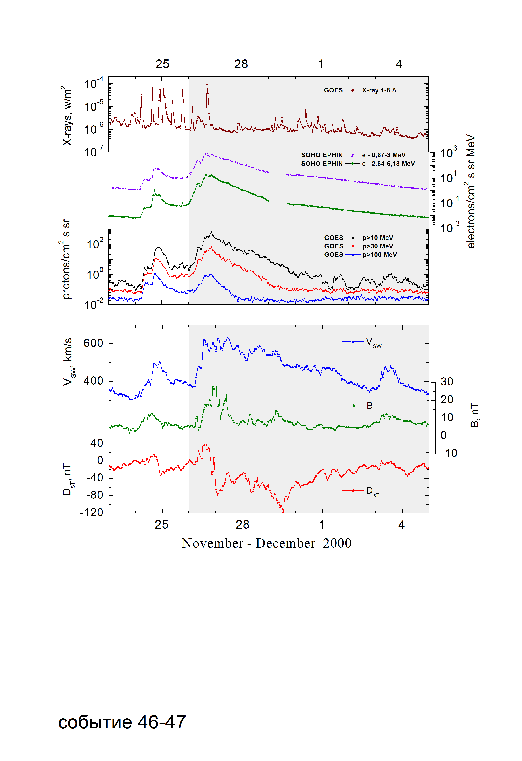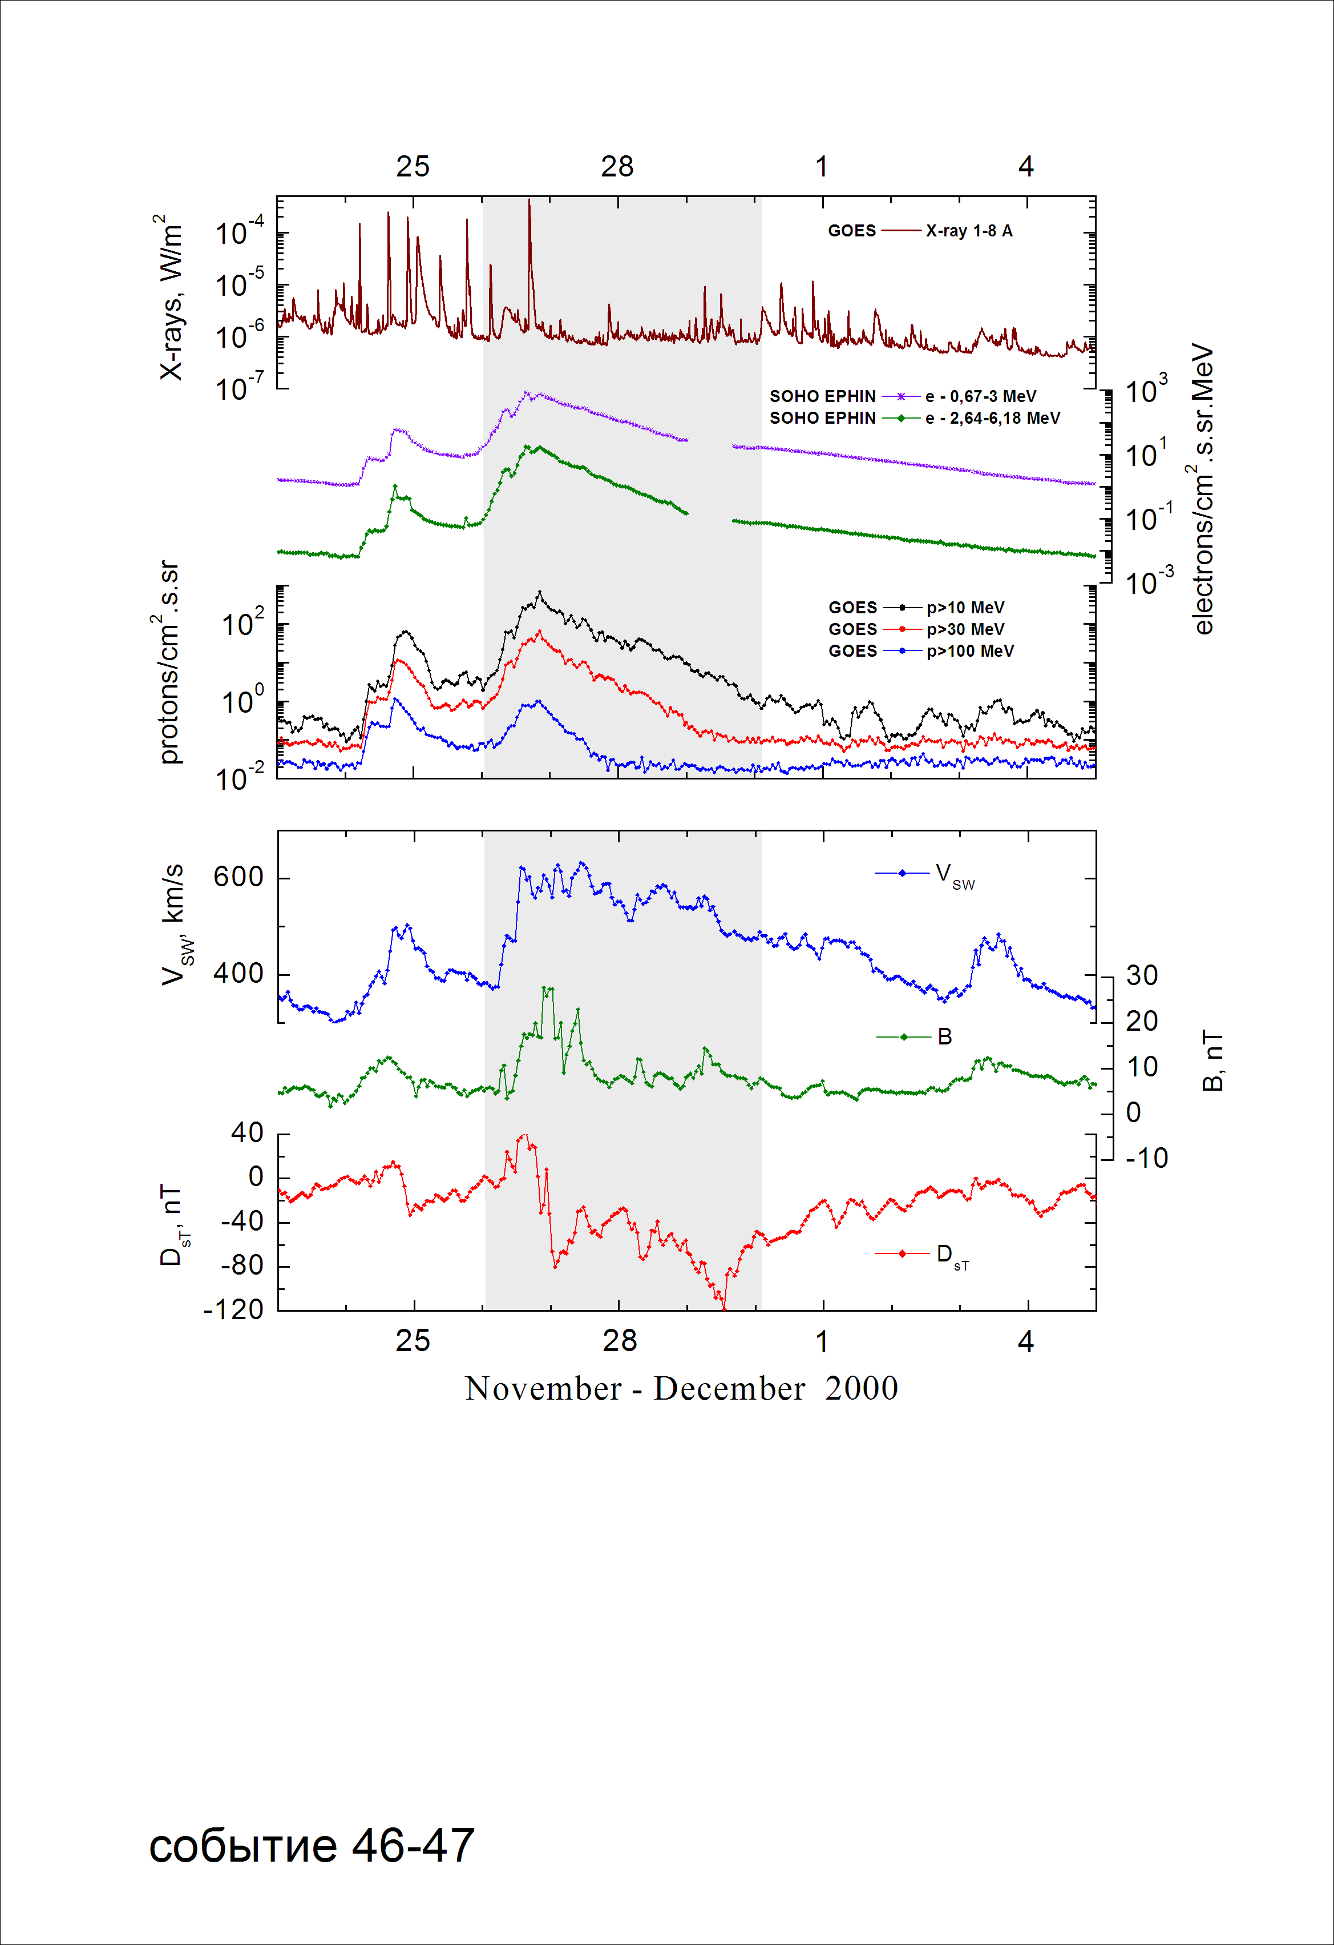

Integral time-of-maximum proton spectrum
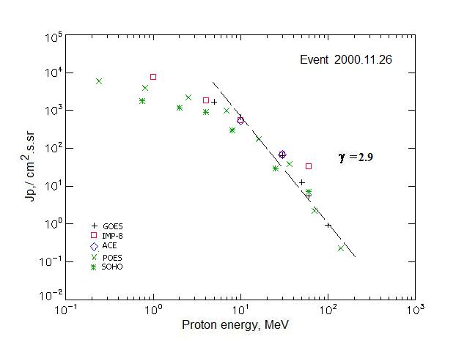

Integral fluxes of protons for the event of 2000 November 26

S/c,  instruments | Eр, MeV | To | Tmax | Jmax,  /cm².s.sr | Dura-tion | Comments
GOES 10
EPS | >5 | 03^{h} | 20^{h} | 1705 | 5d
EPS | >10 | 03^{h} | 20^{h} | 670 | 4d
EPS | >30 | 03^{h} | 20^{h} | 64.5 | 3d
EPS | >50 | 03^{h} | 20^{h} | 12.6 | 2d
EPS | >60 | 03^{h} | 20^{h} | 5.6 | 2d
EPS | >100 | 03^{h} | 20^{h} | 0.95 | 1.5d
POES 16
MEPED | >0.24 | - | 17^{h} | 5910 | 5d
MEPED | >0.8 | - | 17^{h} | 3820 | 5d
MEPED | >2.5 | - | 17^{h} | 2145 | 5d
MEPED | >6.9 | - | 17^{h} | 900 | 4d
MEPED | >16 | - | 17^{h} | 179.5 | 3d
MEPED | >36 | - | 17^{h} | 38 | 2d
MEPED | >70 | - | 17^{h} | 2.25 | 2d
MEPED | >140 | - | 17^{h} | 0.23 | 1.5d
IMP-8
CPME | >1 | 02^{h} | 20^{h} | 7600 | 5d
CPME | >4 | 02^{h} | 20^{h} | 1900 | 5d
CPME | >10 | 02^{h} | 20^{h} | 568 | 4d
CPME | >30 | 02^{h} | 20^{h} | 70 | 4d
CPME | >60 | 02^{h} | 20^{h} | 34 | 3d
ACE
SIS | >10 | 02^{h} | 20^{h} | 532 | 4d
SIS | >30 | 02^{h} | 20^{h} | 68.5 | 3d
SOHO
EPHIN (INT) | >50 | 04 ^{h} | 21^{h} | 6.5 | 3d

Differential fluxes of protons for the event of 2000 November 26

S/c, instruments | ∆Е, MeV | To | Tmax | Jmax  /cm².s.sr.MeV | Dura-tion | Comments
IMP-8
CPME | 1-2 | 01^{h} | 20^{h} | 3350 | 7d
CPME | 2-4.6 | 01^{h} | 20^{h} | 1110 | 7d
CPME | 4.6-15 | 01^{h} | 20^{h} | 124 | 6d
CPME | 15-25 | 01^{h} | 20^{h} | 24 | 5d
CPME | 25-48 | 01^{h} | 20^{h} | 2.2 | 4d
CPME | 48-96 | 01^{h} | 20^{h} | 0.24 | 4d
CPME | 96-145 | - | - | - | -
CPME | 145-440 | - | - | - | -
SOHO
LION | 0,75-2 | 04^{h} | 21^{h} | 345 | 7d
LION | 2-6 | 04^{h} | 21^{h} | 70 | 7d
EPHIN | 4-8 | 04^{h} | 21^{h} | 193 | 7d
EPHIN | 8-25 | 04^{h} | 21^{h} | 23.7 | 6d
EPHIN | 25-41 | 04^{h} | 21^{h} | 1.1 | 6d
EPHIN | 41-53 | - “ - | - “ - | - “ - | - “ -

References:
No information on publications, excepting for:
http://www.swpc.noaa.gov/ftpdir/indices/SPE.txt

