Event 2001.03.26 – (2001- 085)

Particle event: To(Ep>10 MeV) – 26d20^{h}
Tmax(Ep>10 MeV) – 27d08^{h}, Jmax (Ep>10 MeV) – 1.8 /cm².s.sr
Duration of the event –1.5 days
Energy of the SCR and 0.1 GCR fluxes balance – Eb = 55 MeV

Sources: ʘ solar flare 26d13^{h}03^{m}, M2.2/1F, N15E27, АR9393
Main X-ray burst 1-8 Ǻ: onset – 26d13^{h}03^{m}, max – 26d13^{h}26^{m}, Ф = 0.037 J/m²;
CME: 26d13^{h}50^{m}, V = 0541 km/s, Δφ = 055º, dA = 104º
▲SC 27d17^{h}47 ^{m}

Particle fluxes and associated phenomena
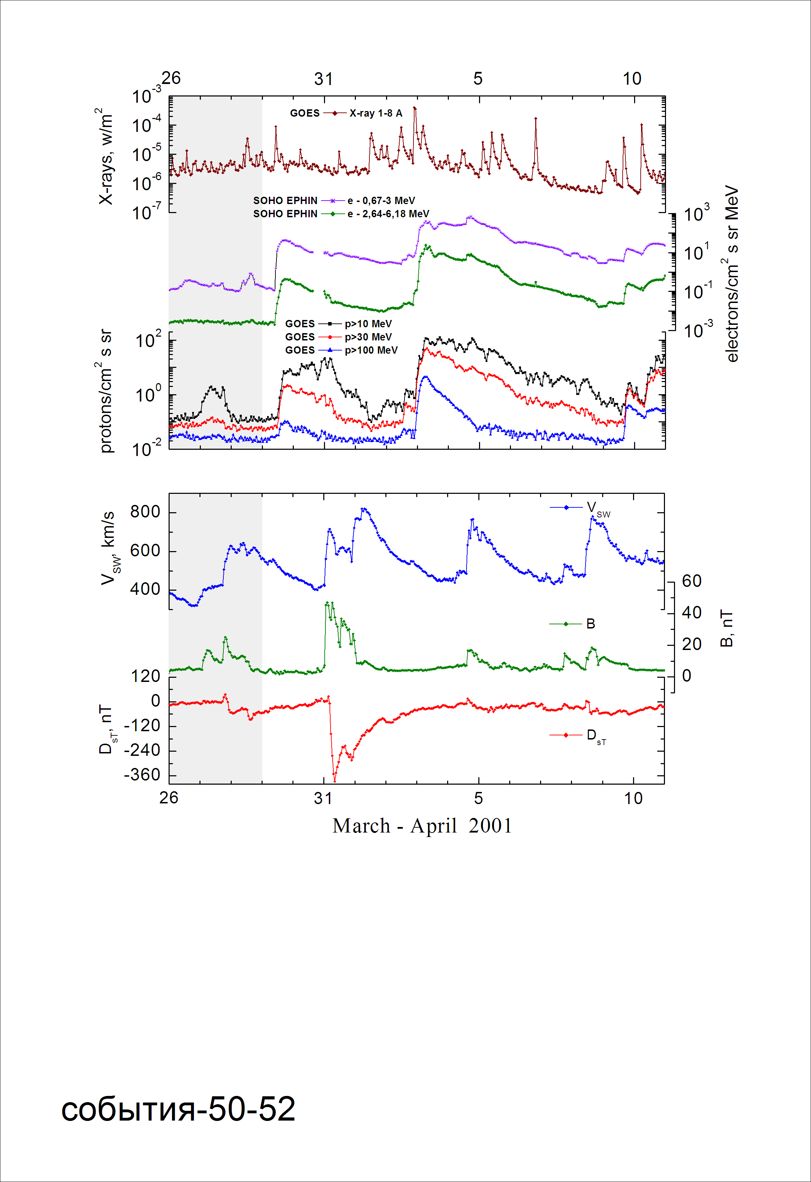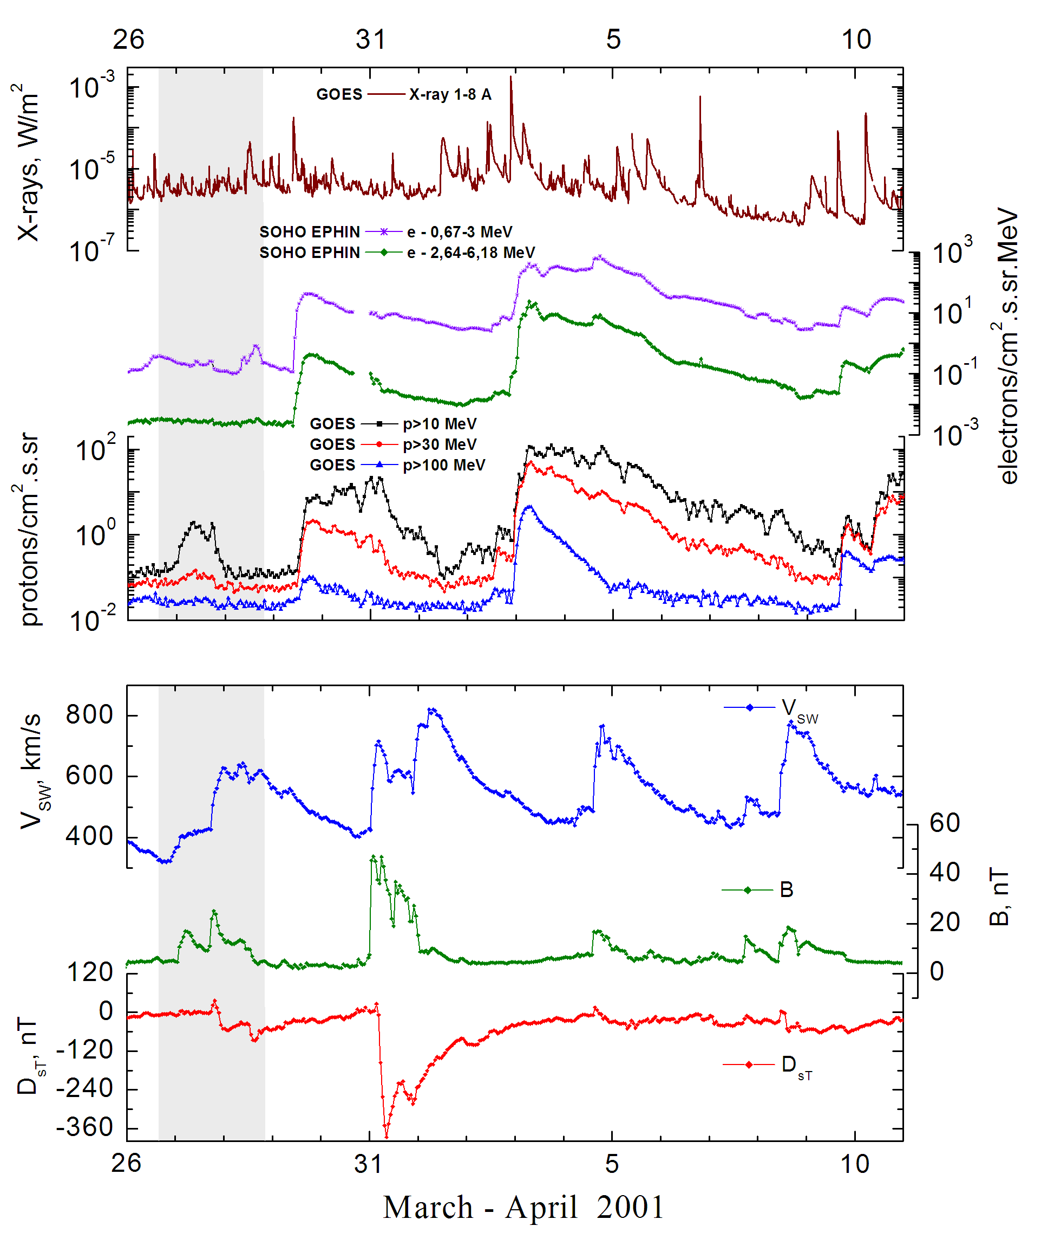
Integral time-of-maximum proton spectrum 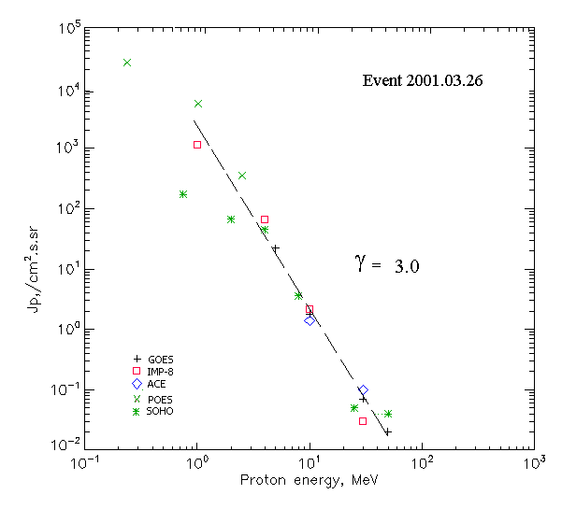

Integral fluxes of protons for the event of 2001 March 26

S/c, instruments | Eр, MeV | To | Tmax | Jmax,  /cm².s.sr | Dura-tion | Comments
GOES-10
EPS | >5 | 20^{h} | 08^{h} | 22.2 | 2.5d
EPS | >10 | 20^{h} | 08^{h} | 1.8 | 2.5d
EPS | >30 | 21^{h} | 09^{h} | 0.07 | 2d
EPS | >50 | - | 09^{h} | 0.02 | -
EPS | >60 | - | - | - | -
EPS | >100 | - | - | - | -
POES-16
MEPED | >0.24 | - | 18^{h} | 2.5·10⁴ | 3 d
MEPED | >0.8 | - | 18^{h} | 6.2·10³ | 3 d
MEPED | >2.5 | - | 18^{h} | 355 | 3 d
MEPED | >6.9 | - | - | - | -
MEPED | >16 | - | - | - | -
MEPED | >36 | - | - | - | -
MEPED | >70 | - | - | - | -
MEPED | >140 | - | - | - | -
IMP-8
CPME | >1 | 01^{h} | 12^{h} | 1160 | 3 d
CPME | >4 | 01^{h} | 12^{h} | 66 | 3 d
CPME | >10 | 01^{h} | 11^{h} | 2.2 | 3 d
CPME | >30 | - | 11^{h} | 0.03 | -
CPME | >60 | - | - | - | -
ACE
SIS | >10 | 16^{h} | 10^{h}- | 1.4 | 1.5d
SIS | >30 |  | 10^{h} | 0.1 | 1d
SOHO
EPHIN (INT) | >50 | 23^{h} | 17^{h} | 0.04 *) | - | *) The increase on Forbush

Differential fluxes of protons for the event of 2001 March 27
S/c, instruments | ∆Е, MeV | To | Tmax | Jmax. /cm².s.sr.MeV | Dura-tion | Comments
IMP-8
CPME | 1-2 | 13^{h} | 12^{h} | 867 | 3,5d
CPME | 2-4.6 | 12^{h} | 12^{h} | 112 | 3d
CPME | 4.6-15 | 16^{h} | 12^{h} | 3.2 | 3d
CPME | 15-25 | 08^{h} | 11^{h} | 0.029 | 2,5d
CPME | 25-48 | - | - | - | -
CPME | 48-96 | - | - | - | -
CPME | 96-145 | - | - | - | -
CPME | 145-440 | - | - | - | -
SOHO
LION | 0.75-2 | 17^{h} | 17^{h} | 60 | 2d
LION | 2-6 | 17^{h} | 17^{h} | 5.6 | 2d
EPHIN | 4-8 | 17^{h} | 17^{h} | 10.3 | 2d
EPHIN | 8-25 | 17^{h} | 17^{h} | 0.21 | 2d
EPHIN | 25-41 | 17^{h} | 16^{h} | 3.6·10⁻⁴ | 2d
EPHIN | 41-53 | - “ - | - “ - | - “ - | - “ -

References:
No information on publications, excepting for:
http://www.swpc.noaa.gov/ftpdir/indices/SPE.txt

