Event 2001.04.02 – (2001-092)

Particle event: To(Ep>10 MeV) – 02d23^{h}
Tmax(Ep>10 MeV) – 03d07^{h}, Jmax (Ep>10 MeV) – 112 /cm².s.sr
Duration of the event – 5 days
Energy of the SCR and 0.1 GCR fluxes balance – Eb = 575 MeV

Sources:  solar flare 02d21^{h}32^{m}, X20/, N19W90, АR9393
Main X-ray burst 1-8 Ǻ: onset – 02^{d} 21^{h} 32^{m}, max – 02d21^{h}51^{m}, Ф = 1.5 J/m²
CME: 02d22^{h}06^{m}, V= 2505 km/s, Δφ = 244º, dA = 293º
▲SC 04d14^{h}55 ^{m}

Particle fluxes and associated phenomena
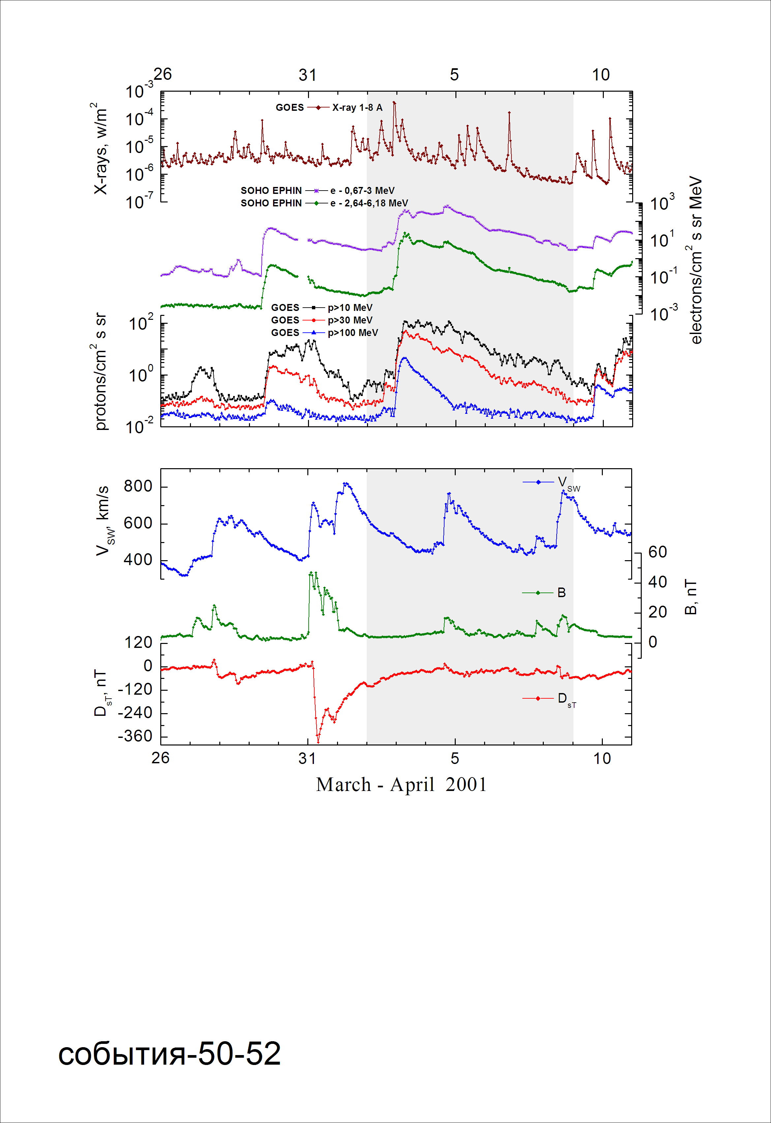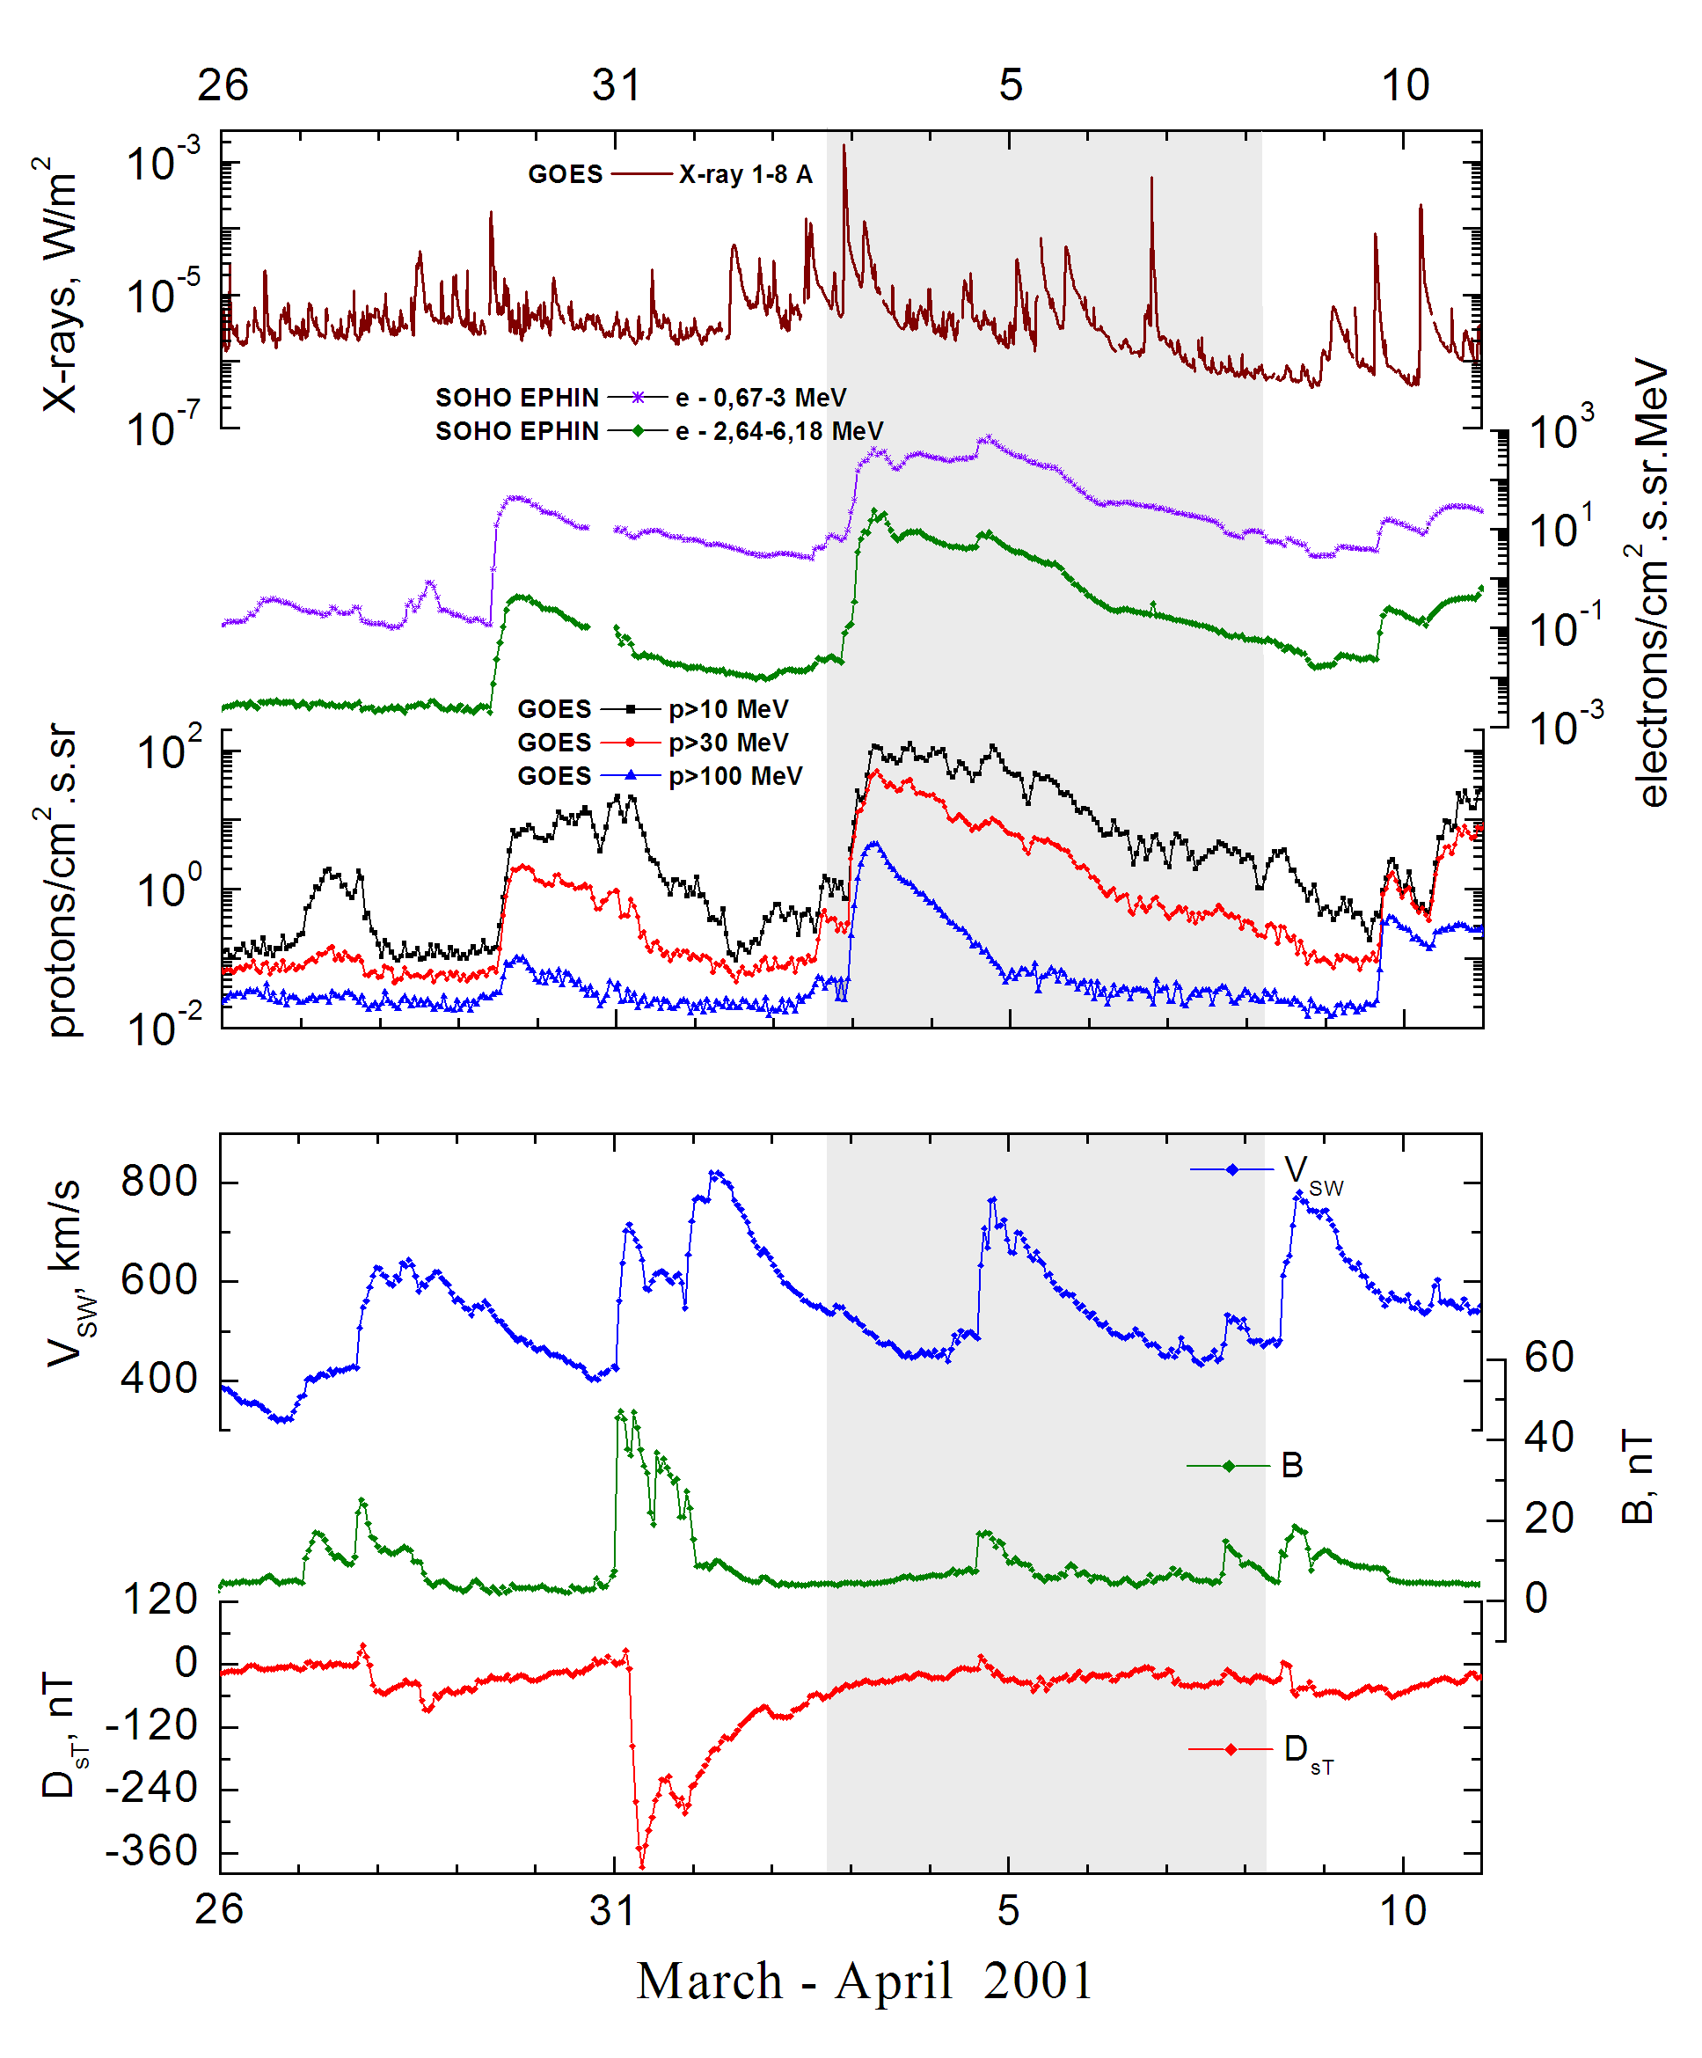
Integral time-of-maximum proton spectrum
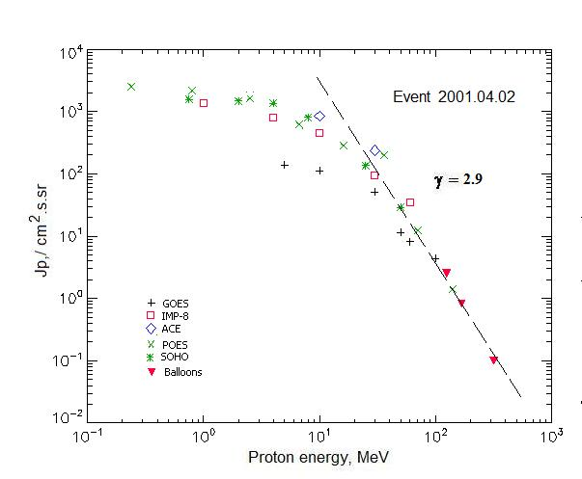

Integral fluxes of protons for the event of 2001 April 02

S/c, instruments | Eр, MeV | To | Tmax | Jmax,  /cm².s.sr | Dura-tion | Comments
GOES-10
EPS | >5 | 23^{h} | 03d07^{h} | 140 | 5d
EPS | >10 | 23^{h} | 03d07^{h} | 112 | 5d
EPS | >30 | 23^{h} | 03d07^{h} | 51 | 4d
EPS | >50 | 23^{h} | 03d07^{h} | 11.5 | 3d
EPS | >60 | 23^{h} | 03d06^{h} | 13 | 2d
EPS | >100 | 23^{h} | 03d06^{h} | 4.4 | 2d
POES-16
MEPED | >0.24 | - | 03d03^{h} | 2035 | 5d
MEPED | >0.8 | - | 03d03^{h} | 1670 | 5d
MEPED | >2.5 | - | 03d03^{h} | 1330 | 5d
MEPED | >6.9 | - | 03d03^{h} | 560 | 5d
MEPED | >16 | - | 03d03^{h} | 282 | 4d
MEPED | >36 | - | 03d03^{h} | 200 | 3d
MEPED | >70 | - | 03d03^{h} | 12.4 | 2d
MEPED | >140 | - | 03d03^{h} | 1.4 | 2d
IMP-8
CPME | >1 | 23^{h} | 03d07^{h} | 1370 | 5d
CPME | >4 | 23^{h} | 03d07^{h} | 815 | 5d
CPME | >10 | 23^{h} | 03d07^{h} | 452 | 5d
CPME | >30 | 23^{h} | 03d07^{h} | 95 | 5d
CPME | >60 | 23^{h} | 03d07^{h} | 34.6 | 5d
ACE
SIS | >10 | 22^{h} | 03d06^{h} | 845 | 5d
SIS | >30 | 22^{h} | 03d06^{h} | 237 | 5d
SOHO
EPHIN (INT) | >50 | 23^{h} | 03d06^{h} | 29 | 3d
BALLOONS
Mi | >125 |  | 03d(09^{h}30^{m}-10^{h}12^{m}) | 2.5
Mi | >168 |  | 03d(09^{h}30^{m}-10^{h}12^{m}) | 0.8
Mi | >320 |  |  | 0.1

Differential fluxes of protons for the event of 2001 April 02

S/c,  instruments | ∆Е, MeV | To | Tmax | Jmax. /cm².s.sr.MeV | Dura-tion | Comments
IMP-8
CPME | 1-2 | 19^{h} | 03d06^{h} | 236 | 4d
CPME | 2-4.6 | 18^{h} | 03d07^{h} | 144 | 4d
CPME | 4.6-15 | 23^{h} | 03d07^{h} | 40.3 | 4d
CPME | 15-25 | 23^{h} | 03d07^{h} | 21.9 | 4d
CPME | 25-48 | 23^{h} | 03d07^{h} | 3.4 | 4d
CPME | 48-96 | 23^{h} | 03d07^{h} | 0.59 | 4d
CPME | 96-145 | - | - | - | -
CPME | 145-440 | - | - | - | -
SOHO
LION | 0.75-2 | 23^{h} | 03d07^{h} | 43.3 | 7d
LION | 2-6 | 23^{h} | 03d07^{h} | 30.5 | 7d
EPHIN | 4-8 | 23^{h} | 03d07^{h} | 120 | 7d
EPHIN | 8-25 | 23^{h} | 03d07^{h} | 34 | 7d
EPHIN | 25-41 | 23^{h} | 03d07^{h} | 3.9 | 7d
EPHIN | 41-53 | - “ - | - “ - | - “ - | - “ -

References:
Kuwabara T., Bieber J.W., Clem J., et.al., 2006.
Веселовский И.С., Мягкова И.Н., Яковчук О.С., 2012.

