Event 2001.04.10 – (2001-100)

Particle event: To(Ep>10 MeV) – 10d08^{h}
Tmax₁(Ep>10 MeV) – 11d01^{h}, Jmax₁(Ep>10 MeV) – 50 /cm².s.sr
Tmax₂(Ep>10 MeV) – 11d20^{h}, Jmax₂(Ep>10 MeV) – 280 /cm².s.sr
Duration of the event – 2 days
Energy of the SCR and 0.1 GCR fluxes balance – Eb(max₁) = 350 MeV
– Eb(max₂) = 260 MeV
Sources: ● solar flare 10d04^{h}59^{m}, 3N/X2.3, S23W09, АR9415
Ø solar flare 11d12^{h}56^{m}, M2.3/1F, S20W28 АR9415
Main X-ray burst 1-8 Ǻ: onset – 10d05^{h}06^{m}, max – 10d05^{h}26^{m}, Ф = 0.3 J/m²
CME 10d05^{h}30^{m}, V=2411 km/s, Δφ =360º, dA= 166º
ΔSC 11d13 ^{h}43 ^{m}, Δ SC 11d15 ^{h}19 ^{m}

Particle fluxes and associated phenomena
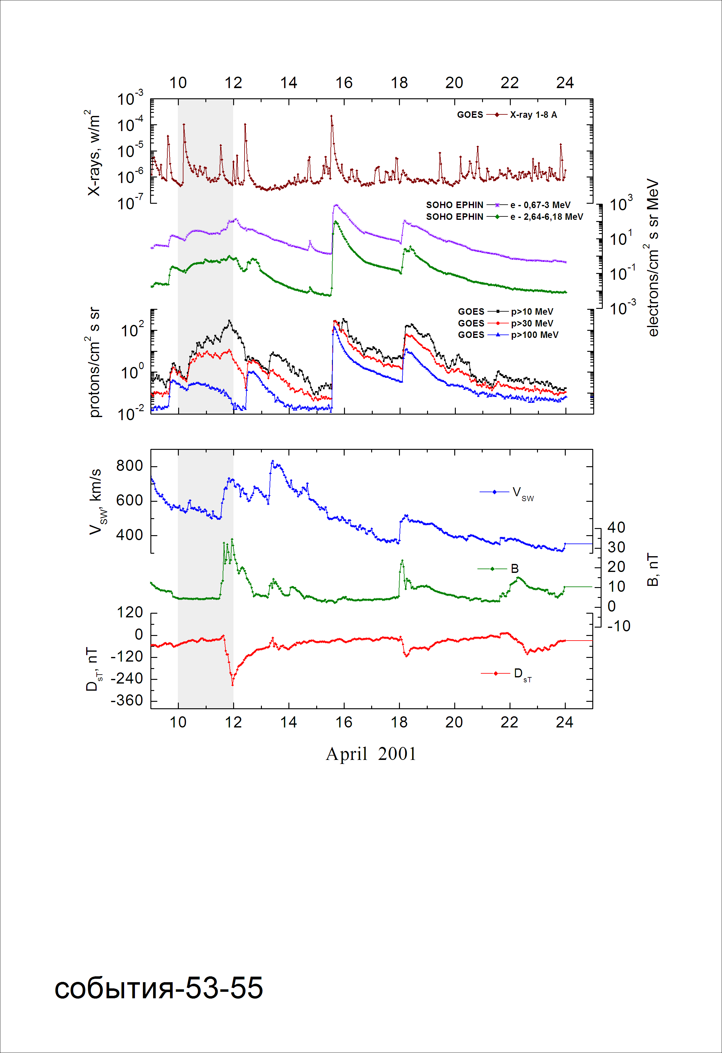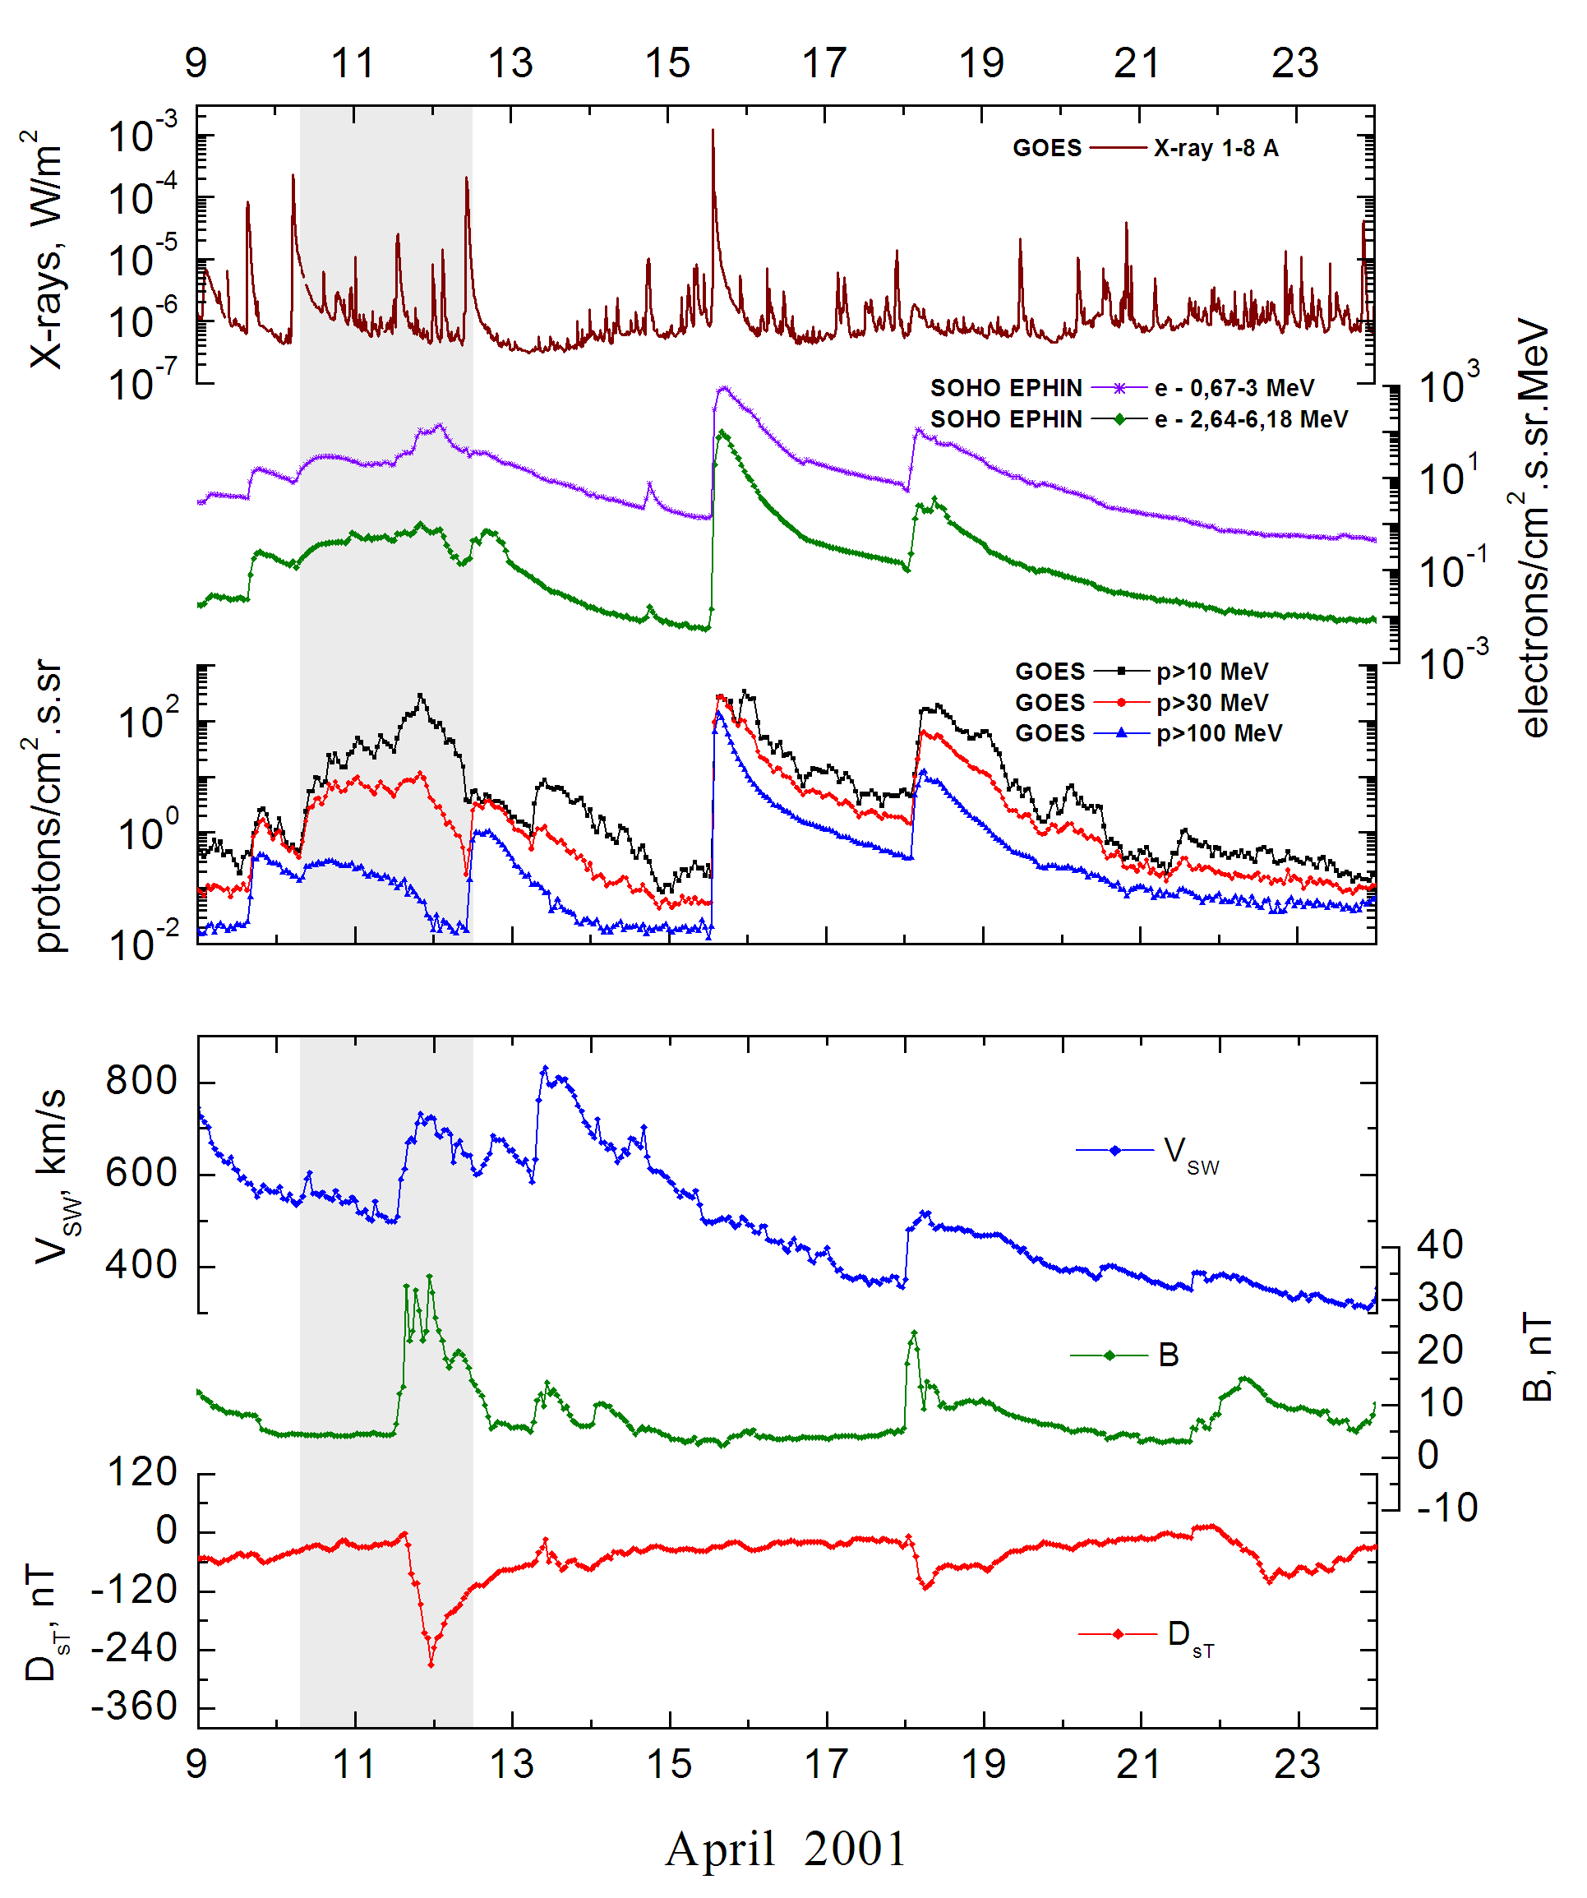
Integral time-of-maximum proton spectrum 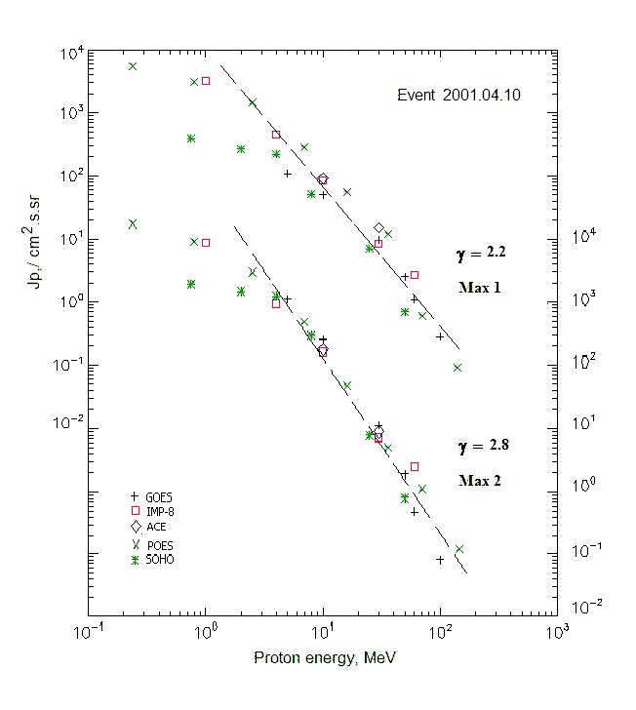

Integral fluxes of protons for the event of 2001 April 10

S/c, instruments | Eр, MeV | To | Tmax | Jmax,  /cm².s.sr | Dura-tion | Comments
GOES-10
EPS | >5 | 08^{h} | 11d01 ^{h}/11d20^{h} | 109/1256 | 2d
EPS | >10 | 08^{h} | 11d01 ^{h}/11d20^{h} | 50/280 | 2d
EPS | >30 | 08^{h} | 11d01 ^{h}/11d20^{h} | 9.6/11.6 | 2d
EPS | >50 | 08^{h} | 21^{h}/11d20^{h} | 2.5/ 1.9 | 2d
EPS | >60 | 08^{h} | 19^{h}/11d18^{h} | 1.1/0.47 | 2d
EPS | >100 | 08^{h} | 17^{h}/11d17^{h} | 0.28/0.08 | 2d
POES-16
MEPED | >0.24 | 08^{h} | 11d01^{h}/11d20^{h} | 5500/20230 | 2d
MEPED | >0.8 | 08^{h} | 11d01^{h}/11d20^{h} | 3085/10330 | 2d
MEPED | >2.5 | 08^{h} | 11d01^{h}/11d20^{h} | 1485/3340 | 2d
MEPED | >6.9 | 09^{h} | 11d01^{h}/11d20^{h} | 285/540 | 2d
MEPED | >16 | 09^{h} | 11d01^{h}/11d20^{h} | 55/50 | 2d
MEPED | >36 | 08^{h} | 11d01^{h}/11d20^{h} | 11/8.05 | 2d
MEPED | >70 | 08^{h} | 11d01^{h}/11d20^{h} | 0.6/1.1 | 2d
MEPED | >140 | 08^{h} | 11d01^{h}/11d20^{h} | 0.09/0.12 | 2d
IMP-8
CPME | >1 | 09^{h} | 11d01^{h}/11d20^{h} | 3230/9760 | 2d
CPME | >4 | 08^{h} | 11d00^{h}/11d20^{h} | 450/1060 | 2d
CPME | >10 | 08^{h} | 11d00^{h}/11d20^{h} | 86/172 | 2d
CPME | >30 | 08^{h} | 20^{h}/11d20^{h} | 8.4/7.5 | 2d
CPME | >60 | 08^{h} | 16^{h}/11d20^{h} | 2.7/2.5 | 2d
ACE
SIS | >10 | 08^{h} | 11d01^{h}/11d20^{h} | 92/195 | 2d
SIS | >30 | 08^{h} | 20^{h}/11d20^{h} | 15/9.2 | 2d
SOHO
EPHIN (INT) | >50 | 08^{h} | 16^{h}/11d18^{h} | 0.7/0.8 | 2d

Differential fluxes of protons for the event of 2001 April 10

S/c, instruments | ∆Е, MeV | To | Tmax | Jmax. /cm².s.sr.MeV | Dura-tion | Comments
IMP-8
CPME | 1-2 | 11^{h} | 11d02^{h}/11d18^{h} | 1680/8070 | 2d
CPME | 2-4.6 | 09^{h} | 11d01^{h}/11d20^{h} | 536/1200 | 2d
CPME | 4.6-15 | 08^{h} | 11d01 ^{h}/11d20^{h} | 30.8/80 | 2d
CPME | 15-25 | 08^{h} | 11d01 ^{h}/11d20^{h} | 3.3/6.1 | 2d
CPME | 25-48 | 08^{h} | 11d01 ^{h}/11d20^{h} | 0.4/0.33 | 2d
CPME | 48-96 | 08^{h} | 11d01^{h}/11d20^{h} | 0.05/0.025 | 2d
CPME | 96-145 | 08^{h} | - | - | -
CPME | 145-440 | 08^{h} | - | - | -
SOHO
LION | 0.75-2 | 10^{h} | 21^{h}/11d21^{h} | 69.6/285 | 2d
LION | 2-6 | 10^{h} | 19^{h}/11d21^{h} | 11.5/59.6 | 2d
EPHIN | 4-8 | 08^{h} | 21^{h}/11d20^{h} | 42.7/265 | 2d
EPHIN | 8-25 | 08^{h} | 18^{h}/11d20^{h} | 2.6/18.9 | 2d
EPHIN | 25-41 | 08^{h} | 18^{h}/11d20^{h} | 0.29/0.36 | 2d
EPHIN | 41-53 | - “ - | - “ - | - “ - | - “ -

References:
Веселовский И.С., Мягкова И.Н., Яковчук О.С., 2012.

