Event 2001.04.12– (2001-102)

Particle event: To(Ep>10 MeV) – 12d12^{h}
Tmax₁(Ep>10 MeV) – 12d17^{h}, Jmax₁ (Ep>10 MeV) – 4.3 /cm².s.sr
Tmax₂(Ep>10 MeV) – 13d10^{h}, Jmax₂ (Ep>10 MeV) – 8.7 /cm².s.sr
Duration of the event – 2 days
Energy of the SCR and 0.1 GCR fluxes balance – Eb(max₁) = 410 MeV
– Eb(max₂) = 275 MeV
Sources: ● solar flare 12d09^{h}39^{m}, X2.0/2B, S20W42, АR9415
Main X-ray burst 1-8 Ǻ: onset – 12d09^{h}39^{m}, max – 12d10^{h}28^{m}, Ф = 0.3 J/m²
CME: 12d10^{h}31^{m}, V= 1184km/s, Δφ = 360º, dA = 221º
▲ SC 13d07^{h}34^{m}

Particle fluxes and associated phenomena
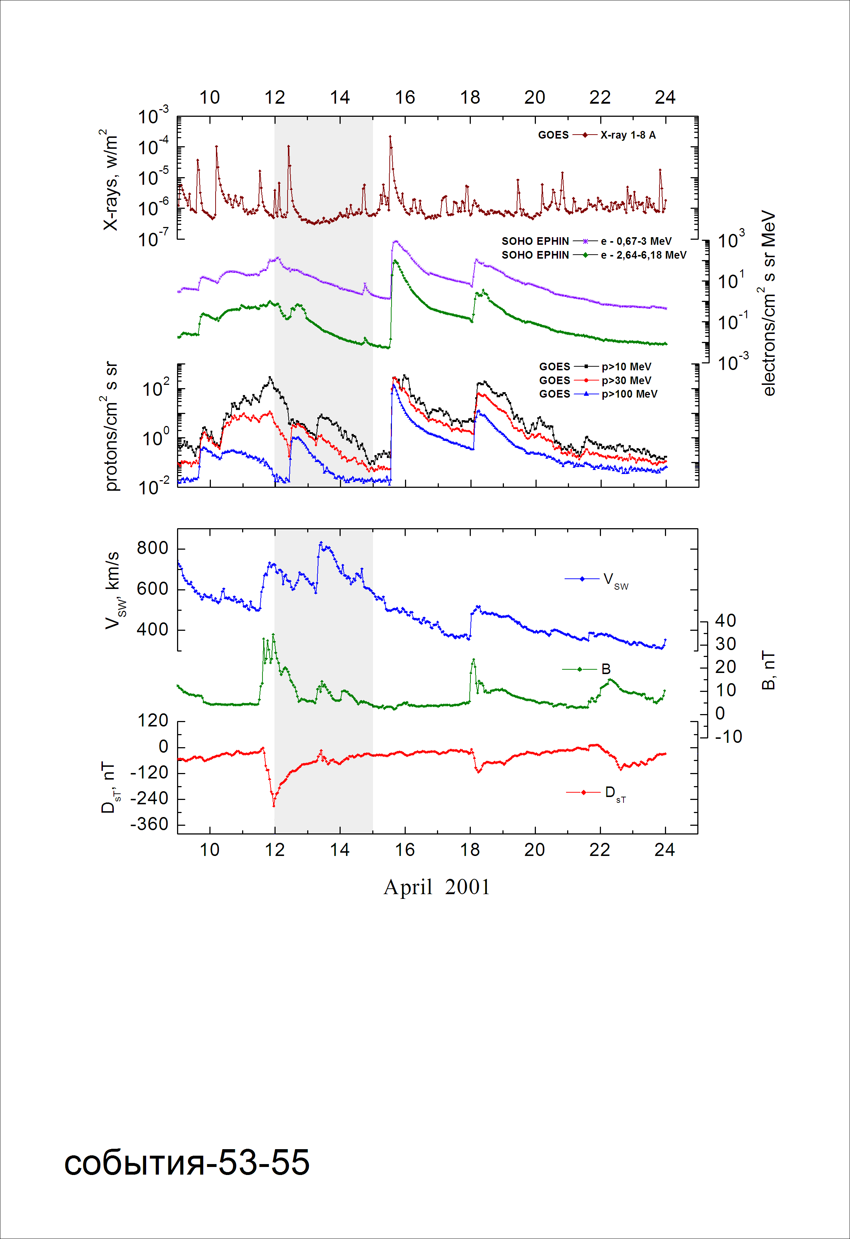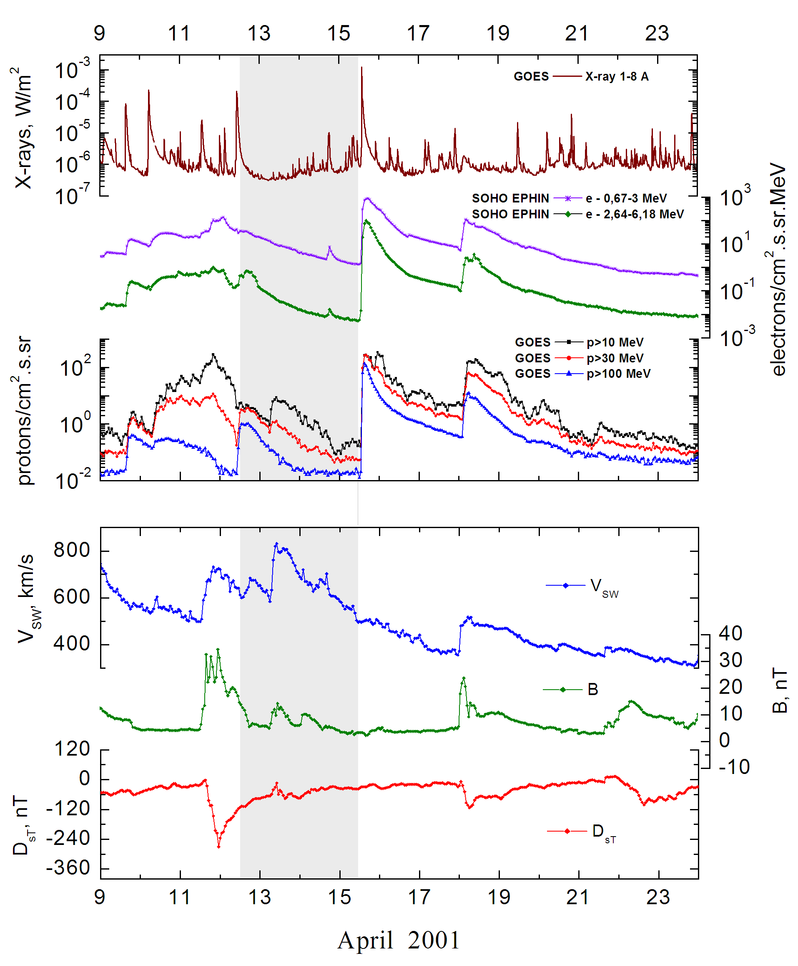

Integral time-of-maximum proton spectrum 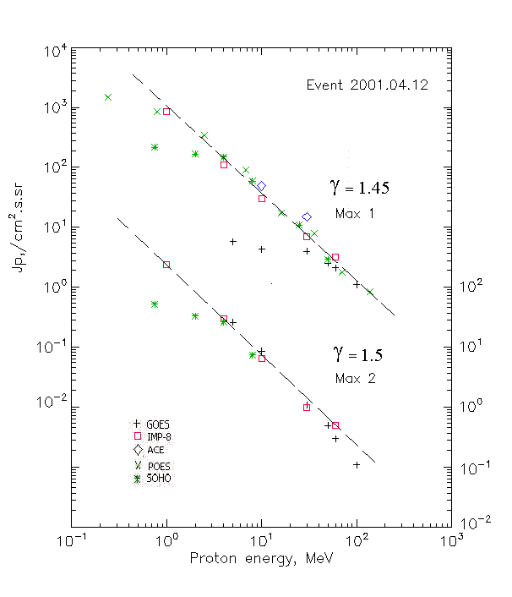

Integral fluxes of protons for the event of 2001 April 12

S/c, instruments | Eр, MeV | To | Tmax | Jmax,  /cm².s.sr | Dura-tion | Comments
GOES-10
EPS | >5 | - | 17^{h}/13d10^{h} | 5.8/26.2 | 2d
EPS | >10 | 12^{h} | 17^{h}/13d10^{h} | 4.3/8.7 | 2d
EPS | >30 | 12^{h} | 17^{h}/13d10^{h} | 4/1.1 | 2d
EPS | >50 | 12^{h} | 17^{h}/13d10^{h} | 2.6/0.5 | 2d
EPS | >60 | 12^{h} | 17^{h}/13d08^{h} | 2.1/0.3 | 2d
EPS | >100 | 11^{h} | 17^{h}/13d08^{h} | 1.1/0.11 | 2d
POES-16
MEPED | >0.24 | 14^{h} | 18^{h}/ - | 1470/- | 1d
MEPED | >0.8 | 14^{h} | 18^{h}/ - | 850/- | 1d
MEPED | >2.5 | 14^{h} | 18^{h}/ - | 345/- | 1d
MEPED | >6.9 | 14^{h} | 18^{h}/ - | 90/- | -
MEPED | >16 | 14^{h} | 18^{h}/ - | 17.5/- | -
MEPED | >36 | 14^{h} | 18^{h}/ - | 7.8/- | -
MEPED | >70 | 14^{h} | 18^{h}/ - | 1.8/- | -
MEPED | >140 | 14^{h} | 18^{h}/ - | 0.83/- | -
IMP-8
CPME | >1 | 12^{h} | 19^{h}/13d10^{h} | 840/240 | 2d
CPME | >4 | 12^{h} | 17^{h}/13d10^{h} | 110/30 | 2d
CPME | >10 | 12^{h} | 17^{h}/13d14^{h} | 30/6.6 | 2d
CPME | >30 | 12^{h} | 17^{h}/13d14^{h} | 7/1 | 2d
CPME | >60 | 12^{h} | 17^{h}/13d14^{h} | 3.2/0.5 | 2d
ACE
SIS | >10 | 12^{h} | 19^{h}/ - | 49/ - | 2d
SIS | >30 | 12^{h} | 19^{h}/ - | 15/ - | 2d
SOHO
EPHIN (INT) | >50 | 10^{h} | 18^{h}/ - | 2.7/ - | 1.5d

Differential fluxes of protons for the event of 2001 April 12

S/c, instruments | ∆Е, MeV | To | Tmax | Jmax. /cm².s.sr.MeV | Dura-tion | Comments
IMP-8
CPME | 1-2 | 10^{h} | 19^{h}/13d14 ^{h} | 610/156 | 3d
CPME | 2-4.6 | 10^{h} | 19^{h}/13d14 ^{h} | 94.5/26.8 | 3d
CPME | 4.6-15 | 10^{h} | 19^{h}/13d14 ^{h} | 6.5/2 | 3d
CPME | 15-25 | 10^{h} | 19^{h}/13d14 ^{h} | 1.33/0.22 | 3d
CPME | 25-48 | 10^{h} | 19^{h}/ - | 0.24/ - | 3d
CPME | 48-96 | 10^{h} | 19^{h}/ - | 0.057/ - | 2d
CPME | 96-145 | 10^{h} | 19^{h}/ - | 0.052/ - | 2d
CPME | 145-440 | 10^{h} | 19^{h}/ - | 0.0036/ - | 1d
SOHO
LION | 0.75-2 | 10^{h} | 20^{h}/13d12 ^{h} | 28.7/10.8 | 3d
LION | 2-6 | 10^{h} | 19^{h}/13d12 ^{h} | 5/1.7 | 3d
EPHIN | 4-8 | 10^{h} | 19^{h}/13d14 ^{h} | 22.8/4.8 | 3d
EPHIN | 8-25 | 10^{h} | 19^{h}/13d14 ^{h} | 2.8/0.44 | 3d
EPHIN | 25-41 | 10^{h} | 19^{h}/ - | 0.29/ - | 3d
EPHIN | 41-53 | - “ - | - “ - | - “ - | - “ -

References:
Веселовский И.С., Мягкова И.Н., Яковчук О.С., 2012.

