.Event 2001.04.18 – (2001-108) − GLE-61

Particle event: To(Ep>10 MeV) – 18d03^{h}
Tmax(Ep>10 MeV) – 18d10^{h}, Jmax (Ep>10 MeV) – 190 /cm².s.sr
Duration of the event – 4 days
Energy of the SCR and 0.1 GCR fluxes balance – Eb = 2100 MeV

Sources: ▪ solar flare 18d02^{h}11^{m}, C2.2, S20W90, АR9415
Main X-ray burst 1-8 Ǻ: onset – 18d02^{h}11^{m}, max – 18d02^{h}14^{m}, Ф = 0.0004 J/m²
CME: 18d02^{h}30^{m}, V=2465 km/s, Δφ = 360º, dA = 263º
ΔSC 21d16^{h}01^{m}

Particle fluxes and associated phenomena
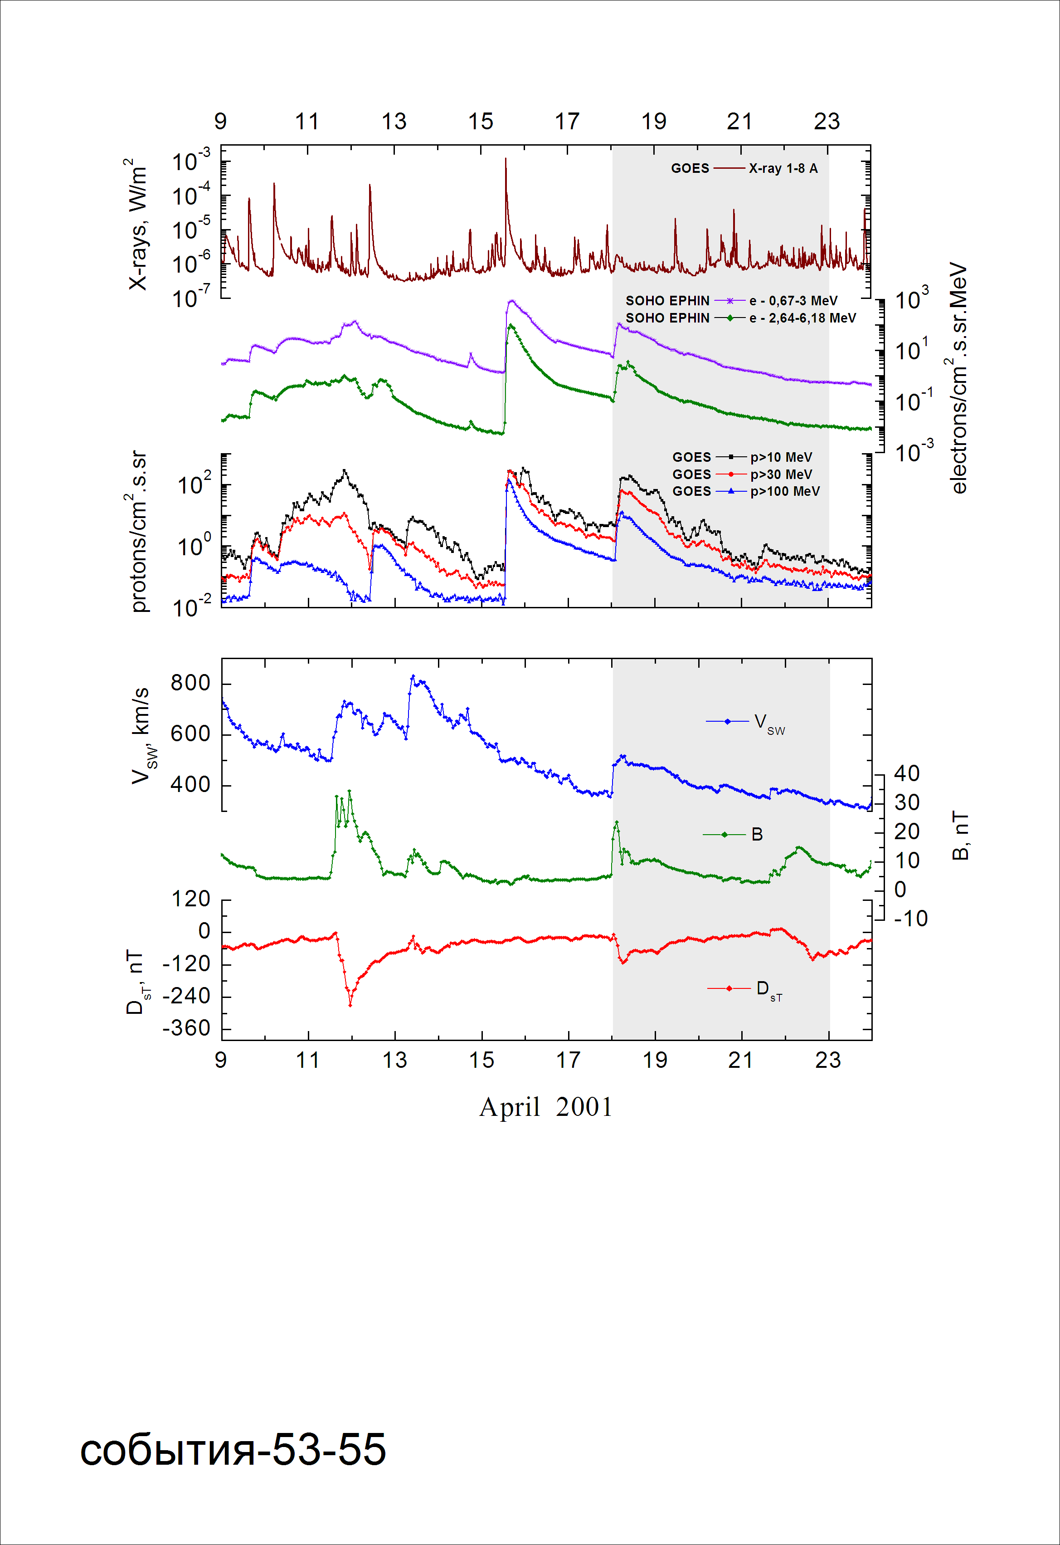

Integral time-of-maximum proton spectrum 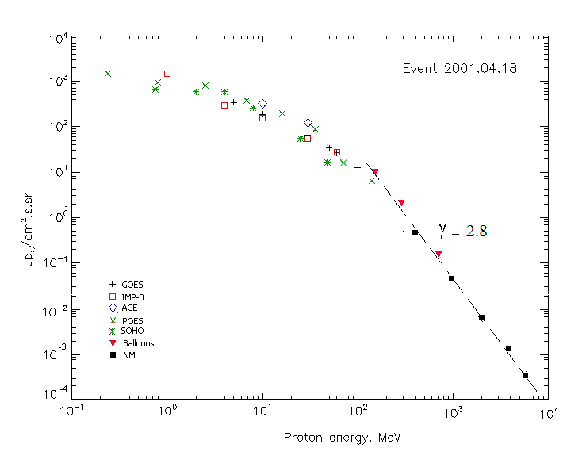

Integral fluxes of protons for the event of 2001 April 18

S/c, instruments | Eр, MeV | To | Tmax | Jmax,  /cm².s.sr | Dura-tion | Comments
GOES-10
EPS | >5 | 03^{h} | 10^{h} | 342 | 3d
EPS | >10 | 03^{h} | 10^{h} | 190 | 3d
EPS | >30 | 03^{h} | 06^{h} | 64.5 | 3d
EPS | >50 | 03^{h} | 06^{h} | 33.9 | 3d
EPS | >60 | 03^{h} | 06^{h} | 26.4 | 3d
EPS | >100 | 03^{h} | 06^{h} | 12.4 | 3d
POES-16
MEPED | >0.24 | 03^{h} | 05^{h} | 1572 | 3d
MEPED | >0.8 | 03^{h} | 05^{h} | 1004 | 3d
MEPED | >2.5 | 03^{h} | 05^{h} | 830 | 3d
MEPED | >6.9 | 03^{h} | 05^{h} | 620 | 3d
MEPED | >16 | 03^{h} | 05^{h} | 197 | 3d
MEPED | >36 | 03^{h} | 05^{h} | 90 | 3d
MEPED | >70 | 03^{h} | 05^{h} | 15.4 | 3d
MEPED | >140 | 03^{h} | 05^{h} | 6.5 | 3d
IMP-8
CPME | >1 | - | 07^{h} | 1470 | -
CPME | >4 | - | 07^{h} | 296 | -
CPME | >10 | - | 07^{h} | 156 | -
CPME | >30 | 03^{h} | 06^{h} | 54.2 | 4 d
CPME | >60 | 03^{h} | 06^{h} | 27.4 | 4 d
ACE
SIS | >10 | 03^{h} | 09^{h} | 320 | 4 d
SIS | >30 | 03^{h} | 09^{h} | 126 | 4 d
SOHO
EPHIN (INT) | >50 | 03^{h} | 09^{h} | 16.9 | 3d
BALLOONS
Mi | >153 |  | 06^{h}45^{m} -07^{h}39^{m} | 9.7
Mi | >287 |  | 06^{h}45^{m} -07^{h}39^{m} | 2.07
Mi | >707 |  | 06^{h}45^{m} -07^{h}39^{m} | 0.15
NM
Network | >433 | ⁻ | 04^{h}20^{m} | 0.41 | -
Network | >1000 | ⁻ | 04^{h}20^{m} | 0.046 | -
Network | >2000 | ⁻ | 04^{h}20^{m} | 0.0075 | -
Network | >3700 | ⁻ | 04^{h}20^{m} | 0.0014 | -
Network | >5800 | ⁻ | 04^{h}20^{m} | 0.00036 | -

Differential fluxes of protons for the event of 2001 April 18

S/c, instruments | ∆Е, MeV | To | Tmax | Jmax. /cm².s.sr.MeV | Dura-tion | Comments
IMP-8
CPME | 1-2 | 04^{h} | 10^{h} | 771 | 7d
CPME | 2-4.6 | 06^{h} | 10^{h} | 269 | 7d
CPME | 4.6-15 | 03^{h} | 10^{h} | 30.3 | 6d
CPME | 15-25 | 03^{h} | 12^{h} | 8.2 | 5d
CPME | 25-48 | 03^{h} | 10^{h} | 1.6 | 5d
CPME | 48-96 | 03^{h} | 10^{h} | 0.4 | 4d
CPME | 96-145 | 03^{h} | 10^{h} | 0.34 | 4d
CPME | 145-440 | 02^{h} | 10^{h} | 0.026 | 3d
SOHO
LION | 0.75-2 | 05^{h} | 10^{h} | 41 | 6d
LION | 2-6 | 04^{h} | 10^{h} | 13 | 6d
EPHIN | 4-8 | 03^{h} | 09^{h} | 70 | 6d
EPHIN | 8-25 | 02^{h} | 09^{h} | 11.9 | 6d
EPHIN | 25-41 | 03^{h} | 09^{h} | 1.6 | 6d
EPHIN | 41-53 | - “ - | - “ - | - “ - | - “ -

References:
Struminsky A.B., 2003.
Matsubara Y., Muraki Y., Sako T., et.al., 2005.
Kuwabara T., Bieber J.W., Clem J., et.al., 2006.
Miroshnichenko L.I. and Perez-Peraza J., 2008.
Kasatkina E.A., Shumilov O.I., Rycroft M.J., et.al., 2009.
Веселовский И.С., Мягкова И.Н., Яковчук О.С., 2012.

