Event 2001.06.15 – (2001-166)

Particle event: To(Ep>10 MeV) – 15d16^{h}
Tmax₁(Ep>10 MeV) – 15d20^{h}, Jmax₁(Ep>10 MeV) – 5 /cm².s.sr
Tmax₂(Ep>10 MeV) – 16d06^{h}, Jmax₂(Ep>10 MeV) – 8.1 /cm².s.sr
Duration of the event – 3 days
Energy of the SCR and 0.1 GCR fluxes balance – Eb(max₁) = 335 MeV
– Eb(max₂) = 120 MeV
Sources: □ activity behind West limb
o solar flare 15d10^{h}01^{m}, M6.3/1N, S26E42 АR9502
CME 15d15^{h}56^{m}, V=1701 km/s, Δφ = 360º; dA = 255º;

Particle fluxes and associated phenomena
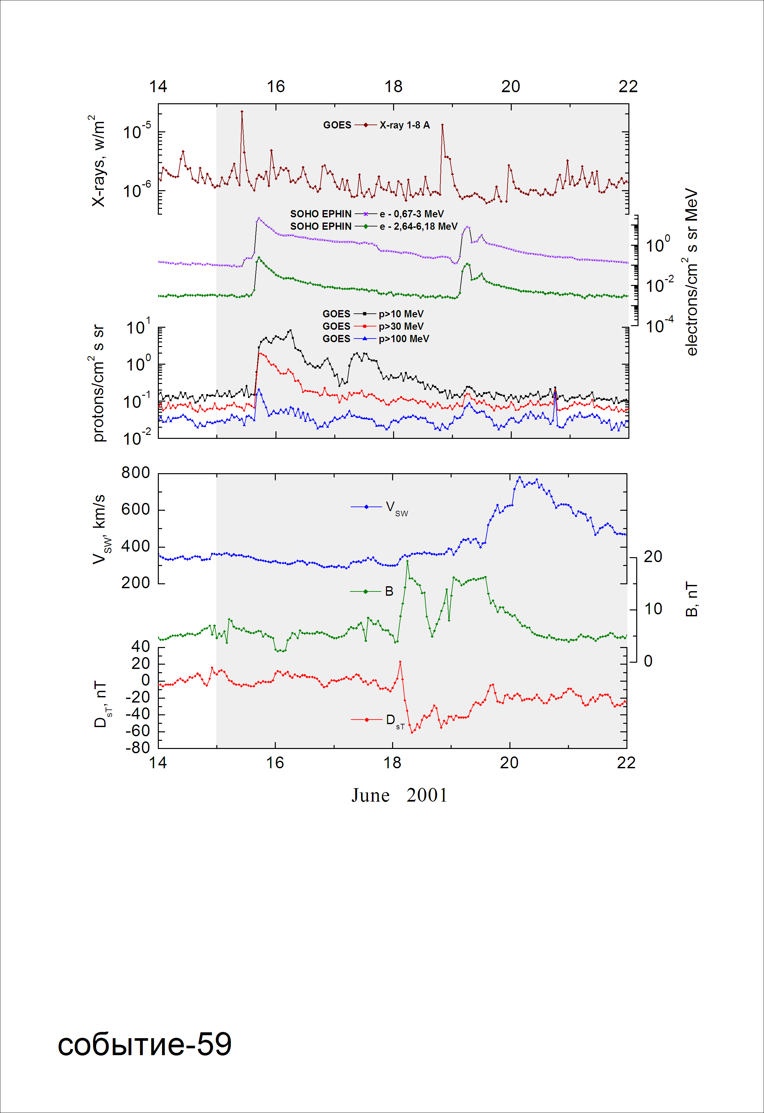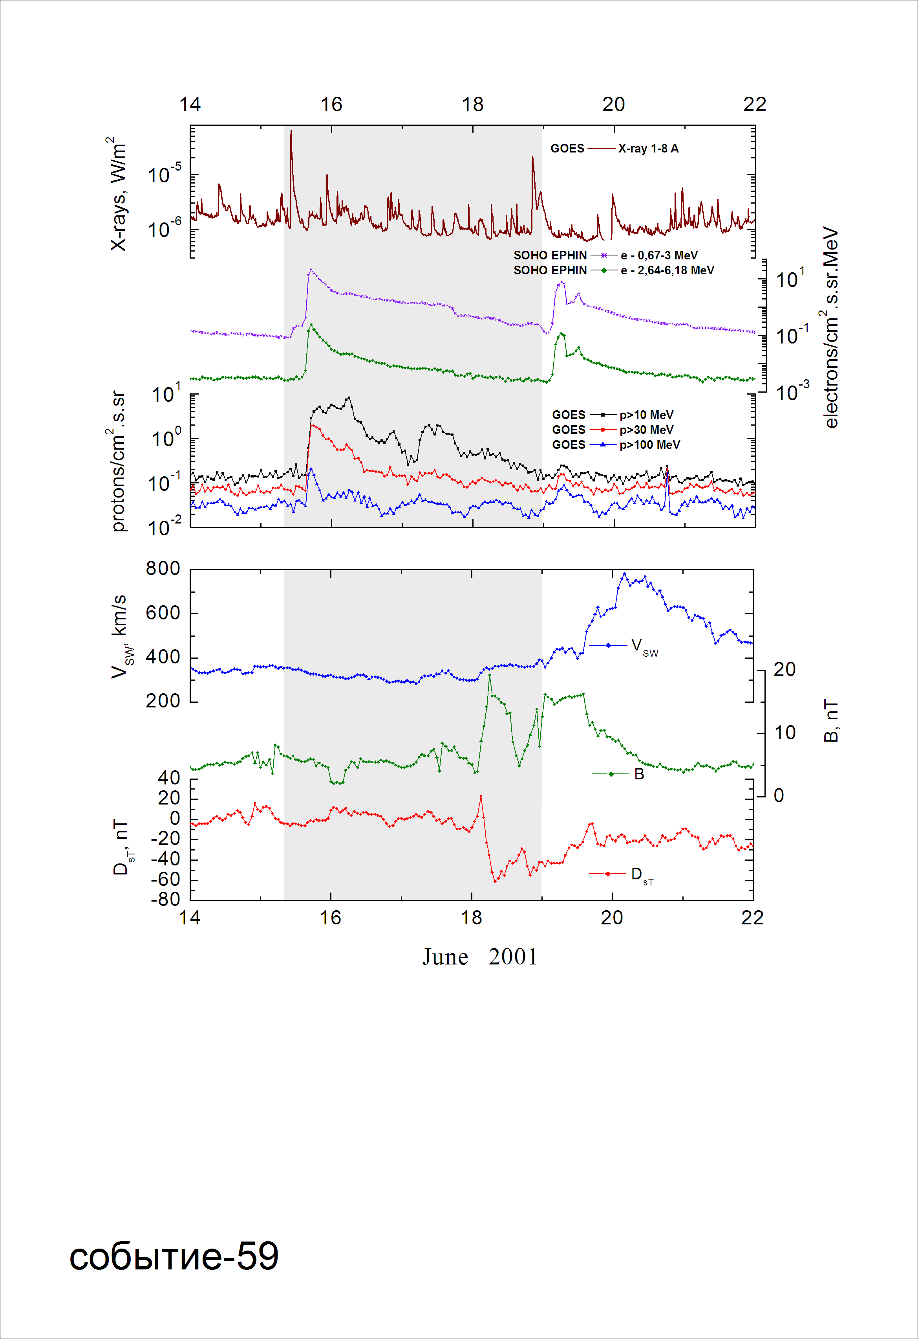
Integral time-of-maximum proton spectrum
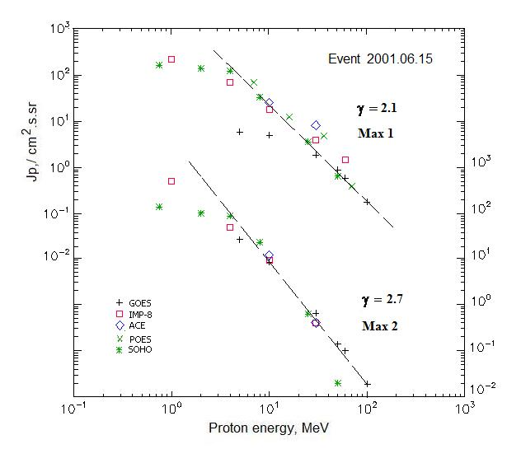

Integral fluxes of protons for the event of 2001 June 15

S/c, instruments | Eр, MeV | To | Tmax | Jmax,  /cm².s.sr | Dura-tion | Comments
GOES-10
EPS | >5 | 16^{h} | 20^{h}/16d06^{h} | 5.9/25.1 | 3d
EPS | >10 | 16^{h} | 20^{h}/16d06^{h} | 5.0/8.1 | 3d
EPS | >30 | 16^{h} | 18^{h}/16d05^{h} | 1.9/0.65 | 3d
EPS | >50 | 16^{h} | 17^{h}/16d05^{h} | 0.9/0.14 | 2d
EPS | >60 | 16^{h} | 17^{h}/16d05^{h} | 0.59/0.1 | 2d
EPS | >100 | 16^{h} | 17^{h}/16d05^{h} | 0.18/0.02 | 2d
POES-16
MEPED | >0.24 | - | - | - | -
MEPED | >0.8 | - | - | - | -
MEPED | >2.5 | - | - | - | -
MEPED | >6.9 | 17^{h} | 18^{h}/ - | 70/ - | > 2d
MEPED | >16 | 17^{h} | 18^{h}/ - | 12.5/ - | > 1d
MEPED | >36 | 17^{h} | 18^{h}/ - | 4.9/ - | > 1d
MEPED | >70 | 17^{h} | 18^{h}/ - | 0.4/ - | > 1d
MEPED | >140 | - | - | - | -
IMP-8
CPME | >1 | 17^{h} | 23^{h}/16d06^{h} | 218/450 | 5d
CPME | >4 | 16^{h} | 23^{h}/16d06^{h} | 70/46 | 4.5d
CPME | >10 | 16^{h} | 19^{h}/16d06^{h} | 18.2/8.8 | 4d
CPME | >30 | 16^{h} | 18^{h}/16d05^{h} | 3.9/0.4 | 2d
CPME | >60 | 16^{h} | 18^{h}/ - | 1.45/ - | 2d
ACE
SIS | >10 | 16^{h} | 19^{h}/16d10^{h} | 25.2/11.5 | 3 d
SIS | >30 | 16^{h} | 19^{h}/16d10^{h} | 8.2/4 | 2 d
SOHO
EPHIN (INT) | >50 | 16^{h} | 17^{h}/16d08^{h} | 0.66/0.02 | 1d

Differential fluxes of protons for the event of 2001 June 15

S/c, instruments | ∆Е, MeV | To | Tmax | Jmax. /cm².s.sr.MeV | Dura-tion | Comments
IMP-8
CPME | 1-2 | 19^{h} | 23^{h}/16d10^{h} | 99.5/289 | -
CPME | 2-4.6 | 18^{h} | 23^{h}/16d09^{h} | 38.8/53.5 | -
CPME | 4.6-15 | 17^{h} | 23^{h}/16d09^{h} | 5/3.5 | -
CPME | 15-25 | 16^{h} | 19^{h}/16d06^{h} | 0.83/0.36 | 2d
CPME | 25-48 | 16^{h} | 18^{h}/16d06^{h} | 0.14/0.023 | 2d
CPME | 48-96 | 16^{h} | 17^{h}/16d06^{h} | 0.025/0.0025 | 1.5d
CPME | 96-145 | 16^{h} | - | - | -
CPME | 145-440 | 16^{h} | - | - | -
SOHO
LION | 0.75-2 | 18^{h} | 23^{h}/16d05^{h} | 14.2/18.8 | 5d
LION | 2-6 | 18^{h} | 23^{h}/16d05^{h} | 4.2/3 | 5d
EPHIN | 4-8 | 18^{h} | 22^{h}/16d08^{h} | 22/14.7 | 5d
EPHIN | 8-25 | 16^{h} | 20^{h}/16d08^{h} | 1.7/1.24 | 4d
EPHIN | 25-41 | 16^{h} | 19^{h}/16d08^{h} | 0.14/0.03 | 3.5d
EPHIN | 41-53 | - “ - | - “ - | - “ - | - “ -

References:
No information on publications, excepting for:
http://www.swpc.noaa.gov/ftpdir/indices/SPE.txt

