Event 2001.08.09 – (2001-221)

Particle event: To(Ep>10 MeV) – 09d20^{h}
Tmax(Ep>10 MeV) – 10d11^{h}, Jmax (Ep>10 MeV) – 6 /cm².s.sr
Duration of the event – 1.5 days
Energy of the SCR and 0.1 GCR fluxes balance – Eb = 85 MeV

Sources: ๏ solar flare 09d11^{h}16^{m}, C3.7/SF (DSF)
Main X-ray burst 1-8 Ǻ: onset – 09d11^{h}16^{m}, max – 09d11^{h}22^{m}, Ф = 0.0021 J/m²
CME 09d10^{h}32^{m}, V=0479 km/s, Δφ = 175º, dA = 255º

Particle fluxes and associated phenomena
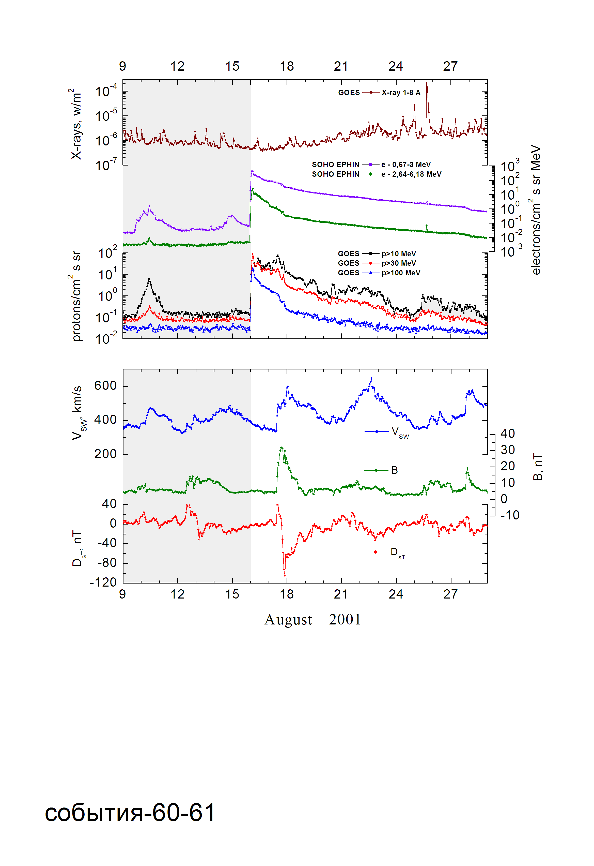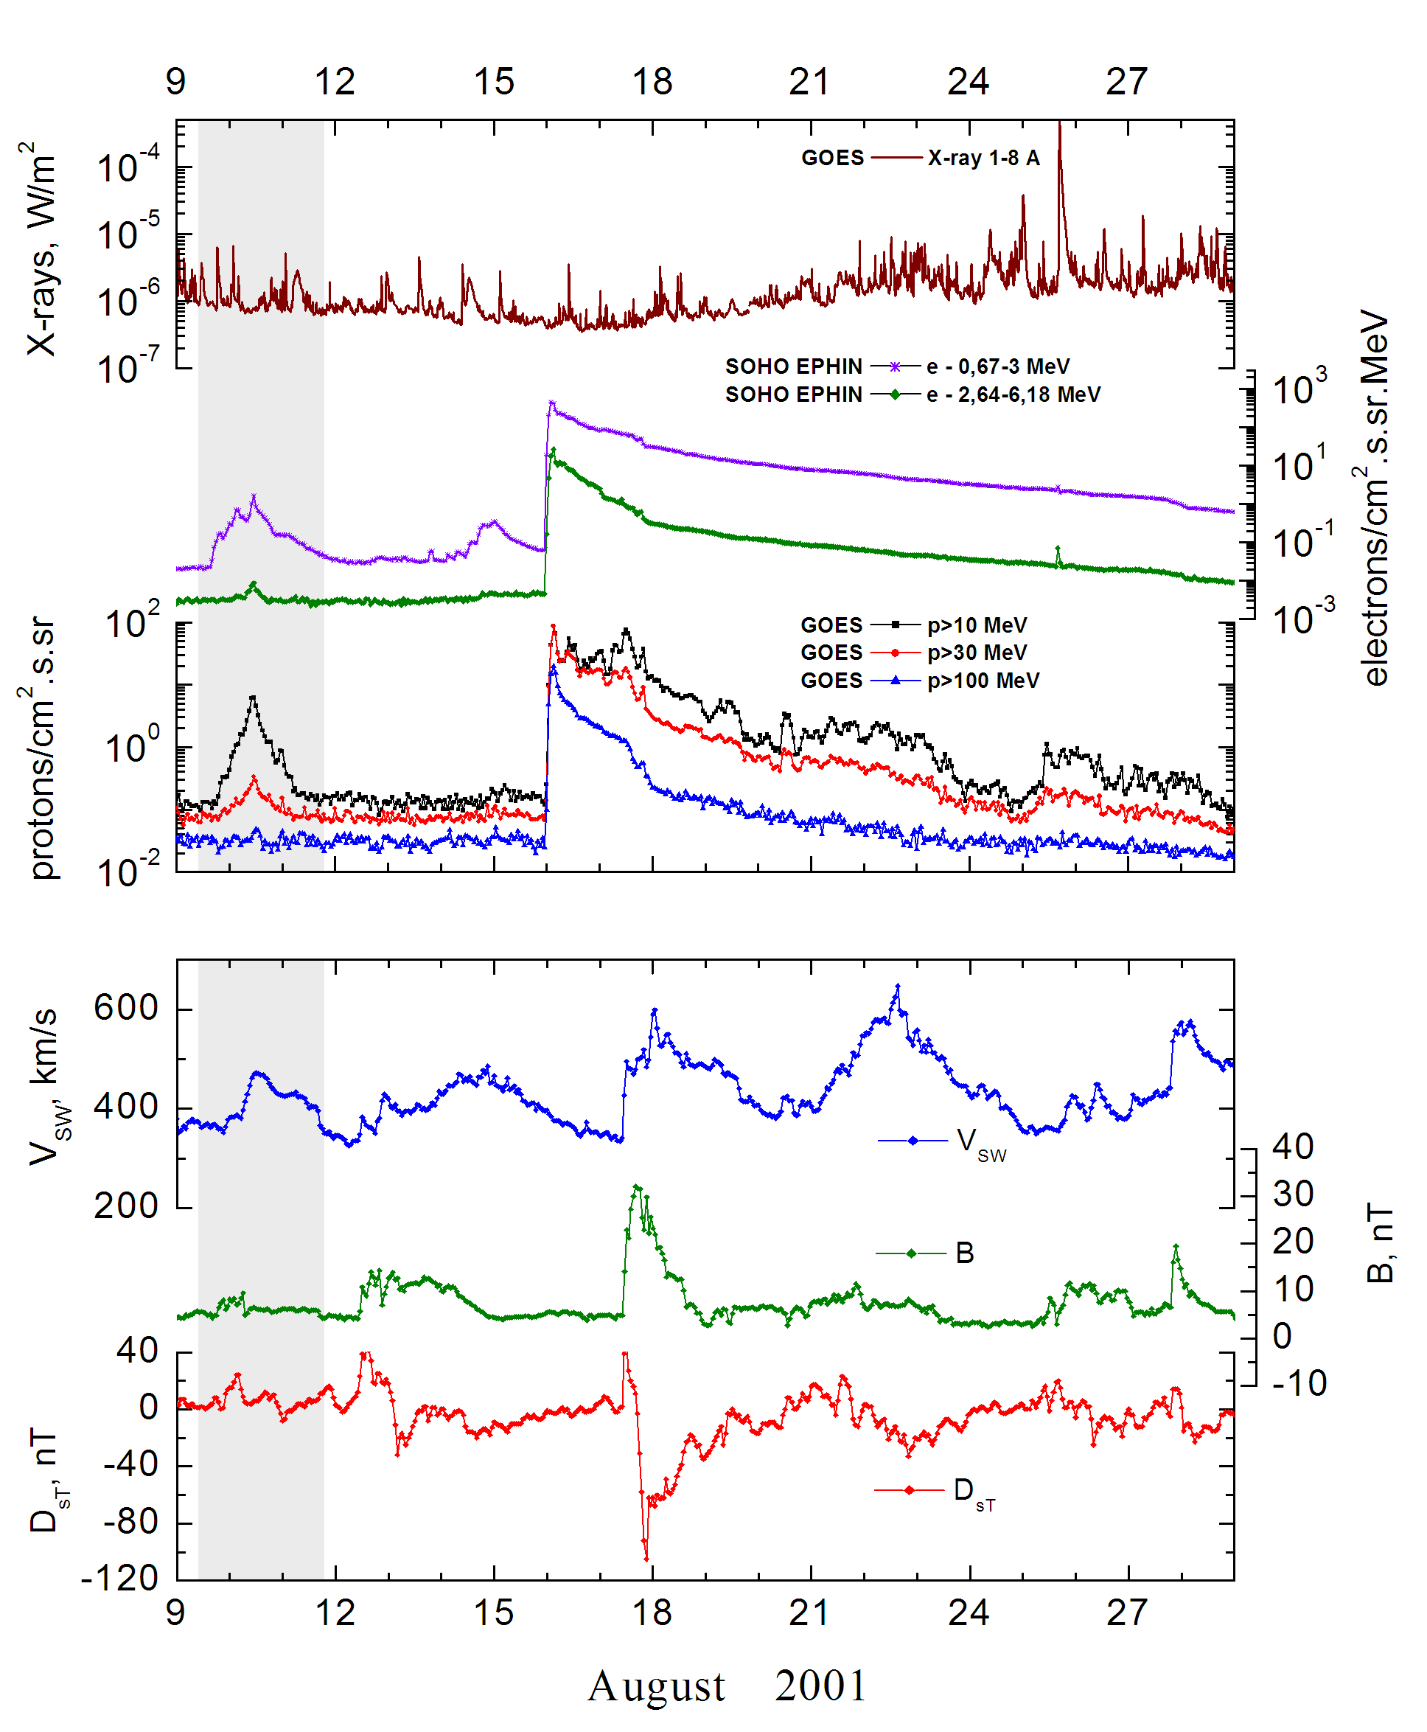

Integral time-of-maximum proton spectrum
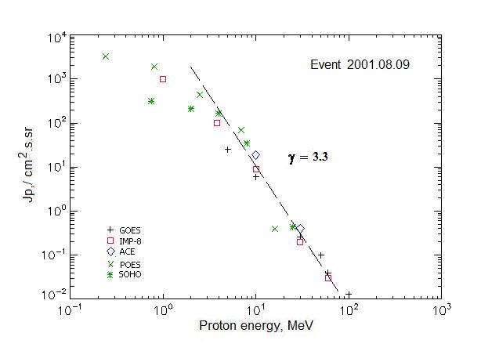

Integral fluxes of protons for the event of 2001 August 09

S/c, instruments | Eр, MeV | To | Tmax | Jmax,  /cm².s.sr | Dura-tion | Comments
GOES-10
EPS | >5 | 20^{h} | 10d11^{h} | 25.2 | 1.5d
EPS | >10 | 20^{h} | 10d11^{h} | 6 | 1d
EPS | >30 | 21^{h} | 10d11^{h} | 0.26 | 1d
EPS | >50 | - | 10d11^{h} | 0.1 | 0.5d
EPS | >60 | - | 10d12^{h} | 0.04 | 0.3d
EPS | >100 | - | 10d12^{h} | 0.013 | 0.3d
POES-16
MEPED | >0.24 | - | 10d10^{h} | 3304 | -
MEPED | >0.8 | - | 10d10^{h} | 1919 | -
MEPED | >2.5 | - | 10d10^{h} | 437 | -
MEPED | >6.9 | - | 10d10^{h} | 69 | -
MEPED | >16 | - | 10d10^{h} | 0.4 | -
MEPED | >36 | - | 10d10^{h} | - | -
MEPED | >70 | - | 10d10^{h} | - | -
MEPED | >140 | - | 10d10^{h} | - | -
IMP-8
CPME | >1 | 18^{h} | 10d12^{h} | 970 | 5 d
CPME | >4 | 18^{h} | 10d12^{h} | 98.7 | 4 d
CPME | >10 | 18^{h} | 10d11^{h} | 8.8 | 3 d
CPME | >30 | 18^{h} | 10d11^{h} | 0.2 | 0.5d
CPME | >60 | 18^{h} | 10d11^{h} | 0.03 | 0.3d
ACE
SIS | >10 | 18^{h} | 10d11^{h} | 18.8 | 2d
SIS | >30 | 18^{h} | 10d11^{h} | 0.4 | 5h
SOHO
EPHIN (INT) | >50 | - | - | - | -

Differential fluxes of protons for the event of 2001 August 09

S/c, instruments | ∆Е, MeV | To | Tmax | Jmax. /cm².s.sr.MeV | Dura-tion | Comments
IMP-8
CPME | 1-2 | 23^{h} | 10d09^{h} | 820 | 5d
CPME | 2-4.6 | 23^{h} | 10d09^{h} | 109 | 5d
CPME | 4.6-15 | 23^{h} | 10d12^{h} | 5.9 | 5d
CPME | 15-25 | 23 ^{h} | 10d11^{h} | 0.26 | 2d
CPME | 25-48 | 23^{h} | 10d11^{h} | 0.011 | 1d
CPME | 48-96 | 23^{h} | 10d09^{h} | 0.0005 | 1d
CPME | 96-145 | - | - | - | -
CPME | 145-440 | - | - | - | -
SOHO
LION | 0.75-2 | 18^{h} | 10d12^{h} | 57.4 | 5d
LION | 2-6 | 18^{h} | 10d12^{h} | 11.9 | 5d
EPHIN | 4-8 | 17^{h} | 10d11^{h} | 32,3 | 5d
EPHIN | 8-25 | 17^{h} | 10d11^{h} | 2,04 | 5d
EPHIN | 25-41 | 17^{h} | 10d11^{h} | 0,02 | 3d
EPHIN | 41-53 | - “ - | - “ - | - “ - | - “ -

References:
No information on publications, excepting for:
http://www.swpc.noaa.gov/ftpdir/indices/SPE.txt

