Event 2001.10.01 – (2001-274)

Particle event: To(Ep>10 MeV) – 01d14^{h}
Tmax₁(Ep>10 MeV) – 01d23^{h}, Jmax₁(Ep>10 MeV) – 370 /cm².s.sr
Tmax₂(Ep>10 MeV) – 02d07^{h}, Jmax₂(Ep> 10MeV) – 1.3·10³ /cm².s.sr
Duration of the event – 3.5 days
Energy of the SCR and 0.1 GCR fluxes balance – Eb(max₁₎ = 155 MeV
– Eb(max₂₎ = 150 MeV
Sources: ■ solar flare 01d04^{h}41^{m}, M9.1/…, S18W80, АR9628
□ flare activity AR9628 behind W–limb
Main X-ray burst 1-8 Ǻ: onset – 01d04^{h}41^{m}, max – 01d05^{h}15^{m}, Ф = 0.086 J/m²
CME: 01d05^{h}30^{m}, V= 1405 km/s, Δφ = 360º , dA = 225º

Particle fluxes and associated phenomena
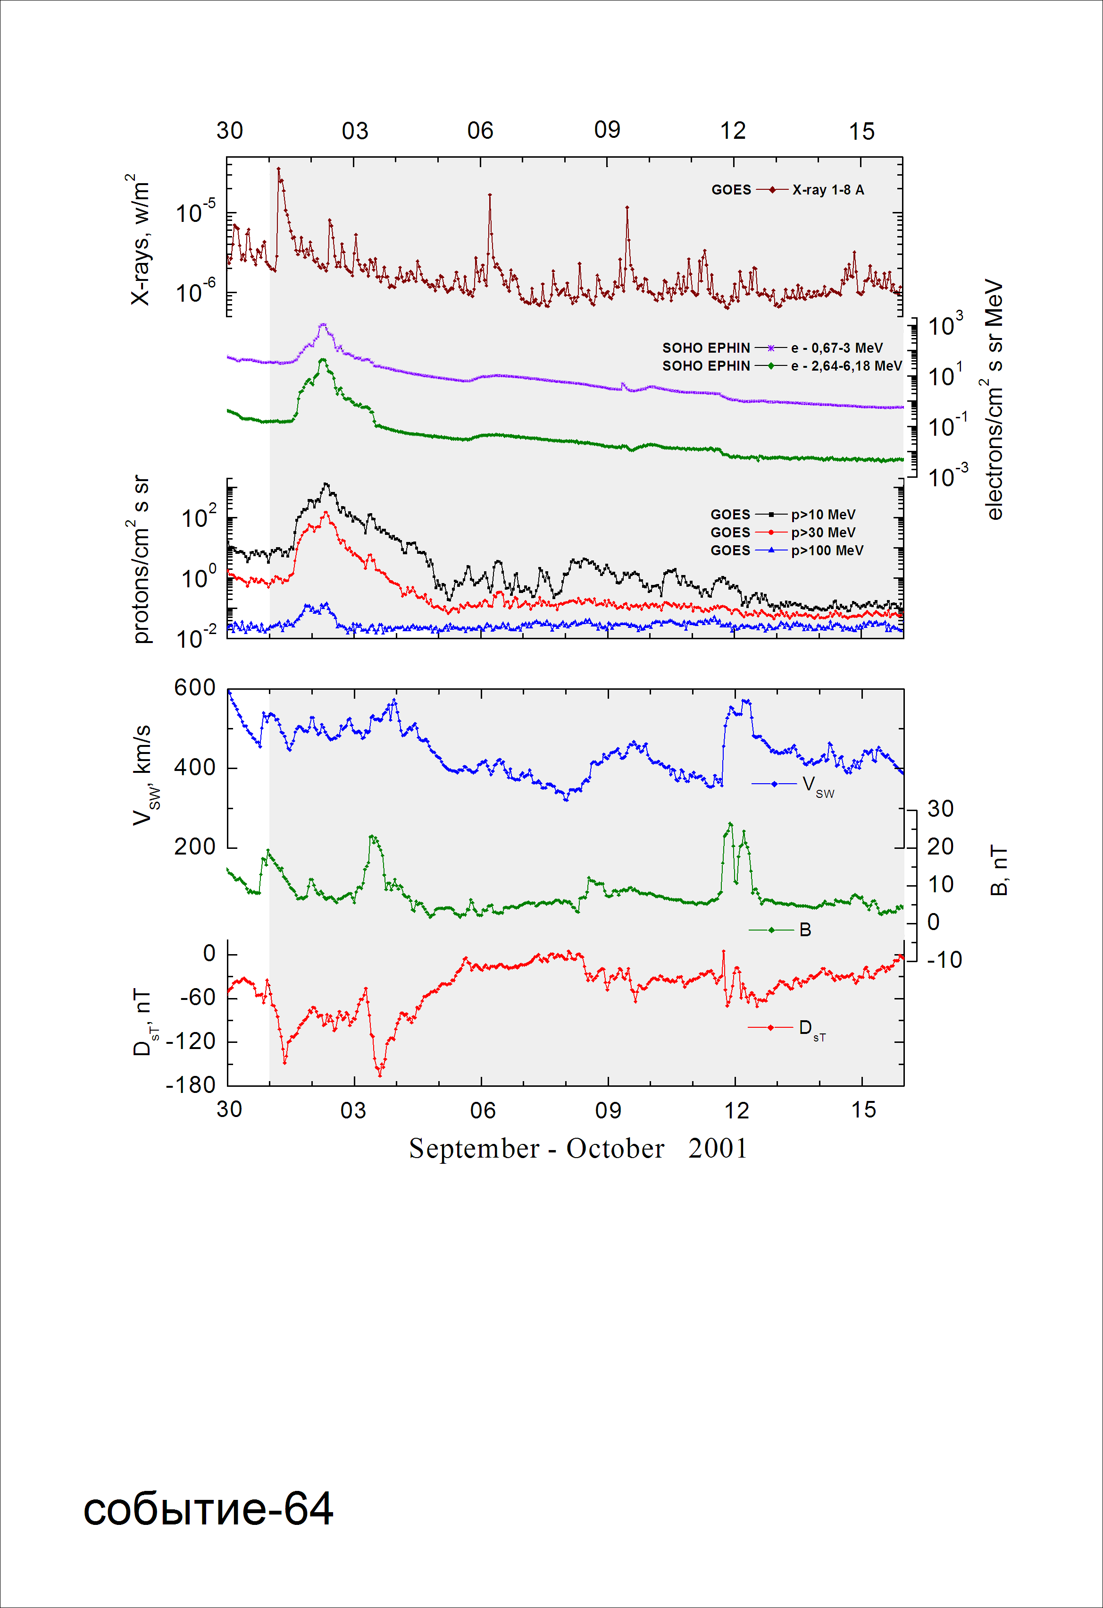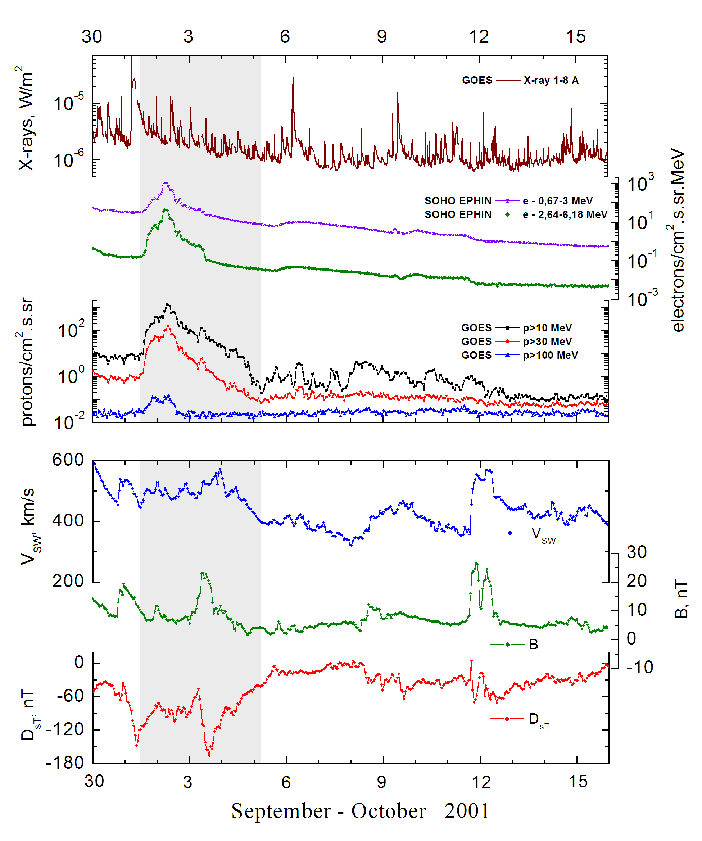
Integral time-of-maximum proton spectrum 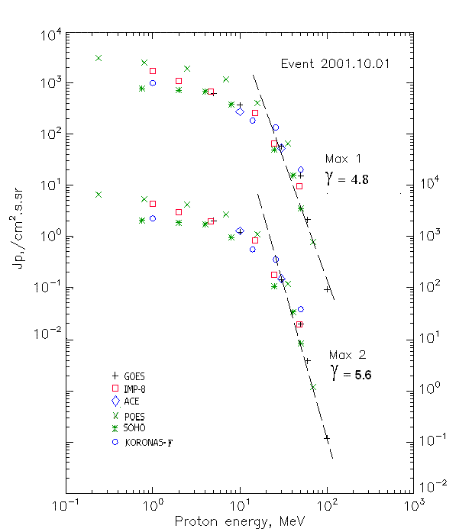

Integral fluxes of protons for the event of 2001 October 01

S/c, instruments | Eр, MeV | To | Tmax | Jmax,  /cm².s.sr | Dura-tion | Comments
GOES-10
EPS | >5 | 14^{h} | 23^{h}/02d07^{h} | 633/2186 | 3.5d
EPS | >10 | 14^{h} | 23^{h}/02d07^{h} | 370/1300 | 3.5d
EPS | >30 | 14^{h} | 23^{h}/02d08^{h} | 57.2/151 | 3d
EPS | >50 | 14^{h} | 22^{h} /02d08^{h} | 15.4/20.6 | 2d
EPS | >60 | 14^{h} | 22^{h} /02d08^{h} | 2.1/3.9 | 1.5d
EPS | >100 | 14^{h} | 21^{h} /02d08^{h} | 0.09/0.12 | 1d
POES-16
MEPED | >0.24 | 13^{h} | 21^{h}/2d08^{h} | 3090/7190 | 6d
MEPED | >0.8 | 13^{h} | 21^{h}/2d08^{h} | 2520/5840 | 6d
MEPED | >2.5 | 13^{h} | 21^{h}/2d08^{h} | 1920/4460 | 6d
MEPED | >6.9 | 13^{h} | 21^{h}/2d08^{h} | 1195/2920 | 6d
MEPED | >16 | 13^{h} | 21^{h}/2d08^{h} | 414/1200 | 6d
MEPED | >36 | 13^{h} | 21^{h}/2d08^{h} | 65.1/128 | 6d
MEPED | >70 | 13^{h} | 21^{h}/2d08^{h} | 0.76/1.2 | 6d
MEPED | >140 | 13^{h} | - | - | -
CORONAS-F
MKL | >1 | 14^{h} | 21^{h}/2d08^{h} | 1020/2400 | 6d
MKL | >14 | 14^{h} | 21^{h}/2d08^{h} | 185/610 | 6d
MKL | >26 | 14^{h} | 21^{h}/2d08^{h} | 136/380 | 6d
MKL | >50 | 14^{h} | 21^{h}/2d10^{h} | 53/113 | 6d
ACE
SIS | >10 | 13^{h} | 23^{h} /02d07^{h} | 273/1380 | 3d
SIS | >30 | 13^{h} | 23^{h} /02d07^{h} | 53/160 | 3d
SOHO
EPHIN (INT) | >50 | 12^{h} | 23^{h} /02d06^{h} | 3.5/8.6 | 2d

Differential fluxes of protons for the event of 2001 October 01
S/c, instruments | ∆Е, MeV | To | Tmax | Jmax.  /cm².s.sr.MeV | Dura-tion | Comments
IMP-8
CPME | 1-2 | 14^{h} | 23^{h} /02d08^{h} | 620/1350 | 6d
CPME | 2-4.6 | 14^{h} | 22^{h} /02d08^{h} | 178/490 | 6d
CPME | 4.6-15 | 14^{h} | 21^{h} /02d08^{h} | 41/115 | 6d
CPME | 15-25 | 14^{h} | 21^{h} /02d08^{h} | 19.3/70 | 6d
CPME | 25-48 | 14^{h} | 21^{h} /02d08^{h} | 2.33/7.3 | 4d
CPME | 48-96 | 14^{h} | 21^{h} /02d08^{h} | 0.2/0.45 | 4d
CPME | 96-145 | - | - | - | -
CPME | 145-440 | - | - | - | -
SOHO
LION | 0.75-2 | 13^{h} | 23^{h} /02d07^{h} | 31.5/110 | 6d
LION | 2-6 | 13^{h} | 23^{h} /02d07^{h} | 10.8/38.8 | 6d
EPHIN | 4-8 | 12^{h} | 23^{h} /02d07^{h} | 74/210 | 6d
EPHIN | 8-25 | 12^{h} | 23^{h} /02d07^{h} | 19.8/53.2 | 6d
EPHIN | 25-41 | 12^{h} | 23^{h} /02d06^{h} | 2.1/4.9 | 4d
EPHIN | 41-53 | - “ - | - “ - | - “ - | - “ -

References:
Kuwabara T., J.W. Bieber, J. Clem, et.al., 2006

