Event 2001.10.22 – (2001-295)

Particle event: To(Ep>10 MeV) – 22d16^{h}
Tmax(Ep>10 MeV) – 22d21^{h}, Jmax (Ep>10 MeV) – 17 /cm².s.sr
Duration of the event – 2.5 days
Energy of the SCR and 0.1 GCR fluxes balance – Eb = 425 MeV

Sources: ● solar 22d17^{h}44^{m}, X1.2/2B, S18E16, АR9672
Ø solar 22d14^{h}16^{m}, 2N/M6.7, S17E20, АR9672
Main X-ray burst 1-8 Ǻ: onset – 22d17^{h}44^{m}, max – 22d17^{h}59^{m}, Ф = 0.12 J/m²
CME: 22d18^{h}26^{m}, V = 0618 km/s, 106º , dA = 126 º
▲SC 25d08 ^{h}50 ^{m}
Particle fluxes and associated phenomena
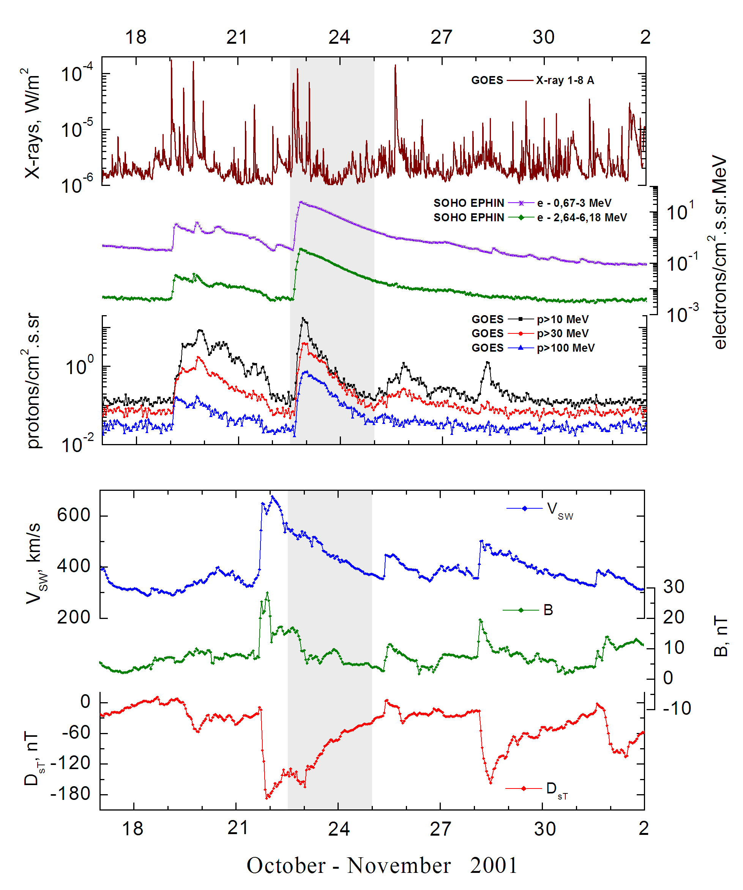
Integral time-of-maximum proton spectrum 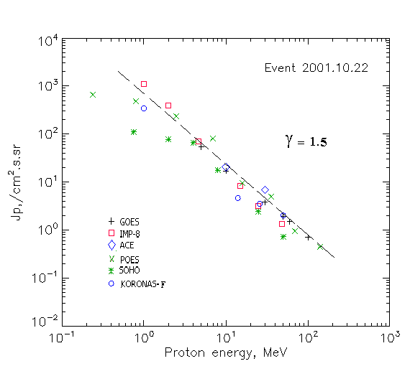

Integral fluxes of protons for the event of 2001 October 22

S/c, instruments | Eр, MeV | To | Tmax | Jmax,  /cm².s.sr | Dura-tion | Comments
GOES-10
EPS | >5 | 16^{h} | 22^{h} | 53.6 | 2.5d
EPS | >10 | 16^{h} | 21^{h} | 17.0 | 2.5d
EPS | >30 | 16^{h} | 22^{h} | 3.8 | 2.5d
EPS | >50 | 16^{h} | 22^{h} | 1.9 | 2.5d
EPS | >60 | 16^{h} | 22^{h} | 1.5 | 2.5d
EPS | >100 | 16^{h} | 22^{h} | 0.7 | 2.5d
POES-16
MEPED | >0.24 | 18^{h} | 20^{h} | 663 | 2.5d
MEPED | >0.8 | 18^{h} | 20^{h} | 478 | 2.5d
MEPED | >2.5 | 18^{h} | 20^{h} | 236 | 2.5d
MEPED | >6.9 | 18^{h} | 20^{h} | 81 | 2.5d
MEPED | >16 | 18^{h} | 20^{h} | 9.5 | 2.5d
MEPED | >36 | 18^{h} | 20^{h} | 5 | 2.5d
MEPED | >70 | 18^{h} | 20^{h} | 0.95 | 2.5d
MEPED | >140 | 18^{h} | 20^{h} | 0.45 | 2.5d
CORONAS-F
MKL | >1 | 18^{h} | 23d02^{h} | 342 | 2.5d
MKL | >14 | 18^{h} | 23d00^{h} | 4.6 | 2.5d
MKL | >26 | 18^{h} | 23d00^{h} | 3.5 | 2.5d
MKL | >50 | 18^{h} | 23d00^{h} | 2.0 | 2.5d
ACE
SIS | >10 | 16^{h} | 21^{h} | 20.4 | 3d
SIS | >30 | 16^{h} | 22^{h} | 6.9 | 3d
SOHO
EPHIN (INT) | >50 | 16^{h} | 21^{h} | 0.73 | 3d

Differential fluxes of protons for the event of 2001 October 22

S/c, instruments | ∆Е, MeV | To | Tmax | Jmax. /cm².s.sr.MeV | Dura-tion | Comments
IMP-8
CPME | 1-2 | 18^{h} | 23^{h} | 690 | >1.5d
CPME | 2-4.6 | 18^{h} | 23^{h} | 136 | >1.5d
CPME | 4.6-15 | 17^{h} | 23^{h} | 6 | >1.5d
CPME | 15-25 | 16^{h} | 22^{h} | 0.5 | >1.5d
CPME | 25-48 | 17^{h} | 23^{h} | 0.08 | >1.5d
CPME | 48-96 | 17^{h} | 23^{h} | 0.028 | >1.5d
CPME | 96-145 | - | - | - | -
CPME | 145-440 | - | - | - | -
SOHO
LION | 0.75-2 | 18^{h} | 23d01^{h} | 18.5 | 7d
LION | 2-6 | 18^{h} | 23d01^{h} | 3.7 | 7d
EPHIN | 4-8 | 17^{h} | 21^{h} | 12.2 | 7d
EPHIN | 8-25 | 17^{h} | 21^{h} | 0.9 | 7d
EPHIN | 25-41 | 16^{h} | 21^{h} | 0.06 | 7d
EPHIN | 41-53 | - “ - | - “ - | - “ - | - “ -

References:
No information on publications, excepting for:
http://www.swpc.noaa.gov/ftpdir/indices/SPE.txt

