Event 2001.10.28 – (2001-301)

Particle event: To(Ep>10 MeV) – 28d02^{h}
Tmax(Ep>10 MeV) – 28d07^{h}, Jmax (Ep>10 MeV) – 1.1 /cm².s.sr
Duration of the event – 1day
Energy of the SCR and 0.1 GCR fluxes balance – Eb = 60 MeV

Sources: unknown
○ solar flare 28d04^{h}36^{m}, M1.3/1F, N12E40, АR0682
Main X-ray burst 1-8 Ǻ: onset – 28d04^{h}36^{m}, max – 28d05^{h}08^{m}, Ф = 0.013 J/m²
ΔSC 28d13^{h}19 ^{m}

Particle fluxes and associated phenomena
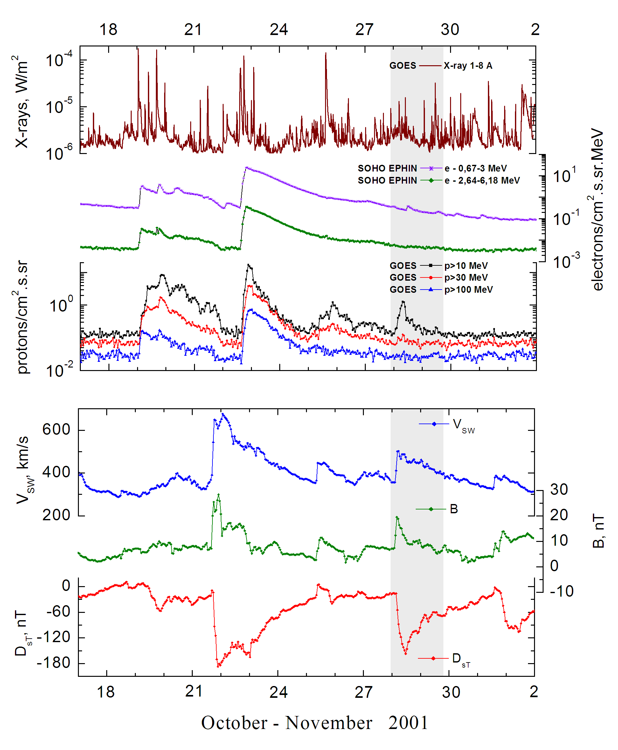

Integral time-of-maximum proton spectrum
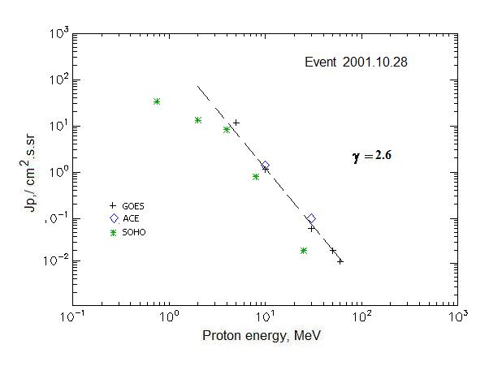

Integral fluxes of protons for the event of 2001 October 28

S/c, instruments | Eр, MeV | To | Tmax | Jmax,  /cm².s.sr | Dura-tion | Comments
GOES-10
EPS | >5 | 02^{h} | 08^{h} | 11.6 | 1.5d
EPS | >10 | 02^{h} | 07^{h} | 1.14 | 1d
EPS | >30 | 02^{h} | 07^{h} | 0.06 | 0.5d
EPS | >50 | 02^{h} | 07^{h} | 0.02 | -
EPS | >60 | 02^{h} | 07^{h} | 0.01 | -
EPS | >100 | - | - | - | -
ACE
SIS | >10 | 06^{h} | 07^{h} | 1.4 | 0.5d
SIS | >30 | - | 08^{h} | 0.1 | -
SOHO
EPHIN (INT) | >50 | - | - | - | -
Differential fluxes of protons for the event of 2001 October 28

S/c, instruments | ∆Е, MeV | To | Tmax | Jmax. /cm².s.sr.MeV | Dura-tion | Comments
SOHO
LION | 0.75-2 | 26d18^{h} | 28d09^{h} | 11.4 | 3d
LION | 2-6 | 26d18^{h} | 28d08^{h} | 1.2 | 3d
EPHIN | 4-8 | 26d18^{h} | 28d08^{h} | 1.9 | 3d
EPHIN | 8-25 | - | 28d09^{h} | 0.045 | 3d
EPHIN | 25-41 | - | 28d08^{h} | 0.0006 | -
EPHIN | 41-53 | - “ - | - “ - | - “ - | - “ -

References:
No information on publications, excepting for:
http://www.swpc.noaa.gov/ftpdir/indices/SPE.txt

