Event 2001.11.04 – (2001-308) – GLE-62

Particle event: To(Ep>10 MeV) – 04d16^{h}
Tmax₁(Ep>10 MeV) – 04d20^{h}, Jmax₁(Ep>10 MeV) – 540 /cm².s.sr
Tmax₂(Ep>10 MeV) – 06d00^{h}, Jmax₂(Ep>10 MeV) – 2.4·10⁴ /cm².s.sr
Duration of the event – 5 days
Energy of the SCR and 0.1 GCR fluxes balance – Eb(max₁₎ = 750 MeV
– Eb(max₂₎ = 685 MeV
Sources: ● solar flare 04d16^{h}03^{m}, X1.0/3B, N07W19, АR9684
Ø solar flare 04d06^{h}38^{m}, X1.0/3B, N14W57, АR9682 –
Ø solar flare 05d09^{h}07^{m}, M2.1/1N, N03W37, АR9684
Main X-ray burst 1-8 Ǻ: onset – 04d16^{h}03^{m}, max – 04d16^{h}20^{m}, Ф = 0.22 J/m²
CME 04d16^{h}35^{m}, V = 1810 km/s, Δφ = 360º, dA = 239º,
▲SC 06d01^{h}52 ^{m}

Particle fluxes and associated phenomena
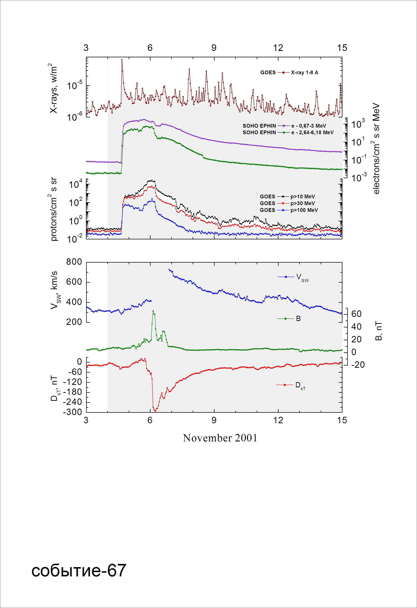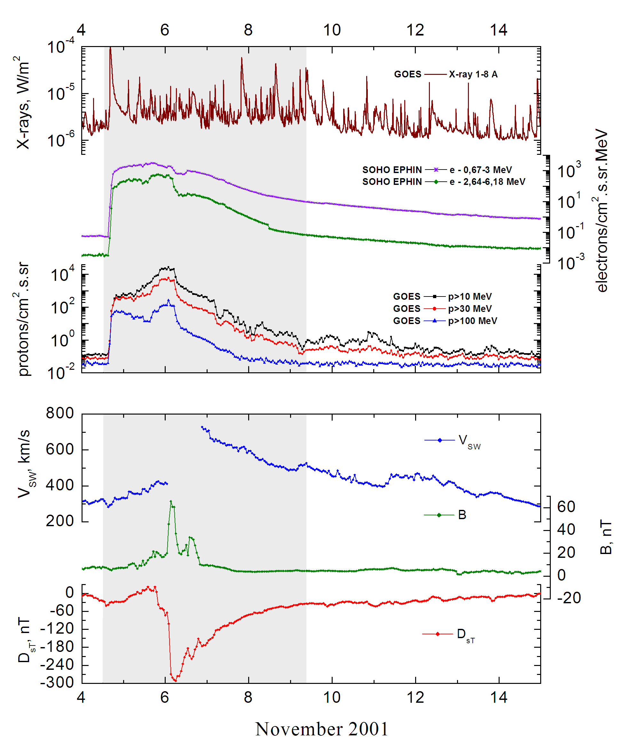
Integral time-of-maximum proton spectrum 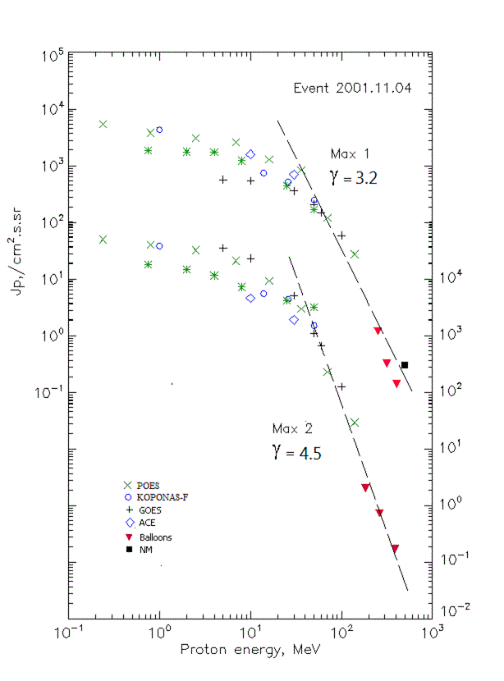

Integral fluxes of protons for the event of 2001 November 04

S/c, instruments | Eр, MeV | To | Tmax | Jmax,  /cm².s.sr | Dura-tion | Comments
GOES-10
EPS | >5 | 16^{h} | 20^{h}/06d00^{h} | 570/3.5∙10⁴ | 5d
EPS | >10 | 16^{h} | 20^{h}/06d00^{h} | 540/2.3∙10⁴ | 5d
EPS | >30 | 16^{h} | 20^{h}/06d00^{h} | 360/5.1∙10³ | 5d
EPS | >50 | 16^{h} | 20^{h}/06d00^{h} | 210/1.1∙10³ | 5d
EPS | >60 | 16^{h} | 20^{h}/06d00^{h} | 148/670 | 5d
EPS | >100 | 16^{h} | 20^{h}/06d00^{h} | 59/126 | 5d
POES-16
MEPED | >0.24 | 16^{h} | 22^{h}/06d03^{h} | 5.4∙10³/5∙10⁴ | 5d
MEPED | >0.8 | 16^{h} | 22^{h}/06d03^{h} | 3.8∙10³/4∙10⁴ | 5d
MEPED | >2.5 | 16^{h} | 22^{h}/06d03^{h} | 3.1∙10³/3.2∙10⁴ | 5d
MEPED | >6.9 | 16^{h} | 22^{h}/06d03^{h} | 2.6∙10³/2.1∙10⁴ | 5d
MEPED | >16 | 16^{h} | 22^{h}/06d03^{h} | 1.3∙10³/9.3∙10³ | 5d
MEPED | >36 | 16^{h} | 22^{h}/06d03^{h} | 840/3∙10³ | 5d
MEPED | >70 | 16^{h} | 22^{h}/06d03^{h} | 121/230 | 5d
MEPED | >140 | 16^{h} | 22^{h}/06d03^{h} | 27.6/29.4 | 5d
CORONAS-F
MKL | >1. | 16^{h} | 22^{h}/06d02^{h} | 4.3∙10³/3.8∙10⁴ | 5d
MKL | >14 | 16^{h} | 22^{h}/06d02^{h} | 750/5.5∙10³ | 5d
MKL | >26 | 16^{h} | 22^{h}/06d02^{h} | 515/4.4∙10³ | 5d
MKL | >50 | 16^{h} | 22^{h} /06d02^{h} | 252/1.5∙10³ | 5d
ACE
SIS | >10 | 16^{h} | 23^{h}/6d00^{h} | 1.6∙10³/4.6∙10³ | 5d
SIS | >30 | 16^{h} | 23^{h}/6d00^{h} | 700/1.9∙10³ | 5d
SOHO
EPHIN (INT) | >50 | 16^{h} | 20^{h}/06d02^{h} | 170/3.2∙10³ | 4d
BALLOONS
Mu | >254 |  | 05d(08^{h}08^{m} -08^{h}37^{m}) | 1.2/ -
Mu | >317 |  | 05d(08^{h}08^{m} -08^{h}37^{m}) | 0.32/ -
Mu | >409 |  | 05d(08^{h}08^{m} -08^{h}37^{m}) | 0.14/ -
Mu | >184 |  | 06d(02^{h}16^{m} -02^{h}57^{m}) | - /2.0
Mu | >265 |  | 06d(02^{h}16^{m} -02^{h}57^{m}) | - /0.73
Mu | >390 |  | 06d(02^{h}16^{m} -02^{h}57^{m}) | - /0.17
NM
Network | >500 |  | 20^{h}/- | 0.003/ -

Differential fluxes of protons for the event of 2001 November 04
S/c, instru-ments | ∆Е, MeV | To | Tmax | Jmax. /cm².s.sr.MeV | Dura-tion | Comments
SOHO
LION | 0.75-2 | 17^{h} | 05d02^{h}/06d02^{h} | 49.4/1800 | 8d
LION | 2-6 | 17^{h} | 05d02^{h}/06d02^{h} | 3.4/810 | 8d
EPHIN | 4-8 | 17^{h} | 06d03^{h}/06d01^{h} | 130/1080 | 8d
EPHIN | 8-25 | 17^{h} | 06d03^{h}/06d01^{h} | 46.3/180 | 8d
EPHIN | 25-41 | 17^{h} | 05d20^{h}/06d02^{h} | 12.4/44.1 | 8d
EPHIN | 41-53 | - “ - | - “ - | - “ - | - “ -

References:
Struminsky A.B., 2003.
Kuwabara T., J.W. Bieber, J. Clem, et.al., 2006.
Rawat R., S. Alex, and G.S. Lakhina, 2006.
Miroshnichenko L.I. and J. Perez-Peraza, 2008.
Lario D., Aran A., Decker R.B, 2009.
Kasatkina E.A., O.I. Shumilov, M.J. Rycroft, et.al., 2009.
Tylka A.J., O.E. Malandraki, G. Dorrian, et.al., 2013.

