Event 2001.11.17 – (2001-321)

Particle event To(Ep>10 MeV) – 17d10^{h}
Tmax(Ep>10 MeV) – 19d22^{h}, Jmax (Ep>10 MeV) – 13 /cm².s.sr
Duration of the event – 5 days
Energy of the SCR and 0.1 GCR fluxes balance – Eb = 45 MeV

Sources: ● solar flare 17d04^{h}48^{m}, M2.8/2N, S13E42, АR9704
Main X-ray burst 1–8 Ǻ: onset – 17d04^{h}49^{m}, max – 17d05^{h}25^{m}, Ф = 0.1 J/m²
CME: 05^{h}30^{m}, V = 1379 km/s, Δφ = 360º , dA = 058º
▲SC19d18 ^{h}15 ^{m}

Particle fluxes and associated phenomena
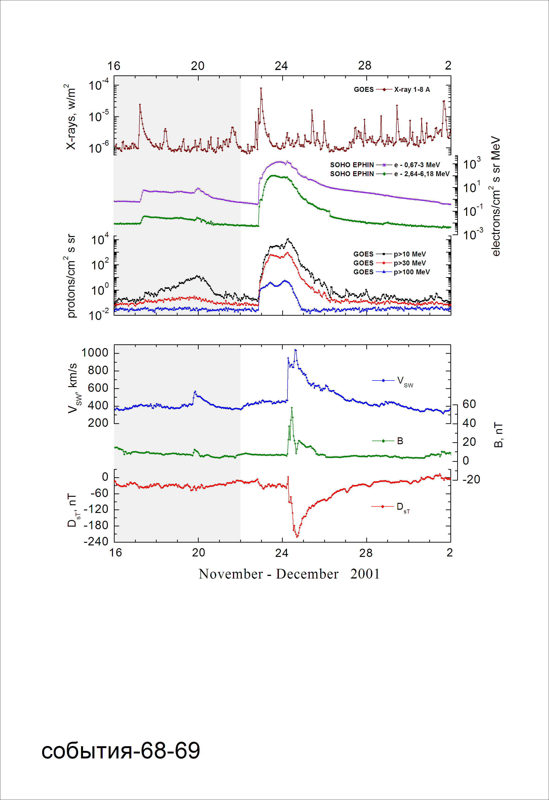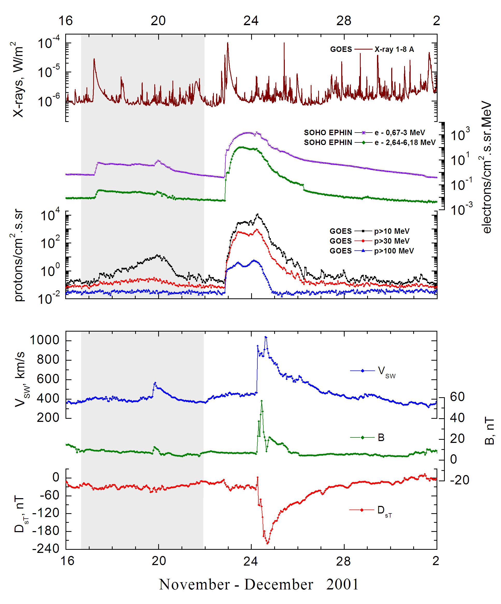

Integral time-of-maximum proton spectrum 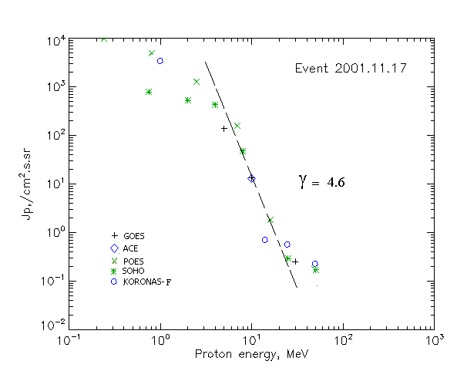

Integral fluxes of protons for the event of 2001 November 17

S/c, instruments | Eр, MeV | To | Tmax | Jmax,  /cm².s.sr⁻¹ | Dura-tion | Comments
GOES-10
EPS | >5 | 10^{h} | 20d01^{h} | 139 | 5d
EPS | >10 | 10^{h} | 19d22^{h} | 13 | 5d
EPS | >30 | 10^{h} | 19d19^{h} | 0.25 | 4d
EPS | >50 | - | - | - | -
EPS | >60 | - | - | - | -
EPS | >100 | - | - | - | -
POES-16
MEPED | >0.24 | 10^{h} | 19d20^{h} | 9932 | 6d
MEPED | >0.8 | 10^{h} | 19d20^{h} | 4978 | 6d
MEPED | >2.5 | 10^{h} | 19d20^{h} | 1299 | 5d
MEPED | >6.9 | 10^{h} | 19d20^{h} | 156 | 5d
MEPED | >16 | 10^{h} | 19d20^{h} | 1.85 | 4d
MEPED | >36 | - | - | - | -
MEPED | >70 | - | - | - | -
MEPED | >140 | - | - | - | -
CORONAS F
MKL | >1. | 10^{h} | 20d01^{h} | 3440 | 5d
MKL | >14 | 10^{h} | 20d01^{h} | 0.72 | 4d
MKL | >26 | 10^{h} | 20d01^{h} | 0.57 | 4d
MKL | >50 | 10^{h} | 20d01^{h} | 0.21 | 4d
ACE
SIS | >10 | - | 20d01^{h} | 13 | 5d
SIS | >30 | - | - | - | -
SOHO
EPHIN (INT) | >50 | 19d20^{h} | 20d00^{h} | 0.17 | 1d

Differential fluxes of protons for the event of 2001 November 17

S/c, instruments | ∆Е, MeV | To | Tmax | Jmax. /cm².s.sr.MeV | Dura-tion | Comments
SOHO
LION | 0.75-2 | 12^{h} | 19d21^{h} | 150 | 5d
LION | 2-6 | 11^{h} | 19d21^{h} | 23.6 | 5d
EPHIN | 4-8 | 09^{h} | 20d01^{h} | 95.4 | 5d
EPHIN | 8-25 | 09^{h} | 20d01^{h} | 2.8 | 5d
EPHIN | 25-41 | 09^{h} | 20d00^{h} | 0.006 | 5d
EPHIN | 41-53 | - “ - | - “ - | - “ - | - “ -

References:
No information on publications, excepting for:
http://www.swpc.noaa.gov/ftpdir/indices/SPE.txt

