Event 2001.11.22 – (2001-326)

Particle event: To(Ep>10 MeV) – 22d21^{h}
Tmax₁(Ep>10 MeV) – 23d10^{h}, Jmax₁(Ep>10 MeV) – 2.7·10³ /cm².s.sr
Tmax₂(Ep>10 MeV) – 24d06^{h}, Jmax₂(Ep>10 MeV) – 1.1·10⁴ /cm².s.sr
Duration of the event – 4 days
Energy of the SCR and 0.1 GCR fluxes balance – Eb(max₁₎ = 390 MeV
– Eb(max₂₎ = 350 MeV
Sources: ● solar flare 22d<22^{h}09^{m}, M9.9/3B, S13W38, АR9704
Ø solar flare 22d20^{h}18^{m}, M3.8/2B, S26W68, АR9704
Main X-ray burst 1-8 Ǻ: onset – 22d22^{h}32^{m}, max – 22d23^{h}30^{m}, Ф = 0.31 J/m²
CME:22d23^{h}30^{m}, V = 1437 km/s, Δφ = 360º, dA = 341º
▲SC 24d05^{h}56 ^{m}

Particle fluxes and associated phenomena
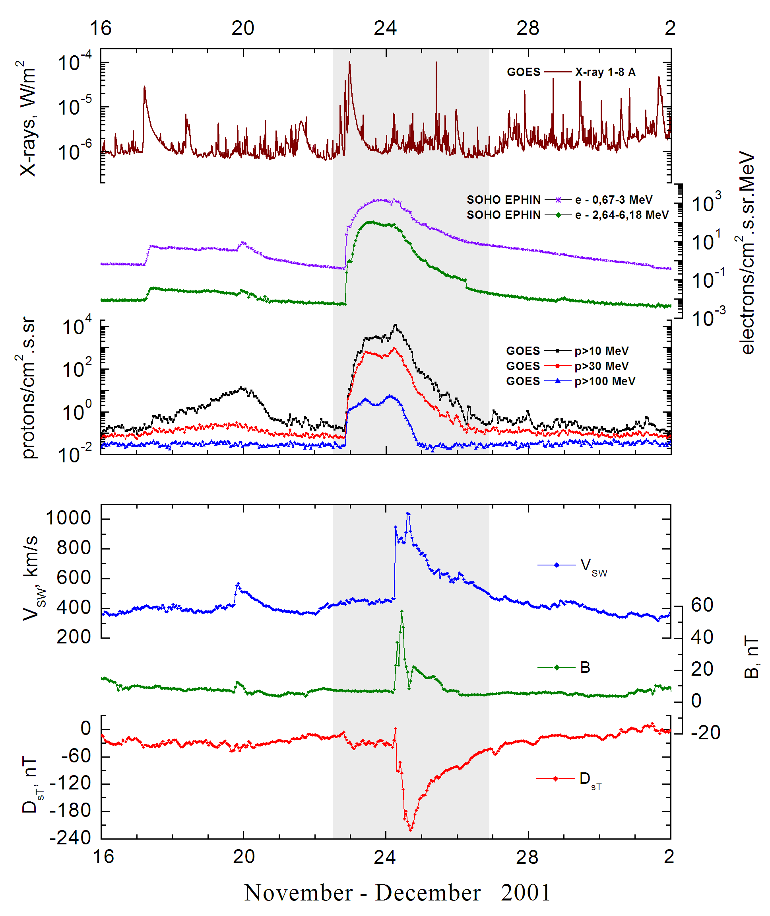
Integral time-of-maximum proton spectrum 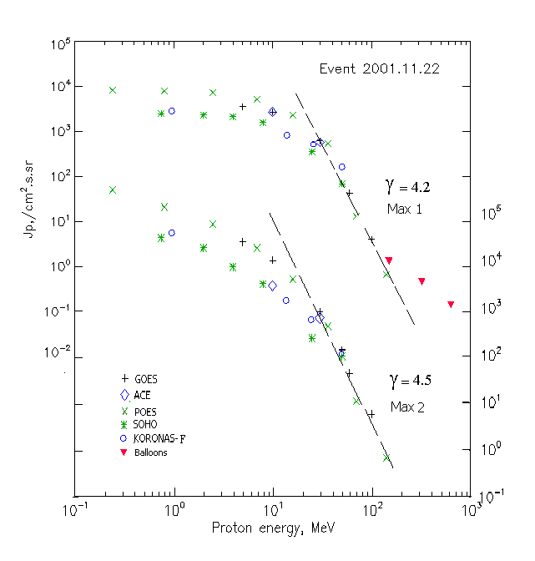

Integral fluxes of protons for the event of 2001 November 22

S/c, instruments | Eр, MeV | To | Tmax | Jmax,  /cm².s.sr | Dura-tion | Comments
GOES-10
EPS | >5 | 21^{h} | 23d11^{h}/24d06^{h} | 3.6∙10³/2.8∙10⁴ | 4d
EPS | >10 | 21^{h} | 23d10 ^{h}/24d06^{h} | 2.7∙10³/1.1∙10⁴ | 4d
EPS | >30 | 21^{h} | 23d10^{h}/24d05^{h} | 624/923 | 3d
EPS | >50 | 21^{h} | 23d10^{h}/24d05^{h} | 137/145 | 3d
EPS | >60 | 21^{h} | 23d10^{h}/24d05^{h} | 43/46 | 2.5d
EPS | >100 | 21^{h} | 23d10^{h}/24d02^{h} | 4/5.6 | 2d
POES-16
MEPED | >0.24 | 21^{h} | 23d07^{h}/24d07^{h} | 8.3∙10³/3.6∙10⁵ | 4d
MEPED | >0.8 | 21^{h} | 23d07^{h}/24d07^{h} | 8∙10³/1.5∙10⁵ | 4d
MEPED | >2.5 | 21^{h} | 23d07^{h}/24d07^{h} | 7.3∙10³/6.7∙10⁴ | 4d
MEPED | >6.9 | 21^{h} | 23d07^{h}/24d07^{h} | 5.3∙10³/2.1∙10⁴ | 4d
MEPED | >16 | 21^{h} | 23d07^{h}/24d07^{h} | 2.3∙10³/4.7∙10³ | 3d
MEPED | >36 | 21^{h} | 23d07^{h}/24d07^{h} | 550/458 | 3d
MEPED | >70 | 21^{h} | 23d07^{h}/24d07^{h} | 13.1/12 | 2d
MEPED | >140 | 21^{h} | 23d07^{h}/24d07^{h} | 0.67/0.67 | 2d
CORONAS-F
MKL | > 1 | 21^{h} | 23d11^{h}/24d06^{h} | 2.9∙10³/4.3∙10⁴ | 4d
MKL | >14 | 21^{h} | 23d11^{h}/24d06^{h} | 920/1.6∙10³ | 4d
MKL | >26 | 21^{h} | 23d11^{h}/24d06^{h} | 520/595 | 4d
MKL | >50 | 21^{h} | 23d11^{h}/24d06^{h} | 150/121 | 4d
ACE
SIS | >10 | 21^{h} | 23d11^{h}/24d06^{h} | 2.7∙10³/3.3∙10³ | 4d
SIS | >30 | 21^{h} | 23d11^{h}/24d06^{h} | 575/688 | 3d
SOHO
EPHIN (INT) | >50 | 21^{h} | 23d11^{h}/24d05^{h} | 68.7/108 | 3.2d
BALLOONS
Mu | >150 |  | 23d(10 ^{h}-11 ^{h})/ - | 1.3/ -
Mu | >323 |  | 23d(10 ^{h}-11 ^{h})/ - | 0.45/ -
Mu | >633 |  | 23d(10 ^{h}-11 ^{h})/ - | 0.14/ -

Differential fluxes of protons for the event of 2001 November 22

S/c, instruments | ∆Е, MeV | To | Tmax | Jmax. /cm².s.sr.MeV | Dura-tion | Comments
SOHO
LION | 0.75-2 | 23d01^{h} | 23d11^{h}/24d05^{h} | 73.5/7560 | 8d
LION | 2-6 | 23d01^{h} | 23d11^{h}/24d05^{h} | 50.4/3210 | 8d
EPHIN | 4-8 | 23^{h} | 23d11^{h}/24d05^{h} | 132/1170 | 8d
EPHIN | 8-25 | 22^{h} | 23d11^{h}/24d05^{h} | 73.5/200 | 8d
EPHIN | 25-41 | 21^{h} | 23d11^{h}/24d05^{h} | 12.7/7.4 | 8d
EPHIN | 41-53 | - “ - | - “ - | - “ - | - “ -

References:
Kuwabara T., J.W. Bieber, J. Clem, et.al., 2006.
Lario D, Aran A, Decker R.B, 2009
Веселовский И.С., И.Н. Мягкова, О.С. Яковчук, 2012.

