Event 2001.12.26 – (2001-360) – GLE-63

Particle event: To(Ep>10 MeV) – 26d05^{h}
Tmax(Ep>10 MeV) – 26d11^{h}, Jmax (Ep>10 MeV) – 336 /cm².s.sr
Duration of the event – 3 days
Energy of the SCR and 0.1 GCR fluxes balance – Eb = 800 MeV

Sources: ● solar flare 26d04^{h}32^{m}, M7.1/1B, N08W54, АR9742
Main X-ray burst 1-8 Ǻ: onset – 26d04^{h}32^{m}, max – 26d05^{h}40^{m}, Ф = 0.34 J/m²
CME: 26d05^{h}30^{m}, V = 1446 km/s, Δφ = 212º, dA = 266º

Particle fluxes and associated phenomena
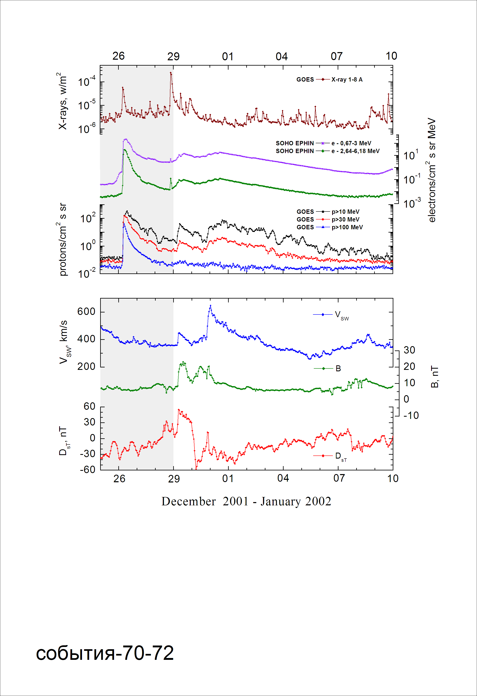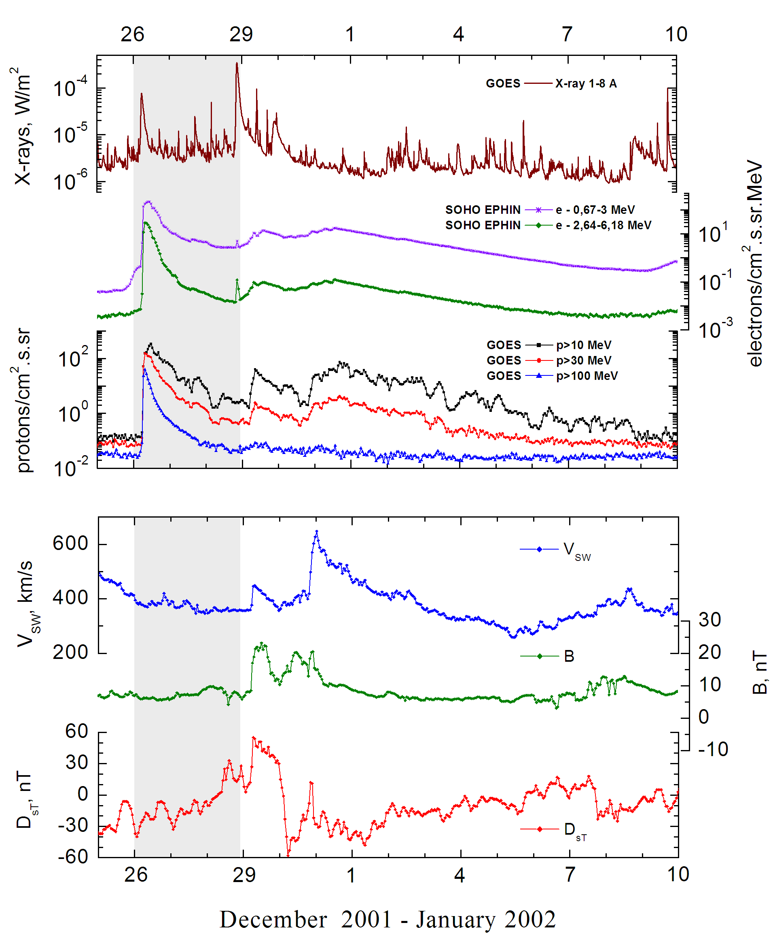
Integral time-of-maximum proton spectrum 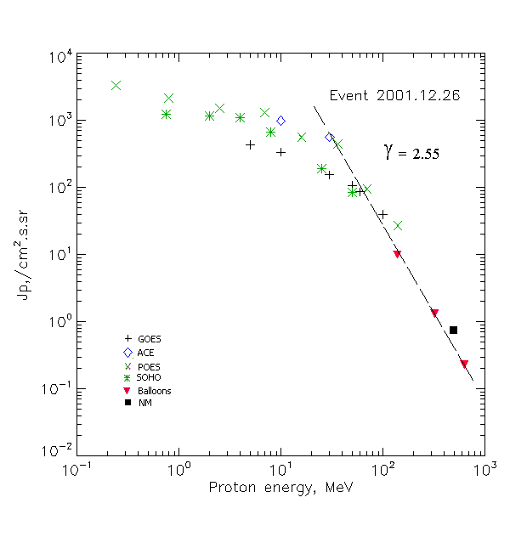

Integral fluxes of protons for the event of 2001 December 26

S/c,  Instruments | Eр, MeV | To | Tmax | Jmax,  /cm².s.sr | Dura-tion | Comments
GOES-10
EPS | >5 | 05^{h} | 11^{h} | 432 | 3d
EPS | >10 | 05^{h} | 11^{h} | 340 | 3d
EPS | >30 | 05^{h} | 07^{h} | 154 | 3d
EPS | >50 | 05^{h} | 07^{h} | 106 | 3d
EPS | >60 | 05^{h} | 07^{h} | 86 | 2.5d
EPS | >100 | 05^{h} | 07^{h} | 40 | 2d
POES 16
MEPED | >0.24 | 05^{h} | 07^{h} | 3350 | 3d
MEPED | >0.8 | 05^{h} | 07^{h} | 2150 | 3d
MEPED | >2.5 | 05^{h} | 07^{h} | 1500 | 3d
MEPED | >6.9 | 05^{h} | 07^{h} | 1300 | 3d
MEPED | >16 | 05^{h} | 07^{h} | 563 | 3d
MEPED | >36 | 05^{h} | 07^{h} | 448 | 3d
MEPED | >70 | 05^{h} | 07^{h} | 94 | 2d
MEPED | >140 | 05^{h} | 07^{h} | 27 | 2d
ACE
SIS | >10 | 05^{h} | 09^{h} | 987 | 2.5d
SIS | >30 | 05^{h} | 07^{h} | 565 | 2d
SOHO
EPHIN (INT) | >50 | 05^{h} | 07^{h} | 84 | 2d
BALLOONS
Mu | >139 |  | 07^{h}07^{m} -08^{h}44^{m} | 9.9
Mu | >323 |  | 07^{h}07^{m} -08^{h}44^{m} | 1.31
Mu | >633 |  | 07^{h}07^{m} -08^{h}44^{m} | 0.23
NM
Network | >500 |  | 07^{h} | 0.74

Differential fluxes of protons for the event of 2001 December 26
S/c, instruments | ∆Е, MeV | To | Tmax | Jmax. /cm².s.sr.MeV | Dura-tion | Comments
SOHO
LION | 0.75-2 | 05^{h} | 12^{h} | 29.4 | 3d
LION | 2-6 | 05^{h} | 12^{h} | 17.3 | 3d
EPHIN | 4-8 | 05^{h} | 11^{h} | 107 | 3d
EPHIN | 8-25 | 05^{h} | 11^{h} | 28.2 | 3d
EPHIN | 25-41 | 05^{h} | 09^{h} | 4.7 | 2.5d
EPHIN | 41-53 | - “ - | - “ - | - “ - | - “ -

References:
Struminsky A.B, 2003.
Kuwabara T., J.W. Bieber, J. Clem, et.al., 2006.
Miroshnichenko L.I. and J. Perez-Peraza, 2008.

