Event 2001.12.29 – (2001-363)

Particle event: To(Ep>10 MeV) – 29d05^{h}
Tmax(Ep>10 MeV) – 29d08^{h}, Jmax (Ep>10 MeV) – 40 /cm².s.sr
Duration of the event – 1.5 days
Energy of the SCR and 0.1 GCR fluxes balance – Eb = 195 MeV

Sources:  solar flare 28d20^{h}02^{m}, X3.4/…, S26E90, АR9767
 solar flare 28d09^{h}38^{m}, M9.3/…, S08W88, АR9748
Main X-ray burst 1-8 Ǻ: onset – 28d20^{h}02^{m}, max – 28d20^{h}45^{m}, Ф = 1.3 J/m²
CME: 28d20^{h}30^{m}, V=2216 km/s, Δφ = 360º, dA = 115º;
▲SC 29d05 ^{h}38 ^{m}

Particle fluxes and associated phenomena
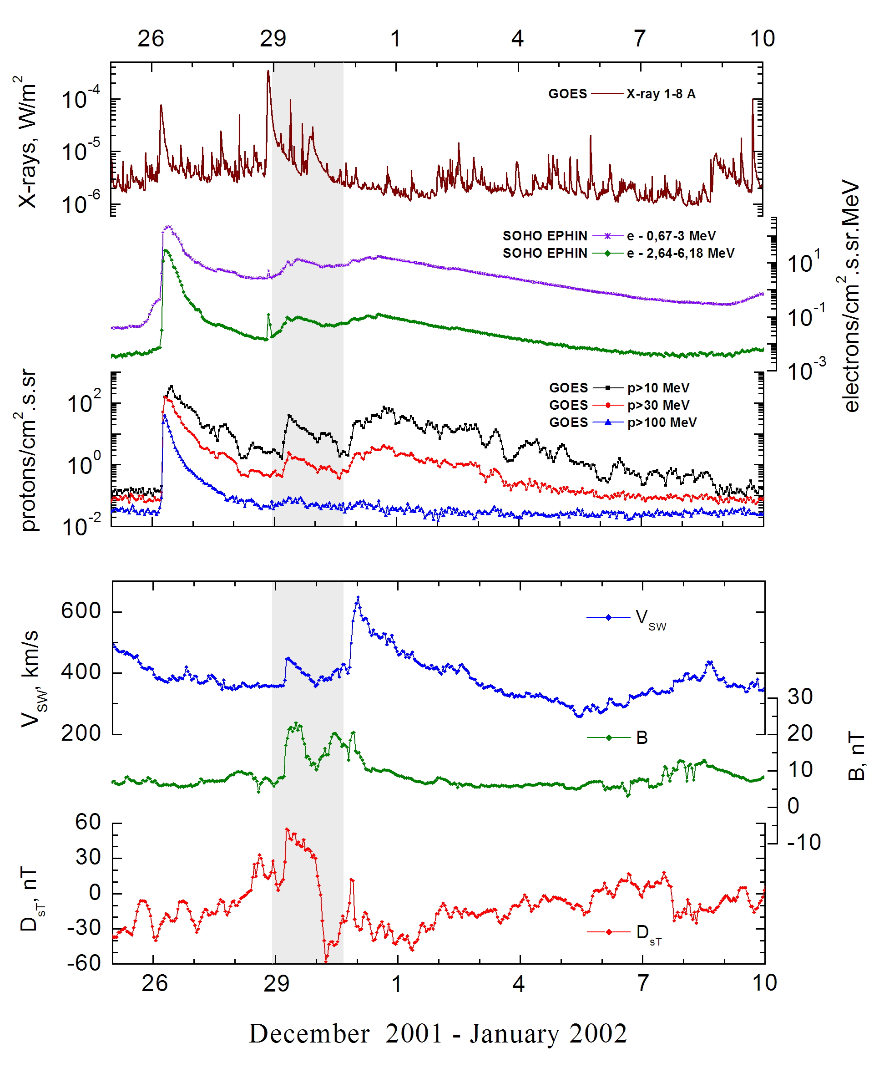
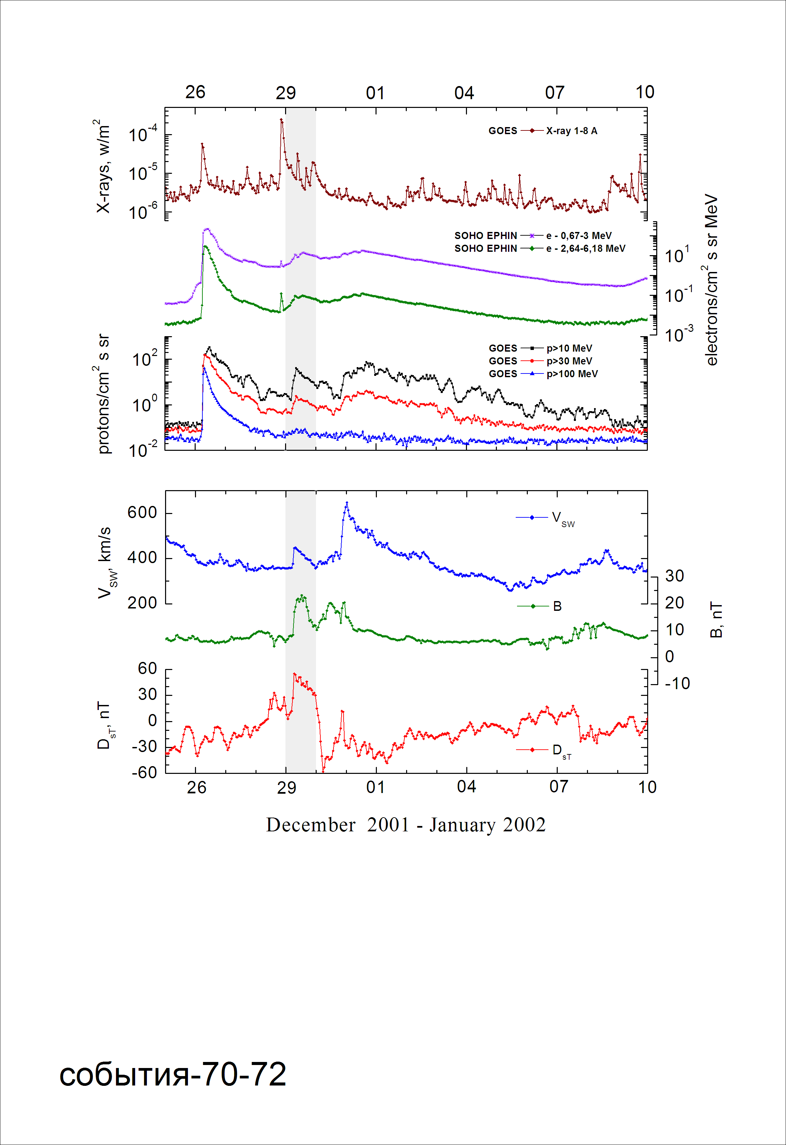
Integral time-of-maximum proton spectrum 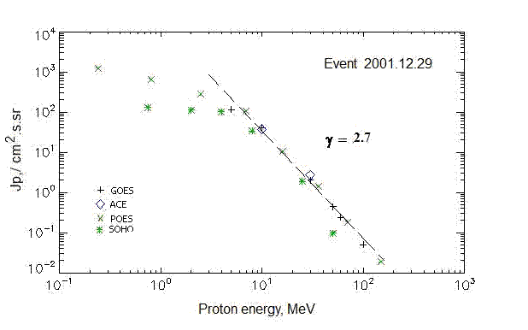

Integral fluxes of protons for the event of 2001 December 29

S/c, instruments | Eр, MeV | To | Tmax | Jmax,  /cm².s.sr | Dura-tion | Comments
GOES-10
EPS | >5 | 05^{h} | 08^{h} | 115 | 1.5d
EPS | >10 | 05^{h} | 08^{h} | 40 | 1.5d
EPS | >30 | 05^{h} | 08^{h} | 2 | 1.5d
EPS | >50 | 05^{h} | 08^{h} | 0.44 | 1d
EPS | >60 | 05^{h} | 08^{h} | 0.24 | 1d
EPS | >100 | 05^{h} | 08^{h} | 0.05 | 1d
POES-16
MEPED | >0.24 | 04^{h} | 09^{h} | 1200 | 1.5d
MEPED | >0.8 | 04^{h} | 09^{h} | 640 | 1.5d
MEPED | >2.5 | 04^{h} | 09^{h} | 274 | 1.5d
MEPED | >6.9 | 04^{h} | 09^{h} | 106 | 1.5d
MEPED | >16 | 04^{h} | 09^{h} | 10.7 | 1.5d
MEPED | >36 | 04^{h} | 09^{h} | 1.4 | 1d
MEPED | >70 | 04^{h} | 09^{h} | 0.18 | 1d
MEPED | >140 | 04^{h} | 09^{h} | 0.018 | 1d
ACE
SIS | >10 | 03^{h} | 08^{h} | 37.7 | 1.5d
SIS | >30 | 04^{h} | 08^{h} | 2.7 | 1d
SOHO
EPHIN (INT) | >50 | 01^{h} | 07^{h} | 0.08 | 1d

Differential fluxes of protons for the event of 2001 December 29
S/c, instruments | ∆Е, MeV | To | Tmax | Jmax. /cm².s.sr.MeV | Dura-tion | Comments
SOHO
LION | 0.75-2 | 02^{h} | 08^{h} | 10.6 | 1.5d
LION | 2-6 | 02^{h} | 08^{h} | 2.7 | 1.5d
EPHIN | 4-8 | 02^{h} | 08^{h} | 16.8 | 1d
EPHIN | 8-25 | 01^{h} | 07^{h} | 1.9 | 1d
EPHIN | 25-41 | 01^{h} | 07^{h} | 0.07 | 1d
EPHIN | 41-53 | - “ - | - “ - | - “ - | - “ -

References:
No information on publications, excepting for:
http://www.swpc.noaa.gov/ftpdir/indices/SPE.txt

