Event 2002.01.15 – (2002-015)

Particle event: To(Ep>10 MeV) – 15d07^{h}
Tmax(Ep>10 MeV) – 15d18^{h}, Jmax(Ep>10 MeV) – 7.5 /cm².s.sr
Duration of the event – 4 days
Energy of the SCR and 0.1 GCR fluxes balance – Eb = 80 MeV

Sources: □ solar flare 14d05^{h}29^{m}, M4.4/…, S23W90, АR9767, 1.5d behind W-limb
Ø solar flare 14d01^{h}48^{m}, 2N/M1.7, N05E44, АR9782
Main X-ray burst 1-8 Ǻ: onset – 14d05^{h}29^{m}, max – 14d06^{h}27^{m}, Ф = 0.34 J/m²
CME: 14d05^{h}35^{m}; V = 1492 km/s; ∆φ = 360º; dA = 246º

Particle fluxes and associated phenomena
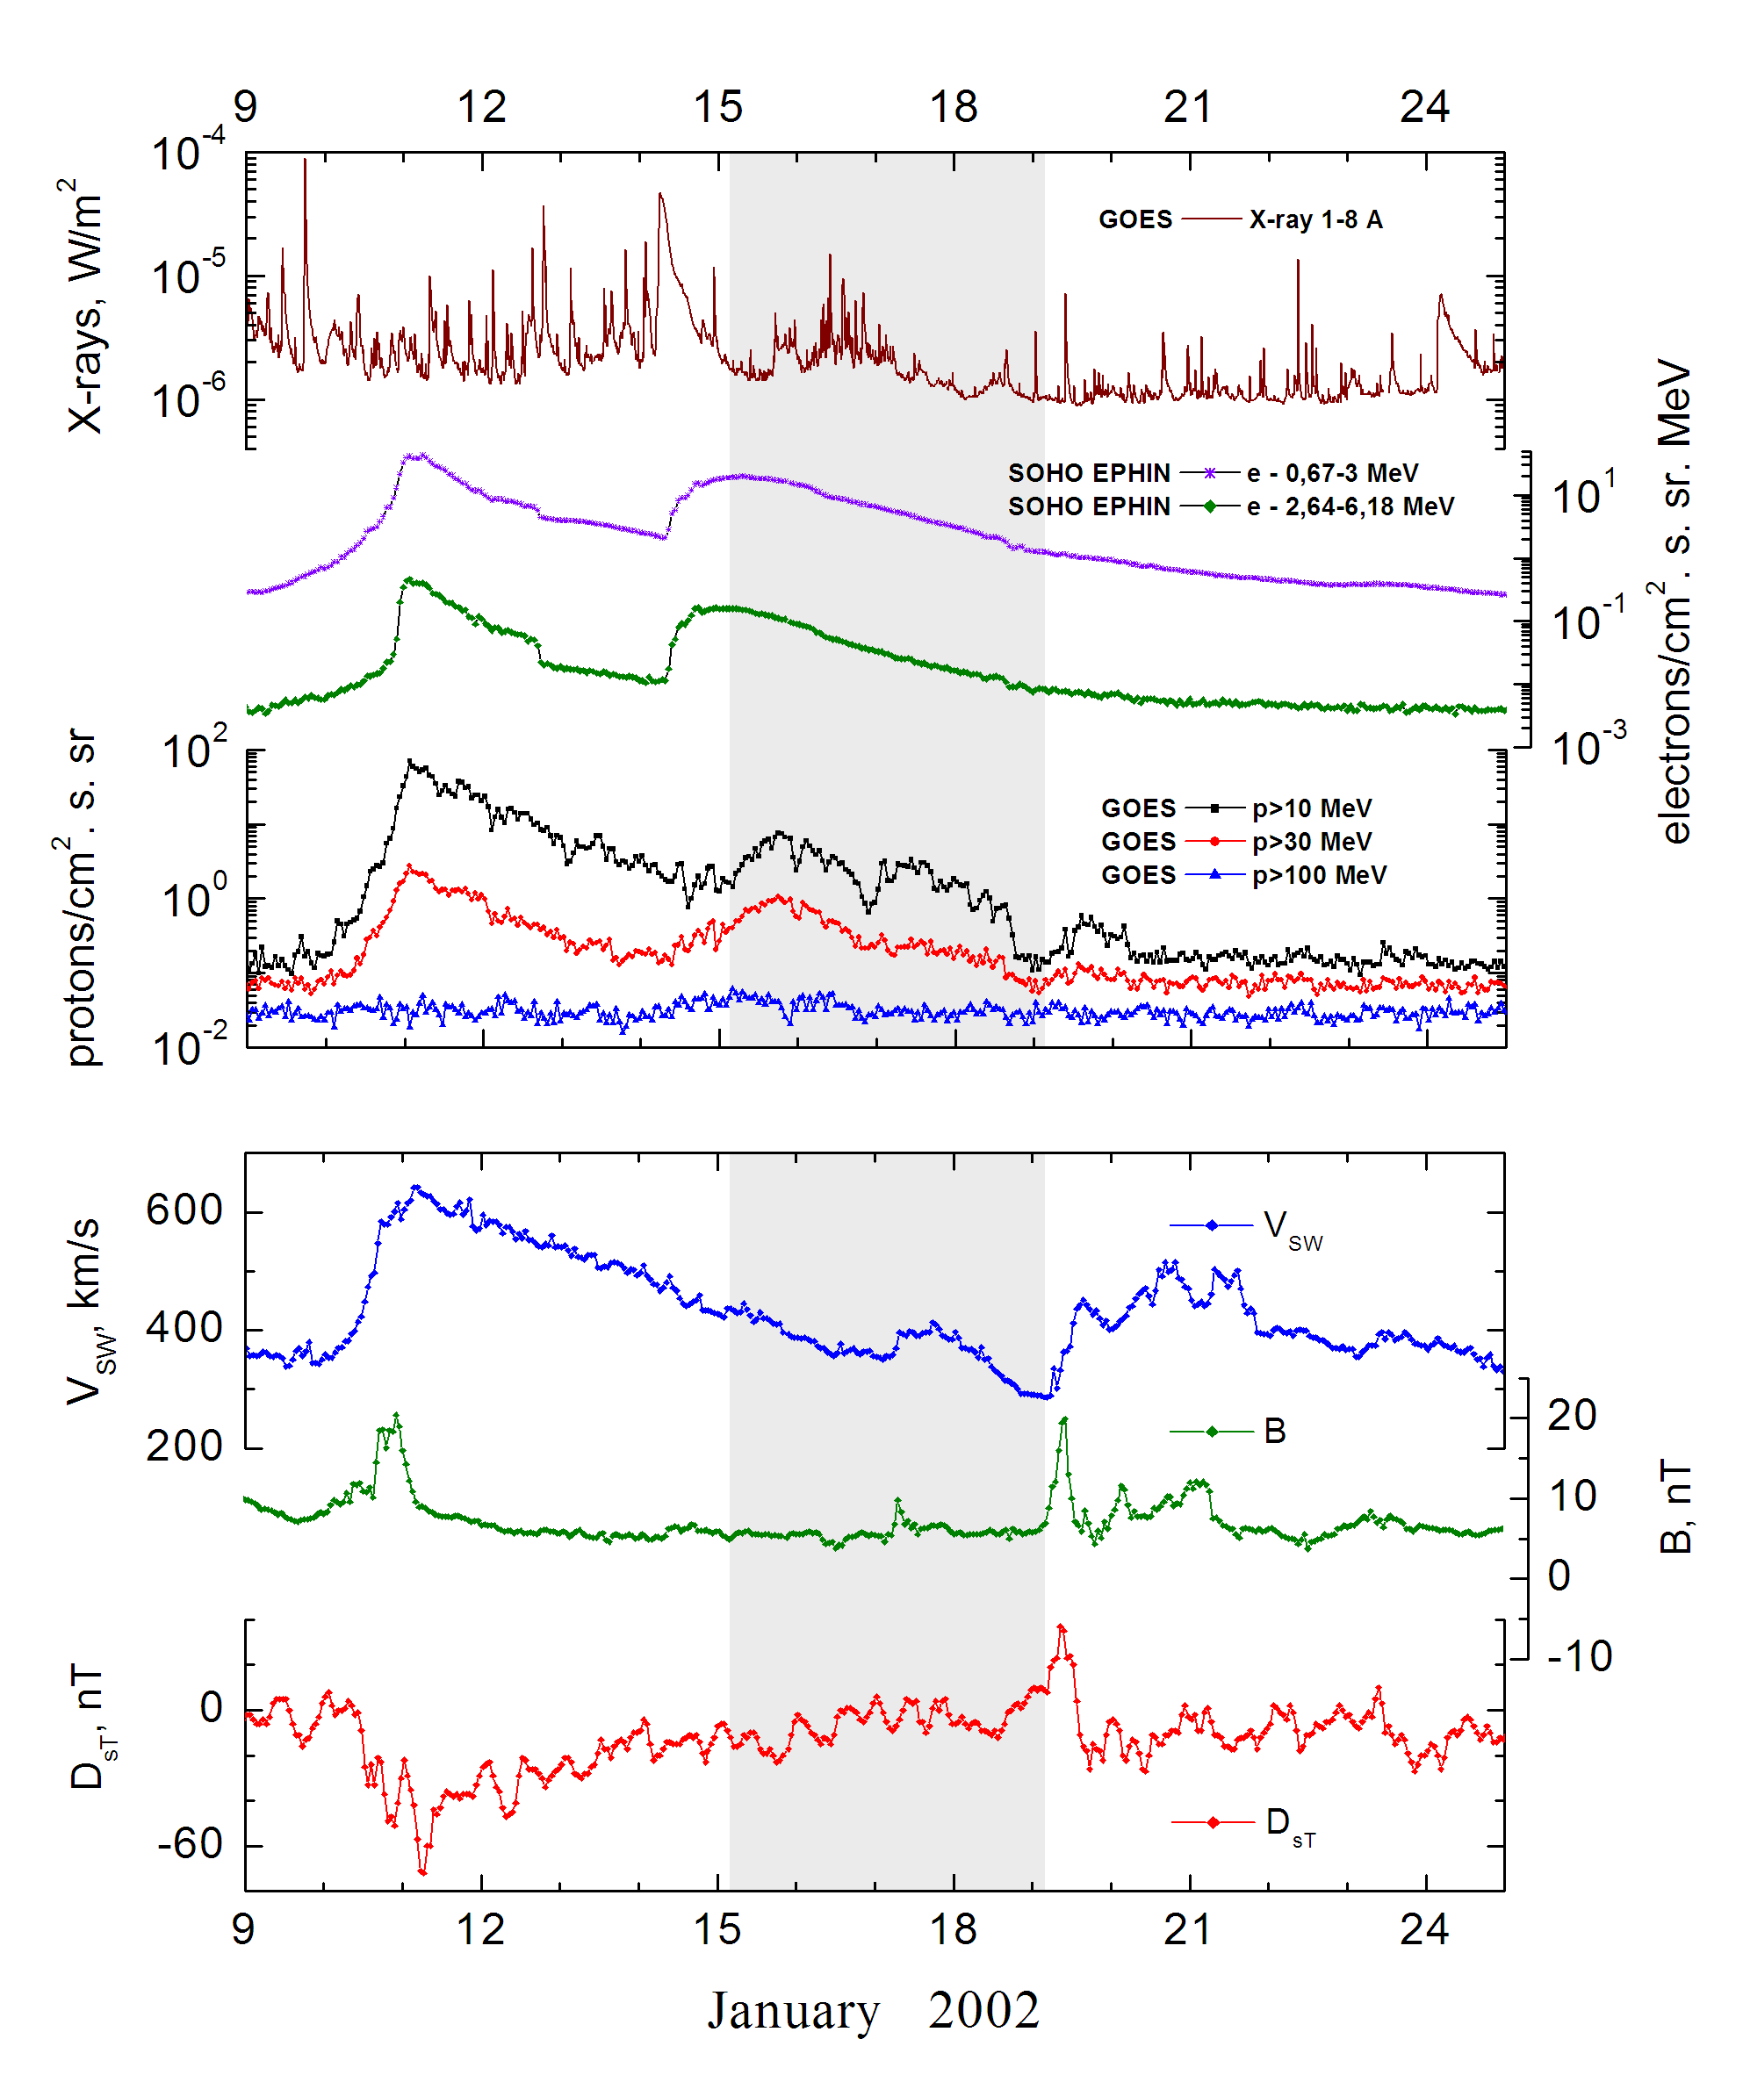
Integral time-of-maximum proton spectrum
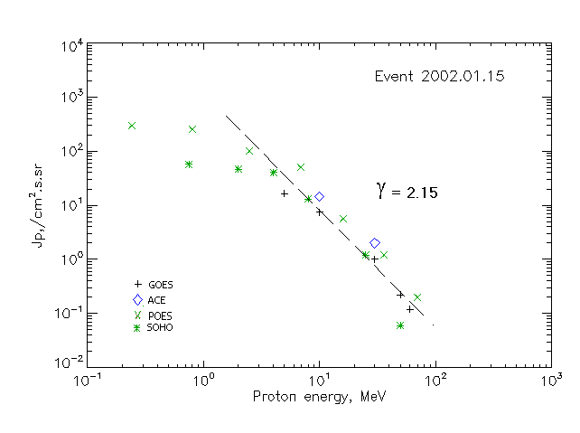

Integral fluxes of protons for the event of 2002.01.15

S/c, instruments | Eр, MeV | To | Tmax | Jmax,  (cm².s.sr)⁻¹ | Dura-tion | Comments
GOES-10
EPS | >5 | 07^{h} | 19^{h} | 16.2 | 4d
EPS | >10 | 07^{h} | 18^{h} | 7.5 | 4d
EPS | >30 | 07^{h} | 18^{h} | 1.0 | 3d
EPS | >50 | 07^{h} | 15^{h} | 0.22 | 2d
EPS | >60 | - | 15^{h} | 0.12 | 2d
EPS | >100 | - | - | - | -
POES-16
MEPED | >0.24 | - | 22^{h} | 310 | 4d
MEPED | >0.8 | - | 22^{h} | 250 | 4d
MEPED | >2.5 | - | 22^{h} | 105 | 4d
MEPED | >6.9 | - | 22^{h} | 52 | 3d
MEPED | >16 | - | 22^{h} | 5.7 | 2d
MEPED | >36 | - | 21^{h} | 1.2 | 2d
MEPED | >70 | - | 20^{h} | 0.2 | 4d
MEPED | >140 | - | - | - | -
ACE
SIS | >10 | 14d23^{h} | 22^{h} | 14.5 | 5d
SIS | >30 | 14d11^{h} | 18 ^{h} | 2 | 5d
SOHO
EPHIN (INT) | >50 | 14d08^{h} | 16^{h} | 0.06 | 2d
Differential fluxes of protons for the event of 2002.01.15

S/c,  instruments | ∆Е, MeV | To | Tmax | Jmax, (cm².s.sr.MeV)⁻¹ | Dura-tion | Comments
SOHO
LION | 0.75-2 | 14^{h} | 21^{h} | 9.1 | 5d
LION | 2-6 | 11^{h} | 21^{h} | 1.8 | 5d
EPHIN | 4-8 | 13^{h} | 20^{h} | 6.8 | 5d
EPHIN | 8-25 | 13^{h} | 20^{h} | 0.7 | 5d
EPHIN | 25-41 | 14d09^{h} | 20^{h} | 0.04 | 5d
EPHIN | 41-53 | - “ - | - “ - | - “ - | - “ -

References:
No information on publications, excepting for:
http://www.swpc.noaa.gov/ftpdir/indices/SPE.txt

