Event 2002.02.20 – (2002-051)

Particle event: To(Ep>10 MeV) – 20d07^{h}
Tmax(Ep>10 MeV) – 20d08^{h}, Jmax (Ep>10 MeV) – 3.3 /cm².s.sr
Duration of the event – 2 days
Energy of the SCR and 0.1 GCR fluxes balance – Eb = 145 MeV

Sources: ● solar flare 20d05^{h}52^{m}, M5.1/1N, N12W72, АR9825
Main X-ray burst 1-8 Ǻ: onset – 20d05^{h}52^{m}, max – 20d06^{h}12^{m}, Ф = 0.022 J/m²
CME: 20d06^{h}30^{m}, V=952 km/s, ∆φ = 360º, dA = 263 º

Particle fluxes and associated phenomena
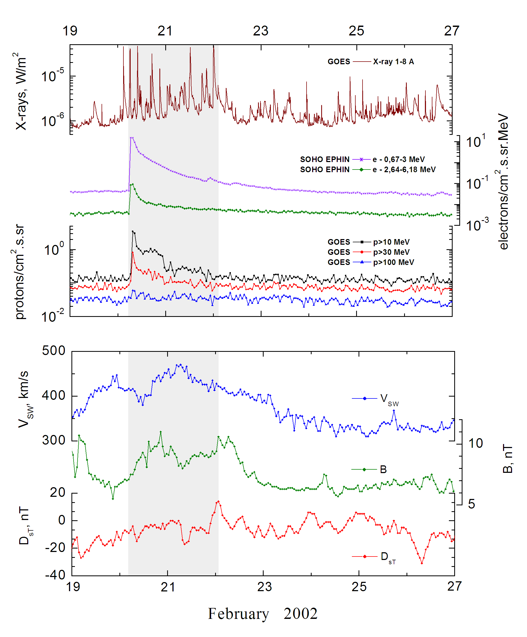
Integral time-of-maximum proton spectrum
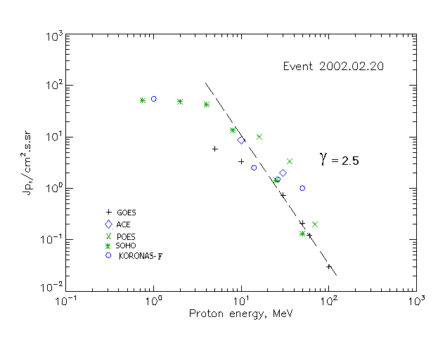

Integral fluxes of protons for the event of 2002.02.20

S/c, instruments | Eр, MeV | To | Tmax | Jmax,  (cm².s.sr)⁻¹ | Dura-tion | Comments
GOES-10
EPS | >5 | 07^{h} | 08^{h} | 5.8 | 2d
EPS | >10 | 07^{h} | 08^{h} | 3.3 | 2d
EPS | >30 | 04^{h} | 07^{h} | 0.74 | 1d
EPS | >50 | 02^{h} | 07^{h} | 0.21 | 1d
EPS | >60 | 02^{h} | 07^{h} | 0.12 | 1d
EPS | >100 | 02^{h} | 07^{h} | 0.03 | 1d
POES-16
MEPED | >0.24 | - | - | - | -
MEPED | >0.8 | - | - | - | -
MEPED | >2.5 | - | - | - | -
MEPED | >6.9 | - | - | - | -
MEPED | >16 | - | 07^{h} | 10 | 1d
MEPED | >36 | - | 07^{h} | 3,3 | 1d
MEPED | >70 | - | 07^{h} | 0.2 | 1d
MEPED | >140 | - | ⁻ | - | -
CORONAS F
MKL | >1. | - | 07^{h} | 55 | 1d
MKL | >14 | - | 07^{h} | 2.5 | 1d
MKL | >26 | - | 07^{h} | 1.5 | 1d
MKL | >50 | - | 07^{h} | 1 | 1d
ACE
SIS | >10 | 06^{h} | 07^{h} | 8.6 | 3d
SIS | >30 | 06^{h} | 07^{h} | 2.0 | 2d
SOHO
EPHIN (INT) | >50 | 02^{h} | 06^{h} | 0.13 | 0.5d

Differential fluxes of protons for the event of 2002.02.20

S/c, instruments | ∆Е, MeV | To | Tmax | Jmax, (cm².s.sr.MeV)⁻¹ | Dura-tion | Comments
SOHO
LION | 0.75-2 | 08^{h} | 11^{h} | 2.1 | 9d
LION | 2-6 | 08^{h} | 10^{h} | 1 | 9d
EPHIN | 4-8 | 07^{h} | 08^{h} | 7.1 | 9d
EPHIN | 8-25 | 06^{h} | 07^{h} | 0.7 | 9d
EPHIN | 25-41 | 06^{h} | 07^{h} | 0.046 | 5d
EPHIN | 41-53 | - “ - | - “ - | - “ - | - “ -

References:
No information on publications, excepting for:
http://www.swpc.noaa.gov/ftpdir/indices/SPE.txt

