Event 2002.03.16 – (2002-075)

Particle event: To(Ep>10 MeV) – 16d02^{h}
Tmax₁(Ep>10 MeV) – 16d13^{h}, Jmax₁(Ep>10 MeV) –1.3 /cm².s.sr
Tmax₂(Ep>10 MeV) – 17d11^{h}, Jmax₂(Ep>10 MeV) – 1.1 /cm².s.sr
Duration of the event – 2 days
Energy of the SCR and 0.1 GCR fluxes balance – Eb(max₁) = 70 MeV
– Eb(max₂) = 65 MeV
Sources: ● solar flare 15d22^{h}09^{m}, M2.2/1F, S08W03, AR9866
Ø solar flare 17d10^{h}11^{m}, M1.3/…, S22E14, AR9871
Main X-ray burst 1-8 Ǻ: onset – 15d22^{h}09^{m}, max – 15d23^{h}10^{m}, Ф = 0.13 J/m²
CME: 15d23^{h}06^{m}, V=957 km/s, ∆φ = 360º; dA = 309º

Particle fluxes and associated phenomena
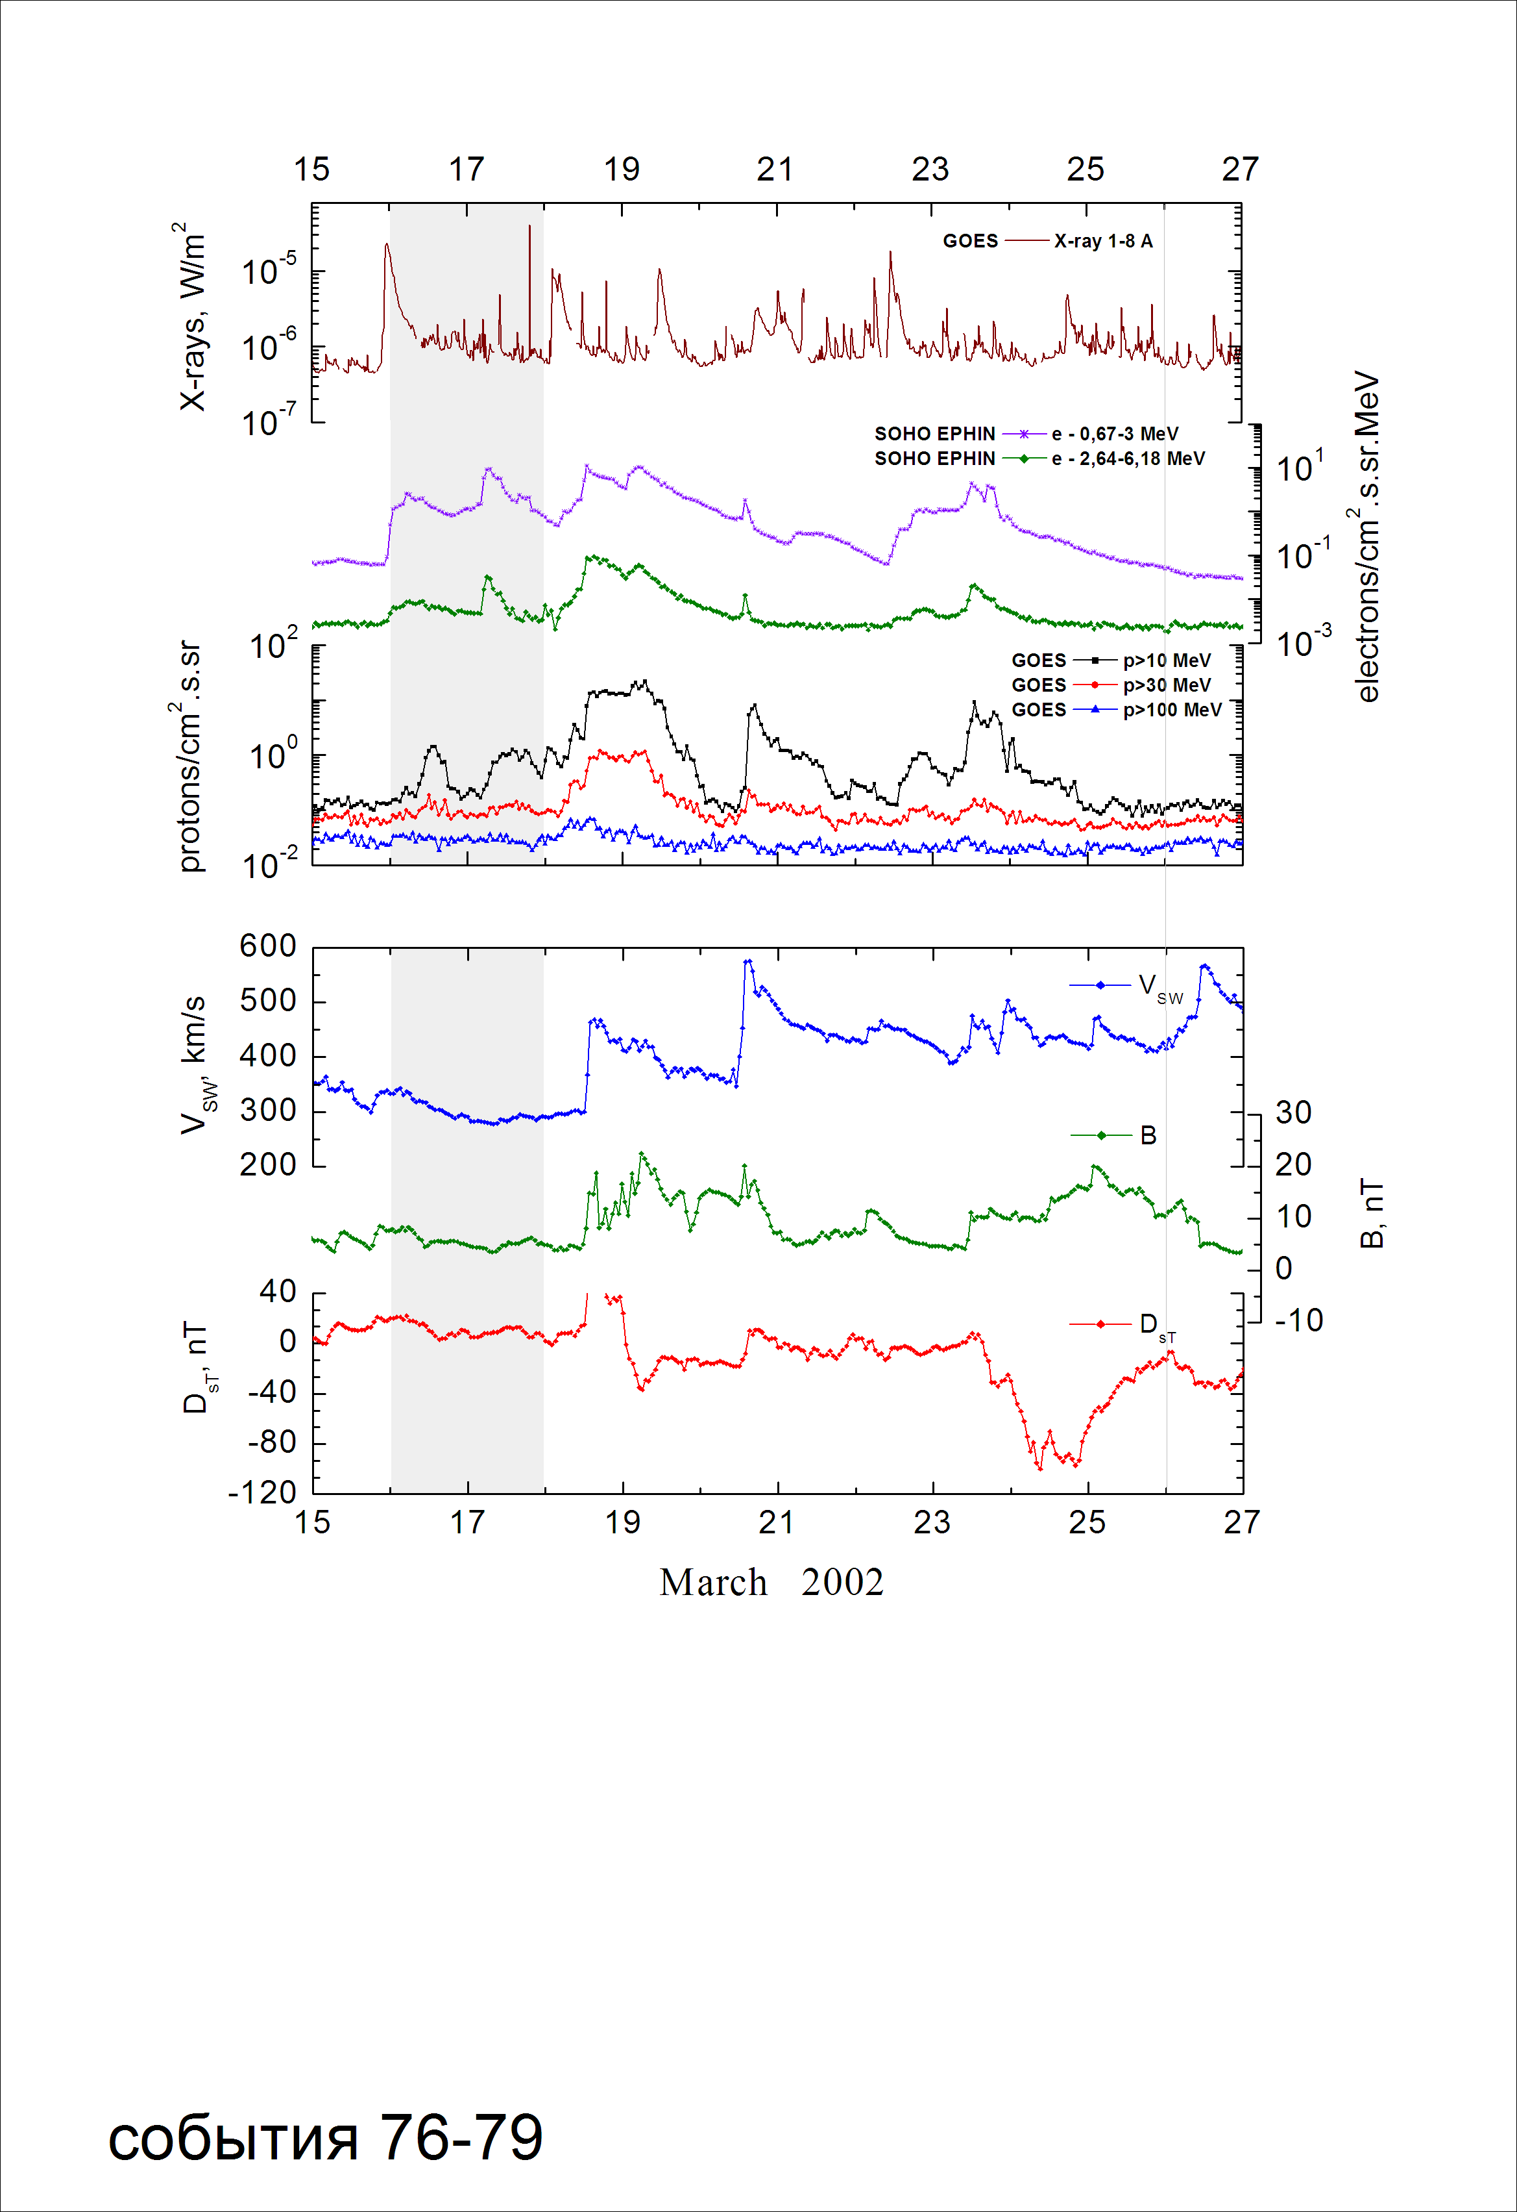
Integral time-of-maximum proton spectrum
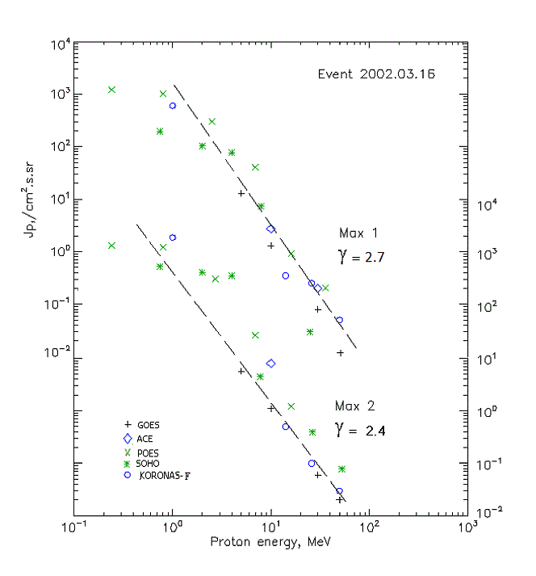

Integral fluxes of protons for the event of 2002.03.16

S/c, instruments | Eр, MeV | To | Tmax | Jmax,  (cm².s.sr)⁻¹ | Dura-tion | Comments
GOES-10
EPS | >5 | 01^{h} | 14^{h}/17d12^{h} | 12.7/5.6 | 2d
EPS | >10 | 02^{h} | 13^{h}/17d11^{h} | 1.3/1.1 | 2d
EPS | >30 | 03^{h} | 12^{h}/17d11^{h} | 0.08/0.06 | 2d
EPS | >50 | - | 12^{h}/17d11^{h} | 0.01/ 0.02 | 2d
EPS | >60 | - | - | - | -
EPS | >100 | - | - | - | -
POES-16
MEPED | >0.24 | - | 14^{h}/17d10^{h} | 1220/1430 | 2d
MEPED | >0.8 | - | 14^{h}/17d10^{h} | 1010/1360 | 2d
MEPED | >2.5 | - | 14^{h}/17d10^{h} | 320/630 | 2d
MEPED | >6.9 | - | 14^{h}/17d10^{h} | 42/54 | 2d
MEPED | >16 | - | 14^{h}/17d09^{h} | 0.9/1.2 | 2d
MEPED | >36 | - | 14^{h}/⁻ | 0.2/- | 2d
MEPED | >70 | - | ⁻ | - | -
MEPED | >140 | - | ⁻ | - | -
CORONAS F
MKL | >1. | - | 14^{h}/17d12^{h} | 600/1980 | 2d
MKL | >14 | - | 13^{h}/17d11^{h} | 0.35/0.5 | 2d
MKL | >26 | - | 12^{h}/17d11^{h} | 0.25/0.1 | 2d
MKL | >50 | - | 12^{h}/17d11^{h} | 0.05/0.03 | 2d
ACE
SIS | >10 | 01^{h} | 11^{h}/17d09^{h} | 2.7/8 | 2d
SIS | >30 | 01^{h} | 11^{h}/ - | 0.2/ - | 2d
SOHO
EPHIN (INT) | >50 | - | - /17d08^{h} | - /0.08 | 2d

Differential fluxes of protons for the event of 2002.03.16

S/c,  instruments | ∆Е, MeV | To | Tmax | Jmax, (cm².s.sr.MeV)⁻¹ | Dura-tion | Comments
SOHO
LION | 0.75-2 | 04^{h} | 11^{h}/17d09^{h} | 50.5/102 | 2d
LION | 2-6 | 04^{h} | 11^{h}/17d09^{h} | 6.7/18.3 | 2d
EPHIN | 4-8 | 03^{h} | 11^{h}/17d08^{h} | 17.4/81.5 | 2d
EPHIN | 8-25 | 01^{h} | 10^{h}/17d08^{h} | 0.43/2.6 | 2d
EPHIN | 25-41 | 00^{h} | 10^{h}/17d08^{h} | 0.002/0.012 | 2d
EPHIN | 41-53 | - “ - | - “ - | - “ - | - “ -

References:
No information on publications, excepting for:
http://www.swpc.noaa.gov/ftpdir/indices/SPE.txt

