Event 2002.07.07 – (2002-188)

Particle event: To(Ep>10 MeV) – 07d13^{h}
Tmax(Ep>10 MeV) – 07d20^{h}, Jmax (Ep>10 MeV) –26/cm².s.sr *)
Duration of the event – 3 days
Energy of the SCR and 0.1 GCR fluxes balance – Eb = 85 MeV
*) Data from s/c ACE (SIS)

Sources: ■ solar flare 07d11^{h}15^{m}, M1/…, S19W90, АR810017
Main X-ray burst 1-8 Ǻ: onset – 07d11^{h}15^{m}, max – 07d11^{h}43^{m}, Ф = 0.062 J/m²
CME: 07d11^{h}30^{m}; V = 1423 km/s; ∆φ = 228º; dA = 260 º

Particle fluxes and associated phenomena
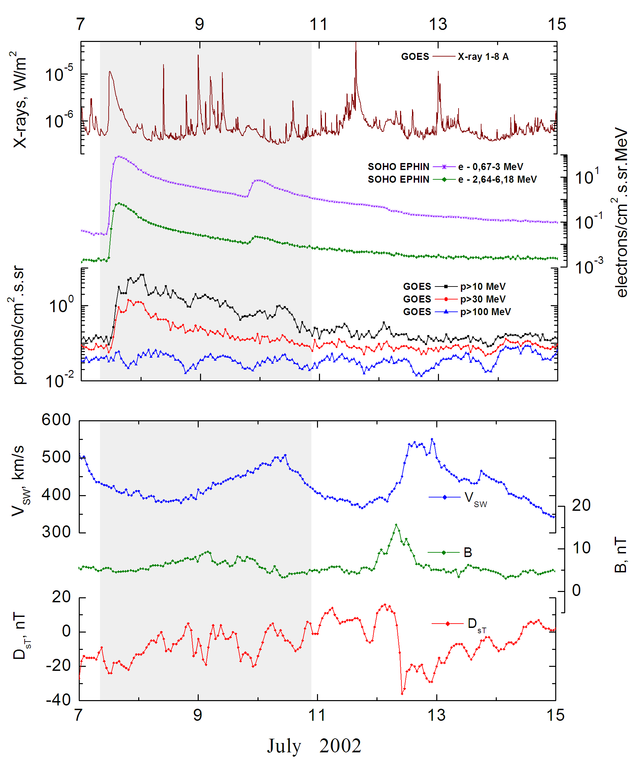

Integral time-of-maximum proton spectrum
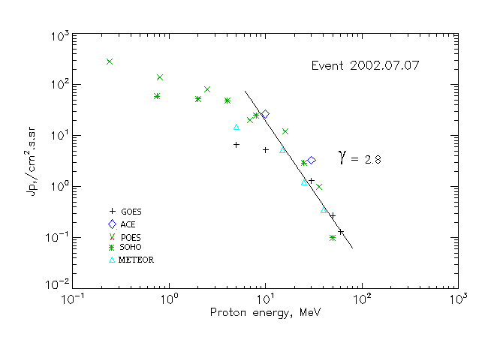

Integral fluxes of protons for the event of 2002.07.07

S/c,  instruments | Eр, MeV | To | Tmax | Jmax,  (cm².s.sr)⁻¹ | Dura-tion | Comments
GOES-10
EPS | >5 | 13^{h} | 20^{h} | 6.6 | 3d
EPS | >10 | 13^{h} | 20^{h} | 5.2 | 3d
EPS | >30 | 13^{h} | 19^{h} | 1.3 | 3d
EPS | >50 | 13^{h} | 21^{h} | 0.27 | 3d
EPS | >60 | 13^{h} | 23^{h} | 0.13 | 3d
EPS | >100 | - | - | - | -
METEOR
CBM | >5 | 12^{h} | 19^{h} | 14.7 | 3d
CBM | >15 | 12^{h} | 19^{h} | 5.2 | 3d
CBM | >25 | 12^{h} | 21^{h} | 1.2 | 2d
CBM | >40 | 12^{h} | 22^{h} | 0.34 | 1d
BP | >90 | - | - | - | -
ChD | >600 | - | - | - | -
POES-16
MEPED | >0.24 | - | 22^{h} | 280 | 3d
MEPED | >0.8 | - | 22^{h} | 140 | 3d
MEPED | >2.5 | - | 22^{h} | 80 | 3d
MEPED | >6.9 | - | 22^{h} | 20 | 3d
MEPED | >16 | - | 22^{h} | 12 | 3d
MEPED | >36 | - | 22^{h} | 1 | 3d
MEPED | >70 | - | ⁻ | - | -
MEPED | >140 | - | ⁻ | - | -
ACE
SIS | >10 | 12^{h} | 20^{h} | 26.6 | 3d
SIS | >30 | 12^{h} | 20^{h} | 3.3 | 3d
SOHO
EPHIN (INT) | >50 | 12^{h} | 19^{h} | 0.1 | 1d

Differential fluxes of protons for the event of 2002.07.07

S/c,  instruments | ∆Е, MeV | To | Tmax | Jmax, (cm².s.sr.MeV)⁻¹ | Dura-tion | Comments
SOHO
LION | 0.75-2 | 12^{h} | 22^{h} | 5.3 | 3d
LION | 2-6 | 12^{h} | 22^{h} | 1.2 | 3d
EPHIN | 4-8 | 12^{h} | 21^{h} | 5.9 | 3d
EPHIN | 8-25 | 12^{h} | 21^{h} | 1.3 | 3d
EPHIN | 25-41 | 12^{h} | 20^{h} | 0.1 | 3d
EPHIN | 41-53 | - “ - | - “ - | - “ - | - “ -

References:
No information on publications, excepting for:
http://www.swpc.noaa.gov/ftpdir/indices/SPE.txt

