Event 2002.07.22 – (2002-203)

Particle event: To(Ep>10 MeV) – 22d01^{h}
Tmax(Ep>10 MeV) – 22d11^{h}, Jmax(Ep>10 MeV) – 18.5 /cm².s.sr
Duration of the event – 10 days
Energy of the SCR and 0.1 GCR fluxes balance – Eb = 85 MeV

Sources: ๏ solar flare 20d21^{h}04^{m}, X3.3/…, S13E90, АR10039
Ø solar flare 23d00^{h}18^{m}, X4.8/2B, S12E70, АR10039
Main X-ray burst 1-8 Ǻ: onset – 20d21^{h}04^{m}, max – 20d21^{h}30^{m}, Ф = 0.72 J/m²
CME: 20d22^{h}06^{m}, V = 1941 km/s, ∆φ = 360º, = 91º

Particle fluxes and associated phenomena
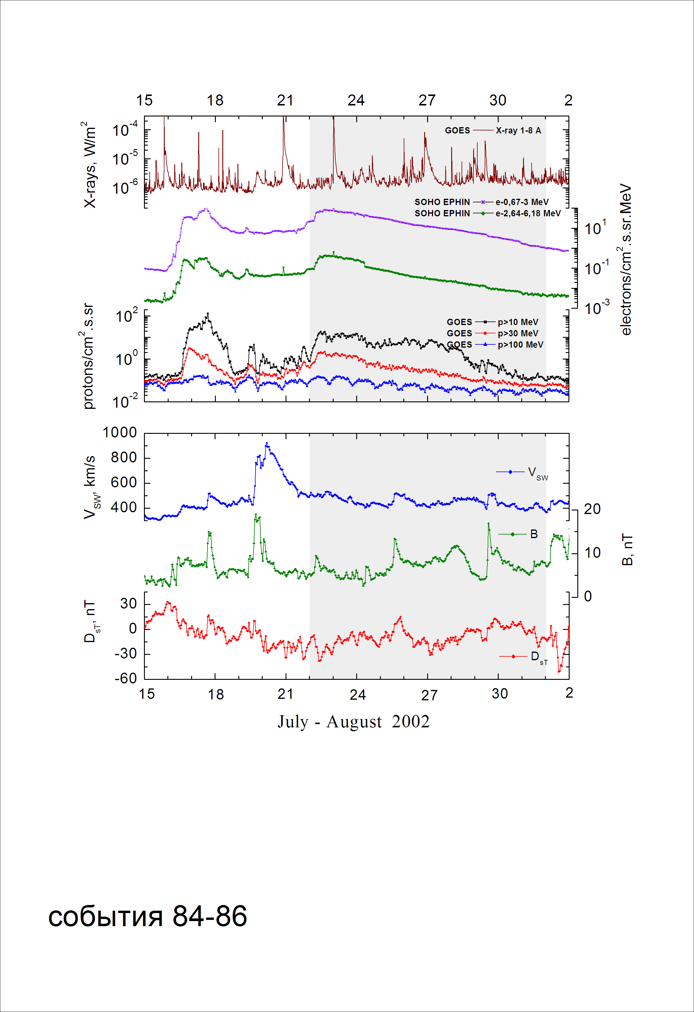
Integral time-of-maximum proton spectrum
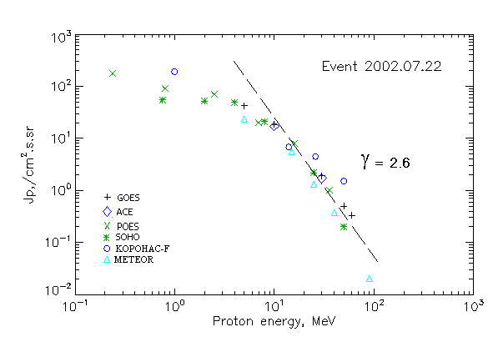

Integral fluxes of protons for the event of 2002.07.22

S/c,  instruments | Eр, MeV | To | Tmax | Jmax,  (cm2.s.sr)-1 | Dura-tion | Comments
GOES-10
EPS | >5 | 01^{h} | 11^{h} | 42.4 | 10d
EPS | >10 | 01^{h} | 11^{h} | 18.5 | 10d
EPS | >30 | 01^{h} | 12^{h} | 1.9 | 9d
EPS | >50 | 01^{h} | 12^{h} | 0.5 | 3d
EPS | >60 | 01^{h} | 12^{h} | 0.33 | 3d
EPS | >100 | - | - | - | -
METEOR
CBM | >5 | - | 14^{h} | 23.3 | 11d
CBM | >15 | - | 12^{h} | 5.6 | 9d
CBM | >25 | - | 12^{h} | 1.3 | 7d
CBM | >40 | - | 12^{h} | 0.37 | 3d
BP | >90 | - | 12^{h} | 0.02 | -
ChD | >600 | - | - | - | -
POES-16
MEPED | >0.24 | - | 10^{h} | 150 | 10d
MEPED | >0.8 | - | 10^{h} | 93 | 9d
MEPED | >2.5 | - | 10^{h} | 72 | 8d
MEPED | >6.9 | - | 10^{h} | 20 | 7d
MEPED | >16 | - | 10^{h} | 8 | 3d
MEPED | >36 | - | 10^{h} | 1 | 3d
MEPED | >70 | - | ⁻ | - | -
MEPED | >140 | - | - | - | -
CORONAS F
MKL | >1. | - | 21^{h} | 190 | 8d
MKL | >14 | - | 21^{h} | 6.8 | 7d
MKL | >26 | - | 21^{h} | 4.5 | 3d
MKL | >50 | - | 21^{h} | 1.5 | 3d
ACE
SIS | >10 | 04^{h} | 10^{h} | 17 | 4d
SIS | >30 | 04^{h} | 09^{h} | 1.7 | 4d
SOHO
EPHIN (INT) | >50 | 05^{h} | 11^{h} | 0.2 | 2d

Differential fluxes of protons for the event of 2002.07.22

S/c,  instruments | ∆Е, MeV | To | Tmax | Jmax, (cm².s.sr.MeV)⁻¹ | Dura-tion | Comments
SOHO
LION | 0.75-2 | 06^{h} | 11^{h} | 2.6 | 11d
LION | 2-6 | 06^{h} | 11^{h} | 1 | 11d
EPHIN | 4-8 | 05^{h} | 10^{h} | 7 | 10d
EPHIN | 8-25 | 05^{h} | 11^{h} | 1.1 | 10d
EPHIN | 25-41 | 05^{h} | 10^{h} | 0.07 | 10d
EPHIN | 41-53 | - “ - | - “ - | - “ - | - “ -

References:
Yurchyshyn V., Wang H., Abramenko V., et.al., 2004.
Gan W.Q, 2004.
Кичигин Г.Н., Мирошниченко Л.И., Сидоров В.И., и др., 2010.
Струминский А.Б., 2011с.
Miroshnichenko L.I. and Gan W.Q., 2012.
Кичигин Г.Н., Мирошниченко Л.И., Сидоров В.И., и др., 2012.
Somov B.V., 2012.

