Event 2002.08.14 – (2002-226)

Particle event: To(Ep>10 MeV) – 14d06^{h}
Tmax₁(Ep>10 MeV) – 14d09^{h}, Jmax₁(Ep>10 MeV) – 6.7 /cm².s.sr
Tmax₂(Ep>10 MeV) – 14d16^{h}, Jmax₂(Ep>10 MeV) – 6.9 /cm².s.sr
Duration of the event – 2 days
Energy of the SCR and 0.1 GCR fluxes balance – Eb(max₁) = 85 MeV
– Eb(max₂) = 50 MeV
Sources: ● solar flare 14d01^{h}47^{m}, M2.3/1N, N10W54, АR10061
Main X-ray burst 1-8 Ǻ: onset – 14d01^{h}47^{m}, max – 14d02^{h}12^{m}, Ф = 0.06 J/m²
CME: 14d02^{h}30^{m}, V = 1309 km/s, ∆φ = 133º, dA = 282 º;

Particle fluxes and associated phenomena
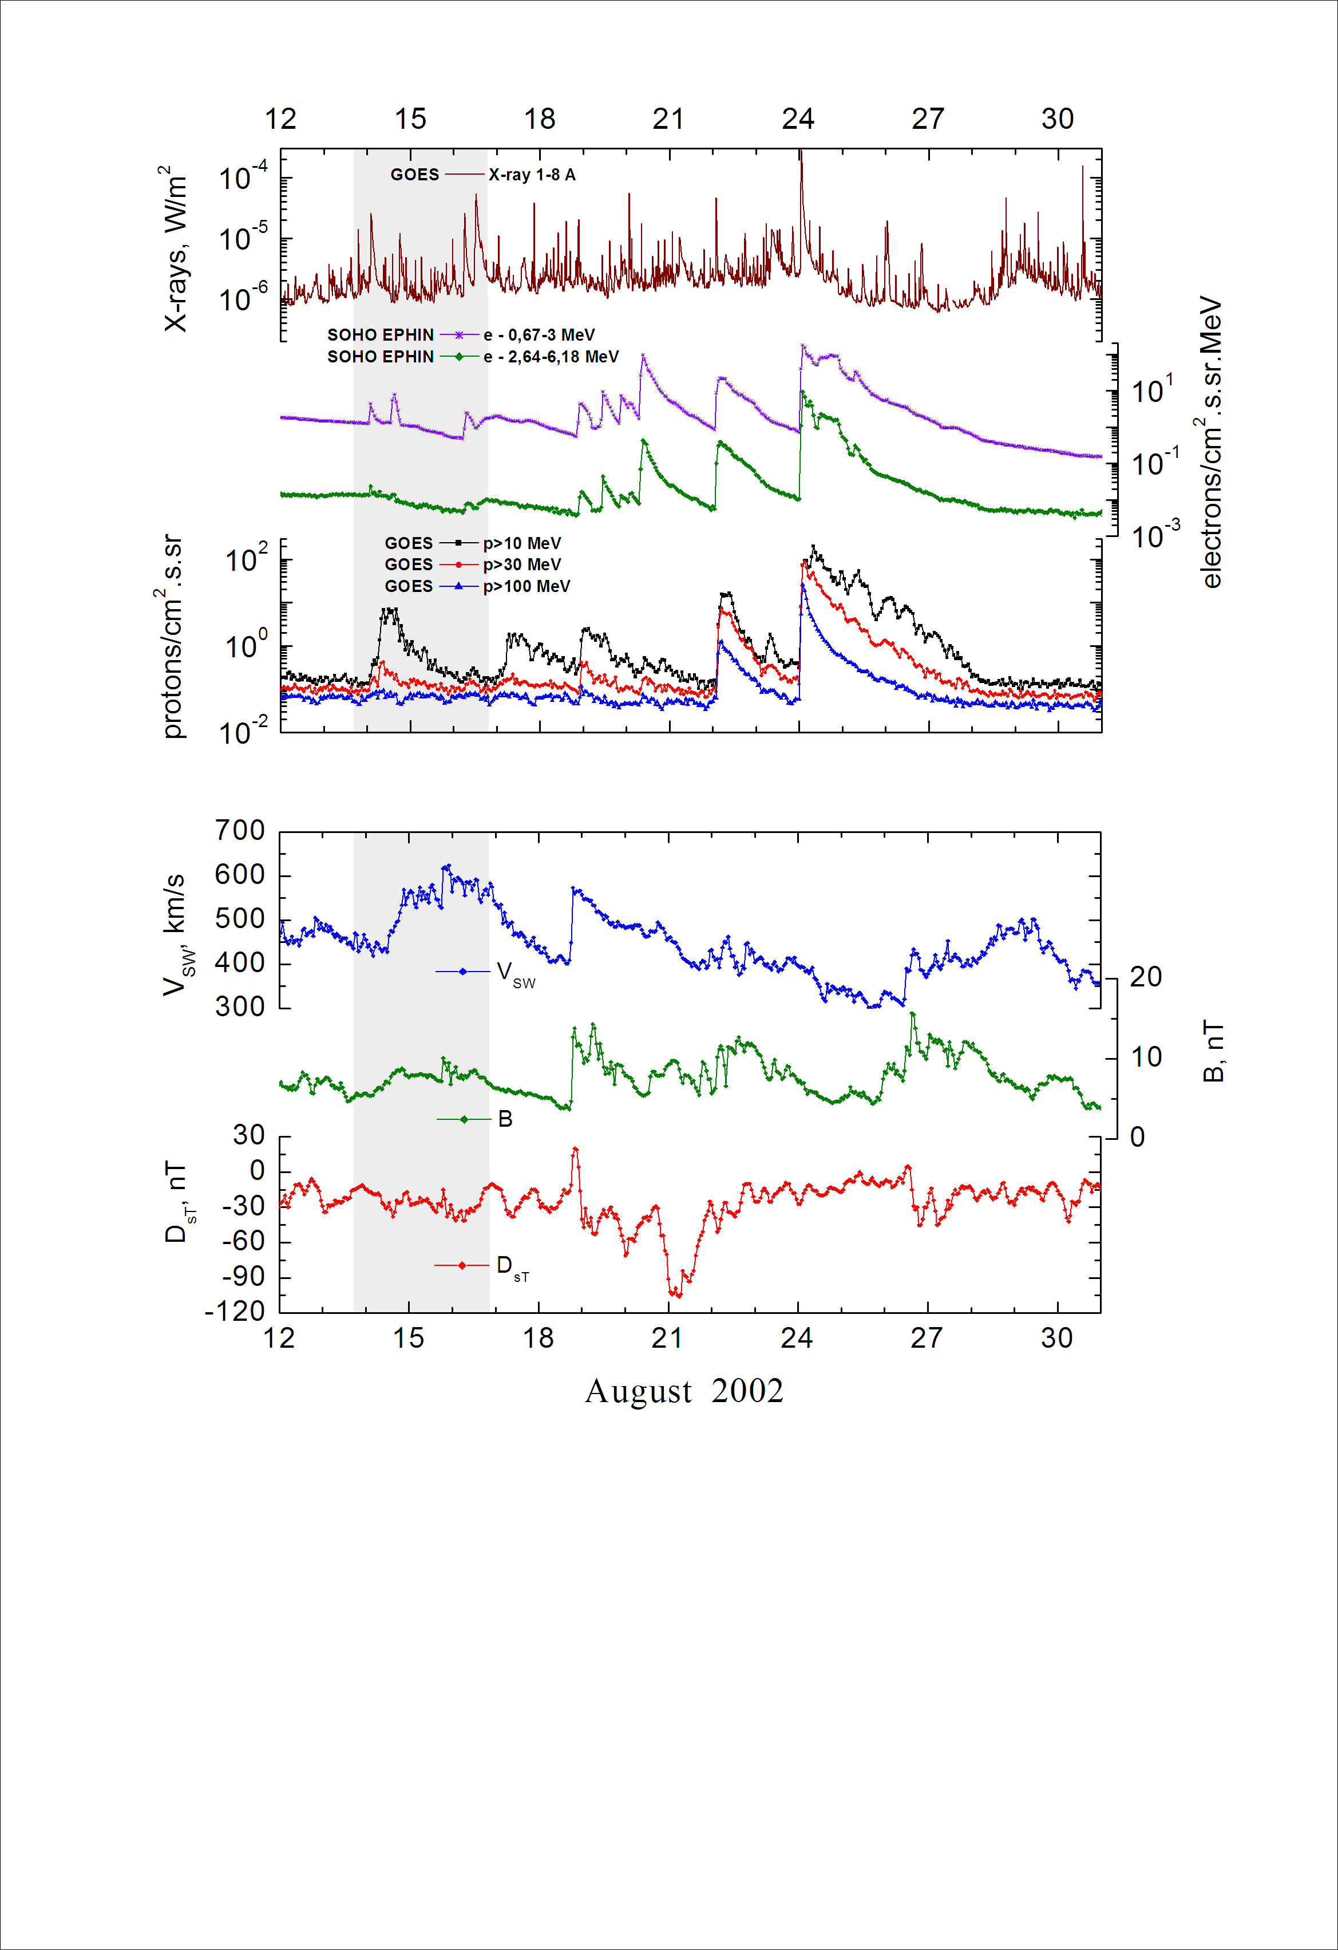
Integral time-of-maximum proton spectrum
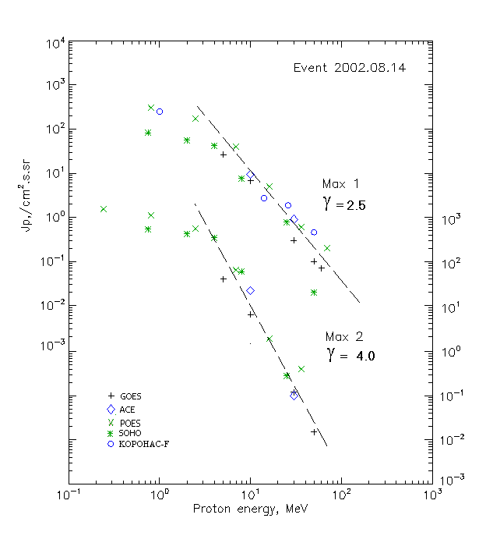

Integral fluxes of protons for the event of 2002.08.14

S/c,  instruments | Eр, MeV | To | Tmax | Jmax,  (cm2.s.sr)-1 | Dura-tion | Comments
GOES 10
EPS | >5 | 02^{h} | 09^{h}/16^{h} | 26.5/44 | 2d
EPS | >10 | 02^{h} | 09^{h}/16^{h} | 6.7/6.9 | 2d
EPS | >30 | 02^{h} | 09^{h}/16^{h} | 0.3/0.12 | 1d
EPS | >50 | 02^{h} | 09^{h}/16^{h} | 0.1/0.015 | 1d
EPS | >60 | - | 09^{h}/ - | 0.07/ - | 1d
EPS | >100 | - | - | - | -
POES 16
MEPED | >0.24 | - | 10^{h}/16^{h} | - /1720 | 2d
MEPED | >0.8 | - | 10^{h}/16^{h} | 310 /1220 | 2d
MEPED | >2.5 | - | 10^{h}/16^{h} | 170/630 | 2d
MEPED | >6.9 | - | 10^{h}/16^{h} | 40/70 | 2d
MEPED | >16 | - | 11^{h}/16^{h} | 5/2 | 1d
MEPED | >36 | - | 10^{h}/16^{h} | 0.6 /0.4 | 1d
MEPED | >70 | - | 10^{h}/16^{h} | 0.2/ - | 1d
MEPED | >140 | - | - | - | -
CORONAS F
MKL | >1. | - | 08^{h}/ - | 250/ - | 2d
MKL | >14 | - | 08^{h}/ - | 2.7/ - | 1d
MKL | >26 | - | 08^{h}/ - | 1.85/ - | 1d
MKL | >50 | - | 08^{h}/ - | 0.46/ - | 1d
ACE
SIS | >10 | 02^{h} | 09^{h}/15^{h} | 9.5/23.8 | 2d
SIS | >30 | 02^{h} | 09^{h}/15^{h} | 0.9/0.1 | 2d
SOHO
EPHIN (INT) | >50 | - | 08^{h}/ - | 0.02/ - | -

Differential fluxes of protons for the event of 2002.08.14

S/c,  instruments | ∆Е, MeV | To | Tmax | Jmax, (cm².s.sr.MeV)⁻¹ | Dura-tion | Comments
SOHO
LION | 0.75-2 | 03^{h} | 09^{h}/16^{h} | 21.6/105 | 2.5d
LION | 2-6 | 03^{h} | 09^{h}/16^{h} | 4.6/28.6 | 2d
EPHIN | 4-8 | 03^{h} | 09^{h}/16^{h} | 8.6/77.9 | 2.5d
EPHIN | 8-25 | 03^{h} | 09^{h}/16^{h} | 0.4/3.8 | 2.5d
EPHIN | 25-41 | 02^{h} | 07^{h} | 0.027/0.009 | 2d
EPHIN | 41-53 | - “ - | - “ - | - “ - | - “ -

References:
No information on publications, excepting for:
http://www.swpc.noaa.gov/ftpdir/indices/SPE.txt

