Event 2002.08.20 – (2002-232)

Particle event: To(Ep>10 MeV) – 20d09^{h}
Tmax(Ep>10 MeV) – 20d10^{h}, Jmax (Ep>10 MeV) – 2.5 /cm².s.sr *)
Duration of the event – 1 day *)
Energy of the SCR and 0.1 GCR fluxes balance – Eb = 80 MeV
*) Data from ACE (SIS)

Sources: ● solar flare 20d01^{h}33^{m}, M5.0/1B, S10W35, АR10069
Main X-ray burst 1-8 Ǻ: onset – 20d01^{h}33^{m}, max – 20d01^{h}40^{m}, Ф = 0.12 J/m²
CME: 20d01^{h}54^{m};V = 0961 km/s, ∆φ = 360º,dA = 121º.

Particle fluxes and associated phenomena
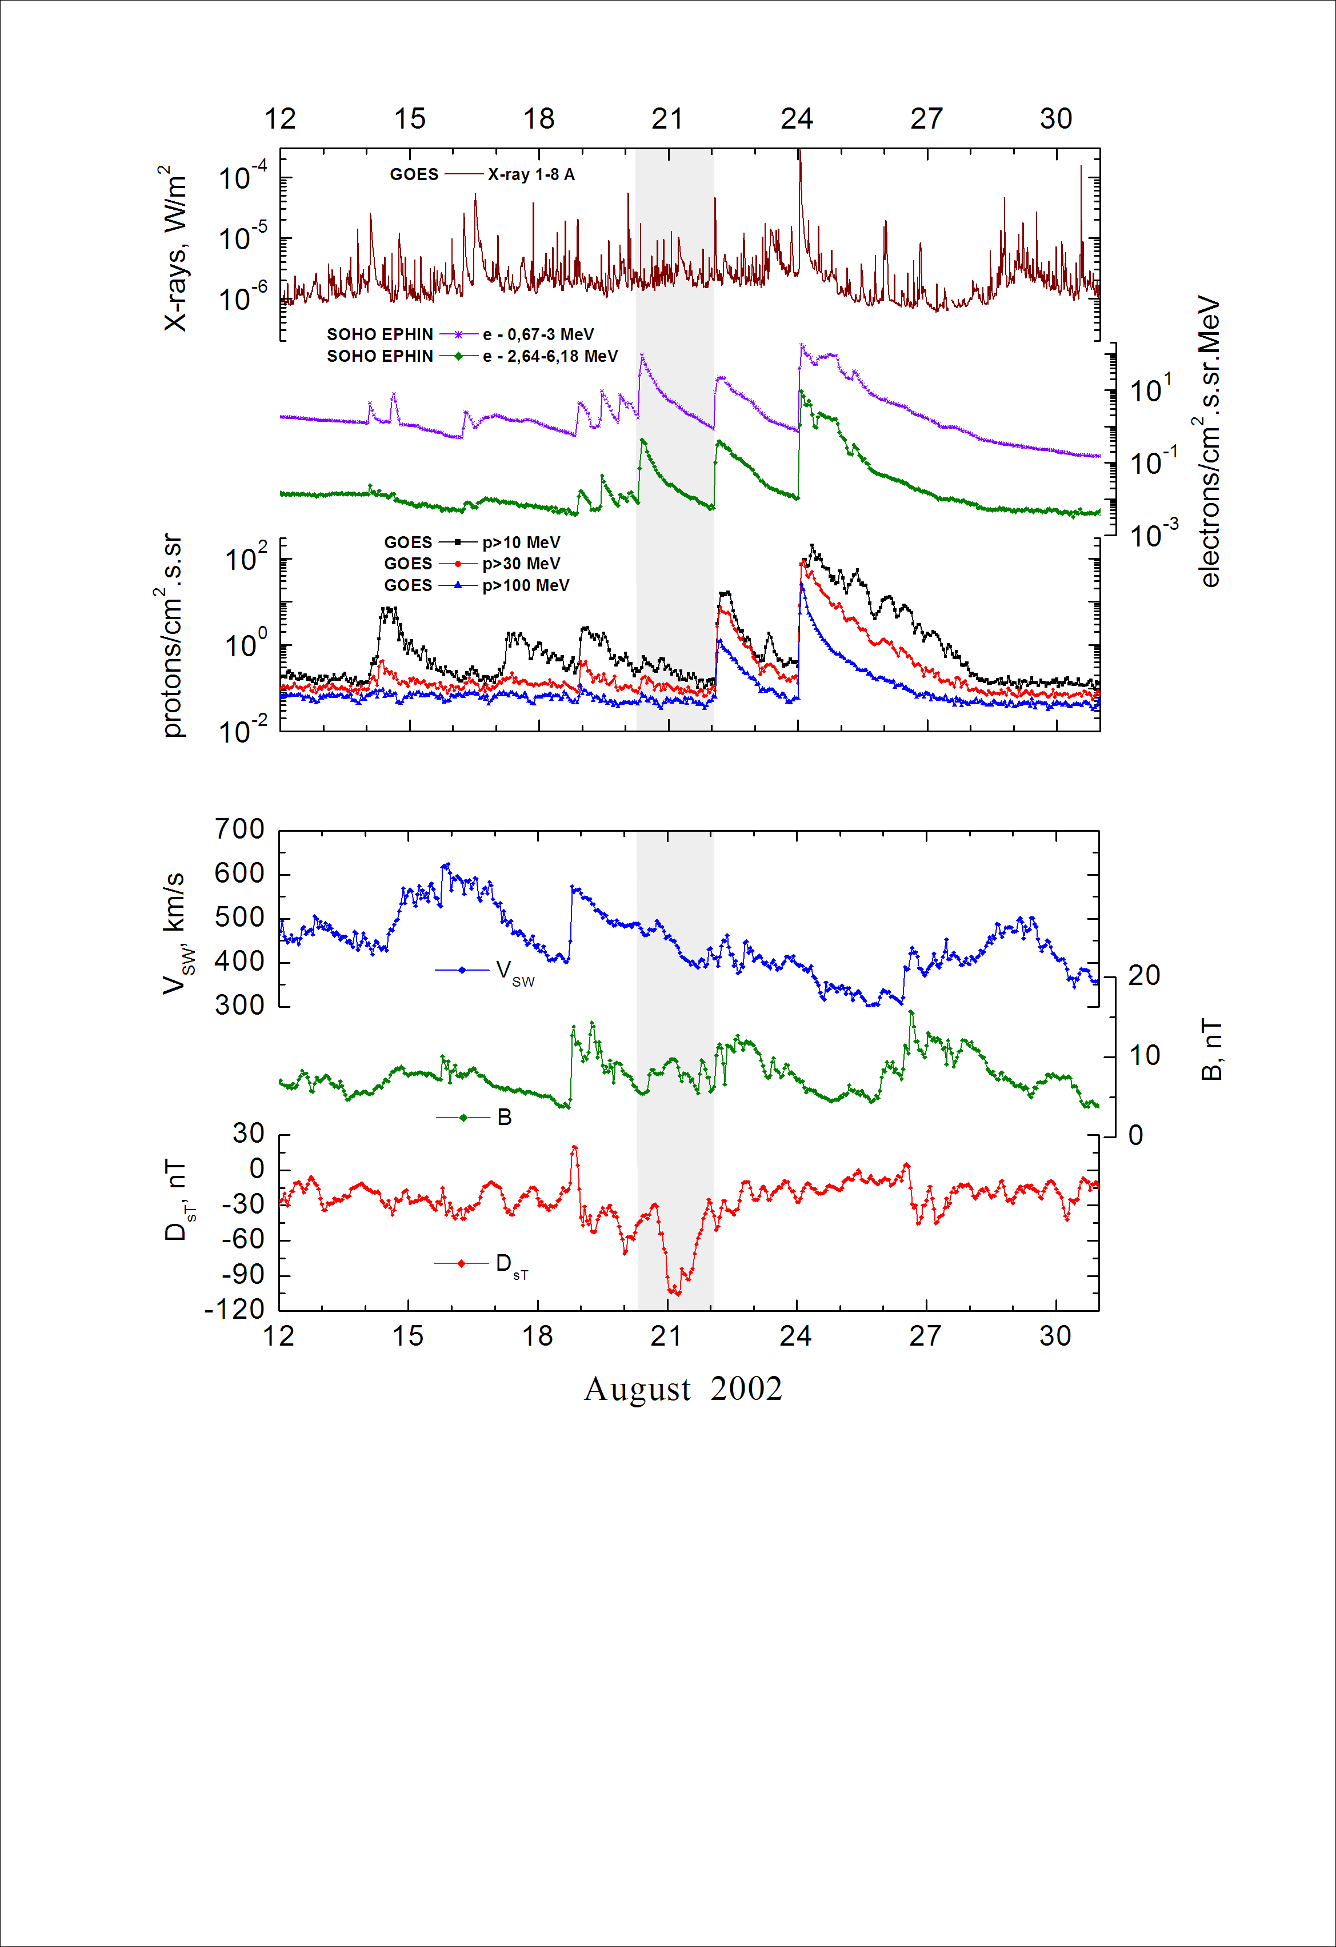
Integral time-of-maximum proton spectrum
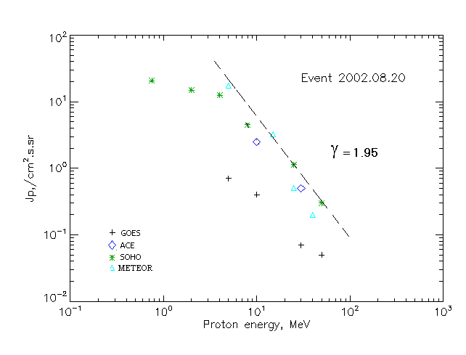

Integral fluxes of protons for the event of 2002.08.20

S/c, instruments | Eр, MeV | To | Tmax | Jmax,  (cm2.s.sr)⁻¹ | Dura-tion | Comments
GOES 10
EPS | >5 | 09^{h} | 10^{h} | 0.7 | 2d
EPS | >10 | 09^{h} | 10^{h} | 0.4 | 2d
EPS | >30 | 08^{h} | 11^{h} | 0.07 | 2d
EPS | >50 | 08^{h} | 11^{h} | 0.05 | 2d
EPS | >60 | - | - | - | -
EPS | >100 | - | - | - | -
METEOR
CBM | >5 | 09^{h} | 10^{h} | 17.3 | 1.2d
CBM | >15 | 09^{h} | 10^{h} | 3.2 | 1.2d
CBM | >25 | 09^{h} | 10^{h} | 0.5 | 0.7d
CBM | >40 | 09^{h} | 10^{h} | 0.2 | 0.7d
BP | >90 | - | - | - | -
ChD | >600 | - | - | - | -
ACE
SIS | >10 | 09^{h} | 10^{h} | 2.5 | 1d
SIS | >30 | 08^{h} | 10^{h} | 0.5 | 1d
SOHO
EPHIN (INT) | >50 | 08^{h} | 10^{h} | 0.3 | 1d

Differential fluxes of protons for the event of 2002.08.20

S/c, instruments | ∆Е, MeV | To | Tmax | Jmax, (cm².s.sr.MeV)⁻¹ | Dura-tion | Comments
SOHO
LION | 0.75-2 | 08^{h} | 14^{h} | 4.7 | 2d
LION | 2-6 | 08^{h} | 13^{h} | 0.75 | 2d
EPHIN | 4-8 | 08^{h} | 11^{h} | 2 | 2d
EPHIN | 8-25 | 08^{h} | 11^{h} | 0.2 | 2d
EPHIN | 25-41 | 08^{h} | 10^{h} | 0.03 | 2d
EPHIN | 41-53 | - “ - | - “ - | - “ - | - “ -

References:
No information on publications, excepting for:
http://www.swpc.noaa.gov/ftpdir/indices/SPE.txt

