Event 2002.08.24 – (2002-236) – GLE 64

Particle event: To(Ep> 10MeV) – 24d01^{h}
Tmax(Ep>10 MeV) – 24d03^{h}, Jmax (Ep>10 MeV) – 92 /cm².s.sr
Duration of the event – 4 days
Energy of the SCR and 0.1 GCR fluxes balance – Eb = 775 MeV

Sources: ● solar flare 24d00^{h}49^{m}, X3.1/1F, S02W81, АR10069
Main X-ray burst 1–8 Ǻ: onset – 24d00^{h}49^{m}, max – 24d01^{h}12^{m}, Ф = 0.46 J/m²;
CME: 24d01^{h}27^{m}; V = 1913 km/s, ∆φ = 360º, dA = 270º ;
▲SC 26d11^{h}31^{m}

Particle fluxes and associated phenomena
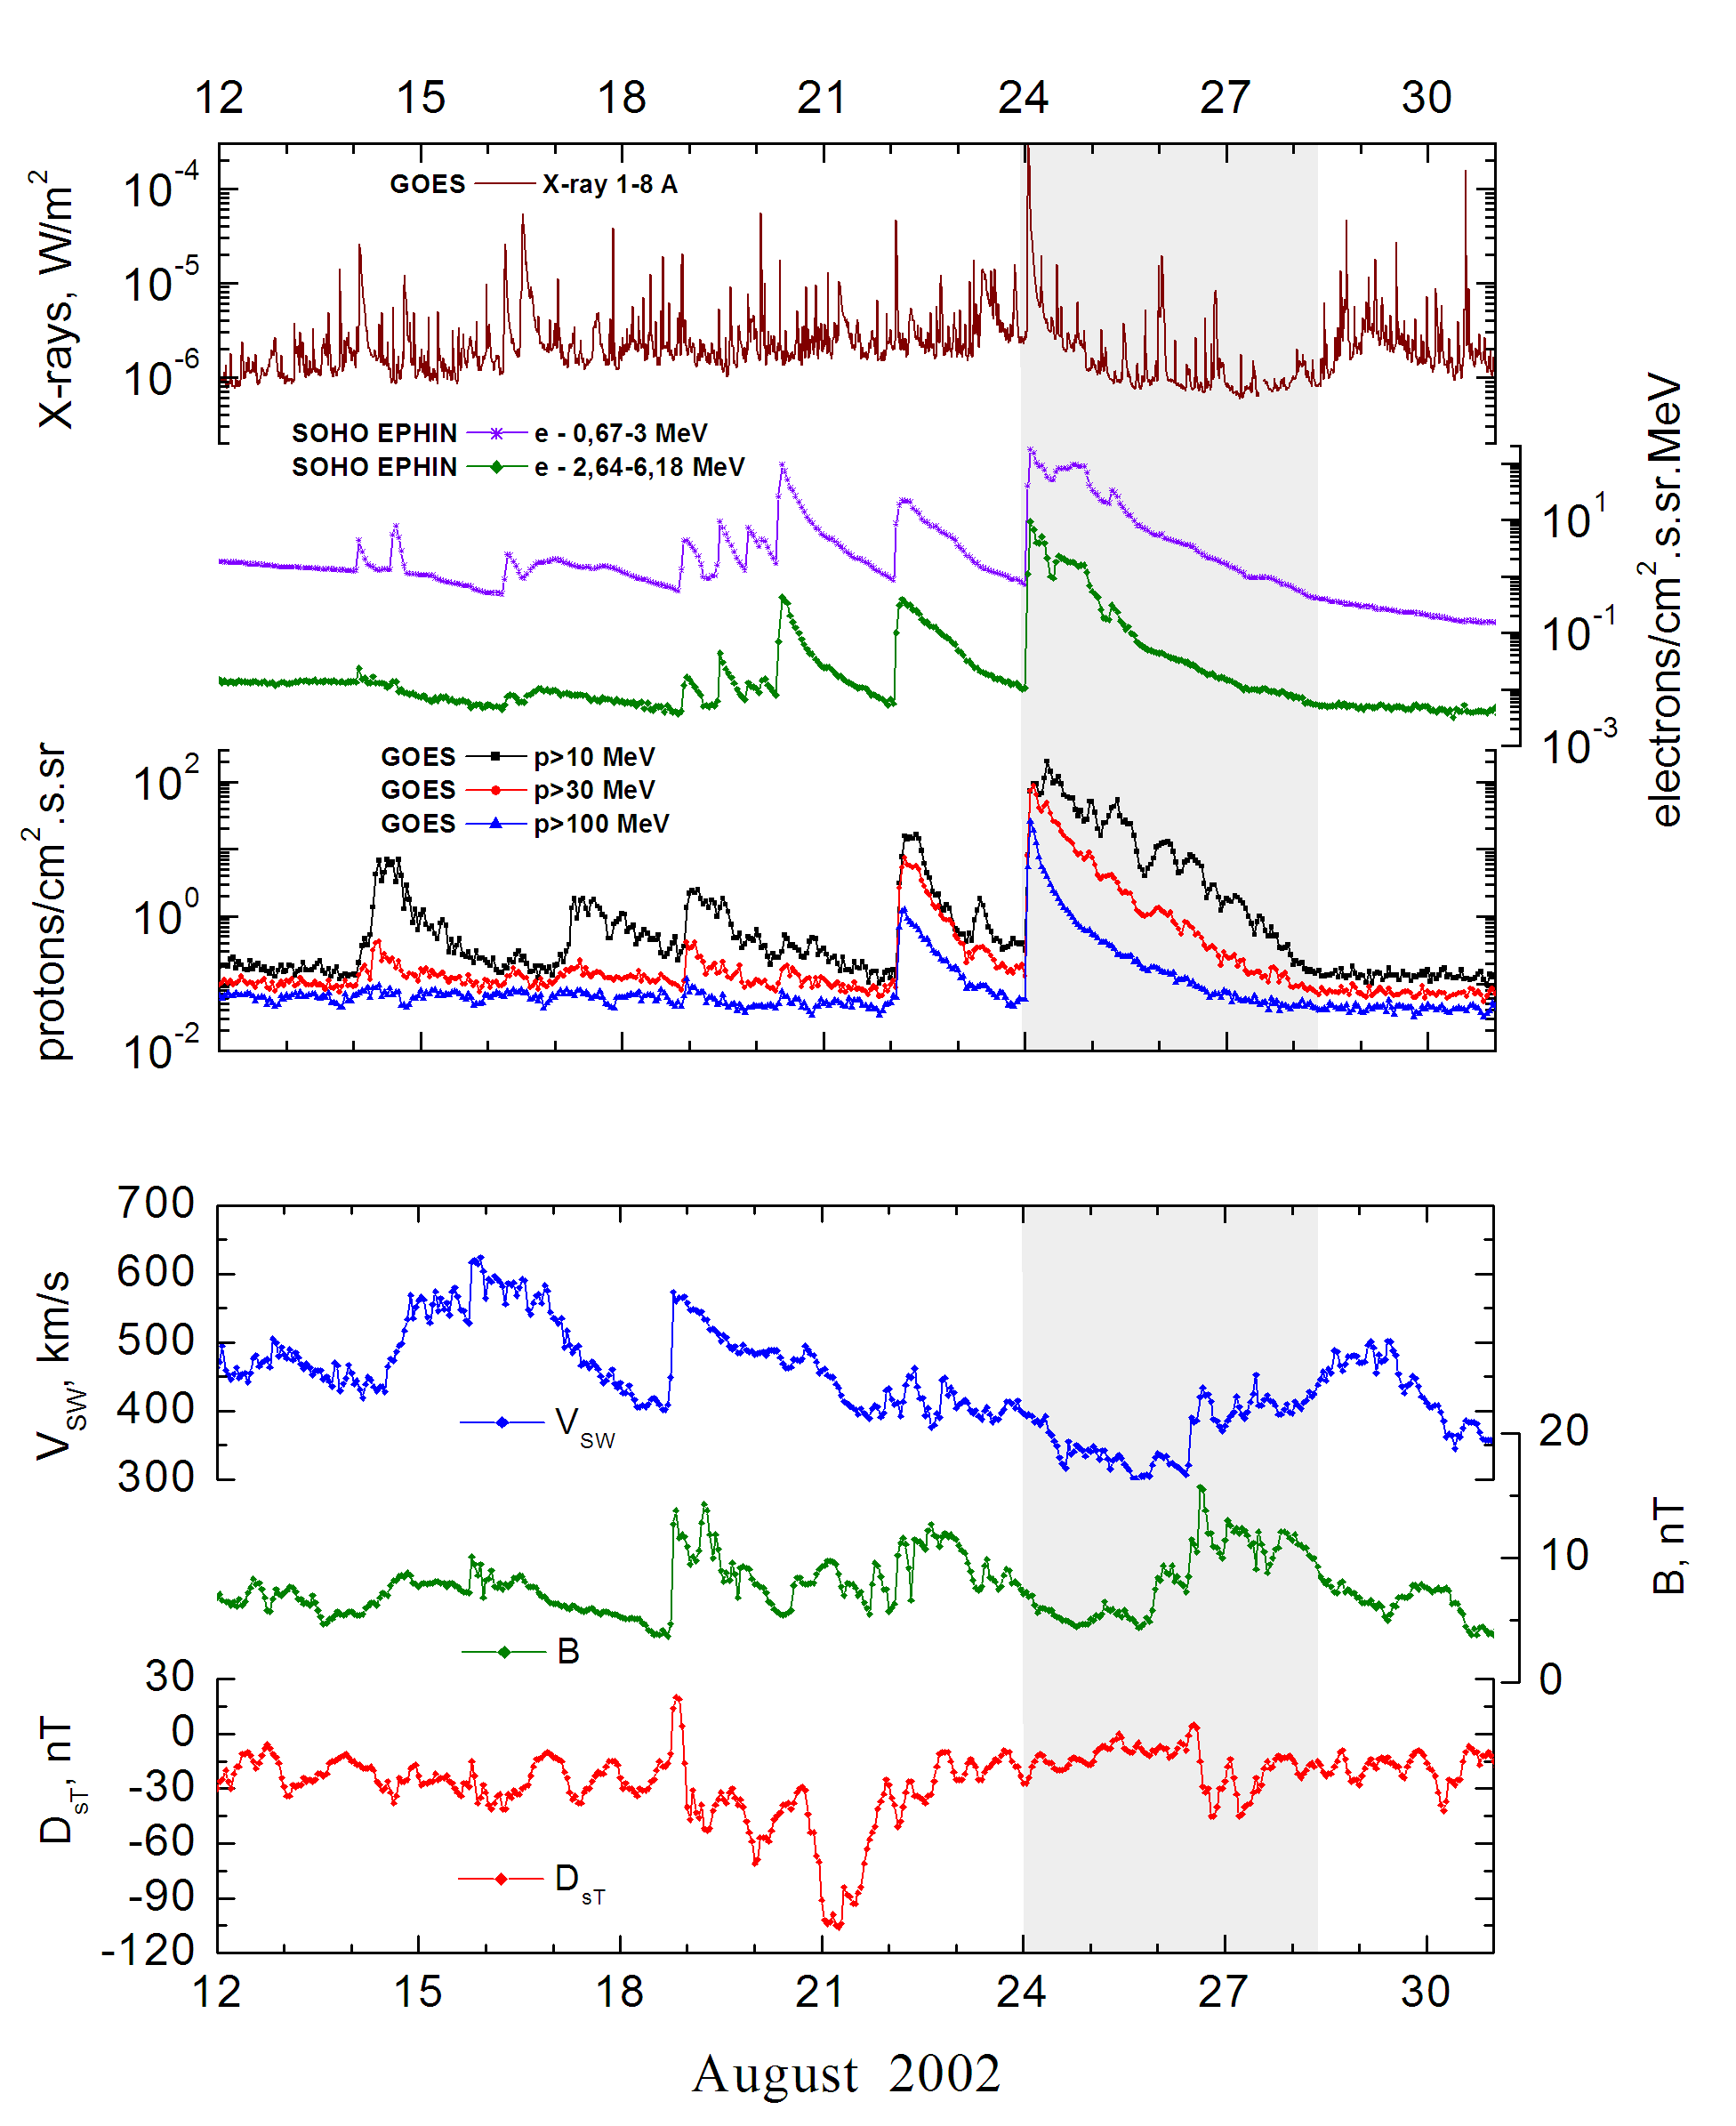
Integral time-of-maximum proton spectrum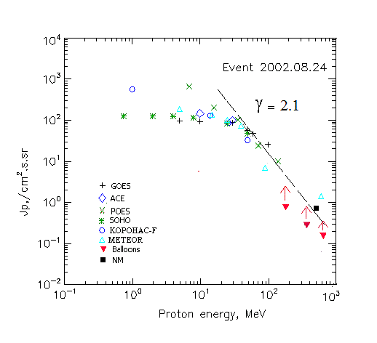

Integral fluxes of protons for the event of 2002.08.24

S/c,  instruments | Eр, MeV | To | Tmax | Jmax,  (cm2.s.sr)-1 | Dura-tion | Comments
GOES-10
EPS | >5 | 01^{h} | 03^{h} | 96 | 4d
EPS | >10 | 01^{h} | 03^{h} | 92 | 4d
EPS | >30 | 01^{h} | 03^{h} | 87 | 4d
EPS | >50 | 01^{h} | 02^{h} | 56 | 3.5d
EPS | >60 | 01^{h} | 02^{h} | 47 | 3.5d
EPS | >100 | 01^{h} | 02^{h} | 26 | 3.5d
METEOR
CBM | >5 | 02^{h} | 03^{h} | 187 | 4d
CBM | >15 | 02^{h} | 03^{h} | 134 | 4d
CBM | >25 | 02^{h} | 03^{h} | 100 | 3d
CBM | >40 | 02^{h} | 03^{h} | 73 | 3d
BP | >90 | 02^{h} | 03^{h} | 7.1 | 2.5d
ChD | >600 | 02^{h} | 03^{h} | 1.43 | 2d
POES-16
MEPED | >0.24 | - | ⁻ | - | -
MEPED | >0.8 | - | ⁻ | - | -
MEPED | >2.5 | - | ⁻ | - | -
MEPED | >6.9 | - | 04^{h} | 730 | 4d
MEPED | >16 | - | 04^{h} | 190. | 4d
MEPED | >36 | - | 03^{h} | 96 | 3.5d
MEPED | >70 | - | 02^{h} | 25 | 3.5d
MEPED | >140 | - | 02^{h} | 10 | 3.5d
CORONAS F
MKL | >1. | - | 05^{h} | 560 | 4d
MKL | >14 | - | 05^{h} | 128 | 3.5d
MKL | >26 | - | 05^{h} | 85 | 3.5d
MKL | >50 | - | 05^{h} | 32.5 | 3.5d
ACE
SIS | >10 | 01^{h} | 03^{h} | 146. | 4d
SIS | >30 | 01^{h} | 03^{h} | 100 | 4d
SOHO
EPHIN (INT) | >50 | 01^{h} | 02^{h} | 48 | 2.5d
BALLOОNS
Mi | >183 | - | 07^{h}06^{m}-08^{h}06^{m} | 0.76 | -
Mi | >359 | - | 07^{h}06^{m}-08^{h}06^{m} | 0.27 | -
Mi | >647 | - | 07^{h}06^{m}-08^{h}06^{m} | 0.15 | -
NM
Network | >500 | 01^{h} | 02^{h} | 0.66 | -

Differential fluxes of protons for the event of 2002.08.24

S/c,  instruments | ∆Е, MeV | To | Tmax | Jmax, (cm².s.sr.MeV)⁻¹ | Dura-tion | Comments
SOHO
LION | 0.75-2 | 01^{h} | 04^{h} | 0.65 | 4d
LION | 2-6 | 01^{h} | 04^{h} | 0.67 | 4d
EPHIN | 4-8 | 01^{h} | 04^{h} | 2.5 | 4d
EPHIN | 8-25 | 01^{h} | 03^{h} | 1.8 | 4d
EPHIN | 25-41 | 01^{h} | 02^{h} | 1.3 | 4d
EPHIN | 41-53 | - “ - | - “ - | - “ - | - “ -

References:
Struminsky A.B. Prolonged release of > 100 MeV protons from local radiation belts of the Sun. – Proc. 26th Annual Seminar “Physics of Auroral Phenomena”, Apatity, Russia, p.162-165, 2003.
Kuwabara T., Bieber J.W., Clem J., et.al., 2006.
Miroshnichenko L.I. and Perez-Peraza J., 2008.
Веселовский И.С., Мягкова И.Н., Яковчук О.С., 2012.

