Event 2003.11.20 – (2003-324)

Particle event: To(Ep>10 MeV) – 20d08^{h}
Tmax(Ep>10 MeV) – 20d11^{h}, Jmax (Ep>10 MeV) – 4.4 /cm².s.sr
Duration of the event – 1 day
Energy of the SCR and 0.1 GCR fluxes balance – Eb = 140 MeV

Sources: ● solar flare 20d07^{h}35^{m}, M9.6/2B, N01W08, АR10501
Main X-ray burst 1-8 Ǻ: onset – 20d07^{h}35^{m}, max – 20d07^{h}47^{m}, Ф = 0.06 J/m²
CME: 20d08^{h}06^{m}, V = 669 km/s, ∆φ = 360º, dA = 219º
▲SC: 20d08^{h}03^{m}

Particle fluxes and associated phenomena

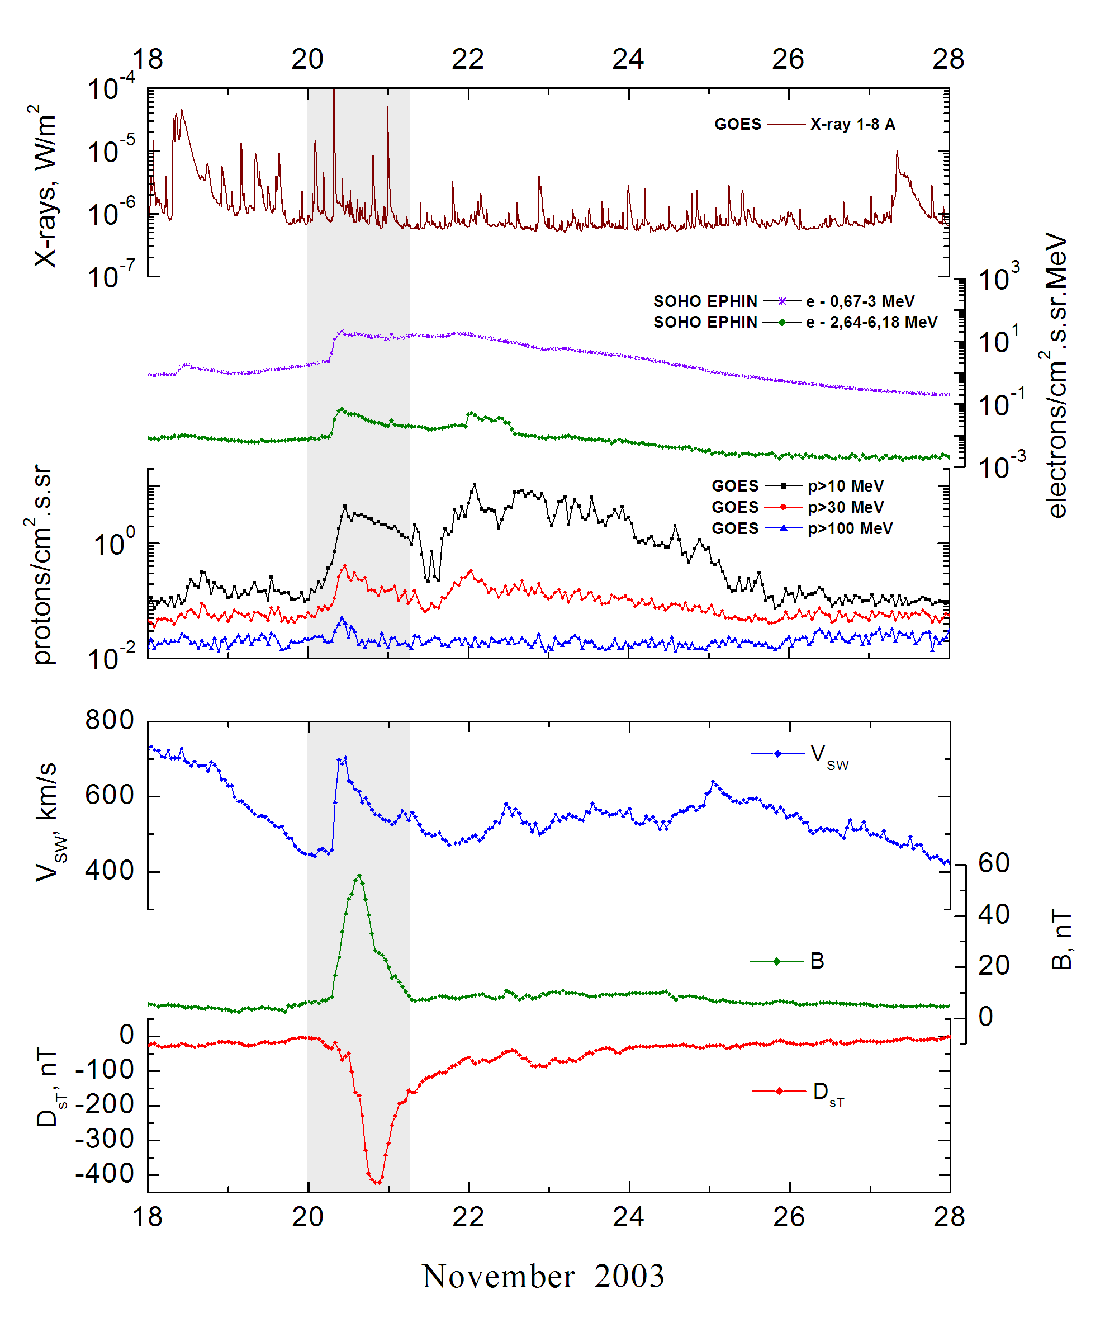
Integral time-of-maximum proton spectrum
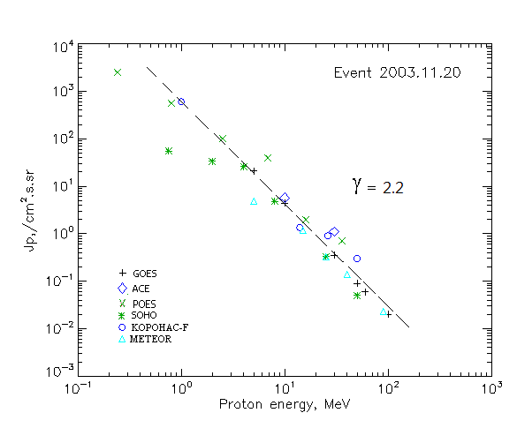

Integral fluxes of protons for the event of 2003.11.20

S/c, instruments | Eр, MeV | To | Tmax | Jmax,  (cm².s.sr)⁻¹ | Dura-tion | Comments
GOES-10
EPS | >5 | 06^{h} | 11^{h} | 21.2 | 1d
EPS | >10 | 08^{h} | 11^{h} | 4.4 | 1d
EPS | >30 | 08^{h} | 11^{h} | 0.35 | 1d
EPS | >50 | 09^{h} | 11^{h} | 0.09 | 1d
EPS | >60 | 09^{h} | 10^{h} | 0.06 | 1d
EPS | >100 | 09^{h} | 10^{h} | 0.02 | 1d
METEOR
CBM | >5 | 08^{h} | 11^{h} | 4.8 | 1d
CBM | >10 | 09^{h} | 11^{h} | 1.16 | 0.7d
CBM | >25 | 10^{h} | 12^{h} | 0.32 | 0.7d
CBM | >40 | 10^{h} | 12^{h} | 0.14 | 0.5d
BP | >90 | 09^{h} | 10^{h} | 0.023 | 0.3d
ChD | >600
POES-16
MEPED | >0.24 | - | 12^{h} | 2570 | 1d
MEPED | >0.8 | - | 12^{h} | 550 | 1d
MEPED | >2.5 | - | 12^{h} | 110 | 1d
MEPED | >6.9 | - | 12^{h} | 40 | 1d
MEPED | >16 | - | 12^{h} | 2 | 1d
MEPED | >36 | - | 12^{h} | 0.7 | 1d
MEPED | >70 | - | ⁻ | - | -
MEPED | >140 | - | - | - | -
CORONAS F
MKL | >1. | - | 12^{h} | 660 | 1d
MKL | >14 | - | 12^{h} | 1.35 | 1d
MKL | >26 | - | 12^{h} | 0.9 | 1d
MKL | >50 | - | 12^{h} | 0.3 | 1d
ACE
SIS | >10 | 08^{h} | 10^{h} | 5.7 | 1d
SIS | >30 | 08^{h} | 10^{h} | 1.1 | 1d
SOHO
EPHIN (INT) | >50 | 08^{h} | 09^{h} | 0.05 | 0.5d

Differential fluxes of protons for the event of 2003.11.20

S/c,  instruments | ∆Е, MeV | To | Tmax | Jmax, (cm².s.sr.MeV)⁻¹ | Dura-tion | Comments
SOHO
LION | 0.75-2 | 01^{h} | 11^{h} | 17.5 | 1d
LION | 2-6 | 02^{h} | 11^{h} | 2.5 | 1d
EPHIN | 4-8 | 07^{h} | 10^{h} | 5.3 | 1d
EPHIN | 8-25 | 07^{h} | 10^{h} | 0.26 | 1d
EPHIN | 25-41 | 08^{h} | 10^{h} | 0.01 | 1d
EPHIN | 41-53 | - “ - | - “ - | - “ - | - “ -

References:
Kuwabara T., J.W. Bieber, J. Clem, et.al., 2006.
Grechnev V.V., Uralov A.M., Slemzin V.A., et.al.,2014.
Grechnev V.V., Uralov A.M., Chertok I.M., et.al.,2014.

