Event 2003.11.21 – (2003-325)

Particle event: To(Ep>10 MeV) – 21d08^{h}
Tmax(Ep>10 MeV) – 22d02^{h}, Jmax (Ep>10 MeV) – 10.7 /cm².s.sr
Duration of the event – 4 days
Energy of the SCR and 0.1 GCR fluxes balance – Eb = 80 MeV

Sources: ● solar flare 20d23^{h}42^{m}, M5.8/2B, N02W17, АR10501
Main X-ray burst 1-8 Ǻ: onset – 20d23^{h}42^{m}, max – 20d23^{h}53^{m}, Ф = 0.028 J/m²
CME: 21d00^{h}26^{m}; V = 494 km/s; ∆φ = 052º; dA = 237º

Particle fluxes and associated phenomena
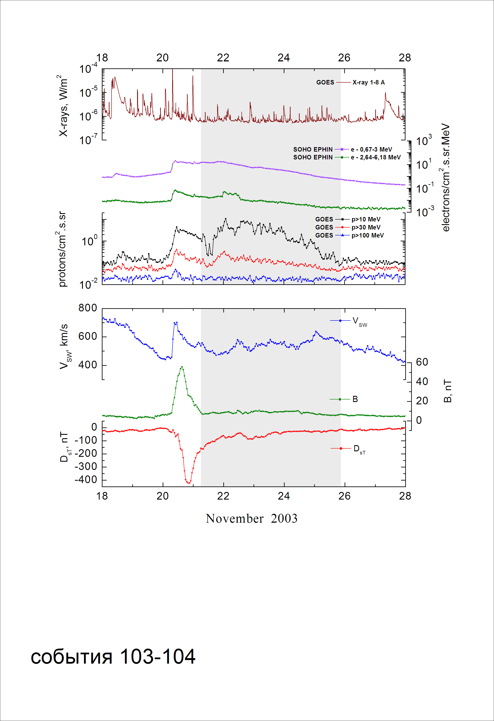
Integral time-of-maximum proton spectrum
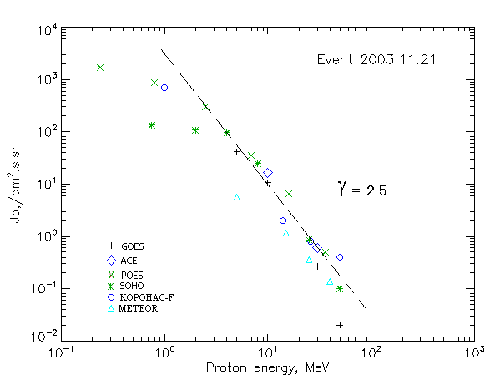

Integral fluxes of protons for the event of 2003.11.21

S/c, instruments | Eр, MeV | To | Tmax | Jmax,  (cm².s.sr)⁻¹ | Dura-tion | Comments
GOES-10
EPS | >5 | 08^{h} | 22d02^{h} | 41 | 5d
EPS | >10 | 08^{h} | 22d02^{h} | 11 | 4d
EPS | >30 | 08^{h} | 22d01^{h} | 0.3 | 3d
EPS | >50 | 08^{h} | 22d01^{h} | 0.02 | 2d
EPS | >60 | - | - | - | -
EPS | >100 | - | - | - | -
METEOR
CBM | >5 | 08^{h} | 22d00^{h} | 5.7 | 3d
CBM | >10 | 09^{h} | 22d00^{h} | 1.17 | 2d
CBM | >25 | 09^{h} | 22d00^{h} | 0.36 | 1.5d
CBM | >40 | 09^{h} | 22d00^{h} | 0.14 | 1d
BP | >90 | - | - | - | -
ChD | >600 | - | - | - | -
POES-16
MEPED | >0.24 | ⁻ | 23^{h} | 1740 | 5d
MEPED | >0.8 | ⁻ | 23^{h} | 870 | 5d
MEPED | >2.5 | ⁻ | 23^{h} | 320 | 5d
MEPED | >6.9 | ⁻ | 23^{h} | 35 | 4d
MEPED | >16 | ⁻ | 23^{h} | 6.5 | 3d
MEPED | >36 | ⁻ | 23^{h} | 0.5 | 2d
MEPED | >70 | ⁻ | - | - | -
MEPED | >140 | ⁻ | - | - | -
CORONAS F
MKL | >1. | ⁻ | 24^{h} | 720 | 5d
MKL | >14 | ⁻ | 24^{h} | 2 | 4d
MKL | >26 | ⁻ | 24^{h} | 0.8 | 3d
MKL | >50 | ⁻ | 24^{h} | 0.4 | 2d
ACE
SIS | >10 | 08^{h} | 24^{h} | 16.5 | 4d
SIS | >30 | 07^{h} | 24^{h} | 0.6 | 1d
SOHO
EPHIN (INT) | >50 | 23^{h} | 22d01^{h} | 0.1 | 0.3d

Differential fluxes of protons for the event of 2003.11.21

S/c, instruments | ∆Е, MeV | To | Tmax | Jmax, (cm².s.sr.MeV)⁻¹ | Dura-tion | Comments
SOHO
LION | 0.75-2 | 08^{h} | 22d03^{h} | 22 | 5d
LION | 2-6 | 08^{h} | 22d02^{h} | 3.8 | 5d
EPHIN | 4-8 | 07^{h} | 22d02^{h} | 17.8 | 5d
EPHIN | 8-25 | 07^{h} | 22d02^{h} | 1.4 | 5d
EPHIN | 25-41 | 07^{h} | 22d01^{h} | 0.027 | 5d
EPHIN | 41-53 | - “ - | - “ - | - “ - | - “ -

References:
Kuwabara T., J.W. Bieber, J. Clem, et.al., 2006.

