Event 2004.04.11 – (2004-102)

Particle event: To(Ep>10MeV) – 11d06^{h}
Tmax₁(Ep>10MeV) – 11d12^{h}, Jmax₁(Ep>10MeV) – 13 /cm².s.sr
Tmax₂(Ep>10MeV) – 11d20^{h}, Jmax₂(Ep>10MeV) – 14.5 /cm².s.sr
Duration of the event – 2 days
Energy of the SCR and 0.1 GCR fluxes balance – Eb(max₁) = 95 MeV
– Eb(max₂) = 80 MeV
Sources: ● solar flare 11d03^{h}54^{m}, C9.6/1F, S14W47, АR10588
Main X-ray burst 1-8 Ǻ : onset – 11d03^{h}54^{m}, max – 11d04^{h}19^{m}, Ф = 0.013 J/m²
CME: 11d04^{h}30^{m}, V = 1645 km/s, Δφ = 314º, dA = 237˚
CME 11d11^{h}54^{m}, V = 1132 km/s, Δφ = 360º, dA = 295˚ - back side event

Particle fluxes and associated phenomena
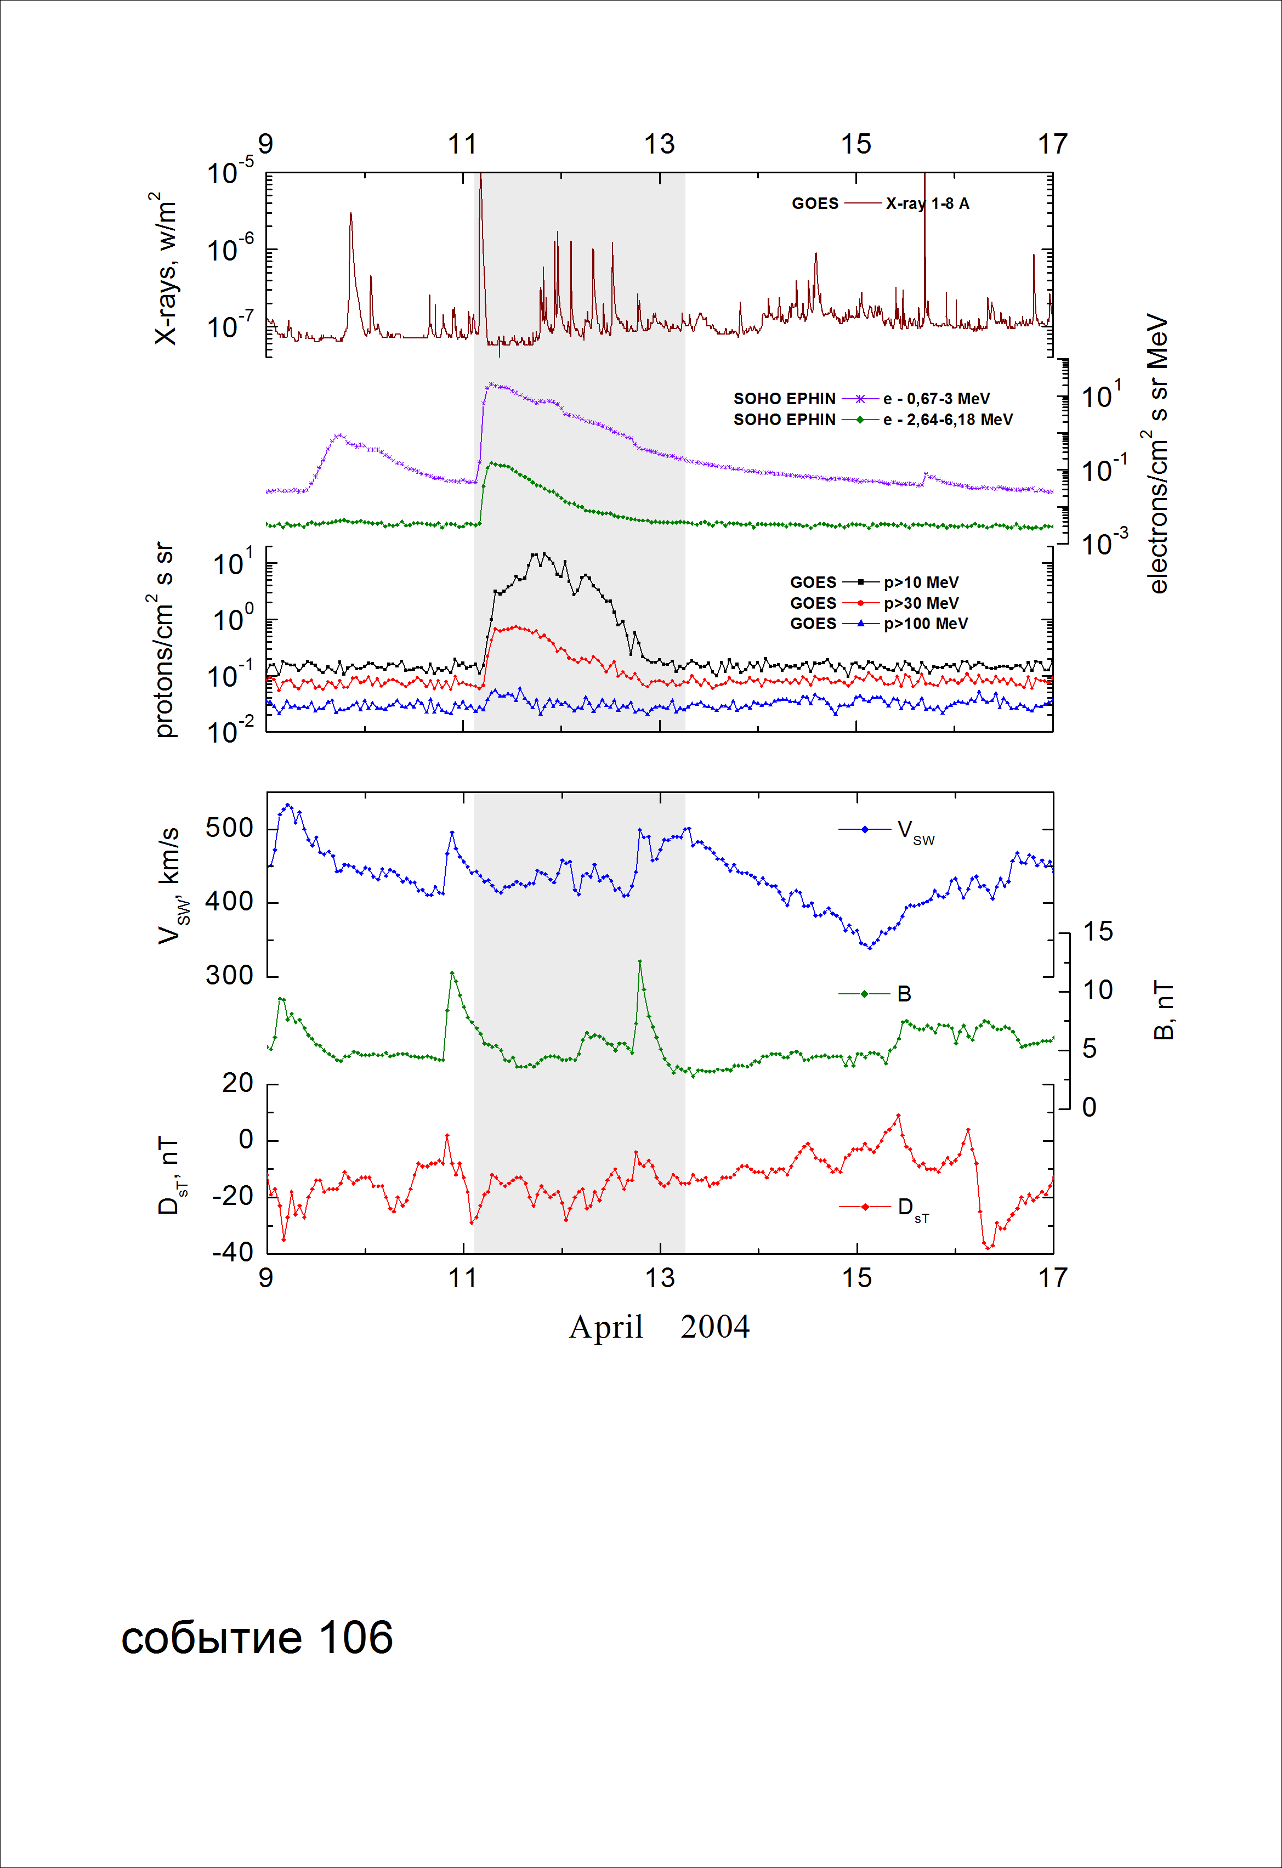
Integral time-of-maximum proton spectrum
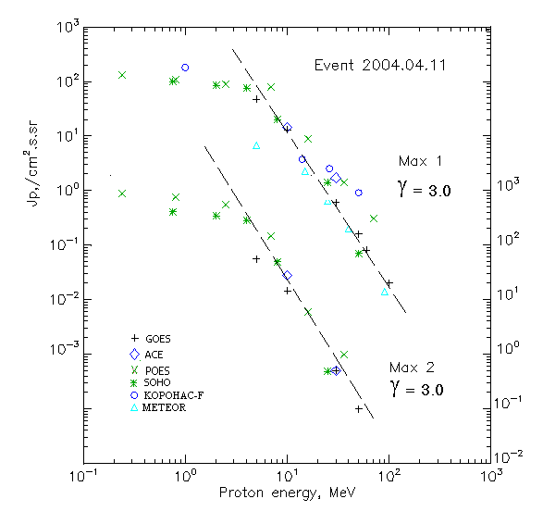

Integral fluxes of protons for the event of 2004.04.11

S/c, instruments | Eр, MeV | To | Tmax | Jmax,  (cm².s.sr)⁻¹ | Dura-tion | Comments
GOES-10
EPS | >5 | 06^{h} | 19^{h}/20^{h} | 47/56.5 | 2d
EPS | >10 | 06^{h} | 12^{h}/20^{h} | 13/14.5 | 2d
EPS | >30 | 06^{h} | 12^{h}/20^{h} | 0.6/0.5 | 2d
EPS | >50 | 06^{h} | 11^{h}/20^{h} | 0.16/0.1 | 1d
EPS | >60 | 06^{h} | 11^{h}/ - | 0.08/ - | 1d
EPS | >100 | 06^{h} | 10^{h}/ - | 0.02/ - | 1d
METEOR
CBM | >5 | 05^{h} | 15^{h}/ - | 6.65/ - | 3d
CBM | >15 | 05^{h} | 13^{h}/ - | 2.2./ - | 2d
CBM | >25 | 06^{h} | 13^{h}/ - | 0.65/ - | 2d
CBM | >40 | 06^{h} | 13^{h}/ - | 0.2/ - | 1d
BP | >90 | 06^{h} | 13^{h}/ - | 0.014/ - | 1d
ChD | >600 | - | - | - | -
POES-16
MEPED | >0.24 | 06^{h} | 12^{h}/20^{h} | 130/880 | 3d
MEPED | >0.8 | 06^{h} | 12^{h}/20^{h} | 110/770 | 3d
MEPED | >2.5 | 06^{h} | 12^{h}/20^{h} | 90/550 | 2d
MEPED | >6.9 | 06^{h} | 12^{h}/20^{h} | 80/150 | 2d
MEPED | >16 | 06^{h} | 12^{h}/20^{h} | 9/6 | 1d
MEPED | >36 | 06^{h} | 12^{h}/20^{h} | 1.4/1 | 1d
MEPED | >70 | - | 11^{h}/ - | 0.3/ - | -
MEPED | >140 | - | - | - | -
CORONAS F
MKL | >1. | - | 13^{h}/ - | 180/ - | 3d
MKL | >14 | - | 13^{h}/ - | 3.7/ - | 2d
MKL | >26 | - | 13^{h}/ - | 2.5/ - | 2d
MKL | >50 | - | 13^{h}/ - | 0.9/ - | 1d
ACE
SIS | >10 | 05 ^{h} | 10 ^{h}/20 ^{h} | 14.3/28.2 | 2d
SIS | >30 | 05^{h} | 10 ^{h}/20 ^{h} | 1.7/0.5 | 1d
SOHO
EPHIN (INT) | >50 | 05^{h} | 11^{h}/ - | 0.07/ - | 2d

Differential fluxes of protons for the event of 2004.04.11

S/c,  instruments | ∆Е, MeV | To | Tmax | Jmax, (cm².s.sr.MeV)⁻¹ | Dura-tion | Comments
SOHO
LION | 0.75-2 | 06 ^{h} | 12^{h}/22^{h} | 8.9/59.2 | 5d
LION | 2-6 | 06^{h} | 12^{h}/22^{h} | 3.3/19.2 | 5d
EPHIN | 4-8 | 05 ^{h} | 11^{h}/21^{h} | 13.8/59.1 | 5d
EPHIN | 8-25 | 05^{h} | 11^{h}/20^{h} | 1.1/2.9 | 5d
EPHIN | 25-41 | 05^{h} | 11^{h}/19^{h} | 0.047/0.017 | 4d
EPHIN | 41-53 | - “ - | - “ - | - “ - | - “ -

References:
No information on publications, excepting for:
http://www.swpc.noaa.gov/ftpdir/indices/SPE.txt

