Event 2004.07.25 – (2004-207)

Particle event: To(Ep>10MeV) – 25d17^{h}
Tmax₁(Ep>10MeV) – 25d21^{h}, Jmax₁(Ep>10MeV) – 27 /cm².s.sr
Tmax₂(Ep>10MeV) – 26d23^{h}, Jmax₂(Ep>10MeV) – 430 /cm².s.sr
Duration of the event – 4 days
Energy of the SCR and 0.1 GCR fluxes balance – Eb(max₁) = 140 MeV
– Eb(max₂) = 155 MeV
Sources: ● solar flare 25d14^{h}19^{m}, M1.1/1F, N08W33, АR10652
Ø solar flare 26d17^{h}23^{m}, M1.1/2N, N03W45, АR10652
Main X-ray burst 1-8 Ǻ: onset – 25d14^{h}19^{m}, max – 25d15^{h}14^{m}, Ф = 0.065 J/m²
CME: 25d14^{h}54^{m}, V = 1333 km/s, Δφ = 360º, dA= 204˚
▲SC 26d22^{h}49^{m};

Particle fluxes and associated phenomena
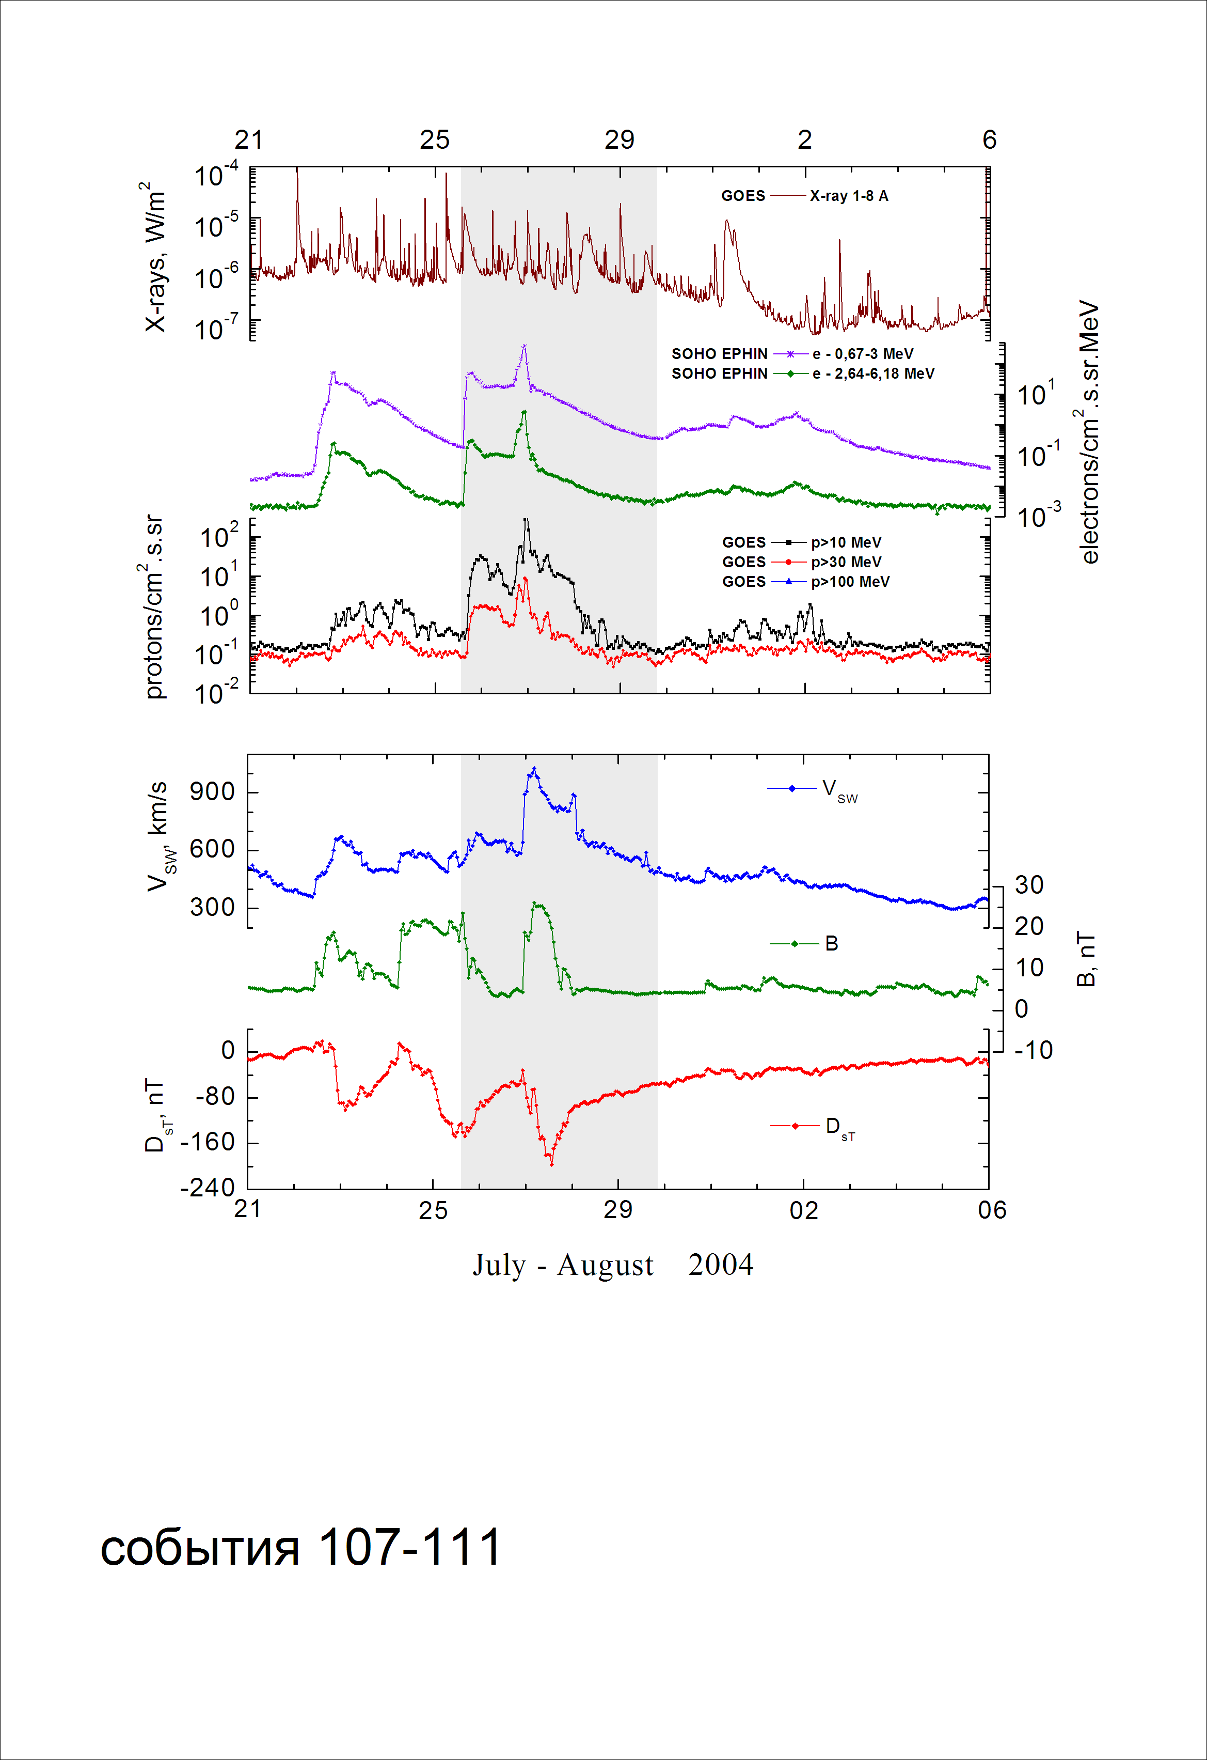
Integral time-of-maximum proton spectrum
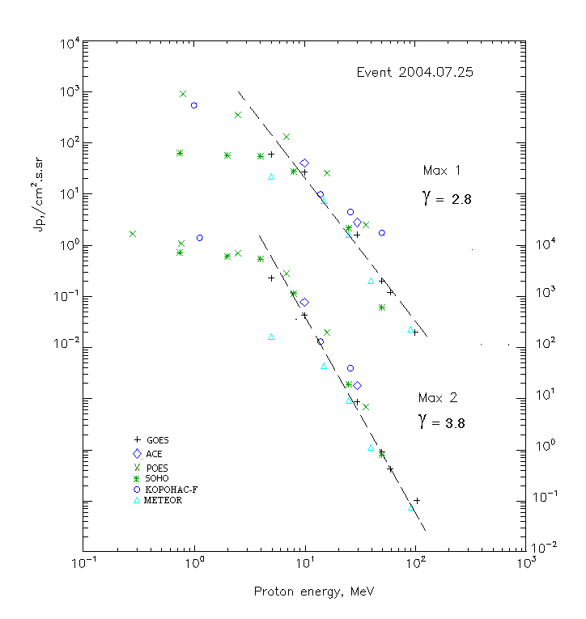

Integral fluxes of protons for the event of 2004.07.25

S/c, instruments | Eр, MeV | To | Tmax | Jmax,  (cm².s.sr)⁻¹ | Dura-tion | Comments
GOES-10
EPS | >5 | 17^{h} | 21^{h}/26d23^{h} | 60/2280 | 4d
EPS | >10 | 17^{h} | 21^{h}/26d23^{h} | 27/430 | 4d
EPS | >30 | 17^{h} | 20^{h}/26d22^{h} | 1.6/8.7 | 3d
EPS | >50 | 17^{h} | 20^{h}/26d22^{h} | 0.2/0.9 | 2d
EPS | >60 | 17^{h} | 19^{h}/26d22^{h} | 0.12/0.42 | 2d
EPS | >100 | 17^{h} | 19^{h}/26d21^{h} | 0.02/0.01 | 2d
METEOR
CBM | >5 | 17^{h} | 21^{h}26d23^{h} | 22/167 | 4d
CBM | >15 | 17^{h} | 21^{h}26d23^{h} | 7.4/45 | 3.5d
CBM | >25 | 17^{h} | 21^{h}/26d23^{h} | 1.6/9.2 | 2d
CBM | >40 | 17^{h} | 21^{h}/26d23^{h} | 0.2/1.1 | 1.5d
BP | >90 | 17^{h} | 22^{h}/26d23^{h} | 0.002/0.007 | 1.5d
ChD | >600 | - | - | - | -
POES-16
MEPED | >0.24 | - | - /26d23^{h} | - /1.9·10⁴ | 4d
MEPED | >0.8 | - | 21^{h}/26d23^{h} | 920/1.1·10⁴ | 4d
MEPED | >2.5 | - | 21^{h}/26d23^{h} | 350/7·10³ | 4d
MEPED | >6.9 | - | 21^{h}/26d23^{h} | 130/2.8·10³ | 4d
MEPED | >16 | - | 21^{h}/26d23^{h} | 26/210 | 3d
MEPED | >36 | - | 21^{h}/26d23^{h} | 2.5/7 | 2d
MEPED | >70 | - | - | - | -
MEPED | >140 | - | - | - | -
CORONAS F
MKL | >1. | - | 20^{h}/26d24^{h} | 540/1.5·10⁴ | 4d
MKL | >14 | - | 20^{h}/26d23^{h} | 9.8//130 | 4d
MKL | >26 | - | 20^{h}/26d22^{h} | 4.5/40 | 4d
MKL | >50 | - | 20^{h}/26d22^{h} | 1.75/10 | 4d
ACE
SIS | >10 | 17^{h} | 19^{h}/26d22^{h} | 40.5/765 | 3d
SIS | >30 | 17^{h} | 19^{h}/26d21^{h} | 2.8/18 | 2d
SOHO
EPHIN (INT) | >50 | 16^{h} | 19^{h}/26d22^{h} | 0.06/0.8 | 2d

Differential fluxes of protons for the event of 2004.07.25

S/c,  instruments | ∆Е, MeV | To | Tmax | Jmax, (cm².s.sr.MeV)⁻¹ | Dura-tion | Comments
SOHO
LION | 0.75-2 | 17^{h} | 22^{h}/26d23^{h} | 5.5/875 | 3d
LION | 2-6 | 17^{h} | 20^{h}/26d23^{h} | 0.9/240 | 3d
EPHIN | 4-8 | 17^{h} | 19^{h}/26d22^{h} | 6.6/1050 | 3d
EPHIN | 8-25 | 16^{h} | 19^{h}/26d21^{h} | 1.5/66 | 3d
EPHIN | 25-41 | 16^{h} | 19^{h}/26d21^{h} | 0.075/0.65 | 3d
EPHIN | 41-53 | - “ - | - “ - | - “ - | - “ -

References:
Kuwabara T., Bieber J.W., Clem J., et.al., 2006.

