Event 2004.09.13 – (2004-257)

Particle event: To(Ep>10MeV) – 13d19^{h}
Tmax₁(Ep>10MeV) – 13d23^{h}, Jmax₁(Ep>10MeV) – 210 /cm².s.sr
Tmax₂(Ep>10MeV) – 14d05^{h}, Jmax₂(Ep>10MeV) – 180 /cm².s.sr
Duration of the event – 4 days
Energy of the SCR and 0.1 GCR fluxes balance – Eb(max₁) = 110 MeV
– Eb(max₂) = 90 MeV
Sources: ⊙solar flare 12d00^{h}04^{m}, M4.8/2N, N04E42, АR10672
Ø solar flare 12d01^{h}36^{m}, M3.2/SN, S14W61, АR10667
Main X-ray burst 1-8 Ǻ onset – 12d00^{h}04^{m}, max – 12d00^{h}56^{m}, Ф = 0.15 J/m²
CME: 12d00^{h}36^{m}, V = 1328 km/s, Δφ = 360º, dA = 132˚
▲SC 13d20^{h}03^{m};

Particle fluxes and associated phenomena
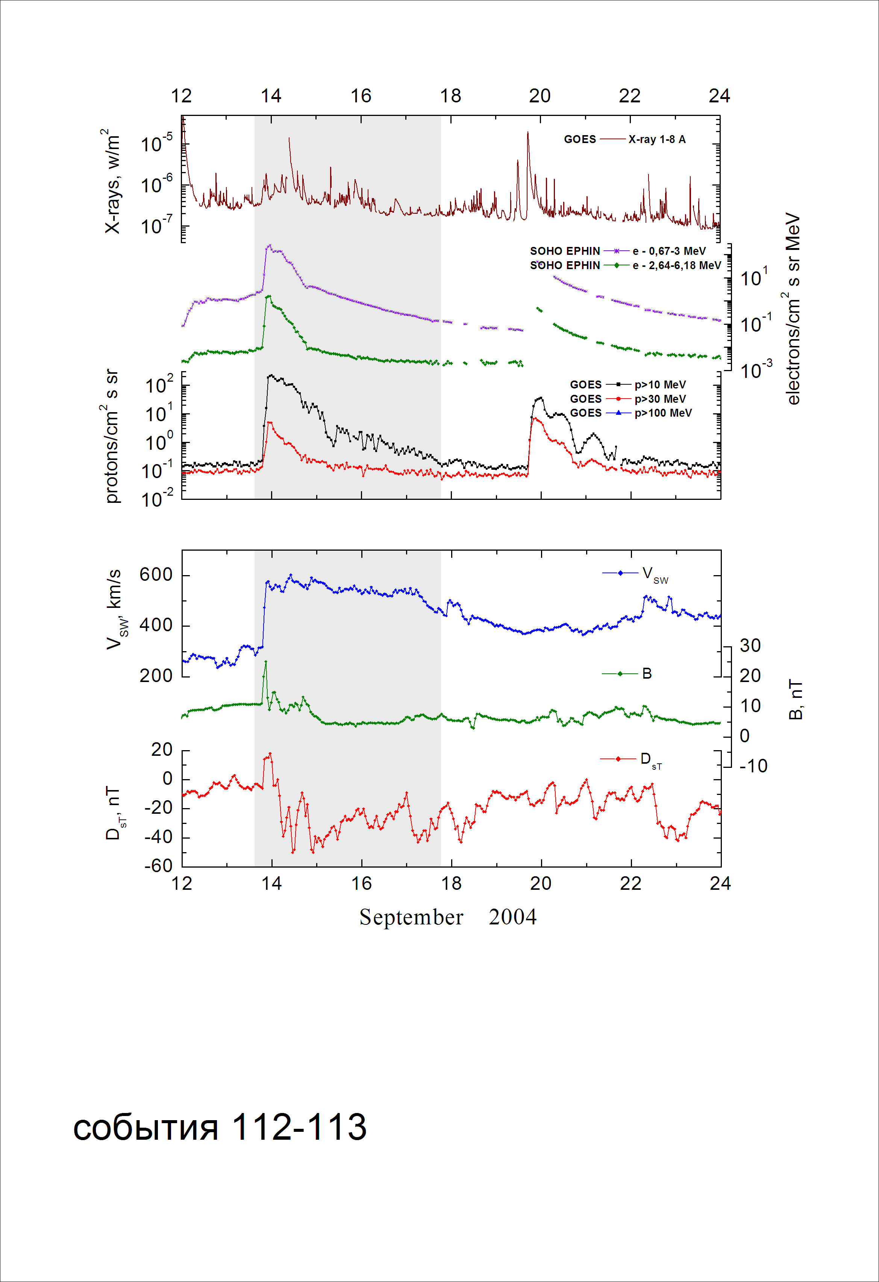
Integral time-of-maximum proton spectrum
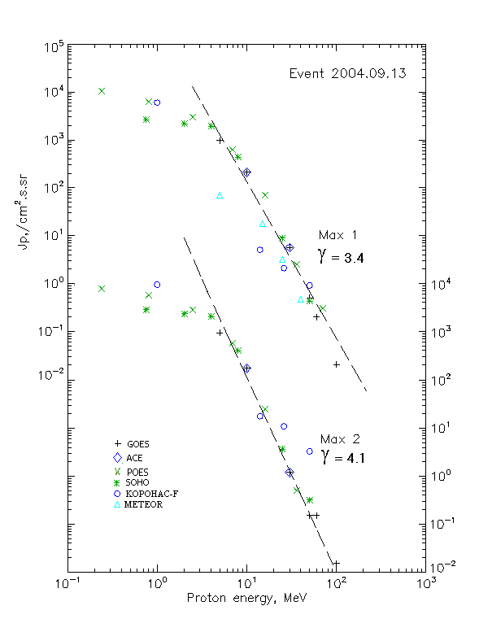

Integral fluxes of protons for the event of 2004.09.13

S/c, instruments | Eр, MeV | To | Tmax | Jmax,  (cm².s.sr)⁻¹ | Dura-tion | Comments
GOES-10
EPS | >5 | 19^{h} | 23^{h}/14d06^{h} | 970/990 | 5d
EPS | >10 | 19^{h} | 23^{h}/14d05^{h} | 210/180 | 4d
EPS | >30 | 19^{h} | 22^{h}/14d06^{h} | 5.6/1.2 | 3d
EPS | >50 | 19^{h} | 22^{h}/14d05^{h} | 0.5/0.15 | 1d
EPS | >60 | 19^{h} | 23^{h}/14d05^{h} | 0.2/0.1 | 1d
EPS | >100 | - | 23^{h}/14d05^{h} | 0.02/0.015 | -
METEOR
CBM | >5 | 18^{h} | 14d01^{h}/ - | 70/ - | 3d
CBM | >15 | 18^{h} | 23^{h}/ - | 18/ - | 2d
CBM | >25 | 18^{h} | 23^{h}/ - | 3.2/ - | 1d
CBM | >40 | 22^{h} | 22^{h}/ - | 0.46/ - | 1d
BP | >90 | - | - | - | -
ChD | >600 | - | - | - | -
POES-16
MEPED | >0.24 | - | 24^{h}/14d08^{h} | 1·10⁵/8.4·10³ | -
MEPED | >0.8 | - | 24^{h}/14d08^{h} | 6.2·10³/6.1·10³ | -
MEPED | >2.5 | - | 24^{h}/14d08^{h} | 3·10³/3·10³ | -
MEPED | >6.9 | - | 24^{h}/14d08^{h} | 620/610 | -
MEPED | >16 | - | 24^{h}/14d08^{h} | 70/25 | -
MEPED | >36 | - | 24^{h}/14d07^{h} | 2.5/0.5 | -
MEPED | >70 | - | 24^{h}/ - | 0.3/ - | -
MEPED | >140 | - | - | - | -
CORONAS F
MKL | >1. | - | 22^{h}/14d05^{h} | 600/1·10⁴ | -
MKL | >14 | - | 22^{h}/14d05^{h} | 5/18 | -
MKL | >26 | - | 22^{h}/14d05^{h} | 2.1/11 | -
MKL | >50 | - | 22^{h}/14d05^{h} | 0.9/3.3 | -
ACE
SIS | >10 | 19^{h} | 23^{h}/14d05^{h} | 210/180 | 4d
SIS | >30 | 19^{h} | 22^{h}/14d06^{h} | 5.6/1.2 | 3d
SOHO
EPHIN (INT) | >50 | 20^{h} | 21^{h}/14d05^{h} | 0.43/0.32 | 1d

Differential fluxes of protons for the event of 2004.09.13

S/c, instruments | ∆Е, MeV | To | Tmax | Jmax, (cm².s.sr.MeV)⁻¹ | Dura-tion | Comments
SOHO
LION | 0.72-2 | 19^{h} | 14d01^{h}/14d06^{h} | 390/447 | 4d
LION | 2-6 | 19^{h} | 14d00^{h}/14d06^{h} | 75/98 | 4d
EPHIN | 4-8 | 19^{h} | 23^{h}/14d05^{h} | 376/443 | 4d
EPHIN | 8-25 | 19^{h} | 23^{h}/14d05^{h} | 25.3/24.4 | 4d
EPHIN | 25-41 | 19^{h} | 22^{h}/14d04^{h} | 0.3/0.12 | 4d
EPHIN | 41-53 | - “ - | - “ - | - “ - | - “ -

References:
Kuwabara T., Bieber J.W., Clem J., et.al., 2006.

