Event: 2004.11.07 – (2004-312)

Particle event: To(Ep>10MeV) – 07d01^{h}
Tmax₁(Ep>10MeV) – 07d23^{h}, Jmax₁(Ep>10MeV) – 490 /cm².s.sr
Tmax₂(Ep>10MeV) – 09d00^{h}, Jmax₂(Ep>10MeV) – 70 /cm².s.sr
Duration of the event – 2 days
Energy of the SCR and 0.1 GCR fluxes balance – Eb(max₁) = 330 MeV
– Eb(max₂) = 100 MeV
Sources: ● solar flare 07d15^{h}42^{m}, X2.0/…, N10W15, АR10696*
Ø solar flare 08d15^{h}43^{m}, M2.3/1N, N08W35, АR10696
Main X-ray burst 1–8 Ǻ: onset – 07d15^{h}42^{m}, max – 07d16^{h}06^{m}, Ф = 0.2 J/m²
CME: 07d16^{h}54^{m}, V = 1759 km/s, Δφ = 360º, dA = 000˚
▲SC 07d02^{h}57^{m}; ▲07d10^{h}52^{m}; ▲07d18^{h}27^{m}; ▲09d09^{h}30^{m};
* − probable localization of the flare event

Particle fluxes and associated phenomena
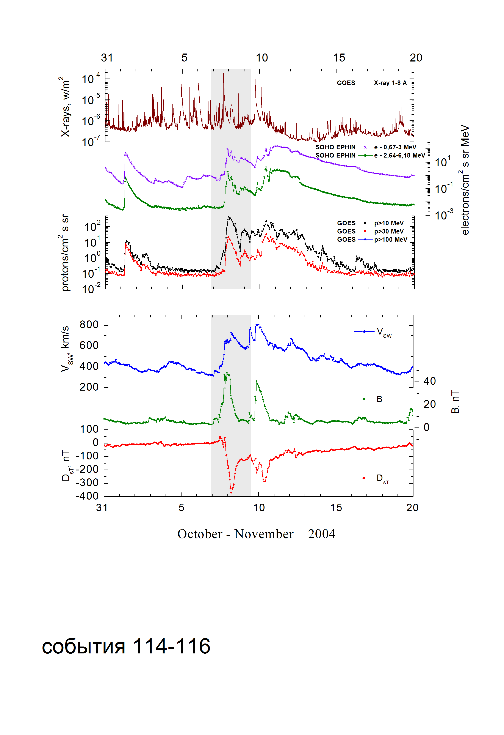
Integral time-of-maximum proton spectrum
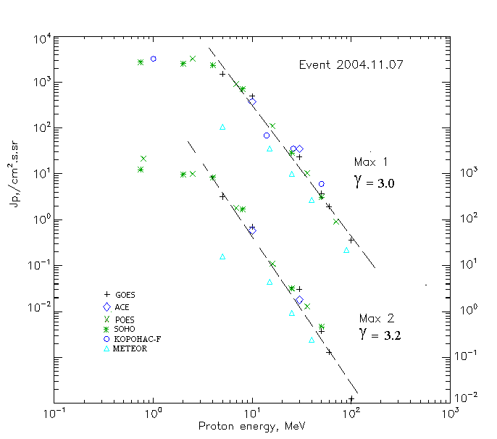

Integral fluxes of protons for the event of 2004.11.07

S/c,  instruments | Eр, MeV | To | Tmax | Jmax,  (cm².s.sr)⁻¹ | Dura-tion | Comments
GOES-10
EPS | >5 | 01^{h} | 23^{h}/09d00^{h} | 1.5·10³/320 | 2d
EPS | >10 | 01^{h} | 23^{h}/09d00^{h} | 490/70 | 2d
EPS | >30 | 01^{h} | 23^{h}/09d00^{h} | 23/3.1 | 2d
EPS | >50 | 01^{h} | 23^{h}/09d00^{h} | 3.7/0.37 | 2d
EPS | >60 | 01^{h} | 22^{h}/09d00^{h} | 1.9/0.13 | 2d
EPS | >100 | - | 22^{h}/08d23^{h} | 0.35/0.01 | 2d
METEOR
CBM | >5 | 18^{h} | 08d03^{h}/08d22^{h} | 107/16 | 2d
CBM | >15 | 18^{h} | 08d03^{h}/08d22^{h} | 35/4.4 | 2d
CBM | >25 | 18^{h} | 23^{h}/08d23^{h} | 10/0.95 | 2d
CBM | >40 | 18^{h} | 23^{h}/08d23^{h} | 2.7/0.24 | 2d
BP | >90 | 18^{h} | 08d00^{h}/ - | 0.22/ - | 2d
ChD | >600 | -
POES-16
MEPED | >0.24 | - | - | - | -
MEPED | >0.8 | - | - /08d23^{h} | - /2.2·10³ | 2d
MEPED | >2.5 | - | 24^{h}/08d23^{h} | 3.3·10³/1·10³ | 2d
MEPED | >6.9 | - | 24^{h}/08d23^{h} | 920/180 | 2d
MEPED | >16 | - | 22^{h}/08d23^{h} | 110/11 | 2d
MEPED | >36 | - | 22^{h}/08d23^{h} | 10.5/1.3 | 2d
MEPED | >70 | - | 22^{h}/ - | 0.9/ - | 2d
MEPED | >140 | - | - | - | -
CORONAS F
MKL | >1. | - | 08d01^{h}/ - | 3.2·10³/ - | 2d
MKL | >14 | - | 08d01^{h}/ - | 68/ - | 2d
MKL | >26 | - | 08d01^{h}/ - | 35/ - | 2d
MKL | >50 | - | 08d01^{h}/ - | 6/ - | 2d
ACE
SIS | >10 | 17^{h} | 21^{h}/09d00^{h} | 375/60 | 2d
SIS | >30 | 17^{h} | 21^{h}/09d00^{h} | 35/1.8 | 2d
SOHO
EPHIN (INT) | >50 | 17^{h} | 21^{h}/09d00^{h} | 3.1/0.46 | 2d

Differential fluxes of protons for the event of 2004.11.07

S/c,  instruments | ∆Е, MeV | To | Tmax | Jmax, (cm².s.sr.MeV)⁻¹ | Dura-tion | Comments
SOHO
LION | 0.75-2 | 08^{h} | 22^{h}/09d00^{h} | 155/213 | 2d
LION | 2-6 | 08^{h} | 22^{h}/09d00^{h} | 74.2/47.3 | 2d
EPHIN | 4-8 | 08^{h} | 21^{h}/09d00^{h} | 400/168 | 2d
EPHIN | 8-25 | 08^{h} | 21^{h}/09d00^{h} | 40/10 | 2d
EPHIN | 25-41 | 08^{h} | 21^{h}/09d00^{h} | 0.9/0.1 | 2d
EPHIN | 41-53 | - “ - | - “ - | - “ - | - “ -

References:
Kuwabara T., Bieber J.W., Clem J., et.al., 2006.
Веселовский И.С., Мягкова И.Н., Яковчук О.С., 2012.

