Event 2005.01.17 – (2005-017) – GLE-68

Particle event: To(Ep>10MeV) – 17d13^{h}
Tmax(Ep>10MeV) – 17d17^{h}, Jmax (Ep>10MeV) – 3.8·10³ /cm².s.sr
Duration of the event – 2 days
Energy of the SCR and 0.1 GCR fluxes balance – Eb = 750 MeV

Sources: ● solar flare 17d06^{h}09^{m}, X3.8/3N, N14W24, АR10720
Main X-ray burst 1-8 Ǻ onset – 17d06^{h}59^{m}, max – 17d09^{h}52^{m}, Ф = 0.84 J/m²
CME: 17d09^{h}30^{m}, V = 2094 km/s, Δφ = 360º, dA = 334˚
CME: 17d09^{h}54^{m}, V = 2547 km/s, Δφ = 360º, dA = 309˚

Particle fluxes and associated phenomena
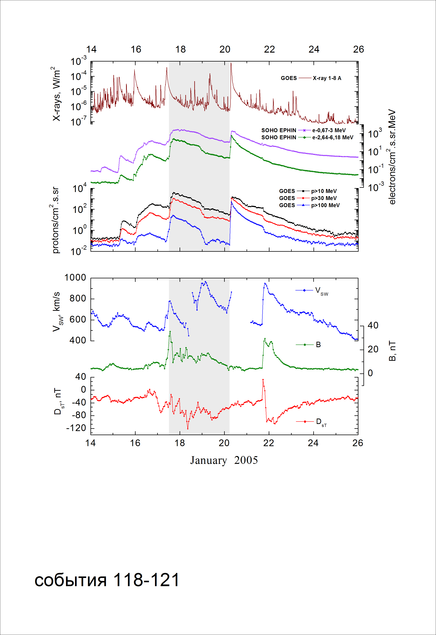

Integral time-of-maximum proton spectrum
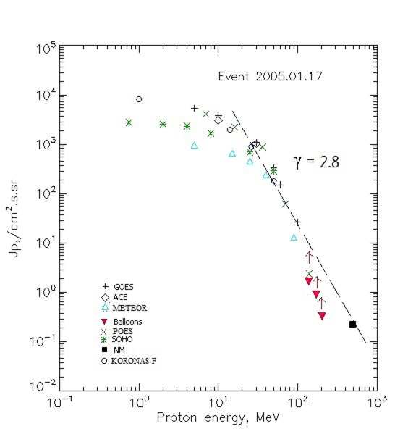

Integral fluxes of protons for the event of 2005.01.17

S/c,  instruments | Eр, MeV | To | Tmax | Jmax,  (cm².s.sr)⁻¹ | Dura-tion | Comments
GOES 10
EPS | >5 | 13^{h} | 17^{h} | 5310 | 2d
EPS | >10 | 13^{h} | 17^{h} | 3820 | 2d
EPS | >30 | 12^{h} | 17^{h} | 1090 | 2d
EPS | >50 | 12^{h} | 17^{h} | 330 | 2d
EPS | >60 | 09^{h} | 17^{h} | 150 | 2d
EPS | >100 | 09^{h} | 16^{h} | 26 | 2d
METEOR
CBM | >5 | 10 ^{h} | 22 ^{h} | 950 | 2d
CBM | >15 | 10 ^{h} | 20 ^{h} | 660 | 2d
CBM | >25 | 10 ^{h} | 18 ^{h} | 460 | 2d
CBM | >40 | 10 ^{h} | 18 ^{h} | 240 | 2d
BP | >90 | 10 ^{h} | 17 ^{h} | 13 | 2d
ChD | >600 | - | - | - | -
POES 16
MEPED | >0.24 | - | - | - | -
MEPED | >0.8 | - | - | - | -
MEPED | >2.5 | - | - | - | -
MEPED | >6.9 | - | 16^{h} | 4060 | 2d
MEPED | >16 | - | 16^{h} | 2210 | 2d
MEPED | >36 | - | 16^{h} | 880 | 2d
MEPED | >70 | - | 15^{h} | 62 | 2d
MEPED | >140 | - | 15^{h} | 2.35 | 2d
CORONAS F
MKL | >1 | - | 20^{h} | 8150 | 2d
MKL | >14 | - | 19^{h} | 1950 | 2d
MKL | >26 | - | 18^{h} | 890 | 2d
MKL | >50 | - | 17^{h} | 180 | 2d
ACE
SIS | >10 | 13^{h} | 16^{h} | 3040 | 2d
SIS | >30 | 11 | 16^{h} | 1020 | 2d
SOHO
EPHIN (INT) | >50 | 09^{h} | 17^{h} | 288 | 2d
BALLOONS
Mi | >138 |  | 18d06^{h} | 1.6 |  | After
Mi | >172 |  | 18d06^{h} | 0.87 |  | maximum
Mi | >203 |  | 18d06^{h} | 0.32 |  | - “ -
NM
Network | >500 | - | 16^{h} | 0.235 | -

Differential fluxes of protons for the event of 2005.01.17

S/c,  instruments | ∆Е, MeV | To | Tmax | Jmax, (cm².s.sr.MeV)⁻¹ | Dura-tion | Comments
SOHO
LION | 0.75-2 | 11^{h} | 18^{h} | 196 | 2d
LION | 2-6 | 11^{h} | 18^{h} | 67.2 | 2d
EPHIN | 4-8 | 10^{h} | 17^{h} | 163 | 2d
EPHIN | 8-25 | 10^{h} | 17^{h} | 57.7 | 2d
EPHIN | 25-41 | 10^{h} | 17^{h} | 14.4 | 2d
EPHIN | 41-53 | - “ - | - “ - | - “ - | - “ -
References:
Miroshnichenko L.I. and Perez-Peraza J., 2008.
Lario D., Decker R.B., and Aran A., 2008.
Lario D, Aran A, Decker R.B., 2009.
Веселовский И.С., Мягкова И.Н., Яковчук О.С., 2012.

