Event 2005.01.20 – (2005-020) - GLE-69

Particle event: To(Ep>10MeV) – 20d06^{h}
Tmax₁(Ep>10MeV) – 20d10^{h}, Jmax₁ (Ep>10MeV) – 1.1·10³ /cm².s.sr
Tmax₂(Ep>10MeV) – 21d17^{h}, Jmax₂ (Ep>10MeV) – 134 /cm².s.sr
Duration of the event – 4 days
Energy of the SCR and 0.1 GCR fluxes balance – Eb(max₁) = 3840 MeV
– Eb(max₂) = 1520 MeV
Sources: ● solar flare 20d06^{h}36^{m}, X7.1/2B, N12W58, AR10720
Main X-ray burst 1-8 Ǻ: onset – 20d06^{h}36^{m}, max – 20d07^{h}01^{m}, Ф = 1.3 J/m²
CME: 20d06^{h}54^{m}, V = 882 km/s, Δφ = 360º, dA = 288˚
▲SC 21d17^{h}11^{m}

Particle fluxes and associated phenomena
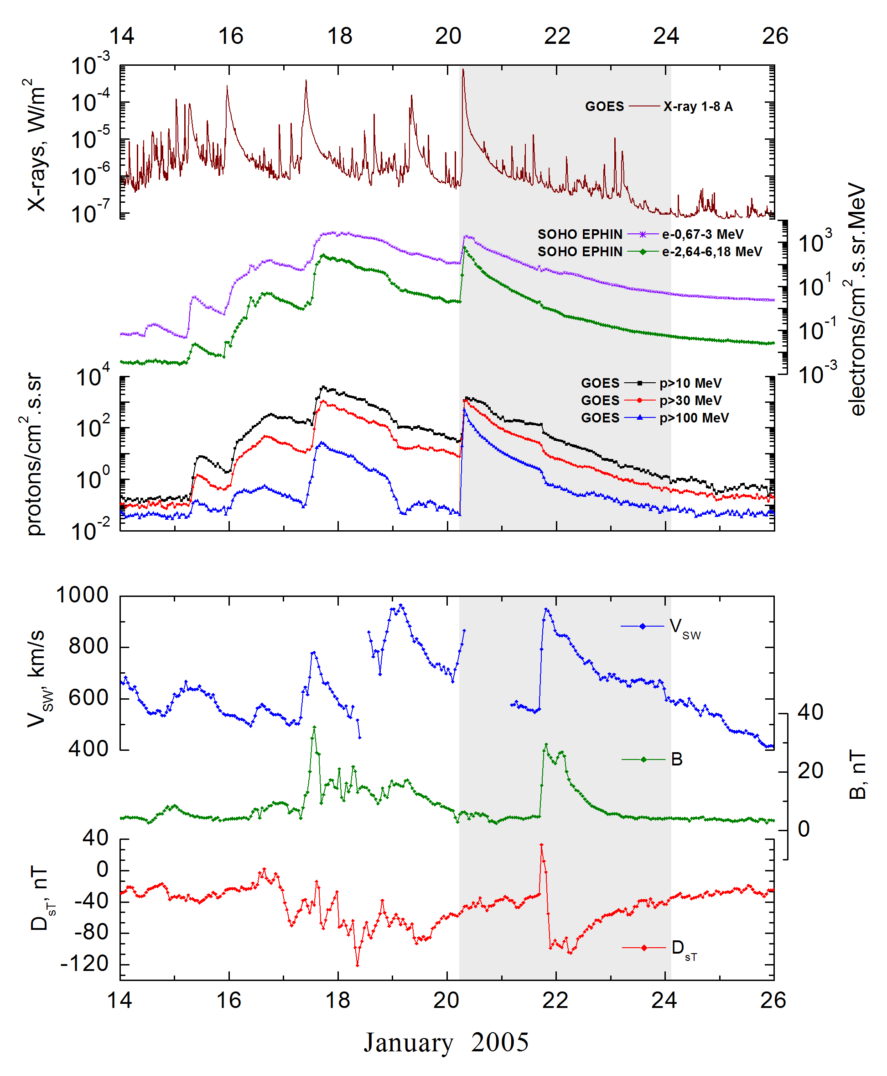
Integral time-of-maximum proton spectrum
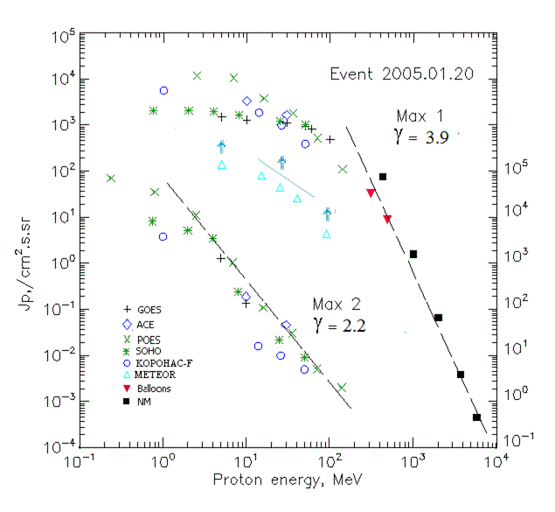
Integral fluxes of protons for the event of 2005.01.20

S/c,  instruments | Eр, MeV | To | Tmax | Jmax,  (cm².s.sr)⁻¹ | Dura-tion | Comments
GOES 10
EPS | >5 | 06^{h} | 12^{h}/21d17^{h} | 1490/1300 | 4d
EPS | >10 | 06^{h} | 10^{h}/21d17^{h} | 1310/134 | 4d
EPS | >30 | 06^{h} | 08^{h}/ - | 1130/ - | 4d
EPS | >50 | 06^{h} | 07^{h}/ - | 940/ - | 4d
EPS | >60 | 06^{h} | 07^{h}/ - | 820/ - | 4d
EPS | >100 | 06^{h} | 07^{h}/ - | 490/ - | 4d
METEOR
CBM | >5 | >03 ^{h} | <21d05^{h} | >140/ - | 5d
CBM | >15 | >03 ^{h} | <21d04^{h} | >81/ - | 5d
CBM | >25 | >03 ^{h} | <21d04^{h} | >45/ - | 5d
CBM | >40 | >03 ^{h} | <21d04^{h} | >26/ - | 3d
BP | >90 | >03 ^{h} | <21d04^{h} | >4.4/ - | 2d
ChD | >600 | - | - | - | -
POES 16
MEPED | >0.24 | - | - /21d18^{h} | - /70800 | 4d
MEPED | >0.8 | - | - /21d18^{h} | - /35000 | 4d
MEPED | >2.5 | - | 07^{h}/21d18^{h} | 11920/11000 | 4d
MEPED | >6.9 | - | 07^{h}/21d18^{h} | 10610/1050 | 4d
MEPED | >16 | - | 08^{h}/21d17^{h} | 3830/110 | 4d
MEPED | >36 | - | 08^{h}/21d17^{h} | 1810/30 | 4d
MEPED | >70 | - | 08^{h}/21d17^{h} | 520/5 | 4d
MEPED | >140 | - | 08^{h}/21d17^{h} | 110/2 | 4d
CORONAS F
MKL | >1 | - | 9^{h}/21d17^{h} | 5570/3800 | 4d
MKL | >14 | - | 9^{h}/21d17^{h} | 1850/16 | 4d
MKL | >26 | - | 9^{h}/21d17^{h} | 985/10 | 4d
MKL | >50 | - | 9^{h}/21d17^{h} | 385/5 | 4d
ACE
SIS | >10 | 06^{h} | 08^{h}/21d16^{h} | 3310/188 | 4d
SIS | >30 | 06^{h} | 08^{h}/21d16^{h} | 1660/45.6 | 4d
SOHO
EPHIN (INT) | >50 | 06^{h} | 07^{h}/21d16^{h} | 1030/9 | 3d
BALLOONS
Mu | >306 |  | 07^{h}45^{m}/ - | 32.7/ -
Mu | >482 |  | 07^{h}45^{m}/ - | 8.7/ -
Mu | >912 |  | 07^{h}45^{m}/ - | 1.15/ -
NM
Network | >433 | - | 07^{h}30^{m}/ - | 73.6/ - | -
Network | >1000 | - | 07^{h}30^{m}/ - | 1.57/ - | -
Network | >2000 | - | 07^{h}30^{m}/ - | 0.065/ - | -
Network | >3700 | - | 07^{h}30^{m}/ - | 0.0038/ - | -
Network | >5800 | - | 07^{h}30^{m}/ - | 0.00044/ - | -

Differential fluxes of protons for the event of 2005.01.20

S/c,  instruments | ∆Е, MeV | To | Tmax | Jmax, (cm².s.sr.MeV)⁻¹ | Dura-tion | Comments
SOHO
LION | 0.75-2 | 08^{h} | 12^{h}/21d17^{h} | 30/2430 | 5d
LION | 2-6 | 08^{h} | 12^{h}/21d17^{h} | 26/580 | 5d
EPHIN | 4-8 | 08^{h} | 11^{h}/21d16^{h} | 79/800 | 4d
EPHIN | 8-25 | 08^{h} | 11^{h}/21d16^{h} | 24.6/13 | 4d
EPHIN | 25-41 | 07^{h} | 08^{h}/21d15^{h} | 6.9/0.45 | 4d
EPHIN | 41-53 | - “ - | - “ - | - “ - | - “ -

References:
Struminsky A., 2005.
Bieber J.W., Clem J., Evenson P., et.al., 2005.
Kuwabara T., Bieber J.W., Clem J., et.al., 2006.
Струминский А.Б., 2006.
Le G.M., Tang Yu.H. and Han Y.B., 2006.
Kuznetsov S.N., Kurt V.G., Yushkov B.Yu., et.al., 2006.
Lario D., Decker R.B. and Aran A., 2008.
Miroshnichenko L.I. and Perez-Peraza, J., 2008.
Perez-Peraza J., Gallegos-Cruz A., Miroshnichenko L.I., et.al., 2008.
Grechnev V.V., Kurt, I.M V., Chertok G., et al., 2008.
Bombardieri D.J., Duldig M.L., Humble J.E., et.al., 2008.
Lario D., Aran A., Decker R.B., 2009.
Perez-Peraza J., Gallegos-Cruz A., Vashenyuk E.V., et.al.,2009.
Troitskaia E.V., Arkhangelskaja I.V., Miroshnichenko L.I., et.al., 2009.
Перес-Пераса Х.А., Веласко-Эррера В.М., Запотитла Х., et.al., 2011.
Мирошниченко Л.И., Перес-Пераса Х.А., Веласко-Эррера В.М., et.al., 2012.
Веселовский И.С., Мягкова И.Н., Яковчук О.С., 2012.
Miroshnichenko L.I. and Gan W.Q., 2012.
Velinov P., Mishev A., 2013.
Bieber, J.W., Clem, J., Evenson, P., et.al., 2013a.

