Event 2005.05.13 – (2005-133)

Particle event: To(Ep>10MeV) – 13d19^{h}
Tmax₁(Ep>10MeV) – 14d03^{h}, Jmax₁(Ep>10MeV) – 7.7 /cm².s.sr
Tmax₂(Ep>10MeV) – 14d14^{h}, Jmax₂(Ep>10MeV) – 155 /cm².s.sr
Tmax₃(Ep>10MeV) – 15d03^{h}, Jmax₃(Ep>10MeV) – 1.9·10³ /cm².s.sr
Duration of the event –2 days
Energy of the SCR and 0.1 GCR fluxes balance – Eb(max₁) = 300 MeV
– Eb(max₂) = 85 MeV
– Eb(max₃) = 85 MeV

Sources: ● solar flare 13d16^{h}13^{m}, M8/2B, N12E12, АR10759
Main X-ray burst 1-8 Ǻ: onset – 13d16^{h}13^{m}, max – 13d16^{h}57^{m}, Ф = 0.18 J/m²
CME: 13d17^{h}12^{m}, V = 1689 km/s, Δφ = 360º, dA = 002˚;
▲SC 15d02^{h}38^{m};

Particle fluxes and associated phenomena
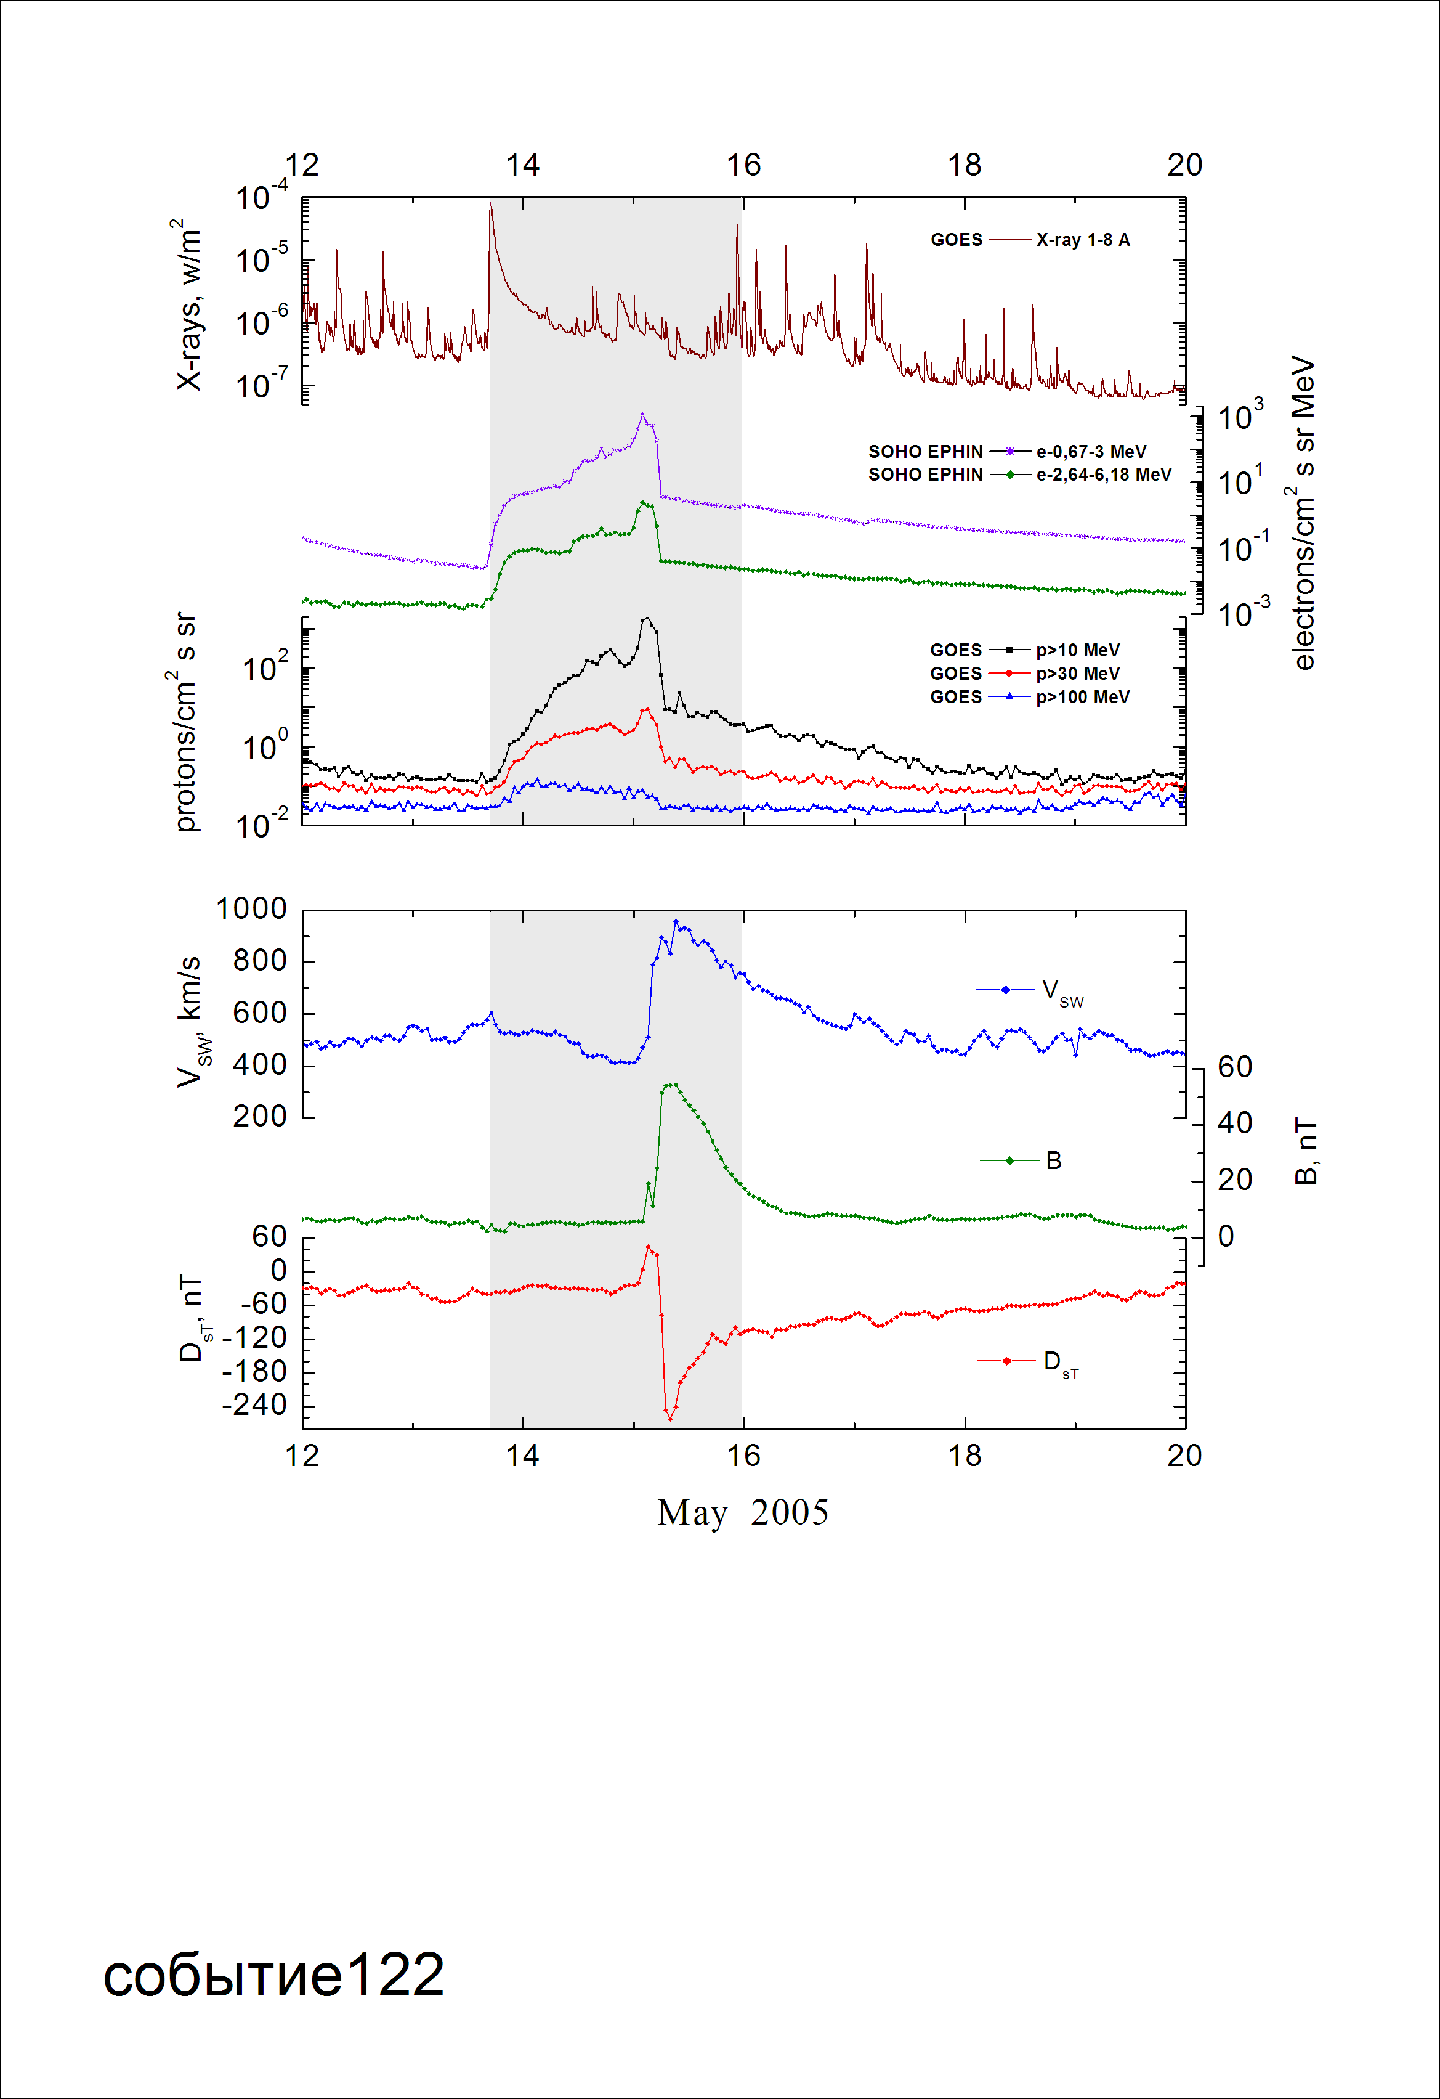
Integral time-of-maximum proton spectrum
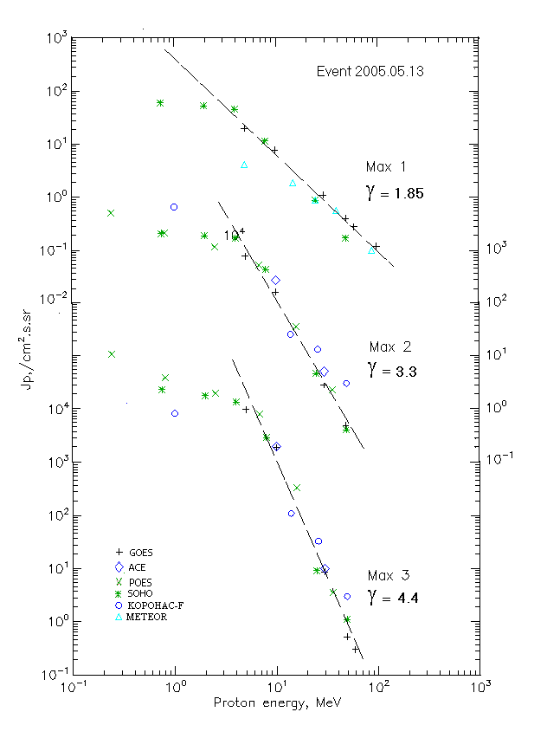

Integral fluxes of protons for the event of 2005.05.13

S/c, instruments | Eр, MeV | To | Tmax | Jmax,  (cm².s.sr)⁻¹ | Dura-tion | Comments
GOES-10
EPS | >5 | 19^{h} | 14d03^{h}/14d14^{h}/15d03^{h} | 19.7/740/1·10⁴ | 2d
EPS | >10 | 19^{h} | 14d03^{h}/14d14^{h}/15d03^{h} | 7.7/155/1.9·10³ | 2d
EPS | >30 | 20^{h} | 14d03^{h}/14d15^{h}/15d03^{h} | 1.1/2.8/8.7 | 2d
EPS | >50 | 20^{h} | 14d03^{h} /14d15^{h}/15d02^{h} | 0.4/0.4/0.52 | 2d
EPS | >60 | 20^{h} | 14d03^{h}/ - /15d02^{h} | 0.28/ - /0.3 | 2d
EPS | >100 | 20^{h} | 14d03^{h}/ - / - | 0.12/ - / - | 2d
METEOR
CBM | >5 | 19^{h} | 14d03 ^{h}/ - / - | 4,2/ - / - | 1d
CBM | >15 | 19^{h} | 14d03 ^{h}/ - / - | 1,9/ - / - | 1d
CBM | >25 | 19^{h} | 14d03 ^{h}/ - / - | 0,9/ - / - | 1d
CBM | >40 | 19^{h} | 14d01 ^{h}/ - / - | 0,56/ - / - | 1d
BP | >90 | 19^{h} | 14d01 ^{h}/ - / - | 0,1/ - / - | 1d
ChD | >600 | - | - | - | -
POES-16
MEPED | >0.24 | - | - /14d14^{h}/15d03^{h} | - /4900/110000 | 2d
MEPED | >0.8 | - | - /14d14^{h}/15d03^{h} | - /2000/40000 | 2d
MEPED | >2.5 | - | - /14d14^{h}/15d03^{h} | - /1100/20000 | 2d
MEPED | >6.9 | - | - /14d14^{h}/15d03^{h} | - /500/8000 | 2d
MEPED | >16 | - | - /14d14^{h}/15d03^{h} | - /35/330 | 2d
MEPED | >36 | - | - /14d14^{h}/15d03^{h} | - /2.3/3.5 | 2d
MEPED | >70 | - | - /14d14^{h}/ - | - /-/ - | 2d
MEPED | >140 | - | - /14d14^{h}/ - | - /-/ - | 2d
CORONAS F
MKL | >1. | - | - /14d14^{h}/15d02^{h} | -/6300/8300 | 2d
MKL | >14 | - | - /14d14^{h}/15d02^{h} | -/25///110 | 2d
MKL | >26 | - | - /14d14^{h}/15d02^{h} | -/13/33 | 2d
MKL | >50 | - | - /14d14^{h}/15d02^{h} | -/3/3// | 2d
ACE
SIS | >10 | 19^{h} | - /14d14^{h}/15d02^{h} | - /262/2·10³ | 3d
SIS | >30 | 19^{h} | - /14d14^{h}/15d02^{h} | - /5/10 | 2d
SOHO
EPHIN (INT) | >50 | 21^{h} | 14d04^{h}/14d13^{h}/15d03^{h} | 0.17/0.4/1.1 | 1d

Differential fluxes of protons for the event of 2005.05.13

S/c, instruments | ∆Е, MeV | To | Tmax | Jmax, (cm².s.sr.MeV)⁻¹ | Dura-tion | Comments
SOHO
LION | 0.75-2 | 21^{h} | 14d02 ^{h}/14d14^{h}/15d03^{h} | 6.2/148/4.3·10³ | 4d
LION | 2-6 | 18^{h} | 14d02 ^{h}/14d14^{h}/15d03^{h} | 2.4/57/1.5·10³ | 4d
EPHIN | 4-8 | 21^{h} | 14d02 ^{h}/14d14^{h}/15d03^{h} | 8.5/304/2.7·10³ | 4d
EPHIN | 8-25 | 20^{h} | 14d02 ^{h}/14d14^{h}//15d03^{h} | 0.62/24.1/173 | 4d
EPHIN | 25-41 | 18^{h} | 14d02 ^{h}/14d14^{h}/15d03^{h} | 0.025/0.15/0.29 | 4d
EPHIN | 41-53 | - “ - | - “ - | - “ - | - “ -

References:
No information on publications, excepting for:
http://www.swpc.noaa.gov/ftpdir/indices/SPE.txt

