Event 2005.06.16– (2005-167)

Particle event: To(Ep>10MeV) – 16d20^{h}
Tmax(Ep>10MeV) – 17d04^{h}, Jmax (Ep>10MeV) – 41 /cm².s.sr
Duration of the event – 2 days
Energy of the SCR and 0.1 GCR fluxes balance – Eb = 510 MeV

Sources: ● solar flare 16d20^{h}01^{m}, M4/SF, N09W87, АR10775
Main X-ray burst 1-8 Ǻ: onset – 16d20^{h}01^{m}, max – 16d20^{h}22^{m}, Ф = 0.062 J/m²
CME: gap

Particle fluxes and associated phenomena
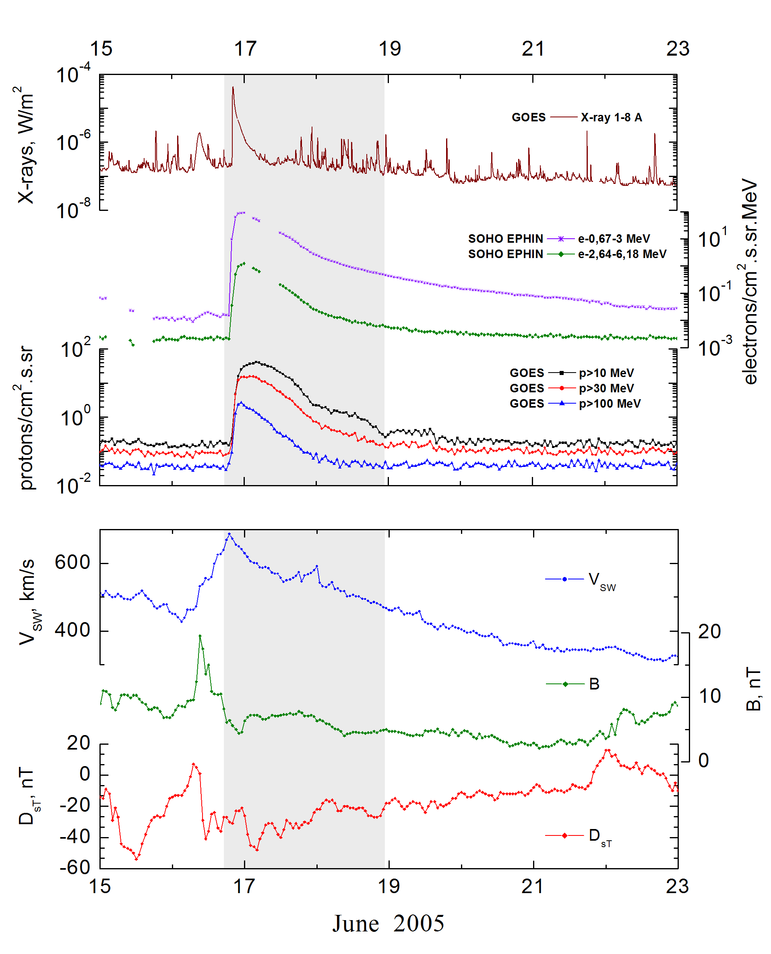
Integral time-of-maximum proton spectrum
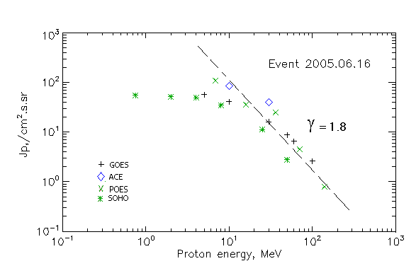

Integral fluxes of protons for the event of 2005.06.16

S/c, instruments | Eр, MeV | To | Tmax | Jmax,  (cm².s.sr)⁻¹ | Dura-tion | Comments
GOES-10
EPS | >5 | 20^{h} | 17d04^{h} | 57 | 2d
EPS | >10 | 20^{h} | 17d04^{h} | 41 | 2d
EPS | >30 | 20^{h} | 17d02^{h} | 16 | 2d
EPS | >50 | 20^{h} | 23^{h} | 8.7 | 2d
EPS | >60 | 20^{h} | 23^{h} | 6.5 | 2d
EPS | >100 | 20^{h} | 23^{h} | 2.6 | 2d
POES-16
MEPED | >0.24 | 20^{h} | - | - | -
MEPED | >0.8 | 20^{h} | - | - | -
MEPED | >2.5 | 20^{h} | - | - | -
MEPED | >6.9 | 20^{h} | 23^{h} | 110 | 2d
MEPED | >16 | 20^{h} | 23^{h} | 36 | 2d
MEPED | >36 | 20^{h} | 23^{h} | 25 | 2d
MEPED | >70 | 20^{h} | 23^{h} | 4.5 | 2d
MEPED | >140 | 20^{h} | 23^{h} | 0.8 | 2d
ACE
SIS | >10 | 20^{h} | 17d02^{h} | 84.5 | 2d
SIS | >30 | 20^{h} | 17d02^{h} | 40 | 1d
SOHO
EPHIN (INT) | >50 | 21^{h} | 17d01^{h} | 2.8 | 1d
Differential fluxes of protons for the event of 2005.06.16

S/c, instruments | ∆Е, MeV | To | Tmax | Jmax, (cm².s.sr.MeV)⁻¹ | Dura-tion | Comments
SOHO
LION | 0.75-2 | 22^{h} | 17d04^{h} | 2.3 | 3d
LION | 2-6 | 22^{h} | 17d04^{h} | 0.9 | 3d
EPHIN | 4-8 | 23^{h} | 17d04^{h} | 3.5 | 3d
EPHIN | 8-25 | 22^{h} | 17d04^{h} | 1.4 | 2d
EPHIN | 25-41 | 22^{h} | 17d01^{h} | 0.3 | 2d
EPHIN | 41-53 | - “ - | - “ - | - “ - | - “ -

References:
Mu J., Wang J.S., Zhao H.J., et.al., 2010.
Веселовский И.С., Мягкова И.Н., Яковчук О.С., 2012.

