Event 2005.07.10 – (2005-191)

Particle event: To(Ep>10MeV) – 10d03^{h}
Tmax₁(Ep>10MeV) – 10d05^{h}, Jmax₁(Ep>10MeV) – 1.1 /cm².s.sr
Tmax₂(Ep>10MeV) – 10d12^{h}, Jmax₂(Ep>10MeV) – 1.9 /cm².s.sr
Duration of the event – 2.5 days
Energy of the SCR and 0.1 GCR fluxes balance – Eb(max₁) = 75 MeV
– Eb(max₂) = 70 MeV

Sources: ● solar flare 09d21^{h}47^{m}, M2.8/1N, N11W27, АR10786
Main X-ray burst 1-8 Ǻ: onset – 09d21^{h}47^{m}, max – 09d22^{h}06^{m}, Ф = 0.029 J/m²
CME: 09d22^{h}30^{m}, V = 1540 km/s, Δφ = 360º, dA = 328˚;
▲SC 10d03^{h}37^{m};

Particle fluxes and associated phenomena
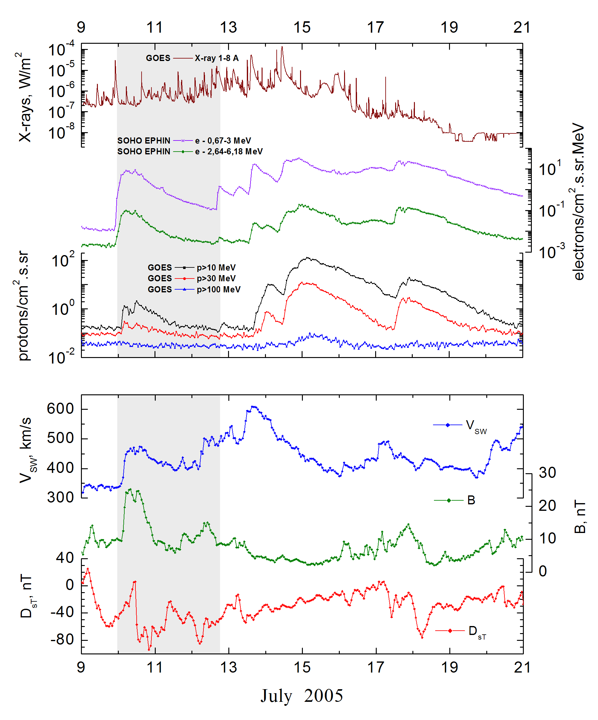
Integral time-of-maximum proton spectrum
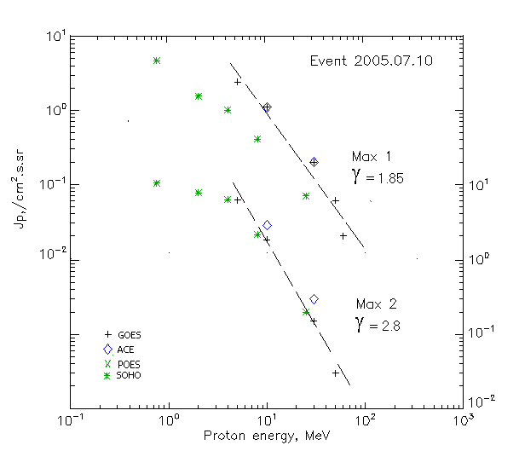

Integral fluxes of protons for the event of 2005.07.10

S/c, instruments | Eр, MeV | To | Tmax | Jmax,  (cm².s.sr)⁻¹ | Dura-tion | Comments
GOES-10
EPS | >5 | 03^{h} | 05^{h}/12^{h} | 2.4/6.5 | 2.5d
EPS | >10 | 03^{h} | 05^{h}/12^{h} | 1.1/1.9 | 2.5d
EPS | >30 | 03^{h} | 04^{h}/12^{h} | 0.2/0.15 | 2.5d
EPS | >50 | - | 04^{h}/12^{h} | 0.06/0.03 | 2d
EPS | >60 | - | 04^{h}/12^{h} | 0.02/0.01 | 2d
EPS | >100 | - | - | - | -
ACE
SIS | >10 | 01^{h} | 05^{h}/11^{h} | 1.1/3 | 1d
SIS | >30 | 02^{h} | 05^{h}/12^{h} | 0.2/0.3 | 1d
SOHO
EPHIN (INT) | >50 | - | - | - | -

Differential fluxes of protons for the event of 2005.07.10

S/c, instruments | ∆Е, MeV | To | Tmax | Jmax, (cm².s.sr.MeV)⁻¹ | Dura-tion | Comments
SOHO
LION | 0.75-2 | 05^{h} | 06^{h}/11 ^{h} | 2.5/2.4 | 2.5d
LION | 2-6 | 05^{h} | 06^{h}/11 ^{h} | 0.18/0.5 | 2.5d
EPHIN | 4-8 | 04^{h} | - /11^{h} | - /1.1 | 2.5d
EPHIN | 8-25 | 02^{h} | - /11^{h} | - /0.12 | 2.5d
EPHIN | 25-41 | 01^{h} | - /11^{h} | - /0.31 | 2.5d
EPHIN | 41-53 | - “ - | - “ - | - “ - | - “ -

References:
No information on publications, excepting for:
http://www.swpc.noaa.gov/ftpdir/indices/SPE.txt

