Event 2005.07.14 – (2005-195)

Particle event: To(Ep>10MeV) – 14d14^{h}
Tmax(Ep>10MeV) – 15d03^{h}, Jmax (Ep>10MeV) – 130 /cm².s.sr
Duration of the event – 3 days
Energy of the SCR and 0.1 GCR fluxes balance – Eb = 185 MeV

Sources: ■ solar flare 14d10^{h}16^{m}, X1.2/…, N11W90, АR10786
Ø solar flare 14d05^{h}57^{m}, M9.1/1N, N11W73, АR10786
Ø solar flare 14d22^{h}50^{m}, M1.1/…, N09W90, АR10786
Main X-ray burst 1-8 Ǻ: onset – 14d10^{h}16^{m}, max – 14d10^{h}55^{m}, Ф = 0,39 J/m²
CME: 14d10^{h}54^{m}, V = 2115 km/s, Δφ =360º, dA = 296˚;
▲SC 17d01^{h}34^{m};

Particle fluxes and associated phenomena
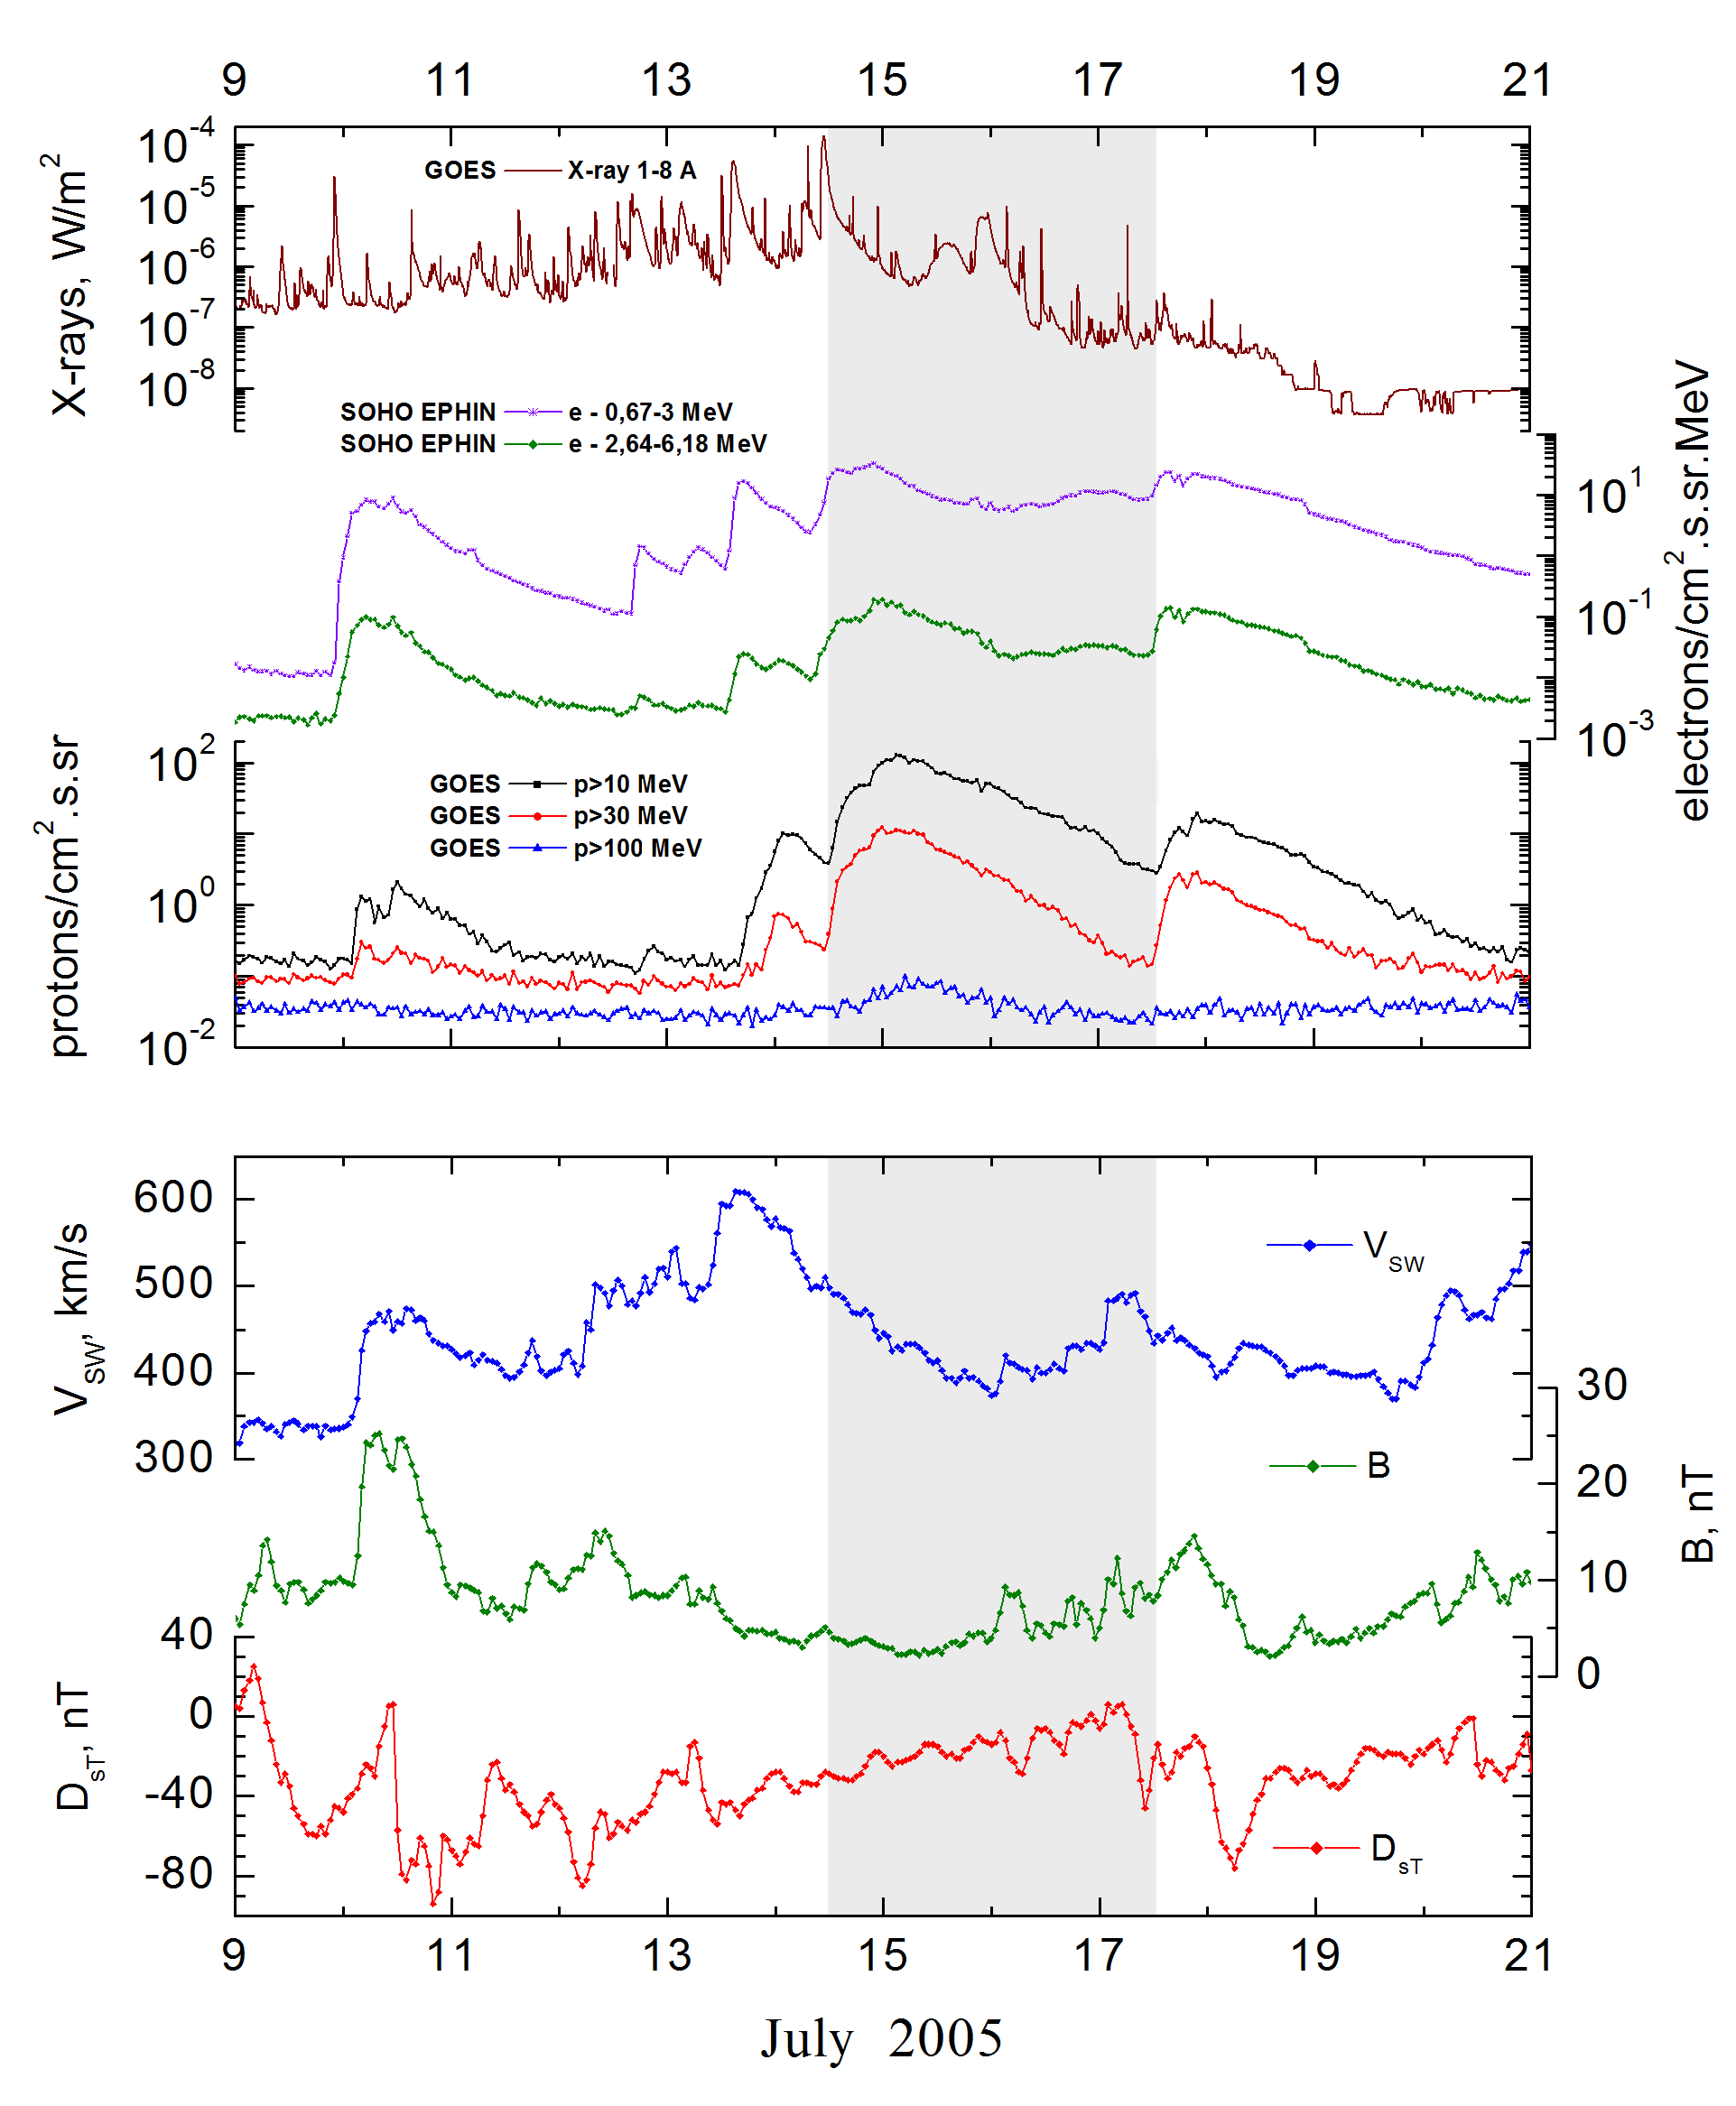
Integral time-of-maximum proton spectrum
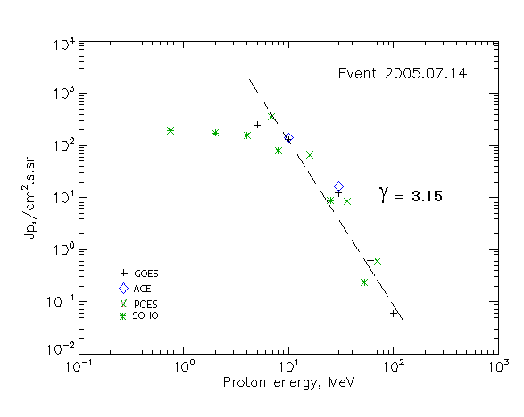

Integral fluxes of protons for the event of 2005.07.14

S/c, instruments | Eр, MeV | To | Tmax | Jmax,  (cm².s.sr)⁻¹ | Dura-tion | Comments
GOES-10
EPS | >5 | 14^{h} | 15d04^{h} | 250 | 3d
EPS | >10 | 14^{h} | 15d03^{h} | 130 | 3d
EPS | >30 | 14^{h} | 15d00^{h} | 12.3 | 3d
EPS | >50 | 14^{h} | 15d05^{h} | 2.08 | 3d
EPS | >60 | 14^{h} | 15d05^{h} | 0.63 | 3d
EPS | >100 | -. | 15d05^{h} | 0.06 | 3d
POES-16
MEPED | >0.24 | - | ⁻ | - | -
MEPED | >0.8 | - | ⁻ | - | -
MEPED | >2.5 | - | ⁻ | - | -
MEPED | >6.9 | - | 15d00^{h} | 350 | 3d
MEPED | >16 | - | 15d05^{h} | 65 | 3d
MEPED | >36 | - | 15d05^{h} | 8.4 | 3d
MEPED | >70 | - | 15d05^{h} | 0.6 | 3d
MEPED | >140 | - | ⁻ | -. | -
ACE
SIS | >10 | 13^{h} | 15d01^{h} | 141 | 3d
SIS | >30 | 12^{h} | 15d02^{h} | 16.4 | 3d
SOHO
EPHIN (INT) | >50 | 14^{h} | 15d01^{h} | 0.26 | 2d

Differential fluxes of protons for the event of 2005.07.14

S/c, instruments | ∆Е, MeV | To | Tmax | Jmax, (cm².s.sr.MeV)⁻¹ | Dura-tion | Comments
SOHO
LION | 0.75-2 | 15^{h} | 15d02^{h} | 14.4 | 3d
LION | 2-6 | 15^{h} | 15d01^{h} | 5.4 | 3d
EPHIN | 4-8 | 15^{h} | 15d04^{h} | 20 | 3d
EPHIN | 8-25 | 15^{h} | 15d04^{h} | 4.1 | 3d
EPHIN | 25-41 | 15^{h} | 15d03^{h} | 0.3 | 3d
EPHIN | 41-53 | - “ - | - “ - | - “ - | - “ -

References:
Чернетский В.А., Лившиц М.А., Кашапова Л.К. и др., 2009.

