Event 2005.07.17 – (2005-198)

Particle event: To(Ep>10MeV) – 17d14^{h}
Tmax₁(Ep>10MeV) – 17d18^{h}, Jmax₁(Ep>10MeV) – 12 /cm².s.sr
Tmax₂(Ep>10MeV) – 17d22^{h}, Jmax₂(Ep>10MeV) – 19 /cm².s.sr
Duration of the event – 3 days
Energy of the SCR and 0.1 GCR fluxes balance – Eb(max₁) = 85 MeV
– Eb(max₂) = 85 MeV
Sources: ⊙ solar flare 17d10^{h}25^{m}, B1.1/…, N13W9, АR10786 - 3d behind W limb;
Main X-ray burst 1-8 Ǻ: onset – 17d10^{h}25^{m}, max – 17d10^{h}32^{m}, Ф = 0,00013 J/m²
CME: 17d11^{h}30^{m}, V = 1527 km/s, Δφ = 360º, dA=316˚;

Particle fluxes and associated phenomena
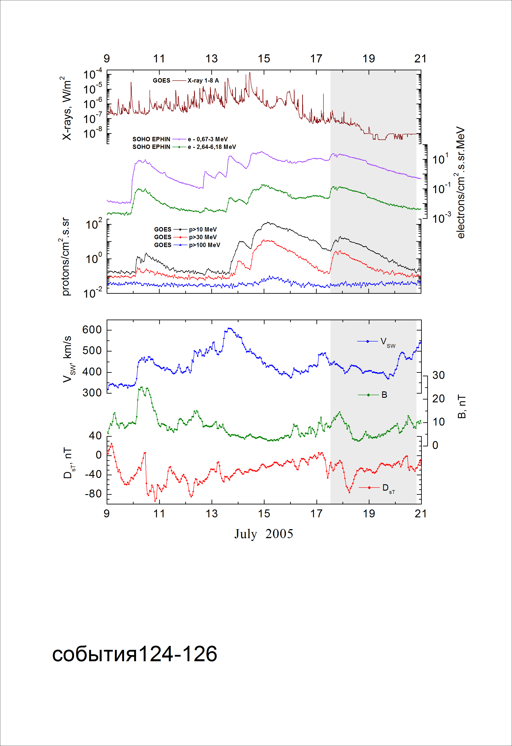
Integral time-of-maximum proton spectrum
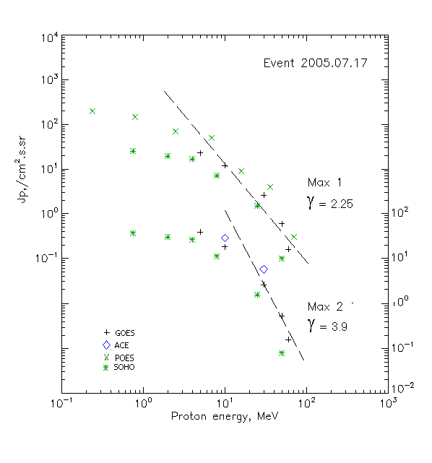

Integral fluxes of protons for the event of 2005.07.17

S/c, instruments | Eр, MeV | To | Tmax | Jmax,  (cm².s.sr)⁻¹ | Dura-tion | Comments
GOES-10
EPS | >5 | 14^{h} | 18^{h}/22^{h} | 23/41 | 3d
EPS | >10 | 14^{h} | 18^{h}/22 ^{h} | 12/19 | 3d
EPS | >30 | 13^{h} | 18^{h}/22 ^{h} | 2.6/2.7 | 3d
EPS | >50 | 13^{h} | 18^{h}/22 ^{h} | 0.6/0.54 | 2d
EPS | >60 | 13^{h} | 18^{h}/22 ^{h} | 0.16/0.16 | 2d
EPS | >100 | - | - | - | -
POES-16
MEPED | >0.24 | - | 18^{h}/- | 230/ - | 3d
MEPED | >0.8 | - | 18^{h}/- | 150/ - | 3d
MEPED | >2.5 | - | 18^{h}/- | 70/ - | 3d
MEPED | >6.9 | - | 18^{h}/- | 50/ - | 3d
MEPED | >16 | - | 18^{h}/- | 9/ - | 3d
MEPED | >36 | - | 18^{h}/- | 4/ - | 2d
MEPED | >70 | - | 18^{h}/- | 0.3/ - | 2d
MEPED | >140 | - | - | - | -
ACE
SIS | >10 | 14^{h} | - /21^{h} | - /30 | 2.5d
SIS | >30 | 13^{h} | - /20^{h} | - /6 | 2d
SOHO
EPHIN (INT) | >50 | 15^{h} | 19^{h}/22 ^{h} | 0.1/0.08 | 1d

Differential fluxes of protons for the event of 2005.07.17

S/c, instruments | ∆Е, MeV | To | Tmax | Jmax, (cm².s.sr.MeV)⁻¹ | Dura-tion | Comments
SOHO
LION | 0.75-2 | 12^{h} | 19^{h}/23 ^{h} | 4.9/5.85 | 4d
LION | 2-6 | 12^{h} | 19^{h}/23 ^{h} | 0.9/1.3 | 4d
EPHIN | 4-8 | 12^{h} | 19^{h}/23 ^{h} | 2.4/4 | 3d
EPHIN | 8-25 | 15^{h} | 19^{h}/23 ^{h} | 0.33/0.6 | 3d
EPHIN | 25-41 | 15^{h} | 19^{h}/23 ^{h} | 0.05/0.054 | 3d
EPHIN | 41-53 | - “ - | - “ - | - “ - | - “ -

References:
No information on publications, excepting for:
http://www.swpc.noaa.gov/ftpdir/indices/SPE.txt

