Event 2005.07.31 – (2005-212)

Particle event: To(Ep>10MeV) – 31d22^{h}
Tmax₁(Ep>10MeV) – 01d05^{h}, Jmax₁(Ep>10MeV) – 21 /cm².s.sr
Tmax₂(Ep>10MeV) – 02d01^{h}, Jmax₂(Ep>10MeV) – 6 /cm².s.sr
Duration of the event – 5 days
Energy of the SCR and 0.1 GCR fluxes balance – Eb(max₁) = 65 MeV
– Eb(max₂) = 65 MeV
Sources: ๏ solar flare 30d06^{h}17^{m}, X1.3/2B, N12E61, АR10792
Main X-ray burst 1-8 Ǻ: onset – 30d16^{h}17^{m}, max – 30d06^{h}35^{m}, Ф = 0.230 J/m²
CME: 30d06^{h}50^{m}, V = 1968 km/s, Δφ = 360º, dA = 050˚....

Particle fluxes and associated phenomena
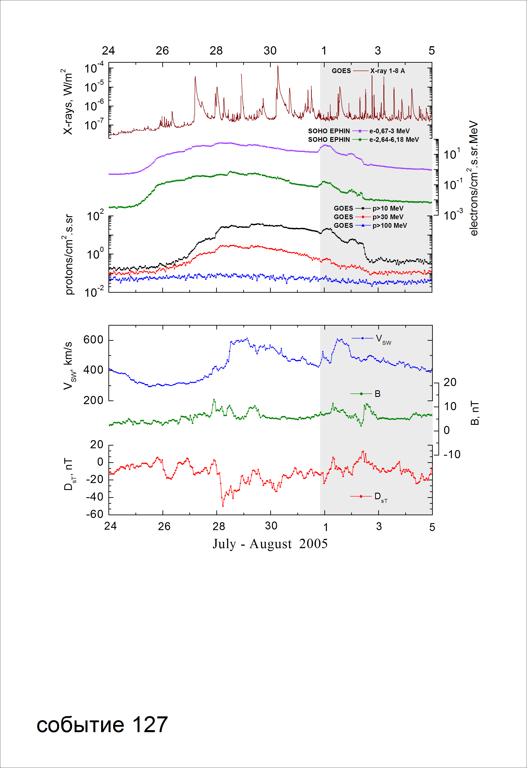
Integral time-of-maximum proton spectrum

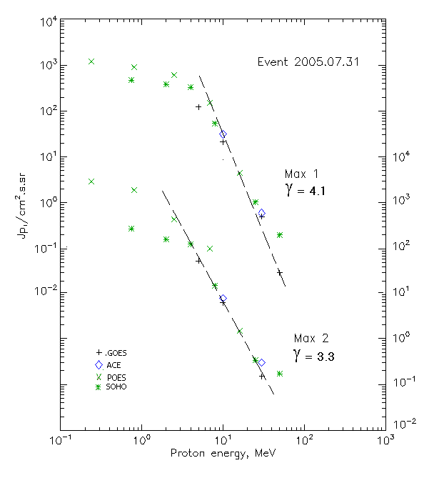

Integral fluxes of protons for the event of 2005.07.31

S/c, instruments | Eр, MeV | To | Tmax | Jmax,  (cm².s.sr)⁻¹ | Dura-tion | Comments
GOES-10
EPS | >5 | 22^{h} | 01d06^{h}/02d02^{h} | 122/49.3 | 6d
EPS | >10 | 22^{h} | 01d05^{h}/02d01^{h} | 21/6 | 5d
EPS | >30 | 22^{h} | 01d02^{h}/02d00^{h} | 0.5/0.15 | 2d
EPS | >50 | 22^{h} | 01d02^{h}/ - | 0.03/ - | 1d
EPS | >60 | 22^{h} | - | -
EPS | >100 | - | - | - | -
POES-16
MEPED | >0.24 | - | 01d06^{h}/02d04^{h} | 1230/2620 | 6d
MEPED | >0.8 | - | 01d06^{h}/02d04^{h} | 910/1710 | 6d
MEPED | >2.5 | - | 01d06^{h}/02d02^{h} | 640/390 | 6d
MEPED | >6.9 | - | 01d05^{h}/02d02^{h} | 150/90 | 5d
MEPED | >16 | - | 01d05^{h}/02d02^{h} | 4.5/1.5 | 5d
MEPED | >36 | - | - | - | -
MEPED | >70 | - | - | - | -
MEPED | >140 | - | - | - | -
ACE
SIS | >10 | 22^{h} | 01d05^{h}/02d02^{h} | 31.3/7.6 | 6d
SIS | >30 | - | 01d05^{h}/02d01^{h} | 0.6/0.3 | 2d
SOHO
EPHIN (INT) | >50 | 24d00 ^{h} | 01d05^{h}/02d03^{h} | 0.2/0.17 | 1.5d

Differential fluxes of protons for the event of 2005.07.31

S/c, instruments | ∆Е, MeV | To | Tmax | Jmax, (cm².s.sr.MeV)⁻¹ | Dura-tion | Comments
SOHO
LION | 0.75-2 | 22^{h} | 01d07^{h}/02d04^{h} | 78/80.5 | 6d
LION | 2-6 | 22^{h} | 01d07^{h}/02d03^{h} | 16.2/9.7 | 6d
EPHIN | 4-8 | 21^{h} | 01d07^{h}/02d04^{h} | 68.3/25.1 | 6d
EPHIN | 8-25 | 21^{h} | 01d07^{h}/02d02^{h} | 3.1/0.82 | 6d
EPHIN | 25-41 | 24d00^{h} | 01d05^{h}/02d02^{h} | 0.03/0.006 | 6d
EPHIN | 41-53 | - “ - | - “ - | - “ - | - “ -

References:
No information on publications, excepting for:
http://www.swpc.noaa.gov/ftpdir/indices/SPE.txt

