Event 2005.08.22 – (2005-234)

Particle event: To(Ep>10MeV) – 22d03^{h}
Tmax(Ep>10MeV) – 22d07^{h}, Jmax (Ep>10MeV) – 5.4 /cm².s.sr
Duration of the event – 0.7 day
Energy of the SCR and 0.1 GCR fluxes balance – Eb = 80 MeV

Sources: ● solar flare 22d00^{h}44^{m}, M2.6/1F, S09W48, АR10798
Main X-ray burst 1-8 Ǻ: onset – 22d00^{h}44^{m}, max – 22d01^{h}33^{m}, Ф = 0.096 J/m²
CME: 22d01^{h}32^{m}, V=1194 km/s, Δφ = 360º, dA= 220º

Particle fluxes and associated phenomena
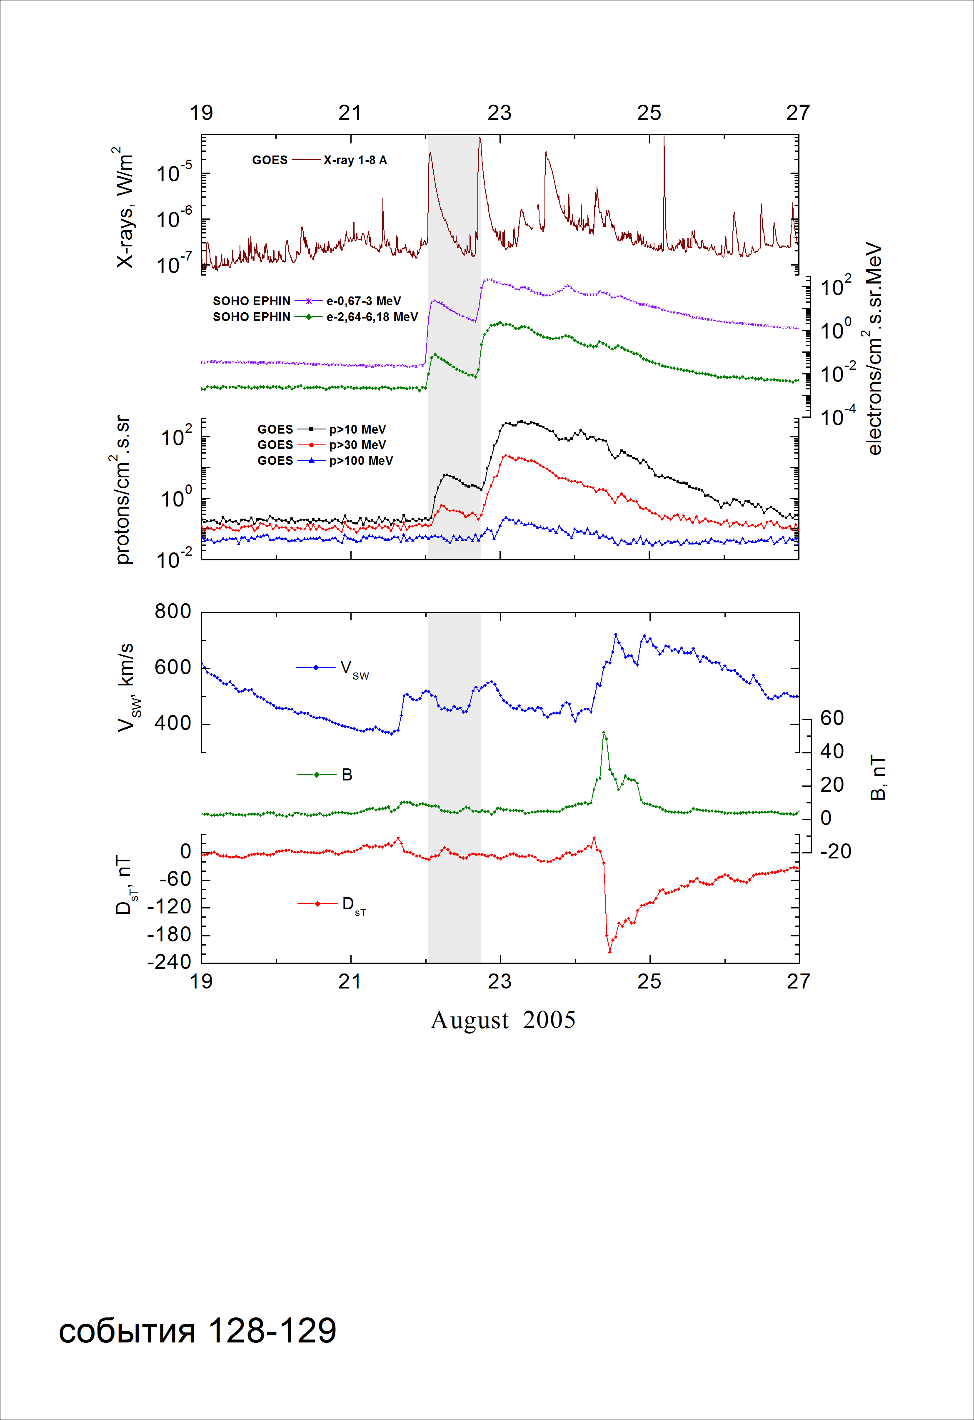
Integral time-of-maximum proton spectrum
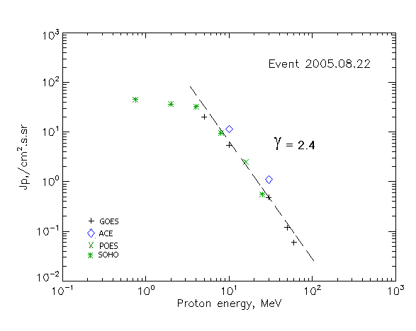

Integral fluxes of protons for the event of 2005.08.22

S/c, instruments | Eр, MeV | To | Tmax | Jmax,  (cm².s.sr)⁻¹ | Dura-tion | Comments
GOES-10
EPS | >5 | 03^{h} | 08^{h} | 20.1 | 0.7d
EPS | >10 | 03^{h} | 07^{h} | 5.4 | 0.7d
EPS | >30 | 03^{h} | 05^{h} | 0.48 | 0.7d
EPS | >50 | 03^{h} | 05^{h} | 0.12 | 0.7d
EPS | >60 | 03^{h} | 05^{h} | 0.06 | 0.7d
EPS | >100 | - | - | - | -
POES-16
MEPED | >0.24 | - | - | - | -
MEPED | >0.8 | - | - | - | -
MEPED | >2.5 | - | - | - | -
MEPED | >6.9 | - | - | - | -
MEPED | >16 | - | 07^{h} | 2.5 | 1d
MEPED | >36 | - | - | - | -
MEPED | >70 | - | - | - | -
MEPED | >140 | - | - | - | -
ACE
SIS | >10 | 03^{h} | 06^{h} | 11.4 | 0.7d
SIS | >30 | 03^{h} | 05^{h} | 1.1 | 0.7d
SOHO
EPHIN (INT) | >50 | - | - | - | -

Differential fluxes of protons for the event of 2005.08.22

S/c, instruments | ∆Е, MeV | To | Tmax | Jmax, (cm².s.sr.MeV)⁻¹ | Dura-tion | Comments
SOHO
LION | 0.75-2 | 03^{h} | 10^{h}/ | 7.4 | 0.7d
LION | 2-6 | 03^{h} | 07^{h}/ | 1.15 | 0.7d
EPHIN | 4-8 | 03^{h} | 09^{h} | 5.8 | 0.7d
EPHIN | 8-25 | 03^{h} | 06^{h} | 0.53 | 0.7d
EPHIN | 25-41 | 03^{h} | 06^{h} | 0.02 | 0.7d

References:
No information on publications, excepting for:
http://www.swpc.noaa.gov/ftpdir/indices/SPE.txt

