Event 2005.09.07 – (2005-250)

Particle event: To(Ep>10MeV) – 07d21^{h}
Tmax₁(Ep>10MeV) – 08d20^{h}, Jmax₁(Ep>10MeV) – 70 /cm².s.sr
Tmax₂(Ep>10MeV) – 10d11^{h}, Jmax₂(Ep>10MeV) –1000 /cm².s.sr
Duration of the event – 5 days
Energy of the SCR and 0.1 GCR fluxes balance – Eb(max₁) = 800 MeV
– Eb(max₂) = 555 MeV
Sources: ● solar flare 07d17^{h}17^{m}, X17.0/3B, S06E89, АR10808
Ø solar flare 08d20^{h}52^{m}, X5.4/2B, S12E62, АR10808
Ø solar flare 09d09^{h}42^{m}, X3.6/1N, S11E64, АR10808
Ø solar flare 09d19^{h}13^{m}, X6.2/2B, S12E67, АR10808
Ø solar flare 10d21^{h}30^{m}, X2.1/..., S13E47, АR10808
Main X-ray burst 1-8 Ǻ: onset – 07d17^{h}17^{m}, max – 07d17^{h}40^{m}, Ф = 2.6 J/m²
CME: gap
▲ SC 09d14^{h}01^{m}; Δ SC 11d01^{h}14^{m}

Particle fluxes and associated phenomena
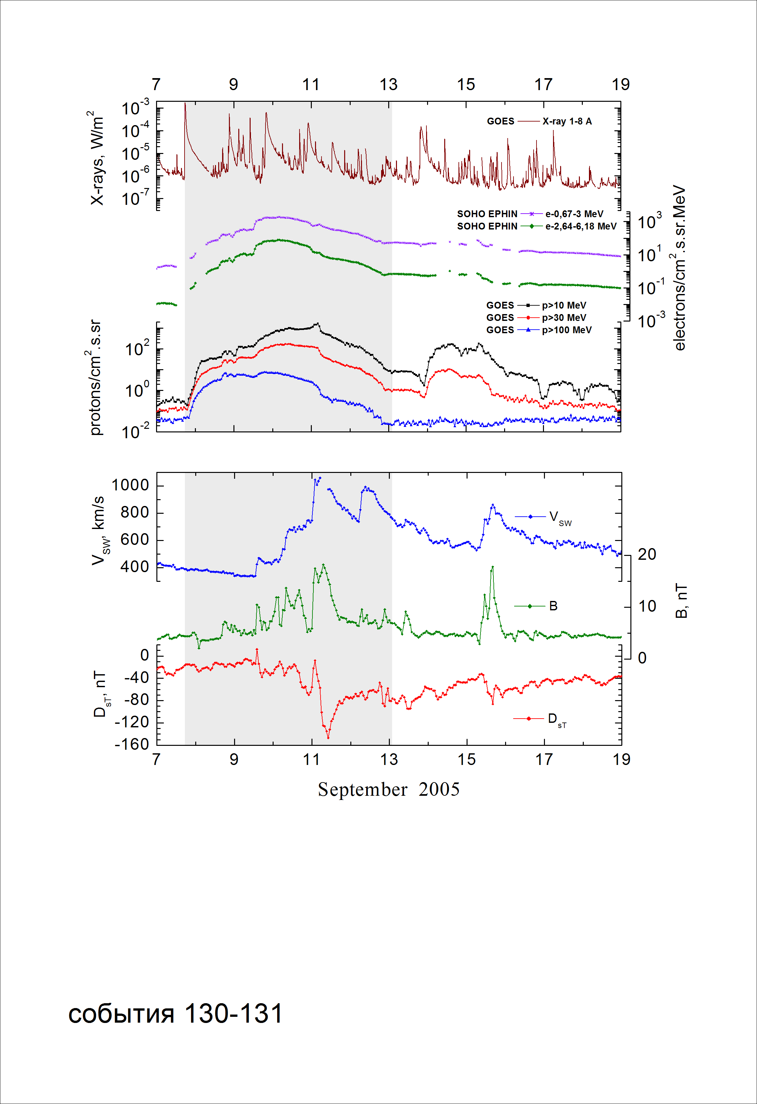
Integral time-of-maximum proton spectrum
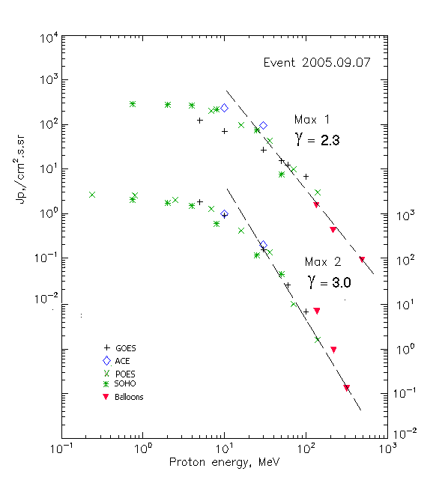

Integral fluxes of protons for the event of 2005.09.07

S/c, instruments | Eр, MeV | To | Tmax | Jmax,  (cm².s.sr)⁻¹ | Dura-tion | Comments
GOES-10
EPS | >5 | 21^{h} | 08d20^{h}/10d12^{h} | 123/2000 | 5d
EPS | >10 | 21^{h} | 08d20^{h}/10d11^{h} | 70/1000 | 5d
EPS | >30 | 21^{h} | 08d20^{h}/10d09^{h} | 26.7/170 | 5d
EPS | >50 | 21^{h} | 08d20^{h}/10d06^{h} | 15.3/47.4 | 5d
EPS | >60 | 21^{h} | 08d19^{h}/10d05^{h} | 12.2/27.4 | 5d
EPS | >100 | 21^{h} | 08d19^{h}/10d03^{h} | 6.8/6.9 | 5d
POES-16
MEPED | >0.24 | - | - /10d12^{h} | - /2920 | 5d
MEPED | >0.8 | - | - /10d12^{h} | - /2810 | 5d
MEPED | >2.5 | - | - /10d10^{h} | - /2230 | 5d
MEPED | >6.9 | - | 08d20^{h}/10d09^{h} | 210/2140 | 5d
MEPED | >16 | - | 08d20^{h}/10d06^{h} | 95/460 | 5d
MEPED | >36 | - | 08d20^{h}/10d04^{h} | 16/150 | 5d
MEPED | >70 | - | 08d20^{h}/10d04^{h} | 10/10.3 | 5d
MEPED | >140 | - | 08d20^{h}/10d04^{h} | 3/1.6 | 5d
ACE
SIS | >10 | 20^{h} | 08d21^{h}/10d11^{h} | 233/1080 | 5d
SIS | >30 | 20^{h} | 08d21^{h}/10d11^{h} | 94/216 | 5d
SOHO
EPHIN (INT) | >50 | 20^{h} | 08d20^{h}/10d04^{h} | 7.6/47.5 | 5d
BALLOONS
Mi | >134 | - | 08d09^{h}25^{m}/ - | 1.5/ - | -
Mi | >216 | - | 08d09^{h}25^{m}/ - | 0.42/ - | -
Mi | >492 | - | 08d09^{h}25^{m}/ - | 0.09/ - | -
Mi | >136 | - | - /09d10^{h}30^{m} | - /6.9 | - | Before max2
Mi | >218 | - | - /09d10^{h}30^{m} | - /0.93 | - | - “ -
Mi | >316 | - | - /09d10^{h}30^{m} | - /0.13 | - | - “ -

Differential fluxes of protons for the event of 2005.09.07

S/c, instruments | ∆Е, MeV | To | Tmax | Jmax, (cm².s.sr.MeV)⁻¹ | Dura-tion | Comments
SOHO
LION | 0.75-2 | 20^{h} | 08d19^{h}/10d09^{h} | 7.4/304 | 5d
LION | 2-6 | 20^{h} | 08d19^{h}/10d10^{h} | 3.3/71.3 | 5d
EPHIN | 4-8 | 20^{h} | 08d19^{h}/10d09^{h} | 13/252 | 5d
EPHIN | 8-25 | 20^{h} | 08d19^{h}/10d08^{h} | 2.4/30.7 | 5d
EPHIN | 25-41 | 20^{h} | 08d19^{h}/10d08^{h} | 0.27/2.9 | 5d

References:
Kuwabara T., Bieber J.W., Clem J., et.al., 2006.
Струминский А.Б., 2011.

