Event 2006.12.05 – (2006-339)

Particle event: To(Ep>10MeV) – 05d15^{h}
Tmax(Ep>10MeV) – 05d20^{h}, Jmax(Ep>10MeV) – 2.5 /cm².s.sr
Duration of the event – 1 day
Energy of the SCR and 0.1 GCR fluxes balance – Eb = 275 MeV

Sources: ● solar flare 05d10^{h}18^{m}, X9/2N, S07E79, АR10930;
Main x-ray burst 1–8 Ǻ: onset – 05d10^{h}18^{m}, max – 05d10^{h}35^{m}, Ф = 0,71 J/m²
CME: gap

Particle fluxes and associated phenomena
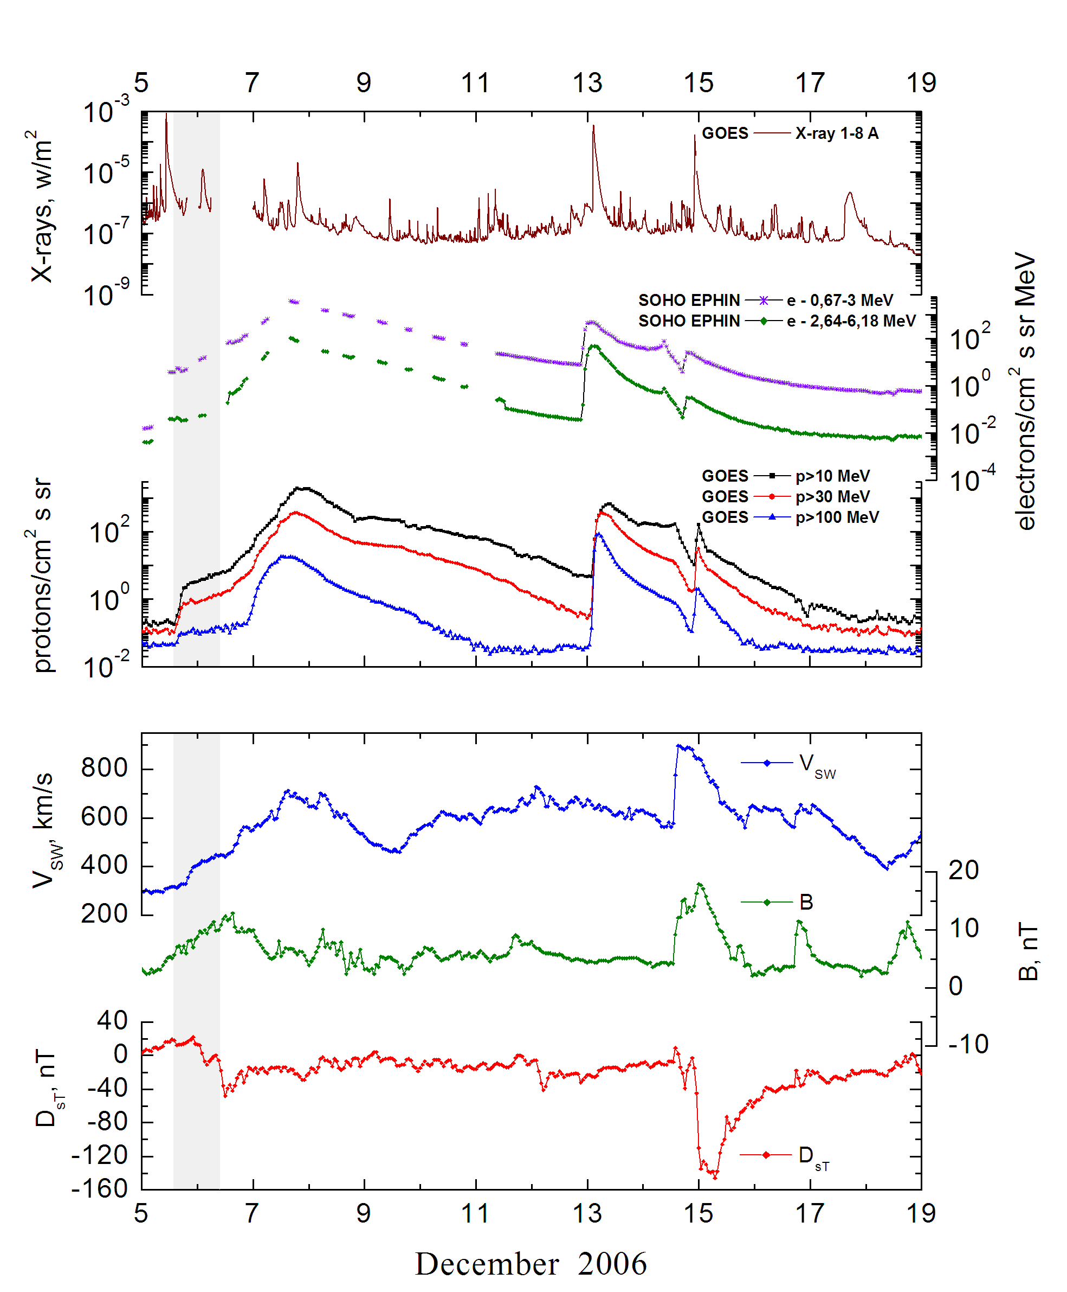

Integral time-of-maximum proton spectrum

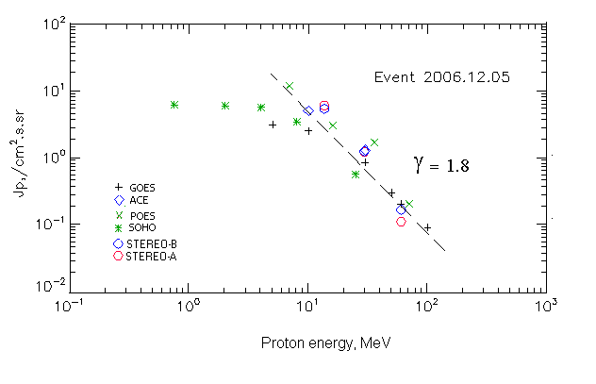

Integral fluxes of protons for the event of 2006.12.05

S/c, instruments | Eр, MeV | To | Tmax | Jmax,  (cm².s.sr)⁻¹ | Dura-tion | Comments
GOES-10
EPS | >5 | 15^{h} | 20^{h} | 3.1 | 1d
EPS | >10 | 15^{h} | 20^{h} | 2.5 | 1d
EPS | >30 | 15^{h} | 21^{h} | 0.85 | 1d
EPS | >50 | 15^{h} | 21^{h} | 0.3 | 1d
EPS | >60 | 15^{h} | 21^{h} | 0.2 | 1d
EPS | >100 | 16^{h} | 22^{h} | 0.09 | 1d
POES-16
MEPED | >0.24 | - | - | - | -
MEPED | >0.8 | - | - | - | -
MEPED | >2.5 | - | ⁻ | - | -
MEPED | >6.9 | - | 20^{h} | 100 | 1d
MEPED | >16 | - | 20^{h} | 3 | 1d
MEPED | >36 | - | 20^{h} | 1.7 | 1d
MEPED | >70 | - | 18^{h} | 0.2 | 1d
MEPED | >140 | - | - | - | -
ACE
SIS | >10 | 14^{h} | 20^{h} | 5 | 1d
SIS | >30 | 14^{h} | 20^{h} | 1.3 | 1d
SOHO
EPHIN (INT) | >50 |  | - | - | -

Differential fluxes of protons for the event of 2006.12.05

S/c, instruments | ∆Е, MeV | To | Tmax | Jmax, (cm².s.sr.MeV)⁻¹ | Dura-tion | Comments
SOHO
LION | 0.75-2 | - | 20^{h} | 0.18 | 1d
LION | 2-6 | - | 20^{h} | 0.08 | 1d
EPHIN | 4-8 | - | 19^{h} | 0.56 | 1d
EPHIN | 8-25 | 08^{h} | 19^{h} | 0.17 | 1d
EPHIN | 25-41 | 08^{h} | 19^{h} | 0.02 | 1d
EPHIN | 41-53 | - “ - | - “ - | - “ - | - “ -
STEREO – A
HET | 13.6-29.5 | 12^{h} | 23^{h} | 0.35 | 1d
HET | 29.5-60 | 12^{h} | 23^{h} | 0.04 | 1d
HET | 60-100 | 12^{h} | 23^{h} | 0.001 | 1d
STEREO - B
HET | 13.6-29.5 | 12^{h} | 23^{h} | 0.3 | 1d
HET | 29.5-60 | 12^{h} | 23^{h} | 0.04 | 1d
HET | 60-100 | 12^{h} | 23^{h} | 0.0015 | 1d

References:
Struminsky A. and Zimovets I., 2008.
Cohen C.M.S., Mason G.M., Mewaldt R.A. et al., 2009.
Damiani A., Storini M., Santee M., S. Wang, 2009.
Data from November 2004 to December 2006, in total 13 events, including 6 and 13 December 2006).
Веселовский И.С., Мягкова И.Н., Яковчук О.С., 2012.

